Unit 1
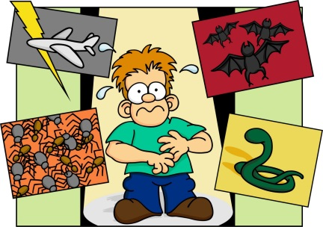
Psychopathology
Definitions of abnormality: | Deviation from social norms, failure to function adequately, statistical infrequency and deviation from ideal mental health
Behavioural, emotional and cognitive characteristics of psychological disorders: | Phobias, depression and obsessive-compulsive disorder (OCD).
The behavioural approach to explaining and treating phobias: | The two-process model, including classical and operant conditioning.  Flooding, Systematic desensitisation, including relaxation and use of hierarchy.
The cognitive approach to explaining and treating depression: | Beck’s negative triad and Ellis’s ABC model.  Cognitive behaviour therapy (CBT), including challenging irrational thoughts.
The biological approach to explaining and treating OCD: | Genetic and neural explanations.  Drug therapy

Definitions of abnormality
‘To study the abnormal is the best way to understand the normal’
William James (1980)

Abnormality is difficult to define; psychologists disagree about the causes of mental disorders and how they reveal themselves. Four criteria for defining abnormality are examined here, each with its strengths and weaknesses.
As will become evident, no single definition is adequate on its own, although each captures some aspect of what we might expect from a true definition of the term. Consequently, abnormality is usually determined by the presence of several of the characteristics we discuss in this pack.

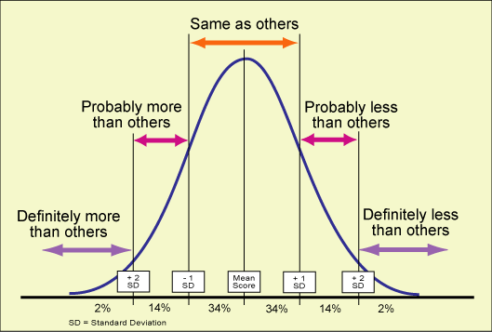
Statistical infrequency
This definition defines behaviours that are abnormal as statistically rare.
A normal distribution curve (as seen on the right) can be drawn to show what proportions of people share the characteristics or behaviour in question. Most people will fall on or near the mean for these.
Any individuals that fall outside the ‘normal distribution’ usually about 5% of a population (2 standard deviation points away from the mean) are perceived as being abnormal.
For example, most people if asked to rate how fearful they are of dogs (if 1=no fear and 10=panic) will give a rating of between 4-7. Their results would cluster around the middle. However, there would be a few people at either end of the scale, some very fearful and some not at all. These ratings would be considered the ‘abnormal’ ratings because they are not the ‘norm’. We would expect to see a normal distribution graph very similar to the one above if we plotted this data.

Notes

Evaluation of the statistical infrequency definition
Strengths
- This way of deciding who is abnormal could be considered objective, if a way of collecting data about behaviour and a ‘cut off point’ has been agreed. It is also based on real, unbiased data and so again could be considered objective. Therefore it avoids the criticism of the other definitions such a deviation from social norms, which is based on subjective standards.

- Statistically infrequency is appropriate in some situations. For example, intellectual disability is defined in terms of normal distribution. Any individual whose IQ is more than 2 standard deviations below the mean is judged as having a mental disorder and this can be used to justify requests for psychiatric assistance.

Limitations
- Not all infrequent behaviours (those showing statistical infrequency) are abnormal- some rare behaviours and characteristics are desirable. For example, being highly intelligent is statistically rare, but desirable. This suggests that there is an element of subjectivity to this definition as if it was truly objective then people with a high IQ would be considered abnormal in the same way as people with a low IQ are.

- Where to draw the line- it can be difficult to decide how far behaviour should deviate from the norm to be seen as abnormal. Many disorders, like depression are experienced by a lot of people. This disorder varies greatly between individuals in terms of its severity so would they all be abnormal or just the individuals who are the furthest away from the norm?

- Cultural factors- the definition doesn’t consider cultural factors. What is statistically normal in one culture may not be in another e.g. in many cultures female genital mutilation is considered statistically normal, however, in the UK this would be statistically abnormal. This issue can lead to the problem of judging people of one culture by the statistical norms of another culture.

Notes

Deviation from social norms

Each society has social norms, which are rules for acceptable behaviour. Quite often these rules are unwritten for example, not being naked in public or not pushing to the front of a queue.
Abnormal behaviour is behaviour that goes against these social norms (deviation from social norms).
The definition draws a line between desirable and undesirable behaviours and labels individuals behaving undesirably as social deviants. This can lead to interventions to help the individual, for instance being admitted to a psychiatric institution.
We are making a collective judgement as a society about what is right/correct behaviour.
Norms are specific to the culture that we live in and are likely to be different for different situations and different generations, so there are very few behaviours that would be considered universally abnormal. For example, homosexuality continues to be viewed as abnormal in some cultures and was considered abnormal on our society in the past.
One important consideration is the degree to which a social norm is deviated from and how important society sees that norm as being.

Notes

Evaluation of the social norms definition
Strengths
- Situational norms- the definition considers the social dimensions of behaviour. It takes into consideration the situation that the behaviour is occurring in and whether that is appropriate. For example, a behaviour seen as abnormal in one setting is regarded as normal in another, for instance walking around town naked would be seen as abnormal but is regarded as normal on a nudist beach.

Weaknesses
- Change over time- the norms defined by society often relate to moral standards that vary over time as social attitudes change. As an example, homosexuality was not removed from the mental disorders classification system (ICD) until 1990. Therefore this definition is limited in its ability to define abnormality because norms are constantly changing.
- Cultural differences- social norms vary within and across cultures so it is difficult to use this definition to assess when these norms are being broken. Due to this limitation it would be difficult to regard someone as normal or abnormal depending on what culture the behaviour was occurring in.
Abnormal? Normal? Normal?
For example, if a male wears a skirt does it indicate abnormality? Would the same be true of a Scottish male wearing a kilt?
This definition of abnormality is an example of cultural relativism.
Cultural relativism- the way in which the function and meaning of a behaviour, value or attitude are relative to a specific cultural setting. Interpretations about the same behaviour may therefore differ between cultures.

- Individualism- those who do not conform to social norms may not be abnormal, but merely individualistic or eccentric and not problematic in any sense. Having individuals that behave in this way may be necessary for making changes within society e.g. Rosa parks broke social norms to achieve the changes in race equality.
Failure to Function Adequately
When someone’s behaviour suggests that they cannot cope with everyday demands e.g. getting up in the morning, getting washed and dressed, and going to work, then they run the risk of being labelled as abnormal by this definition- they are failing to function adequately.
Behaviour is considered abnormal when it causes distress leading to an inability to function properly. It may also be characterised by an inability to experience a normal range of emotions or behaviours.
Rosenhan and Seligman (1989) suggested that the more of these seven features of dysfunction an individual shows the more they are classed as abnormal.

Features of personal dysfunction | Descriptions of features
Personal distress | A key feature of abnormality. Includes depression and anxiety disorders
Maladaptive behaviour | Behaviour stopping individuals from attaining life goals, both socially and occupationally.
Unpredictability | Displaying unexpected behaviours, characterised by loss of control, like attempted suicide.
Irrationality | Displaying behaviour that cannot be explained in a rational way
Observer discomfort | Displaying behaviour that causes discomfort to others
Violation of moral standards | Displaying behaviour that violates society’s moral standards
Unconventionality | Unconventional behaviour

Notes

Evaluation of the failing to function definition
Strengths
- Treatment- The Global Assessment of Functioning scale (GAF) can be used by clinicians to rate the level of social, occupational and psychological functioning of an individual and thus helps in deciding who needs psychiatric help. This can be considered a more sympathetic view of abnormality as it is focused on helping people rather than punishing them for behaviours that society disapproves of.
- Unlike other definitions it is more focused on the individual rather than society’s expectation of the individual. This is a strength because we are not judging people by standards that are subject to change.

Limitations
- Abnormality is not always accompanied by dysfunction. For example psychopaths can cause great harm yet still appear to function normally e.g. Harold Shipman was a English doctor who murdered at least 215 patients, thus was abnormal. However, he was considered to be a respectable doctor and did not display any features of dysfunction. This example demonstrates that many people would not be identified as abnormal according to this definition because they function normally, however if other definitions were used they would be considered vastly abnormal e.g. using your power in a role as a doctor to murder individuals would be considered a deviation from social norms and a deviation from ideal mental health (not an accurate perception of reality).

- Normal abnormality- This definition does not consider situations in which a healthy, psychological response for someone may mean a period of inability to function adequately. For example, when a loved one dies then it is very normal to suffer distress and not be able to cope with everyday demands. Grieving is a perfectly natural response to overcome loss and should not become a factor in defining that person as abnormal.

- Cultural differences- what is considered ‘normal functioning’ varies from culture to culture and so abnormal functioning of one culture should not be used to judge people’s behaviour from other cultures and subcultures.

Notes

Deviation from ideal mental health
Compared with previous definitions that attempt to define what is abnormal, this definition attempts to define what is normal behaviour or an ideal state of mental health.
Thus abnormality is seen as any deviation away from what is defined as normal or the absence of the features described below.
Jahoda (1958) attempted to justify the key features that define ideal mental health:
This can be remembered with the acronym PRAISE.

- Positive attitude towards self: an individual should be in touch with their own identity and feelings. Have self-respect and a positive self-concept.

- Resistance to stress: individuals should be able to resist the effects of stress by having effective coping strategies.

- Accurate perception of reality: individuals should have an objective and realistic view of the world.

- Independent (Autonomy): individuals should be independent and self-reliant and able to make personal decisions.

- Self-actualization: individuals should be focused on the future and their own personal growth and development. ‘Becoming everything one is capable of becoming’.

- Environmental mastery: being competent in all aspects of life and able to meet the demands of any situation. Having the flexibility to adapt to changing life circumstances.

The more characteristics individuals fail to meet and the further they are away from realising individual characteristics, the more abnormal they are.

Notes

Evaluation of the ideal mental health definition
Strengths
- Positivity- this definition takes a positive approach to defining normality in comparison to other definitions. Rather than looking at things that are wrong with an individual like the failure to function definition instead it provides a set of standards for normality that can be used for self-improvement.

- This definition has practical applications for treatment- it allows targeting of areas of dysfunction and can help when treating abnormality. This could be important when treating different types of disorders, such as focusing upon specific problem areas a person with depression has.

Weaknesses
- Over-stringent criteria: most people do not meet all the criteria; as a result, under this definition the majority of us are abnormal! For example, few people achieve self-actualisation and experience personal growth all the time. It would be more useful to consider the criteria as things we should be striving for (ideals) rather than actualities (how you actually are).

- Cultural variation- Jahoda’s views of ideal mental health are rooted in Western views. Many of the concepts, such as autonomy and self-actualisation, would not be recognised as aspects of ideal mental health in many cultures, for example collectivist cultures (non-western) tend to emphasise the importance of inter-dependence (everyone depending on each other) rather than autonomy (independence). This is problematic because it might lead to people from other cultures being considered abnormal because we are judging them from our own cultural stand point.

- The concepts are quite vague and therefore can be hard to measure- for example; it is difficult to decide if someone has achieved self-actualisation. Therefore, this makes the definition subjective and based on the practitioner’s assessment of that individual rather than an objective, scientific measurement.

Notes

Characteristics of Phobias
Phobias are a type of anxiety disorder. Anxiety is an emotion all people experience and is a natural response to potentially dangerous stimuli, but phobias are characterised by uncontrollable, extreme, irrational and enduring fears and involve anxiety levels that are out of proportion to any actual risk.
It is difficult to estimate how many people suffer from a phobia (as many do not seek help) but it is likely that 10% of the population will suffer from a phobia at some point in their life.
Phobias can be long-lasting, enduring over many years. They often originate in childhood and sufferers generally realise their reactions are irrational, but cannot consciously control them.

Sub-types of phobias | Description
Specific phobias | Fear of a specific thing e.g. spiders, blood, flying, water
Social phobias | Being over anxious in social situations e.g. public speaking, interacting with others, crowds
Agrophobia | Fear of leaving home or a safe place. Can be a response to avoidance behaviours.

Symptoms
The symptoms that individuals with phobias suffer from can be broken down into behavioural, emotional and cognitive categories.
Behavioural characteristics of phobias
We respond to things or situations we fear by behaving in particular ways. We respond by feeling high levels of anxiety and trying to escape.
- Panic - A phobic person may panic in response to the presence of the phobic stimulus. Panic may involve a range of behaviours including crying, screaming or running away. Children may react slightly differently, for example, by freezing, clinging or having a tantrum.

- Avoidance - Unless the sufferer is making a conscious effort to face their fear they tend to go to a lot of effort to avoid coming into contact with the phobic stimulus, in order to reduce the chances of anxiety responses occurring. This can severely interfere with their ability to conduct everyday working and social functioning. For example, someone with a fear of public toilets may have to limit the time they spend outside the home in relation to how long they can last without a toilet.

- Endurance - The alternative to avoidance is endurance, in which the sufferer remains in the presence of the phobic stimulus but continues to experience high levels of anxiety. This may be avoidable in some situations, for example for a person who has an extreme fear of flying.
Emotional characteristics of phobias
- Persistent excessive fear and anxiety - Phobias produce an emotional response of anxiety and fear. Anxiety is an unpleasant state of high arousal. This prevents the sufferer from relaxing and makes it difficult to experience any positive emotion.
This emotional response can occur in the presence of or in anticipation of feared objects and situations.

- Fear from exposure to phobic stimulus - Phobias can produce an immediate fear response, even panic attacks, due to the presentation of the phobic object or situation.

- Unreasonable response - Emotional responses to phobic stimuli are unreasonable and wildly disproportionate reactions to the danger posed by the object or situation.
Cognitive characteristics of phobias
The cognitive element concerns the way in which people process information. People with phobias process information about phobic stimuli differently from other objects of situations.
- Selective attention to the phobic stimulus - A sufferer will often not be able to look away from the phobic stimulus. From evolutionary purposes this would have been useful to humans so we are able to react quickly to something potentially dangerous. However, this is not so useful when the fear is irrational.
For example, a pogonophobic will struggle to concentrate on what they are doing if there is someone with a beard in the room.

- Irrational beliefs - A phobic may hold irrational beliefs in relation the phobic stimuli.
For example, social phobias can involve beliefs like ‘if I blush people will think I’m weak’. This kind of belief increases the pressure on the sufferer to perform well in social situations.

- Cognitive distortions - The phobic’s perceptions of the phobic stimulus may be distorted. For example, a coulrophobic may see clowns as scary and dangerous.
Acronym to help you remember these characteristics:
S I C.(k) A P E. PUF
Selective attention, Irrational beliefs, Cognitive distortions
Avoidance, Panic, Endurance
Persistent excessive fear, Unreasonable response, Fear when exposed
Characteristics of depression
Depression is an affective mood disorder involving lengthy disruption of emotions. About 20% of people will suffer from some form of depression throughout their lifetimes, with women twice as vulnerable as men.
At least 5 symptoms must be apparent every day for 2 weeks for depression to be diagnosed by a doctor, with an impairment in general functioning also evident. One of these symptoms must be a constant depressed mood or lessened interest in daily activities.

Type of depression | Description
Major depressive disorder | Severe but often short-term depression
Persistent depressive disorder | Long-term or recurring depression- also called dysthymic depression
Unipolar depression | Sufferers only experience depression and not manic episodes. Clinical symptoms usually occur in cycles.
Bipolar depression | Sufferers experience mixed episodes of mania and depression.

Behavioural characteristics of depression
- Loss of energy
Depressed people can have reduced amounts of energy, resulting in fatigue, lethargy and high levels of inactivity. In severe cases this may mean not being able to get out of bed. In some cases, people with also experience the opposite effect- known as psychomotor agitation e.g. not being able to relax.

- Social impairment
There can be reduced levels of social interaction with friends and relations.

- Weight changes
Significant decreases or increases in weight are often associated with depression. Appetite and eating behaviour is disrupted by this disorder.

- Poor personal hygiene
Depressed people often have reduced incidence of washing, wearing clean clothes etc.

- Sleep pattern disturbance
Depression is often characterised by constant insomnia (inability to fall asleep or stay asleep) or hypersomnia (oversleeping).
Emotional characteristics of depression
- Loss of enthusiasm
Depression is often characterised by a lessened concern with and/or lack of pleasure in daily activities.

- Constant lowered mood
A key characteristic is the ever present and overwhelming feelings of sadness/negativity, sometimes described as feelings of ‘emptiness’.

- Worthlessness
Those suffering from depression often have constant feelings of reduced worth and/or inappropriate feelings of guilt.
It can also be accompanied by lowered self-esteem- liking themselves less than usual. In extreme cases describing a sense of self-loathing (hating themselves).

- Anger
Sufferers of depression also frequently experience anger, directed at the self or others. On occasion these emotions can lead to aggressive or self-harming behaviour.
Cognitive characteristics of depression
People suffering from depression tend to process information about several aspects of the world quite differently from the ‘normal’ ways that people without depression think.
- Reduced concentration
There can be difficulty in paying/maintaining attention and/or slowed-down thinking and indecisiveness. This is likely to interfere with an individual’s work or everyday functioning.

- Attending to and dwelling on the negative
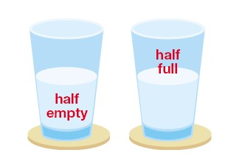
When suffering an episode people with depression are inclined to pay more attention to negative aspects of a situation and ignore the positives-> “glass half empty”. They also have negative schemas.
They might also experience absolute thinking (black and white thinking), whereby they will see an unfortunate situation as an absolute disaster.

- Thoughts of death
Depressives can have constant thoughts of death and/or suicide.
Acronym to help you remember these characteristics: SPEWS CND WALL
Sleep disturbance, personal hygiene, energy-loss of, weight (gain or loss), social impairment
Concentration problems, negative schemas, death (thoughts of)
Worthlessness, anger, loss of enthusiasm, lowered mood
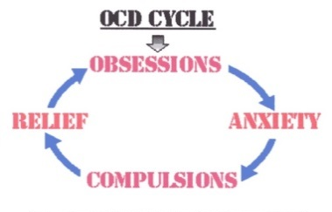
Characteristics of Obsessive Compulsive Disorder (OCD)
OCD is an anxiety disorder where sufferers experience persistent and intrusive thoughts occurring as obsessions, compulsions or a combination of both.
Obsessions tend to be things people think about, which lead to feelings of extreme anxiety (the cognitions). They comprise forbidden or inappropriate ideas and visual images that aren’t based in reality e.g. being convinced that germs are everywhere.
Compulsions are what people do as a result of the obsessions (the behaviour). They comprise intense, uncontrollable urges to repetitively perform tasks and behaviours e.g. obsessively washing hands to remove germs. The compulsions are carried out in order to reduce distress or prevent feared events.
Most sufferers realise their obsessive ideas and compulsions are excessive and inappropriate, but cannot consciously control them, resulting in even higher anxiety. They also appreciate their compulsions are only temporary solutions.
A sufferer’s obsessions and compulsions become very time-consuming, thus interfering with the ability to conduct everyday activities.
There are many different types of OCD, including:
- Hygiene and contamination e.g. washing hands and clothes
- Counting and numbers e.g. multiples
- Hoarding and collecting
- Fear of harming others e.g children
- Sexual ruminations e.g. fearful of being gay

Acronym to help you remember the characteristics: CAR RADDIO
Compulsions-Anxiety Reducing and Repetitive, Avoidance
Depression, Distress
Insight, Obsessive thoughts
Behavioural characteristics of OCD

Compulsive behaviour
- Compulsions are repetitive. Typically sufferers feel compelled to repeat a behaviour e.g. washing hands, counting etc.

- Compulsions reduce anxiety. A majority of these behaviours are performed in an attempt to manage anxiety produced by obsessions e.g. compulsive hand washing is a response to the obsessive fear of germs.

Avoidance: The behaviour of OCD sufferers may also be characterised by their avoidance as they attempt to reduce anxiety by keeping away from situations that trigger it. For example, an obsessive fear of germs may mean the sufferer avoids emptying their rubbish bins, and this can interfere with leading a normal life.
Emotional characteristics of OCD

Anxiety and distress

- OCD is regarded as a particularly unpleasant emotional experience because of the excessive anxiety that accompanies both obsessions and compulsions.

- Obsessive thoughts-> unpleasant/frightening-> anxiety-> urge to repeat compulsion-> anxiety

Accompanying depression

- Anxiety is often accompanied by low mood and lack of enjoyment in activities.

- It can also involve other negative emotions such as irrational guilt or disgust (directed at the self or something external e.g. dirt)

Cognitive characteristics of OCD

Obsessive thoughts

- The major cognitive feature of OCD is obsessive thoughts i.e. thoughts that recur over and over again. They vary from person to person (mind-map on pg 14) but are always unpleasant.

Insight into excessive anxiety

- People suffering from OCD are aware that their obsessions and compulsions are not rational. In spite of this insight, OCD sufferers experience catastrophic thoughts about the worst case scenarios that might result if their anxieties were justified. For example, exposure to germs could result in them catching a disease and dying.

- They tend to be hyper vigilant i.e. maintain constant alertness and attentions focused on potential hazards.

Summary of all disorders and their characteristics

 | Phobias | Depression | OCD
Behavioural | Avoidance  Panic  Endurance | Social impairment  Poor personal hygiene  Energy loss  Weight changes  Sleep disturbance | Compulsive behaviour (anxiety reducing and repetitive)  Avoidance
Cognitive | Selective attention  Irrational beliefs  Cognitive distortions | Concentration reduced  Negative schemas  Death (thoughts of) | Insight into excessive anxiety  Obsessive thoughts
Emotional | Persistent excessive fear and anxiety  Unreasonable response  Fear from exposure | Worthlessness  Anger  Loss of enthusiasm  Lowered moo | Distress  depression
The Behavioural Approach to Explaining Phobias

The two-process model (Acquisition-Maintenance Model)
This section relates to the behaviourist, biological and cognitive approaches. You may find it useful to use your ‘Approaches to Psychology’ pack alongside this one.

Mowrer (1947) proposed this model which suggests that phobias are first acquired through classical conditioning and then maintained through operant conditioning.

Classical conditioning: How phobias are acquired.

Phobias are acquired by associating a neutral stimulus with a fear response.

The case study of Little Albert (Watson & Raynor, 1920) can be used to illustrate this:

Before conditioning:
When Albert was presented with a white rat, he showed no fear response.
White rat = neutral stimulus (NS)

Watson & Raynor found that Albert showed a natural fear response to loud noises (unconditioned stimulus – UCS).
During conditioning:
Albert was presented with the white rat (NS) again and at the same time the researchers struck a steel bar, making a loud noise (UCS) – this led to Albert crying (unconditioned response -UCR)
This was repeated several times.
=

After conditioning:

Now, the white rat (previously the NS but is now the conditioned stimulus – CS) alone makes Albert afraid/cry (conditioned response – CR)

Once a phobia has been acquired, it is maintained by operant conditioning.
Operant conditioning: How phobias are maintained
Operant conditioning states that if behaviours are reinforced they are likely to be repeated.

In the case of phobias, the phobic response is unpleasant and escaping from the object or situation causes a reduction in fear.
This is an example of negative reinforcement because you are removing/taking away something negative and are rewarded for doing so (you feel less anxiety).

For example: Peter is afraid of wasps, when he sees a wasp he becomes very anxious. He does not go out and play with his friends in the park which means he is able to avoid a situation where there may be a wasp. This leads to his anxiety being reduced as he no longer has to worry about coming into contact with a wasp.

Notes

Evaluation of the two-process model
There is supporting evidence for the acquisition of phobias via classical conditioning

Sue et al (1994) found that people with phobias often recall a specific incident when their phobia appeared e.g. being bitten by a dog or experiencing a panic attack in a social situation.

Barlow & Durand (1995) report that 50% of those with specific fear of driving remember a traumatic experience while driving (e.g. an accident) as having caused the onset of the phobia, e.g. some people become intensely afraid of driving a car after a serious accident (associate car with accident).

Both of these studies support the acquisition part of the model through the principles of a stimulus-response association (classical conditioning) however these studies do not tell us how these phobias were maintained therefore we cannot conclude that they fully support the two-process model.

Not all phobias are acquired as a result of a negative experience. For example, Ost (1987) notes that many people with severe fears of snakes, germs, aeroplanes & heights have had no particularly unpleasant experiences with any of these objects or situations. This challenges the two-process model as it is based on the principle that phobias are learnt through experiences. This is a limitation of the model as it suggests that it cannot explain how all phobias are acquired.

Combining classical conditioning and operant conditioning can be seen as a better explanation than looking purely at one or the other to explain phobias. This is because classical conditioning on its own could not explain why, after the initial acquisition of phobias, people continued to be
fearful and avoidant of the stimulus. However, the addition of operant conditioning can provide a reason for the maintenance of phobias.

Some people have negative experiences without developing a phobia. For example, Dinardo (1988) found participants in a control group without a phobia of dogs, experienced a similar proportion of fearful incidents with a dog but had not developed a phobia. This challenges the two-process model as it suggests that not everyone will learn a fear response after a negative experience. This could mean that there may be individual differences in, for example, cognition may play a role in the development of the phobia which the behaviourist approach does not consider.

The model suggests that phobias are maintained through operant conditioning (i.e. avoiding the phobic stimulus) therefore in order to treat the phobia it is important that the sufferer is exposed to their feared object or situation. This has led to practical applications of the theory which includes the development of treatments such as systematic desensitisation. As systematic desensitisation is seen as an effective treatment (see Gilroy et al. P22) we can use this evidence to praise the explanation it originates from.

Extended evaluation

This model cannot fully explain why some phobias are more common than others; the biological preparedness explanation could offer a better explanation for this. This explanation originates from the evolutionary approach and describes the way that humans are more likely to have phobias for stimuli that would have been a real threat to survival. For example, fear of poisonous animals like spiders.

Notes
The Behavioural Approach to Treating Phobias

Systematic desensitisation (SD)

Systematic desensitisation (SD) is a behavioural therapy designed to gradually reduce phobic anxiety through the principles of classical conditioning. If the sufferer can learn to relax in the presence of the phobic stimulus they will be cured.

Essentially a new response to a phobic stimulus is learned (phobic stimulus is paired with relaxation instead of anxiety). This is called counterconditioning.
In addition it is impossible to be afraid and relaxed at the same time, so one emotion prevents the other. This is called reciprocal inhibition.

Three main processes are involved in SD:

Relaxation:

Relaxation techniques are taught to the patient, these include:

- Focussing on breathing and taking slow, deep breaths as when we are anxious we breathe quickly so slowing this down helps us to relax.
- Being mindful of the ‘here and now’.
- Focussing on a particular object or visualising a peaceful scene.
- Progressive muscle relaxation is also used where one muscle at a time is relaxed.

Hierarchy:

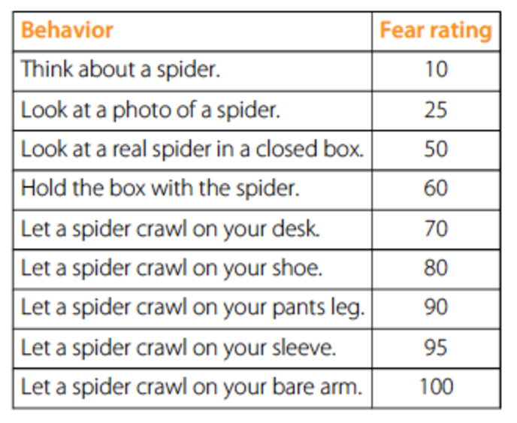
At the beginning of therapy, the therapist and the patient create a hierarchy from most to least fearful stimuli.

Here is an example of a hierarchy for arachnophobia:

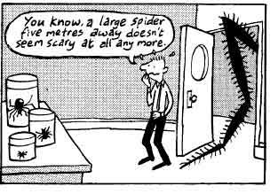
Gradual Exposure:

SD works by gradually exposing the patient to fearful situations one step at a time. At each stage the client practices relaxation so the situation becomes more familiar and their anxiety reduces.
Treatment is successful when the patient can remain relaxed in situations high on the hierarchy.
Below is a diagram which shows the stages of the therapy:

Notes

…. Evaluate treatments:

Two important factors to consider when evaluating treatments it is how ‘effective’ the treatment is and how ‘appropriate’ the treatment is.

In order for us to comment on the effectiveness of a treatment, we tend to look to research studies that have been conducted as they can provide us with evidence on whether the treatment is successful or not.

When commenting on the appropriateness of a treatment, we may consider the following points: how long the treatment takes, if there are any side effects and if the treatment is suitable for all sufferers.

Occasionally these evaluation points are interlinked but as long as you can explain how the point links to appropriateness and/or effectiveness you will have a sound evaluation.

Other ways to evaluate treatments include a comparison with other treatments.

Evaluation of SD
Effectiveness:

Gilroy et al (2003) followed up 42 patients who had been treated for spider phobia in three 45 minutes sessions of systematic desensitisation. Spider phobia was assessed on several measures including the ‘Spider Questionnaire’ and by assessing response to a spider. A control group was
treated by relaxation without exposure. At both 3 months and 33 months after the treatment the
systematic desensitisation group were less fearful than the relaxation group. This shows that the gradual exposure element of systematic desensitisation is crucial to the effectiveness of treating phobias as the control group showed more fear when just given relaxation.

Brosnan and Thorpe (2006) used systematic desensitisation to treat a group of participants who suffered from technophobia (fear of interacting with modern technology). They found that the reduction in anxiety was three times greater for those participants who had treatment compared to those who did not. This shows that using systematic desensitisation as a treatment for phobias is better than no treatment at all.

Appropriateness:

Evidence suggests that SD may be more effective in treating specific phobias whilst other treatments, for example CBT, are better for treating complex phobias such as social phobias. This might be because CBT has more transferrable skills that can be used to address different aspects of a phobia. This means that SD may not be an appropriate treatment for all types of phobias therefore it is important that when considering which behaviourist treatments to give the type of phobia should be taking into account.

Extended evaluation
Making links: What does this suggest about the strength of the behavioural explanation? How could you use this point to critique the behavioural treatments further?

As SD involves gradual exposure to the phobic stimulus and involves the client being relaxed in the presence of the phobic stimulus before moving up the hierarchy, it may be seen as a more ethical treatment as it causes less psychological distress than flooding. This means it may be more appropriate to use SD when treating phobias, especially when treating vulnerable people such as children.

Notes

Flooding

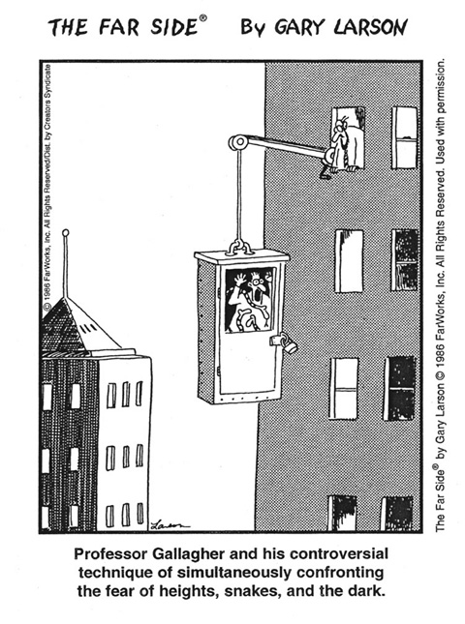

Flooding involves the patient being exposed to an extreme form of a phobic stimulus, essentially forcing them to face their fear e.g. a person who has a phobia of enclosed spaces would be placed into an elevator and would not be able to leave until their anxiety levels reduce.

This technique is based the idea that high levels of anxiety are experienced by the patient when they are bombarded by fear (phobic stimulus), this high level of anxiety cannot be maintained for a long period of time so will eventually subside.

Flooding sessions normally last longer than SD sessions, one session often lasting 2-3 hours. Sometimes only one long session is needed to cure the phobia.

Evaluation of Flooding
Effectiveness:
Kaplan and Tolin (2011) found that 65% of patients with a specific phobia who were given a single session of flooding showed no symptoms of specific phobia 4 years later. This shows that flooding is an effective long term treatment for specific phobias however not all patients were
completely cured of their phobia so this suggests it may not be suitable for everyone.

Wolpe (1960) used flooding to remove a girl’s phobia of being in cars. The girl was forced into a car and driven around for 4 hours until her hysteria stopped. This shows that being bombarded with fear for a long period of time will end the high levels of anxiety experienced in the presence of a specific phobia thus supporting the effectiveness of flooding as a treatment for specific
phobias.

Appropriateness:
Flooding is effective for specific phobias however it appears less effective for more complex phobias such as social phobias. This may be because social phobias have cognitive aspects (e.g. sufferers experience unpleasant thoughts about social situations). Therefore,
similar to SD, we must be cautious when using flooding as a general treatment for all phobias,
perhaps considering other treatments such as CBT for phobias which involve fear of particular
situations.

As flooding can often be done in one session and has been found to be a successful treatment, it can be seen as more cost-effective in comparison to other treatments (e.g. CBT and SD). This means it has the ability to treat people quickly but also has positive economic implications,
flooding costs less than alternative treatments therefore putting less financial pressure on
mental health services.

Although patients give consent to take part in flooding, it can be highly traumatic for them as it involves forcing the sufferer to experience high levels of anxiety. Therefore it may not be seen as suitable for children or vulnerable adults and so is not an appropriate treatment for all sufferers. Also, because flooding causes intense levels of anxiety the drop-out rate is sometimes
rather high which means that it could actually enhance their fear rather than reducing it.

Other evaluation points relevant to both treatments:
Issue of generalisation outside of the clinical setting - the patient may well respond positively towards the previous fearful stimuli when in a clinical setting but may not have the same response when faced with the stimuli in a natural setting. Sometimes SD is done through
imagining scenarios (in vitro desensitisation) and sometimes it involves actual contact (in vivo
desensitisation) therefore if the former is used, it is possible that when the patient is faced with
the actual object or situation they would still have a phobic response.

Ethical considerations: Both treatments can be psychologically distressing however the short term costs of distress may outweigh the long term benefits of removing the fear response.

Notes
The cognitive approach to explaining depression
The underlying assumption of the cognitive explanation is that depression is the result of disturbance in ‘thinking’. In terms of understanding abnormality, cognitive psychologists are most concerned with how irrational thinking leads to a mental disorder. Since depression is very much characterised by faulty and negative thinking, cognitive explanations are particularly appropriate.
There are two examples of the cognitive approach to explaining depression developed by Albert Ellis and Aaron Beck.
Ellis’ ABC Model (1962)
Ellis’s ABC model was developed to explain responses to negative events and how people react differently to stress and adversity. Ellis emphasises the role of the situation or event that can trigger irrational thoughts. Ellis used the ABC model to explain how irrational thoughts affect our behaviour and emotional state.

Activating event (A)
Activating event (A)

Rational Belief (B)
Irrational belief (B)

Healthy emotion (C)
Unhealthy emotion (C)

A refers to an activating event (e.g. you get fired at work)
B is the belief about why the event occurred, which may be rational or irrational (e.g. ‘The company was overstaffed’ or ‘I was sacked because they’ve always had it in for me’).
C is the consequence- the feelings and behaviour the belief now causes. Rational beliefs lead to healthy emotions (e.g. acceptance) whereas irrational beliefs lead to unhealthy emotions (e.g. depression)

The source of irrational beliefs lies in mustabatory thinking- thinking that certain ideas or assumptions must be true in order for an individual to be happy. Ellis identified a range of irrational beliefs:
- I must be approved of or accepted by people I find important.
- I must do well or very well, or I am worthless.
An individual who fails an exam becomes depressed not because they have failed the exam but because they hold an irrational belief regarding that failure (e.g. ‘I must always do well so failing the exam means I’m stupid’).
Beck’s Cognitive Triad
Beck put emphasis on the role of automatic thought in disorders like depression. He believed that depressed individuals feel as they do because their thinking is biased towards negative interpretations of the world. Beck suggested this vulnerability towards negative cognitions (thoughts) is influenced by 3 components:
Negative self-schemas
A schema is a mental framework for the interpretation of information and is developed through experience. Beck perceive negative schemas as developing in childhood and adolescence, when authority figures, such as parents, place unreal demands on individuals and are highly critical of them. These then continue into adulthood and dominate thinking. They are triggered whenever individuals are in situations that are similar to those in which negative schemas were learned.
We use schemas to interpret the world, so if we have a negative self-schema (information about ourselves) we interpret all information about ourselves in a negative way.
Examples include:
- Self-blame schema- makes depressives feel responsible for all misfortunes
- Ineptness schema- makes depressives expect to fail

In adulthood these negative schemas become biases
Cognitive biases
When depressed we attend to negative aspects of a situation and ignore positives. There is an inclination to make overly negative and self-defeating interpretations that lead to low mood and passivity.
For example, if I was depressed and won the £1 million on the lottery, I might focus on the fact that the previous week someone had won £10 million rather than focus on the positives of all I could do with £1 million.
Common misinterpretations include:
- Overgeneralisation- sweeping conclusions drawn on the basis of a single event. For example, a student regarding poor performance on one test as proof of his worthlessness.
- Catastrophising- exaggerating a minor setback until it becomes a complete disaster. For example, believing that if you make one small mistake at your job, you may get fired.

The negative triad
It is worth noting that all 3 aspects of Beck’s theory are linked and the cognitive triad is maintained by negative schemas and cognitive biases/distortions.
The cognitive triad involves people thinking consistently negatively about:
- The self- where individuals see themselves as being hopeless, worthless, and inadequate i.e. ‘nobody loves me’
- The world- an example would be ‘the world is a cold hard place’. This creates the impression that there is no hope anywhere.
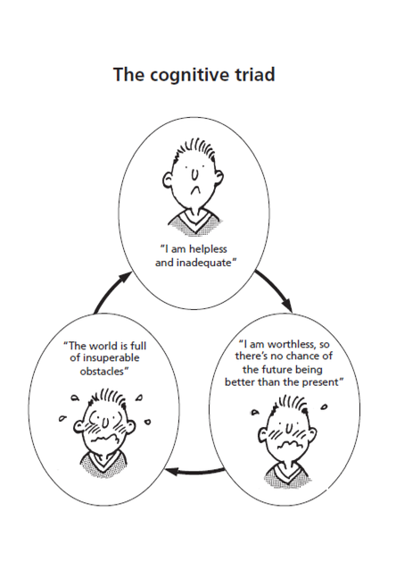
- The future- where personal worthlessness is seen as blocking any improvements i.e. ‘I will always be useless.’

The self

The world
The future

Notes

Evaluation of the cognitive approach to depression
There is lots of research evidence supporting the idea of cognitive vulnerability being linked to the onset of depression, with depressives selectively attending to negative stimuli.

Boury et al. (2001) monitored students’ negative thoughts with the Beck depression inventory (BDI), finding that depressives misinterpret facts and experiences in a negative fashion and feel hopeless about the future, giving support to Beck’s cognitive explanation.
Koster et al. (2005) presented participants with either a positive, negative or neutral word on a screen, after which a square appeared and participants pressed a button to say which area of the screen the square appeared in. Depressed participants took longer to disengage from the negative words than non-depressed participants, which suggest that depressives were focusing more on the negative words in line with Beck’s theory.

Most evidence linking negative thinking to depression is correlational and doesn’t indicate negative thoughts causing depression. So it is still unclear whether there is a cause and effect relationship. Does depression cause negative thinking? Or do negative thoughts cause depression?
Beck came to believe it was a bi-directional relationship, where both elements influence each other.
Depression
Negative thoughts

A high degree of success has been achieved in treating depression with cognitive therapies in comparison to therapies based on other explanations, thus providing support for such explanations. Cognitive behavioural therapy (CBT) aims to identify and challenge components of the negative triad and is consistently found to be the best treatment for depression.

However, depression is a very complex disorder and although both Beck and Ellis’ theories attempt to explain why some people appear to be more vulnerable to depression as a result of their cognitions they do not explain all aspects of depression. For example, why some sufferers experience anger or the fact that some patients suffer hallucinations and delusions.

A comparison can always be made between the cognitive approach and alternative explanations. For example, the cognitive approach does not consider the role of biological factors, such as a chemical imbalance in the brain as a cause of depression. There is a lot of research to support the role of low serotonin levels and a genetic vulnerability in depressed people. However, it does offer a very concise explanation for the distorted thinking present in depression, which cannot be explained well by a biological approach.

Notes

The Cognitive Approach to Treating Depression

Cognitive behavioural therapy (CBT)

CBT is the most common treatment for depression and has been developed based on the key concepts from the cognitive explanation of depression. As behaviour is seen as being generated by thinking, the most logical and effective way of changing maladaptive behaviour is to change the maladaptive thinking underlying it. Therefore CBT assists patients to identify irrational and maladaptive thoughts and alter them.

Alongside the cognitive aspects of CBT, the therapist may also work to encourage a depressed patient to be more active and engage in enjoyable activities. This is called behavioural activation and will provide more evidence for the irrational nature of beliefs.

Two types of CBT are Beck’s cognitive therapy and Ellis’s rational emotive behaviour therapy (REBT).

Beck’s cognitive therapy:

The aim of this therapy is to identify automatic negative or irrational thoughts about the world, the self and the future (the cognitive triad) this is often referred to as ‘thought catching’.

Once identified, these thoughts are challenged. This is a central part of the therapy. As well as challenging these thoughts directly, the patient must also test the reality of their beliefs. One way this can be done is by setting them homework (for example, diary keeping) in which they record times when they have enjoyed an event or when someone was nice to them. Therefore in future sessions, if the patients say that no one is nice to them or there is no point in going to the events, the therapist can then produce this evidence and use it to prove the patient’s statements are incorrect.

Ellis’s REBT:

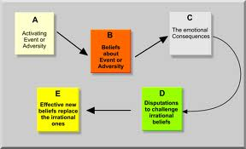
REBT extends the ABC model (see explanation) to an ABCDE model – the D stands for dispute and the E stands for effect. The central part of REBT is to identify and dispute irrational thoughts and beliefs.

There are certain ways in which the therapist will dispute the patient’s irrational thoughts. One way is empirical dispute; this involves asking the patient for proof that their thoughts or beliefs are true. Another way is logical dispute which involves asking if the belief is logical or based on common sense.

The aim is for the client to re-interpret their thoughts and beliefs in a more positive way which will help to reduce the negative emotions they experience as a result of irrational thinking.

Evaluation of CBT

Effectiveness:

There is a large amount of supporting evidence for the effectiveness of CBT being used to treat depression. For example, the Department of Health (2001) reviewed research papers of treatments for depression and found CBT to be the most effective. However they did not endorse the use of CBT alone as other treatments were also effective. This suggests that although CBT is successful it is not the only effective treatment for depression. It may depend on the individual’s case as to which treatment is used.

David et al (2008) found, using 170 patients suffering from major depressive disorder, patients who were treated with 14 weeks of REBT had better treatment outcomes than those treated with the drug fluoxetine 6 months after treatment. This suggests that CBT is a more effective treatment for depression than the drug therapies and suggests it provides a suitable long term
treatment for depression.

Craighead and Dunlop (2014) carried out a meta-analysis to find out whether CBT is more effective when used on its own or in combination with drug therapy. For long-lasting depression, combined treatment was generally more effective. This suggests that biological factors also play a role in the depression and that it is not suitable to just use CBT to treat depression long term.

Appropriateness:

Since many of the symptoms of depression are cognitive, it seems appropriate for the therapy’s central focus to be changing negative and irrational views into ones that are more positive and realistic.

In cases of severe depression, patients may not be able to motivate themselves enough to engage in CBT therefore it may be more appropriate to treat these patients with anti-depressants and commence CBT when they are able to fully engage with the treatment. Therefore CBT may be more effective when used as a combined approach to treating severe depression.

CBT could be seen as more appropriate than other treatments as it is designed to have long term benefits. It is used continually to stop symptoms reoccurring by trying to alter the negative thoughts and beliefs at the root of the depression. However, there are economic implications here as this type of treatment is time consuming and potentially costly to the NHS. Perhaps it should only be used for people with severe depression or used in combination with drug therapy, which has demonstrated the most effective results.

Further evaluation:

The success of the treatment could be down to the patient-therapist relationship rather than the particular techniques that are used.
Many comparative reviews (e.g. Luborsky et al, 2002) find very small differences, supporting the idea that simply having someone to talk to and who will listen is what is most important. Therefore support groups could be used instead as it may not be necessary for a trained mental health professional to be involved in the treatment, support groups would be more accessible, fewer resources would be needed and so would cost less money.
Extended evaluation:
CBT could be criticised for overemphasising cognitions and underestimating the importance of the patients personal circumstances (e.g. if they are in poverty or suffering abuse). It may be that the patients circumstances need to change and focussing on the mind rather than the environment could prevent this.

Notes

The Biological Approach to Explaining OCD

Genetics

Genetic explanations focus on whether individuals inherit a genetic pre-disposition to developing OCD.

Family studies have shown that relatives of OCD are more vulnerable to developing OCD. For example, Nestadt et al (2000) found that first-degree relatives (i.e. parents, siblings) of OCD sufferers had an 11.7% chance of developing the disorder compared to a 2.7% risk in first-degree relatives of control patients without OCD.
Concordance rate:
The probability that a pair of individuals will both have a certain characteristic, given that one of the pair has the characteristic.

Twin studies have also been used to investigate the role genetics play in developing OCD. They involve a comparison between identical twins (monozygotic – MZ) and non-identical twins (dizygotic – DZ). MZ twins share 100% of their genes and DZ share only 50% of their genes so if genes do play a role in developing OCD we would expect to find a higher concordance rate for MZ than DZ. For example, Carey and Gottesman (1981) found MZ twins has a concordance rate of 87% for obsessive symptoms and features compared to 47% in DZ twins.

However, OCD seems to be polygenic. This means that OCD is not caused by one single gene but that several genes are involved. Taylor (2013) found evidence that up to 230 different genes may be involved in OCD.

Evaluation of genetic explanations
There is a large amount of consistent evidence from twin and family studies which show that genetic factors are important in developing OCD.
Van Grootheest et al (2005) reviewed twin studies on OCD and all studies reported higher concordance rates for MZ twins and came to an overall conclusion that there was a moderate genetic influence on the development of OCD.

Nestadt et al (2010) reviewed previous twin studies and found that 68% of identical twins shared OCD as opposed to 31% of non-identical twins.

Both of these studies support the link between genetics and OCD as MZ twins share 100% of their genes whereas DZ twins only share 50% therefore as the concordance rates and percentages are higher for MZ twins this shows that genetics must play a role in developing OCD.

It could be argued that the research investigating how genes are involved in OCD is limited. For example, much of the supporting evidence comes from twin studies meaning the samples used are often unrepresentative of all sufferers of OCD. Therefore it is often difficult to generalise the extent to which genes influence the development of OCD to the wider population.

Although twin studies strongly suggest OCD is largely under genetic control, psychologists have not yet pinned down all the genes involved. One reason for this is because it appears that several genes are involved and that each genetic variation only increases the risk of OCD by a fraction. The consequence is that a genetic explanation is unlikely to ever be very useful because it provides little predictive value.

Evidence for the genetic explanation suggests that some people may be more susceptible to OCD however it does not suggest that genes are the sole cause of OCD. It seems that environmental factors also trigger or increase the risk of developing OCD. For example, Cromer et al (2007) found over half the OCD patients in their sample had a traumatic event in their past, and that OCD was more severe in those with more than one trauma.

Extended evaluation:
Our genetic coding is complex and as genome research has developed there has been some suggestion that MZ may have similar genes but are not completely identical.

Notes

Neural explanations

The neural explanations for OCD include biochemical causes (e.g. the role of the neurotransmitter, serotonin) and neurophysiological causes (certain areas of the brain e.g. the orbitofrontal cortex)

Biochemical causes (serotonin):

If a person has a low level of serotonin then normal transmission of mood-relevant information does not take place which means mood, and sometimes other mental processes, are affected. At least some cases of OCD may be explained by a reduction in the functioning of the serotonin system in the brain.

Neurophysiological causes (areas of the brain):
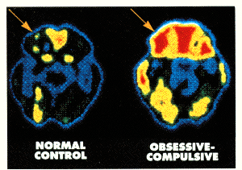
Research has found sufferers of OCD have elevated levels of activity in the orbitofrontal cortex and the caudate nucleus (located in the basal ganglia).
PET scans of patients with OCD have shown higher levels of activity in the OFC.The orbitofrontal cortex is part of a brain circuit; one of the functions of this circuit appears to be turning sensory information into thoughts and actions. Primitive impulses, for example to check and clean, arise from the orbitofrontal cortex in response to sensory inputs.
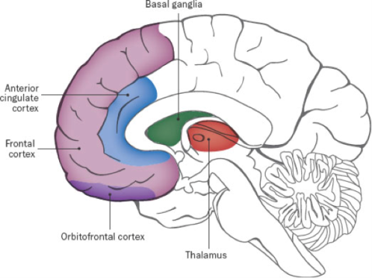
Here is a description of how the circuit relates to OCD:

The orbital frontal cortex sends a message of panic to the caudate nucleus. A normal brain would decide whether or not this issue is important and if it is, it would get passed on to the thalamus to take action. If the message isn’t important or has already been dealt with it will filter out ending the circuit. However in a brain of an OCD sufferer, the caudate nucleus does not work correctly and send the potentially faulty message of panic to the thalamus which then carries out the action e.g. washing hands. This will keep repeating on a loop which is why someone with OCD performs compulsions which are repetitive rituals.
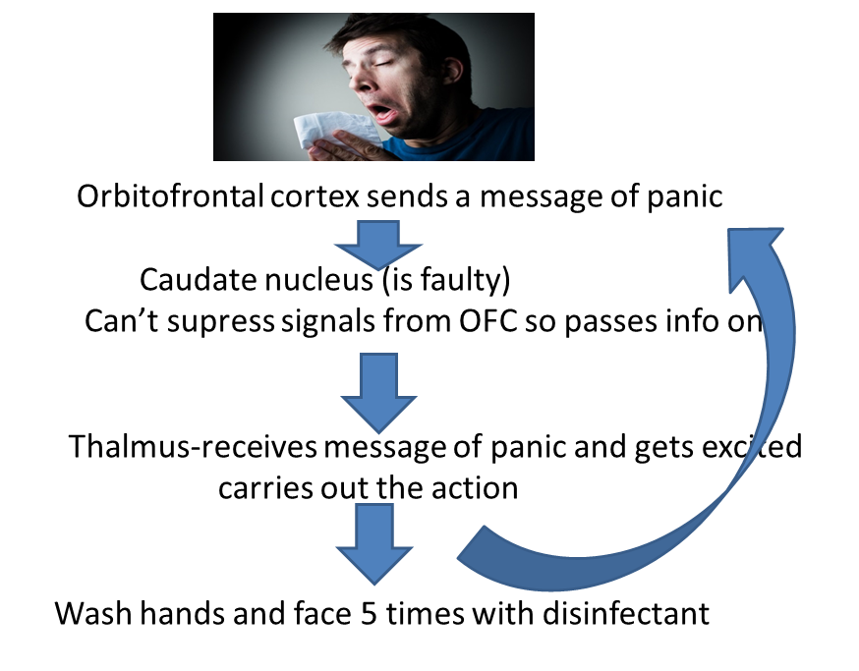
For example, a non-suffer of OCD may have an impulse to wash dirt from their hands; once this is done the impulse to perform the activity stops and so does the behaviour. It may be that the brains of those with OCD have difficulty switching off these impulses so that they turn into obsessions, resulting in compulsive behaviour.

Evaluation of neural explanations
There is supporting evidence for both neural explanations.

Hu (2006) compared serotonin activity in 169 OCD sufferers and 253 non-sufferers, finding serotonin levels to be lower in the OCD patients therefore supporting the link between low levels of serotonin and OCD.

Zohar et al (1987) gave mCPP (a drug that reduces serotonin levels) to 12 OCD patients and 20 non-OCD control participants, finding that symptoms of OCD were significantly enhanced in the OCD patients. This suggests that low levels of serotonin do play a role in OCD as it shows it can cause symptoms to worsen in sufferers.

A review of brain-imaging research shows elevated activity in the orbital region and the caudate nucleus has been found consistently in OCD patients compared to healthy controls. After treatment, activity in these brain areas reduces to a level comparable to that of controls as found by Saxena and Rauch (2000). This supports the neurophysiological explanation as it shows that these areas of the brain are linked to OCD.

It is difficult to establish whether low levels of serotonin actually cause OCD, are an effect of having the disorder or are merely associated with the disorder. Causation cannot be inferred as only associations have been identified from the research conducted. Therefore, there the biochemical explanation is limited as no firm conclusions can be made as to whether it does cause OCD.

The relationship between OCD and the functions of the basal ganglia is not straightforward. Neuroimaging studies have so far failed to identify the basal ganglia impairments in all OCD sufferers, and some people with brain impairments involving the basal ganglia show no signs of OCD (Ring and Serra-Mestres, 2002)

These neural explanations have led to practical applications such as using drug therapies to help reduce the symptoms of OCD in sufferers.

However, the research into the role of serotonin is contradictory; some studies have found taking serotonin enhancing drugs do not always work to relieve symptoms. Therefore it is difficult to draw firm conclusions about the exact role of neurotransmitters in OCD
The Biological Approach to Treating OCD

Drug therapy

Drugs aim to increase or decrease the level of neurotransmitters in the brain. In relation to OCD, drug therapy consists of drugs that increase levels of the neurotransmitter serotonin.

Synaptic transmission

Serotonin is released by certain neurons in the brain.
It is released by the presynaptic neurons and travels across the synapse.
The neurotransmitter transfers the signal from the presynaptic neuron to the postsynaptic neuron by attaching to receptors.
Any serotonin left in the synaptic gap is then reabsorbed by the presynaptic neuron where it is broken down and re-used.

- SSRIs (selective serotonin reuptake inhibitor) are a type of antidepressant drug
- They prevent the re-absorption and breakdown of serotonin.
- This results in more serotonin available in the synapse.
- Increasing levels of serotonin can result in improved symptoms for the sufferer.

It takes about 3-4 months daily use for SSRIs to have much impact on symptoms. One type of SSRI is Fluoxetine. If SSRIs prove ineffective after this time then the dose can be increased or it can be combined with other drugs. Sometimes alternative drugs are given as patients can respond differently to different drugs. Two other examples of drug treatments are; Tricyclics, which have the same effect as SSRI’s (however these are generally only used when patients do not respond to SSRIs as the side effects are more severe) and SNRIs, which are newly developed anti-depressants that increase the level of serotonin and noradrenaline.

As a treatment for OCD, it is common for drugs to be used alongside other treatments, such as CBT.

Notes

Evaluation of the biological treatments

Effectiveness:

Julien (2007) reported that studies of SSRIs show that although the symptoms do not fully disappear between 50% and 80% of OCD patients improve, allowing them to live a fairly normal lifestyle, which they wouldn’t be able to do without the treatment.

Soomro et al (2009) reviewed studies comparing SSRIs to placebos in the treatment of OCD and concluded that all 17 studies reviewed showed significantly better results for SSRIs than for placebo conditions.

Pigott and Seay (1999) reviewed studies testing the effectiveness of drug therapies, finding SSRIs to be consistently effective in reducing OCD symptoms.

These studies suggest that altering serotonin levels in OCD patients quite often helps to reduce the symptoms and that despite drug treatments not always being completely effective, they should still be considered as a possible treatment option for people who suffer from OCD.

Appropriateness:
Drug treatments are widely used to treat the symptoms of OCD as they are seen to be more cost-effective in comparison to psychological treatments. In addition to reducing symptoms in OCD patients, drug therapies also have positive economic implications as they are good value for the NHS.

Drugs reduce obsessive thoughts and compulsive behaviour to such a level that a normal lifestyle can be achieved but they do not ‘cure’ OCD. Therefore drug treatments could be seen as less appropriate, in contrast to psychological treatments, as they do not allow the sufferer to actually overcome their obsessive thoughts and compulsive behaviours. Treating OCD with drugs also has
implications for the sufferers as it means they would have to continue taking medication for the
rest of their lives as without it the symptoms would most probably resurface.

Patients can experience a number of side effects with drug treatments. For example, loss of appetite, loss of sex drive, irritability, sleep pattern disturbance and headaches are all common side effects. This could mean that it may not always be an appropriate treatment for all OCD sufferers plus if the side effects are severe enough, it could actually lead to the patient stopping the treatment all together.

Psychopathology Practical write up

Previous studies have found that press coverage of mental health issues is poor. Reports focus on violent incidents or use inappropriate language like ‘nutcase’ or ‘bonkers’ to describe people with mental health problems. However, there is much better awareness of mental health now so it may be that this is much less of a problem than in the past. The aim of this study is to investigate the language used in press coverage of mental health using a method of indirect observation.

Design a study exam question

A researcher has heard that Cognitive behavioural therapy (CBT) could be a better treatment for OCD that drug therapy. Design an experiment that investigates whether an 8 week course of drug therapy or CBT is a better treatment for OCD. (12 marks)

Include in your answer:
- an operationalised non-directional hypothesis.
- How you will conduct your study; including experimental design, sampling technique and how you will measure you dependent variable.
- Ethical issues to consider

Practice short answer exam questions

- Outline one definition of abnormality (2 marks)
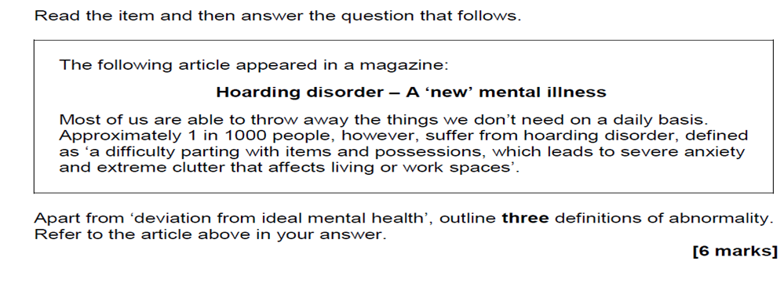

- Briefly outline the deviation from IMH as a definition of abnormality (2 marks)
- Discuss statistical infrequency as a definition of abnormality (6 marks)

- Identify one emotional characteristic of: Depression, OCD and Phobias (3 marks)
- Outline systematic desensitisation as a treatment for phobias (6 marks)
- Outline Ellis’ ABC model (4 marks)
- Outline Becks’s cognitive triad (4 marks)
- Ewan has just been diagnosed with depression having felt overwhelmed with despair for the last 12 weeks. His doctor suggested that the cause of this was the fact that Ewan’s long-term partner walked out on him three months ago. When this happened, Ewan convinced himself that he would never find himself another boyfriend.

Using Ellis’ ABC model, explain why Ewan is suffering from depression (6 marks)
- Outline one neural explanation of OCD (4 marks)
- Give one limitation of the genetic explanation to OCD (3 marks).

Essay Planning
Thomas does not want to go to a friend’s birthday party as his friend is having an outdoor circus party and there will be a clown there. Thomas is really afraid of clowns.
His mother and father are discussing how they can help him overcome his phobia so he can go to this party and potentially other parties too.
His dad says ‘I think I will take him to the party and sit with him in the car outside until he calms down. Then we could go and sit in the living room of the house and watch the clown do his tricks with the other children through the window. Maybe then he might be able to go outside and join the party’.
H-is mum replies ‘I really think the only way he will overcome this fear is for us to just make him go to the party and meet the clown’

Discuss two behavioural treatments for phobias. Refer to the conversation above in your answer.
[16 marks]
Outline the two treatments and apply to the stimulus
Effectiveness
Appropriateness
Other evaluation
“Describe and evaluate the cognitive approach as an explanation of depression” (16 marks)

Outline and evaluate cognitive treatments of depression (8 marks)

Other practice essay questions
- Describe and evaluate two ways of defining abnormality (16 marks)
- Outline and evaluate the behavioural approach to explaining phobias (16 marks)
- Describe and evaluate the biological approach to OCD (16 marks)
- Describe and evaluate the biological approach to the treatment of OCD (16 marks)

