Gender Mini Mock MS

1. Explain what is meant by ‘androgyny’. (1 mark)

1 mark for a correct definition: possessing a balanced combination/mixture of masculine and feminine traits.
Or possessing high levels of both masculine and feminine traits.

2. Read the item and then answer the questions that follow.

In a study of androgyny, a group of 100 18-year-old students completed a self-report sex-role inventory. The inventory gave two sets of scores: a femininity score and a masculinity score. Each set of scores was on a scale of 0–20, with 0 representing no masculinity or no femininity and 20 representing extreme masculinity or extreme femininity.
The researchers calculated measures of central tendency for the masculinity scores. They found that the mean masculinity score was 10.3, the median masculinity score was 9.5 and the mode masculinity score was 7.

Sketch a graph to show the most likely distribution curve for the masculinity scores in this study. Label the axes of your graph and mark on it the positions of the mean, median and mode. [3 marks]

3. Outline the role of chromosomes and hormones in sex and gender (6 marks)

Have you…..
Specific content in answer
Included the following knowledge in your answer
Female and male chromosome patterns (XX and XY)
Y chromosome carries the SRY gene that leads to testes development
Testes secrete androgens (male sex hormones)
Androgens cause foetus to develop into a male (if not present then develops into female)
Androgens play a role in the brain development of foetus. Masculinisation occurs
Masculinisation of brain-> speeds up development of some areas and increase size of others e.g. BSTC.
Testosterone levels and these brain differences might account for differences in gender behaviour that we see e.g. competiveness and aggressiveness in males.
General aspects of your answer
Explained the role of chromosomes AND hormones?

Linked back/referred to ‘sex’ AND ‘gender’ throughout your outline?

4. Explain two limitations of the gender schema theory as a cognitive explanation of gender development (6 marks)

2 developed evaluation paragraphs required for full marks (PEEL structure)

Could include:

- Challenging research e.g. Eisenberg et al.
- Children tend to only use gender schemas when trying to make sense of the behaviour of others (when they do not know the motives of others)
- Comparison with Kohlberg’s gender constancy theory
- Exaggerates the role of schemas at the expense of other environmental variables e.g. reinforcement
- When schemas change, a change in behaviour doesn’t always follow

5. Discuss the influence of culture on the development of gender roles (8 marks)

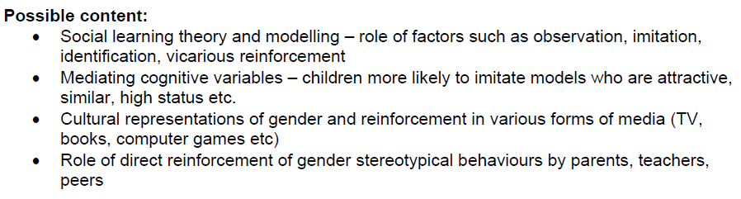
Ensure that the focus of your AO1 is how these factors influence gender roles in different cultures.
