First year research methods mini-mock

A psychologist wished to investigate the effectiveness of a strategy for memory improvement. There has been previous research in this field suggesting that memory strategies improve memory recall. The psychologist carried out an experiment using different participants in each condition. In one condition, participants were taught a memory improvement strategy. In the other condition, different participants were not taught this memory improvement strategy. All participants were asked to memorise 10 pictures of familiar objects. For example, the first was a doll, the second was an apple. All participants were then given 50 pictures each, and asked to select the original 10. The psychologist did a pilot study before carrying out the experiment. The results of the experiment are shown in Table 1.

1 Write an appropriate operationalised hypothesis for this experiment (3 marks)
...........................................................................................................................................................................
..........................................................................................................................................................................
..........................................................................................................................................................................
.....................................................................................................................................................................................................................................................................................................................................................

2 Identify the experimental design used in this study and explain one strength of using this experimental design when carrying out research (3 marks)
..........................................................................................................................................................................
........................................................................................................................................................................... ..........................................................................................................................................................................
...........................................................................................................................................................................
...........................................................................................................................................................................

3 Explain why the psychologist carried out a pilot study for this research (3 marks)
..........................................................................................................................................................................
...........................................................................................................................................................................
..........................................................................................................................................................................
...........................................................................................................................................................................
..........................................................................................................................................................................
.................................................................................................................................................................................................................................................................................................................................................................................................................................................................................................................................
..........................................................................................................................................................................
.................................................................................................................................................................................................................................................................................................................................................................................................................................................................................................................................

4. The data collected in this study is primary data. Explain what is meant by primary data (2 marks)

..........................................................................................................................................................................
.................................................................................................................................................................................................................................................................................................................................................................................................................................................................................................................................

The psychologist was interested in investigating the area of memory improvement further but instead decided to look at the effects of different food on memory. His grandmother had always said that eating fish heads improved your memory but no research had ever been done on this so he decided to carry out a piece of research on this and the initial findings are shown below.

Table 1:Table to show scored on a memory test out of 20 before and after eating fish heads.
participant | Scores on a memory test (out of 20) before eating fish heads | Scores on a memory test (out of 20) after eating fish heads.
1 | 8 | 20
2 | 2 | 20
3 | 4 | 6
4 | 5 | 5
5 | 10 | 9
6 | 12 | 11
7 | 8 | 9
8 | 2 | 15
9 | 1 | 20
10 | 2 | 19
11 | 14 | 15
12 | 3 | 11
13 | 10 | 12
14 | 19 | 20
15 | 13 | 14

5. Using the information from the table work out the observed value (s) for the above data and explain how you reached this answer. (2 marks)

…....................................................................................................................................................................…...............................................................................................................................................................................
…........................................................................................................................................................................

6. Using the information in table 2, what conclusions can you draw about the effect that eating fish heads has on memory. Fully explain your answer (4 marks) Table 2-critical value table
s≤ critical value for findings to be significant
……………………………………………………………………………………………………………………………………………………………………………………………………………………………………………………………………………………………………………………………………………………………………………………………………………………………………………………………………………………………………………………………………………………………………………………………………………………………………………………………………………………………………………………………………………………………………………………………………………………………………………………………………………………………………………………………………………………………………………………………………………………………………………………………………………………………..

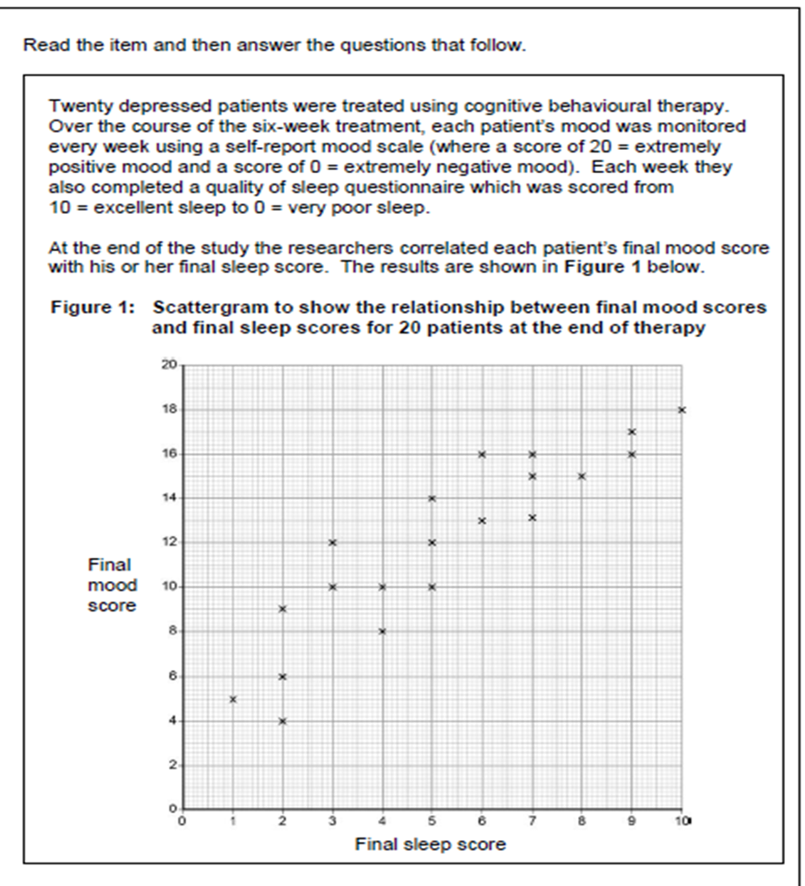
7 (a) Outline the conclusions that could be drawn from the graph shown above. [2 marks]
...........................................................................................................................................................................
..........................................................................................................................................................................
...........................................................................................................................................................................
..........................................................................................................................................................................

(b) Suggest why it would not be appropriate for the researchers to conclude that better sleep improves mood (1 marks)
...........................................................................................................................................................................
..........................................................................................................................................................................
...........................................................................................................................................................................
..........................................................................................................................................................................

(c) Identify one ethical issue which the psychologist should have considered when carrying out this research and how they could deal with this issue. (1+1 marks)
……………………………………………………………………………………………………………………………………………………………………………………………………………………………………………………………………………………………………………………………………………………………………………………………………………………………………………………………………………………………………………………

8. The researcher used volunteer sampling for the research on depression. Explain why they used this type of sampling for this research (1 mark)
………………………………………………………………………………………………………………………………………………………………………………………………………………………………………………………………………………………………………………………………………………………………………………………………………………………………………………………………………………………………………………………

9. Another type of sampling used in psychology is random sampling. Give one disadvantage with using random sampling (2 marks)

……………………………………………………………………………………………………………………………………………………………………………………………………………………………………………………………………………………………………………………………………………………………………………………………………………………………………………………………………………………………………………………

10. A group of researchers conducted a survey about helping behaviour. They asked an opportunity sample of 200 university students to complete a questionnaire. The questionnaire contained open and closed questions. The following are examples of questions used in the questionnaire:

A Do you think that you are generally a helpful person? Yes No

B What do you think most people would do if they were driving in the rain and saw a woman standing alone next to her broken-down car?

C How would you react if someone walking in front of you slipped and fell over?

(a) Identify an open question from A, B or C above. Give one advantage of using open questions.

Example of open question (write A, B or C) ________

(1 mark)
Advantage ………………………………………………………………………………………………………………………………………………………………………………………………………………………………………………………………………………………………………………………………………………………………………………………………………………………………………………………………………………………………………………………………………………………………………………………………………………………………………………………………………………. (1 mark)

11. In an observational study, 100 cars were fitted with video cameras to record the driver’s behaviour. Two psychologists used content analysis to analyse the data from the films. They found that 75% of accidents involved a lack of attention by the driver. The most common distractions were using a hands-free phone or talking to a passenger. Other distractions included looking at the scenery, smoking, eating, personal grooming and trying to reach something within the car.

(a) What is content analysis?
……………………………………………………………………………………………………………………………………………………………………………………………………………………………………………………………………………………………………………………………………………………………………………………………………………………………………………………………………………………………………… (2 mark)

(b) Explain how the psychologists might have carried out content analysis to analyse the film clips of driver behaviour.
………………………………………………………………………………………………………………………………………………………………………………………………………………………………………………………………………………………………………………………………………………………………………………………………………………………………………………………………………………………………………………………………………………………………………………………………………………………………………………………………………………………………………………………………………………………………………………………………………………………………………………………………………………………………………………………………………………………………………………………………………………………………(4 marks)

12. Read the item and then answer the questions that follow.

Participants in an experiment were shown a film of a robbery. The participants were then randomly allocated to one of two groups. One group was interviewed using a standard interview technique and the other group was interviewed using the cognitive interview technique. All participants were then given an ‘accuracy score’ (out of 20) based on how closely their recall matched the events in the film (20 = completely accurate, 0 = not at all accurate).

The results of the experiment are shown in the table below.

The median accuracy score for the standard interview and the cognitive interview

 |  | Standard interview | Cognitive interview
 | Median | 10 | 17

(a) Sketch an appropriate graphical display to show the median accuracy scores in the table above.

(4 marks)

(b) What conclusion could the psychologist draw from the median estimated scores? (2 marks)
………………………………………………………………………………………………………………………………………………………………………………………………………………………………………………………………………………………………………………………………………………………………………………………………………………………………………………………………………………………………………………………

(c) Give one possible reason why the median has been calculated rather than the mean (2 marks)
………………………………………………………………………………………………………………………………………………………………………………………………………………………………………………………………………………………………………………………………………………………………………………………………………………………………………………………………………………………………………………………
(d) Identify one control the researcher put in place (1 mark)
………………………………………………………………………………………………………………………………………………………………………
(e) This study is a laboratory experiment. Give one strength and one limitation of laboratory experiments, refer to this study in your answer (6 marks)
………………………………………………………………………………………………………………………………………………………………………………………………………………………………………………………………………………………………………………………………………………………………………………………………………………………………………………………………………………………………………………………………………………………………………………………………………………………………………………………………………………………………………………………………………………………………………………………………………………………………………………………………………………………………………………………………………………………………………………………………………………………………………………………………………………………………………………………………………………………………………………………………………………………………………………………………………………………………………………………………………………………………………………………………………………………………………………………………………………………………………………………………………………………………………………………………………………………………………………………………………………………………………………………………………………………………………………………………………………………………………………………………………………………………………………………………………………………………………………………………………………………………………………………………………………………………
Total /48 marks
What grade did you get?
A* 42 - 48 D 20 - 25
A 38 - 41 E 14 - 19
B 32 - 37 U 0 - 13
C 26 - 31

Areas I need to improve on | Did I revise these areas?

