Forensic prep 3: Psychological explanations of offending behaviour
- Eysenck’s theory of the criminal personality;
- Cognitive explanations (levels of moral reasoning & cognitive distortions);
- Differential association theory
- Psychodynamic explanations

Task 1: Psychological explanations - Eysenck's theory

a) Read the information on Eysenck's personality theory in the pack and from the following link -
http://www.psychlotron.org.uk/newResources/criminological/A2_AQB_crim_EysenckTheory.pdf.

Once you have read over the information, answer the following questions (without the pack):

- What is the criminal personality according to Eysenck?
- How is the criminal personality measured?
- Outline the biological basis for extraversion and neuroticism?
- Explain the different reasons why individuals with different personality traits may commit a crime.
- What role does socialisation play in offending behaviour according to Eysenck?
- Outline one study that supports and one study that challenges Eysenck's criminal personality theory

b) Click on this link http://similarminds.com/eysenck.html and complete Eysenck's personality questionnaire.

Print off the results page to go with your notes.

- Read the extract below and answer the question:
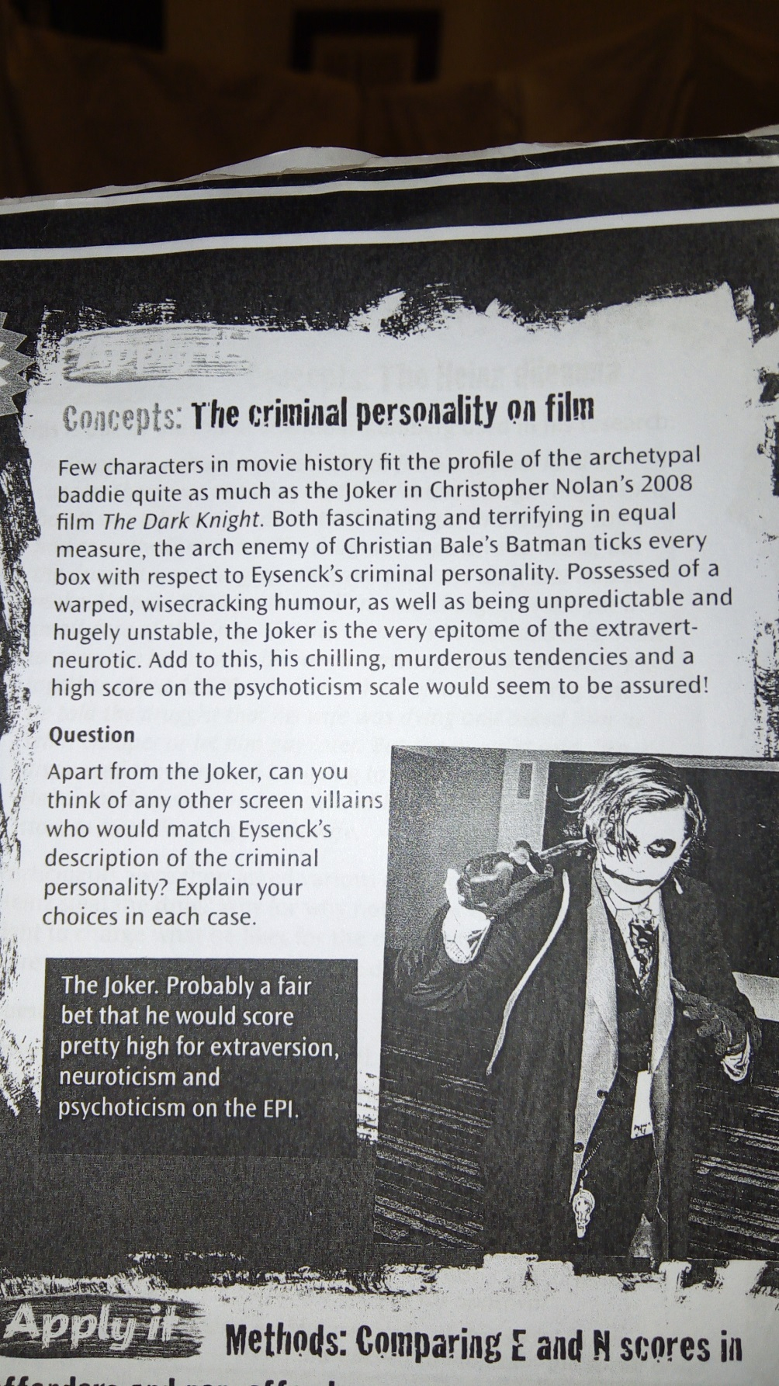

Continued on next page.

Task 2: Cognitive explanations

There are two cognitive explanations you need to know:

1. Levels of Moral reasoning 2: Cognitive distortions (including hostile attribution bias and minimalisation)

a) Explanation 1: Levels of Moral reasoning

Click on this link - http://www.simplypsychology.org/kohlberg.html – and follow the instructions below:

1. Watch the first video clip titled 'Heinz dilemma'- Which option did you choose and what was the stage of moral development?

2. Read through the section on Kohlberg's stages of moral development and watch the video showing examples of responses to the Heinz dilemma.

Note: The names of some of the stages in the clip are slightly different to the ones in the pack – do not worry about this, your understanding of the differences between the stages is more important.

3. Read the two pages outlining Kohlberg’s theory in the pack, then answer the question below:

According to Kohlberg, which level of moral reasoning is more likely to lead to offending behaviour? Explain the reason for your answer and refer to evidence. (4 marks)

b) Explanation 2: Cognitive distortions (Hostile attribution bias and Minimalisation)
Read the information on what these cognitive distortions are and the research studies investigating them, once you have done this, answer the following questions to test your knowledge:
1. What is meant by hostile attribution bias in relation to explaining criminal behaviour? Refer to one piece of evidence (i.e. a study) in your answer.
2. Give an example of an offender displaying hostile attribution bias
3. What is meant by minimalisation in relation to explaining criminal behaviour? Refer to one piece of evidence (i.e. a study) in your answer.
4. Give an example of an offender displaying minimalisation – this must be different to the one in the pack.

Task 3: Differential Association Theory (DAT)
Read the information on this theory in the pack and go through the powerpoint (‘differential association theory PowerPoint’) on psych205.com. Answer the 4 questions on the last slide of the powerpoint below:
1.

2.

3.

4.

Task 4: Psychodynamic explanations
There are two psychodynamic explanations of offending behaviour:
1. The Inadequate Super-ego 2. Defence mechanisms

a) Explanation 1: The Inadequate Super-ego:
Read this theory in your pack and complete the following:
- What is the Superego

- Where does the Superego develop from?

- Which theorist constructed the theory of “The Inadequate Super-ego” to explain Criminal Behaviour?

- Complete the table:
Inadequacy | Cause | How it results in Criminal Behaviour
Weak Super-Ego
Deviant Super-Ego
Over-harsh Superego

b) Explanation 2: Defence mechanisms
Read about the defence mechanisms that are used to explain offending behaviour in the pack and, for each defence mechanism, come with your own example related to crime.
Displacement: – example related to crime:
Sublimation: – example related to crime:
Rationalisation: – example related to crime:

