Prep work for Year 1 Research Methods
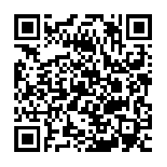
Prep 1: Ethical issues in Psychology
Use pages 32-34 of the pack plus the links.
Task one-Quick quiz (use pack and the QR code link which takes you to the full version of the ethical guidelines)

1. What does BPS stand for?

3. What is the BPS code of ethics and why is it used?

4. What is an ethical issue?

Fill in the table below
Ethical Issue | Describe | How do psychologist deal with this issue
Deception
Right to withdraw
Informed consent |  | (Must include all ways of getting consent)
Protection from harm
Privacy

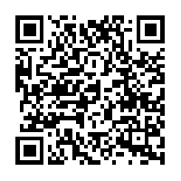
Task two-Why is it important to have ethical guidelines- a case from history.
Click on the link, read the article and summarise why we should be careful with our participants
Harvard's Experiment on the Unabomber, Class of '62

Task three-consent forms

In order to carry out a piece of Psychological research you need to produce and get all participants to sign an informed consent form. When you carry out your research you will need to do this. You need to search on line for examples of informed consent forms, choose one and either print off and bring to lesson or draw it out below.

Prep 2: Correlations
Read through the pack pages 25-27 and work through the tasks below

- Fill in the gaps:
This is a measure of _____________________ between ______ _______________. It measures how strongly the variables are related with each other, and in which ______________________. If a strong correlation is found, a value from one variable can be used to ___________________ the corresponding value of the other.

- Draw a positive and negative correlation on the axes below

Positive Negative

3a) what are these graphs called? _________________________
3b) Give one example of a positive correlation and one example of a negative correlation

+
-
4) Correlations also have hypothesis and as are predicting a relationship and not a difference are worded differently. A directional hypothesis states if it will be positive or negative and a non-directional simply states there will be a correlation.
Identify below whether these are directional or non-directional
There will be a significant correlation between deaths by drowning and ice creams eaten between the months of June and august
There will be a significant negative correlation between amount of Christmas presents bought and cash in the bank.
There will be a significant positive correlation between mince pies eaten and size of waste line.

5) Fill in the gaps:

We use a formula to find out what a correlation coefficient is. This indiciates the strength and direction of the correlation. The correlation coefficient cannot be any value other than those between -1 and 1. A score of ______ indicates a perfect negative correlation, and a score of _____ indicates a perfect positive correlation. A score of _____ indicates no correlation

6) What correlation coefficient would indicate a…

Weak positive correlation? Strong negative correlation?

Negative moderate correlation? weak negative correlation?

7) Estimate the correlation coefficients for the scattergraphs below. Write next to graph.
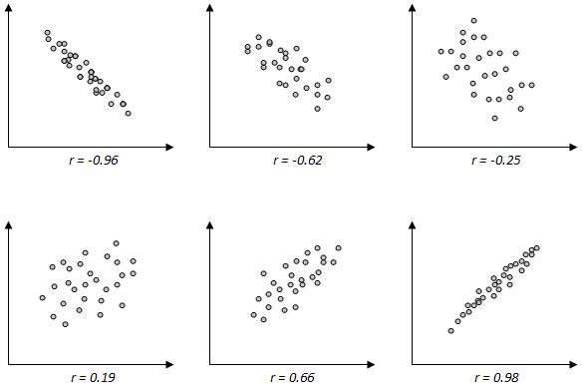
8) Which of these are positive and which are negative criticisms of correlations and add some detail in to create full evaluation
Can be used when research would be impossible or unethical to manipulate an IV for example …………………………..
Cannot and must not infer cause and effect relationships because …………………
Can only detect linear (straight line) relationships.

Correlations are useful tools………….
Prep 3: Sampling
Using your pack (p29-31) fill in the following sampling grid and then attempt the activities to go with it.
Sampling
Define population (with example)

Define Target population (with example)

Define Sample (with example)

Define Sampling bias

Type of sampling and how the sample is gathered | Weaknesses | Strengths
Random

Opportunity

Volunteer

Systematic

Stratified

Now attempt these questions using your new sampling knowledge.
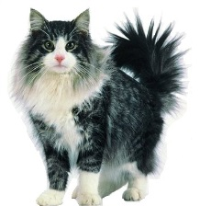
I have been asked by a pet food company to research which brand of cat food is most popular with cat owners. They plan to launch a competing product, similar in packaging, texture and smell, to the most popular brand, but they will make it 3p cheaper in an attempt to gain a large share of the cat food market. I stand on the corner of George Street in Hove, with a clipboard, between the hours of 9.30am and 5pm, Monday to Friday for a week. I ask each person I approach if they are a cat owner. If they say yes, and agree to talk to me, I ask them what cat food they buy for their cat and record the result. At the end of the week, from my research I conclude that Kit-e-kat is the most popular brand of cat food. I go back to my boss with the results of my survey. Consequently, the company markets a product that looks, tastes and smells like kit-e-kat. They distribute it to cat food retailers nationwide BUT Kat-e-Kit flops, The company go bust, I get fired
Where did it all go wrong? Explain where it might have all gone wrong using the terms population, target population, sample and sample bias. Don’t forget to link to the scenario (4 marks)

Identify the type of sampling in the following examples and justify your answer
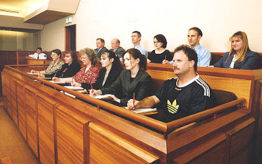
1.) Members of a jury?

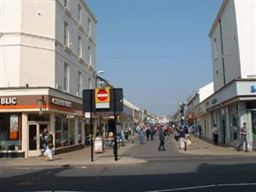
2.) The kit-e-kat market research above?

3.) A firm has been told their workers are de-motivated and demoralised. The union says they need to find out why as is affecting their worker well-being. They don’t want to ask all 1,000 workers so decide a sample of 20 will do, they decide then to ask every 50th employee how they feel.

4.) The head of the Psychology department wants to runs some research on BHASVIC Psychology students but hasn’t got the time or resources to do it on all 600 students. There are 40% males and 60% females so when randomly selecting the students he collects 40 males and 60 females.

Prep 4: Experimental methods

Task 1: Types of experiments - Controlled/Lab, Field Natural and Quasi experiments

- You looked at the types of experiments at the beginning of term so you can complete the following questions to test yourself or read pages 11 and 12 in the Research Methods pack, then answer the following questions:

1. What is the difference between a lab experiment and a field experiment?

2. What is the difference between a quasi experiment and a lab experiment?

3. For each of the studies below, identify which type of experiment they are:

a) A researcher observes the aggressive behaviour of children in a playground who have either regularly attended day care or who have been raised at home.

b) A researcher asks 50 children to watch a video of an adult punching a teddy bear. He then asks 50 children to watch a video of an adult cuddling a teddy bear. The children are then shown into a room with a teddy bear and told they can play with it. Does the video they watched influence how they play with the teddy bear?

c) A researcher wanted to investigate whether males or females differed in their ability to remember a list of 50 words. He gave them 2 minutes to study the list of 50 words then asked them to recall them in any order.

d) A researcher wanted to investigate whether people are more likely to obey an authority figure than another member of the public. A confederate dressed as a Security Guard approached people in a high street and told them to pick up litter. Another confederate dressed as a civilian did the same. The researchers then compared the amount of litter that was picked up by the members of the public.

Task 2: Experimental designs – Repeated measures, independent groups and matched- pairs designs.
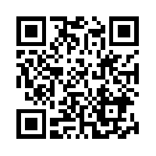
https://www.youtube.com/watch?v=YnTuI_0Ha_Y

NOTE- in the clip he uses the term transfer effects we call these ORDER EFFECTS

- Read pages 15 & 16 of the pack and watch the clip above, then have a go at the following activity:

For each of the following experiments, state whether the design is independent groups, repeated measures or matched pairs.

- Boys and girls are compared on their IQ scores

- Hamsters are tested to see if one genetic strain is better at finding food in a maze than another

- Reaction time is tested before and after a reaction time training activity to see if test scores improve after training

- Students are put in pairs based on their GCSE grades, and then one member of the pair is given a memory test in the morning and one in the afternoon.

- Three groups of participants are given different word lists to remember, in order to find out whether nouns, verbs or adjectives are easier to remember.

Continued on next page.
Answer the following two questions:

One issue with independent groups design is individual differences. How do we deal with this?

One issue with repeated measures design is order effects. We deal with this using counterbalancing, what is this?

Task 3: Hypotheses, variables and controls

- Read pages 7-10 (NOT writing correlational hypothesis section) and page 13 in the pack. Also, watch this video on hypotheses - https://www.youtube.com/watch?v=1CO_Ujb26KI.

Once you have done this answer the questions below:

A) For the following scenarios: highlight or label the IV and DV, then identify which type of hypothesis

1. There will be a difference in the reaction times, in seconds, of participants who have drank alcohol and participants who have not drank alcohol
2. People will be more likely to help a victim of theft when the victim is female rather than male.
3. People who watch aggressive films will be in a significantly worse mood, as measured on a rating scale, than those who watch non-aggressive films.
4. There will be no difference in the amount of football boys and girls play
5. There will be a significant difference in the number of cigarettes smoked during a stressful situation compared to a non-stressful situation.
B) For the research aim below: operationalise the IV and DV, write a non-directional/two tailed hypothesis and suggest one possible EV.

A researcher wants to investigate whether students will work better in a quiet or noisy environment.

(Note: If you need additional help, look back over the writing hypotheses section in the pack)

Operationalised IV =

Operationalised IV =

Non-directional hypothesis =

One potential EV =

Task 4: Revision flashcards:

Make flashcards for all the new terms you have learnt during this Prep (if you are not sure, look at the list on the next page)

NOTE: You can use actual cards or go to www.quizlet.com to make them online.
Quizlet is a great tool - not only can you copy and paste info to make the cards saving valuable time but it also makes tests and games for you to test yourself!

List of key terms related to experimental methods

Experimental method
Experimental condition
Control condition
Lab/controlled experiment
Field experiment
Natural experiment
Quasi experiment
Experimental design
Matched-pairs design
Independent groups design
Repeated measure design
Aims and Hypotheses
Aim
Null hypothesis
Experimental hypothesis
Non-directional/two-tailed hypothesis
Directional/one-tailed hypothesis
Variables and Controls
Independent variable (IV)
Dependent variable (DV)
Extraneous variable (EV)
Confounding variable (CV)
Participant variables
Operationalisation of variables
Demand characteristics
Investigator effects
Order effects
Random allocation
Counterbalancing
Randomisation
Standardisation

Prep 5: Self-report techniques
Read pages 17-20 in the research methods pack, then answer the following questions

- What is the difference between a structured interview and an unstructured interview?

- Give one reason why a questionnaire may be used instead of an interview.

- A researcher wants to find out about the experiences of ex-offenders who were given a custodial sentencing (sent to Prison).

Which would be a better technique to gather this data – questionnaires or interviews? Justify your decision.

- Give one example of a closed question (come up with your own!)

- Give one example of an open question (come up with your own!)

- Give three features of a good questionnaire and three features of a good interview.

- What should be avoided when designing and conducting questionnaires and interviews?
Prep 6: Qualitative Data - Case Studies and Content Analysis
Primary and Secondary Data
Work through the powerpoint on Psych 205 (http://www.psych205.com/research-methods-year-1.html ) and complete the following
- What is a meta analysis?

- Primary Data

Definition:
Strength:
Limitation:
Example:
- Secondary data

Definition:
Strength:
Limitation:
Example:
- Define “Effect size” :

Case Studies : Case studies are detailed and in depth analysis of an individual, a group, institution or event.
Use the Research methods pack page 24 and the internet
Task 1 List 10 different sources of information that might be included in a case study. Group these into those which could gather qualitative or quantitative data (some might arguably fit into both)
Qualitative sources Quantitative sources

Task 2 Read the following examples of case studies and note which topic in your specification you think these case studies link to
- Clive Wearing (Blakemore, 1988)
In March of 1985, Clive Wearing, an eminent English musician and musicologist in his mid-forties, was struck by a brain infection, herpes encephalitis, affecting especially the parts of his brain concerned with memory. He was left with a memory span of only seconds, the most devastating case of amnesia ever recorded. New events and experiences were erased almost instantly. In addition to this inability to preserve new memories, Clive had a retrograde amnesia, a deletion of virtually his entire past. He retained his music ability and skill, and as a result, challenged the notion of a single long term memory store.
Topic :
- Little Hans
Hans developed a phobia of horses. His father documented what his son said and passed the information onto Freud to analyse his behaviour. Freud interpreted the boy’s behaviour as a problem in the phallic Psychosexual stage. Hans’ fascination with his “widdler” was important as Freud explained this to be indicative of the phallic stage of development. Hans enjoyed spending time alone with his mother which Freud argued to be evidence of the Oedipus complex.
Topic:
Task 3 Case studies are idiographic as they focus on the individual and not populations or groups (nomothetic). What do you think is a suggested advantage or disadvantage of this?(refer to generalisability and qualitative vs quantitative data)
________________________________________________________________________________________________________________________________________________________________________________________________________________________________________________________________________________________________________________________________________________________________________________________________________________________________________________________________________________________________________________________________________________________________________________________________________________________________________________

Task 4 Which of these are advantages and which are disadvantages of case studies?

Advantage or Disadvantage?
Rich in detail: Case studies provide great depth and understanding about individuals and acknowledge human diversity.

The only possible method to use: Case studies allow psychologists to study unique behaviours or experiences that could not have been studied any other way.
Not representative: As no two case studies are the same, results cannot be generalised to others, therefore generalisation to whole populations is impossible
Useful for theory contradiction: Just one case study can contradict a theory and necessitate a change in the theory. For example, the Clive Wearing case was important for challenging the idea that LTM is a single unitary store.
Subjectivity and Researcher Bias: researchers conducting case studies may be biased in their subjective interpretations or methods of reporting, which will question the validity of the findings
Reliance on Memory: many case studies can be anecdotal and rely on the participants own accounts of what happened and these may not be accurate.

Longitudinal- Case studies can be longitudinal which means they study behaviour over time

Content Analysis
Use page 28 in the pack and answer the following
- Explain what a “Content analysis” is.

- Describe how is a content analysis conducted in as much detail as you can.

Prep 7: Quantitative data: descriptive statistics and data representation
Task 1: Complete the following table based on the powerpoint on Psych205 - http://www.psych205.com/research-methods-year-1.html
Definition | Strengths | Limitations
Descriptive statistics
Mean
Median
Mode
Measures of Dispersion
Range
Standard deviation

Task 2 – Refer to pages 38-40 in your RM pack
Calculate the mean, median and mode for the following:

1a) Data from a psychology quiz:

1, 2, 3, 7, 10, 20, 30, 43, 47, 48, 50

Mean = Median= Mode=

1b) The number of faces recalled out of 12 in a free recall task:

1, 1, 5, 2, 3, 7, 6, 5, 2, 1, 8, 7, 9, 5, 4, 3, 2, 5

Mean = Median= Mode=

Task 3 : What is the range for the following data sets?

a) 5, 4 ,1, 2, 1, 2, 3, 4, 5, 6, 8, 7, 2. Range _______________________
b) 9, 11, 16, 4, 6, 17, 22, 35, 2, 12, 13. Range _______________________
c) 3, 4, 5, 8, 11, 14, 12, 16, 1, 9, 15, 17. Range _______________________

If the standard deviation is low, this tells us that the mean is _______________________
.
If the standard deviation is high, it this tells us that the mean is _____________________
Task 4 : Read the research scenarios below and then answer the questions for each one:
- Ps were tested on their ability to avoid obstacles in a computer driving simulation. The simulator recorded how many times the Ps hit an obstacle during the simulation (max. 30). Half of the Ps were engaged in conversation during the simulation by the experimenter, so they had to respond verbally to a series of questions. The other half completed the same task but in silence.
Directional Hypothesis: Participants will be more likely to hit obstacles when they are engaged in conversation than when they are not

 | Conversation condition | Silence condition
Mean | 7.3 | 5.4
Standard Deviation | 4.7 | 1.2

- What do the means in each condition suggest about the effect of the distraction task on their performance? ______________________________________________________________________________________________________________________________________

- Comment on what the standard deviations in each condition tell us about the data: _________________________________________________________________________________________________________________________________________________________________________________________________________

Researchers asked A Level student PPs, to complete a questionnaire about how long they spent studying each week. They were divided into two groups: those who spent more than ten hours a week studying and those who spent ten hours or less. After the exams, the researchers compared the exam marks (max. 100) of the two groups.
 | Less than 10 hrs | 10 hrs or more
Mean | 65.9 | 68.3
Standard Deviation | 15.4 | 8.9
Directional Hypothesis: Students who study for more than ten hours per week will achieve higher exam scores than those who study for less than ten hours per week.

- What do the means in each condition suggest about the effect studying on their performance? ______________________________________________________________________________________________________________________________________

````
- Comment on what the standard deviations in each condition tell us about the data: _________________________________________________________________________________________________________________________________________________________________________________________________________

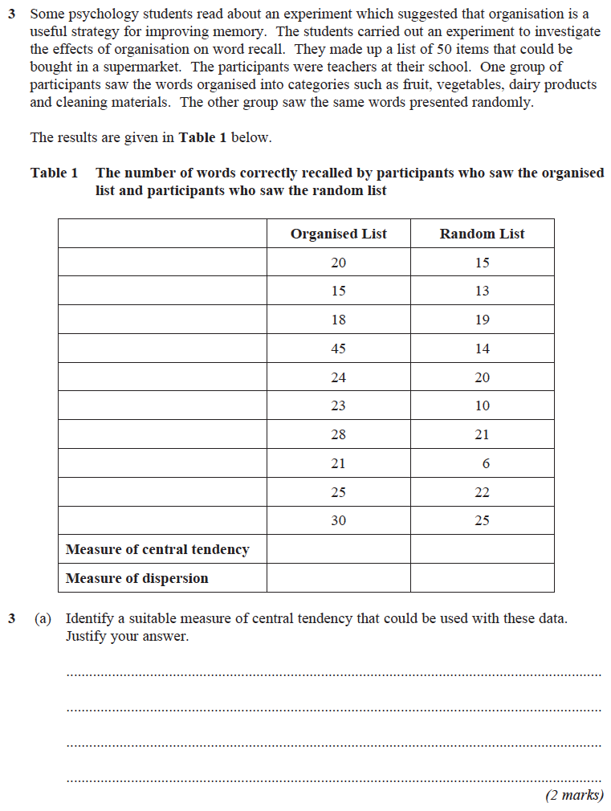

The Display of Quantitative Data
Task 1: read pages 41-42 of your pack.
- What types of data are represented in the following charts or graphs?
Tables

Bar Charts

Histogram

Scattergram

Task 2: Watch the videos and note take on bar charts and a histogram
https://www.youtube.com/watch?v=JsEwJD1mYpU
https://www.youtube.com/watch?v=iYIuqvuGvAw
Bar Charts Histogram

Draw a graph for the following sets of data
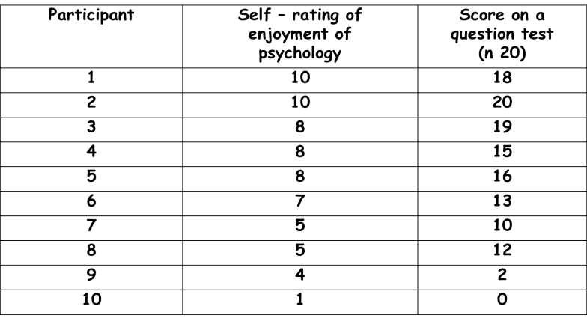
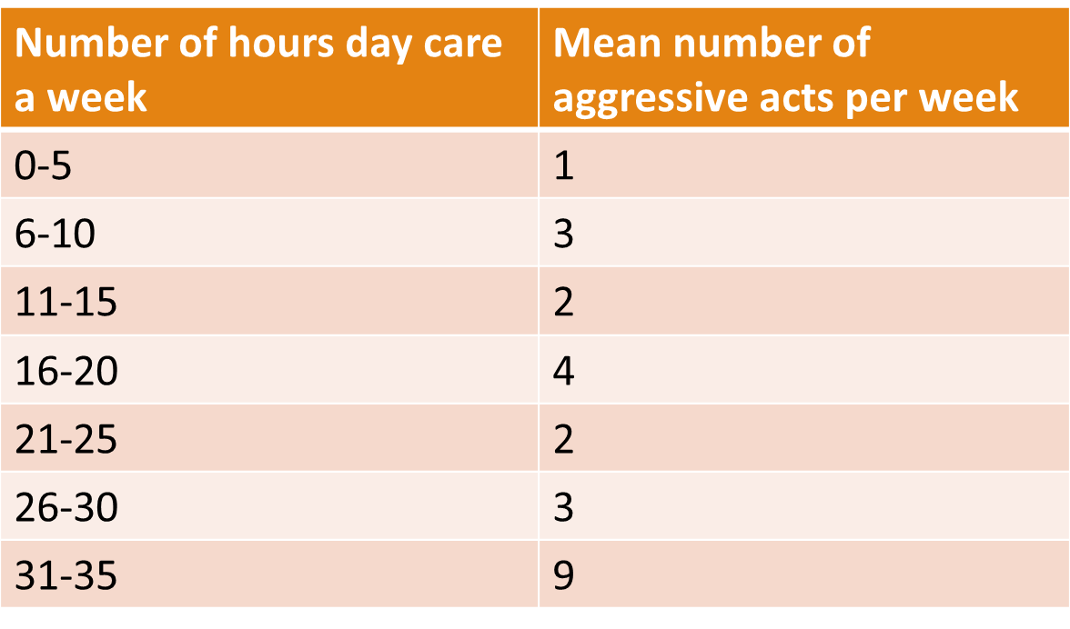
Data set 1 Data Set 2

Prep 8: Data Distributions and an introduction to statistical testing

Normal and Skewed Distributions
Task 1: Normal Distribution
Watch the clip https://www.youtube.com/watch?v=8MLFHd7kW0k
Answer the questions below
- Explain the appearance of a normal distribution curve
- Explain three characteristics/features of a normal distribution
- ________of the population fall between one standard deviation above and one standard deviation below the mean value (the middle section of the curve).
- ______________of the population fall between two standard deviations above and below the mean value
- ___________of the population fall between three standard deviations above and below the mean value

Task 2: Skewed Distribution
Watch the clip : https://www.youtube.com/watch?v=xpbYKaEbcPA

Answer the following
- Sketch a graph demonstrating a negative distribution (left skew)
- Sketch a graph demonstrating a positive distribution (right skew)
- Explain why a mean is always lower that the mode and median in a negative skew.

A psychologist is investigating the investment model of relationships, devised a self-report Investment Scale for use with a group of 100 female participants. The scale gave an investment score for each participant on a scale of 0–20, with 0 representing no investment in relationships and 20 representing extreme investment in relationships. The psychologist calculated measures of central tendency for the investment scores. He found that the mean investment score was 8.6, the median investment score was 9.5 and the mode investment score was 13.
Sketch a graph to show the most likely distribution curve for the investment scores in this study. Label the axes of your graph and mark on it the positions of the mean, median and mode. [3 marks]

What sort of distribution does your graph show? [1 mark]

Introduction to statistical testing
Task 1: Levels of measurement
Use the link: http://psc.dss.ucdavis.edu/faculty_sites//sommerb/sommerdemo/scaling/levels.htm
Define the following types of data and provide an example
Nominal:
Ordinal:
Interval:
The Sign test
The Sign test is the only statistical test you need to calculate in the exam.
Task 2: We use a sign test when….(fill in the gaps using your RM pack page 48)
- We are looking for a ____________________, rather than an association
- We have used a _________________measures design
- Data is organised into _______________(known as ____________ data)

Task 3: Watch the sign test clips on Psych205 and read pages 49-50 of your research methods pack and complete the following
Important things to remember for a sign test (fill in the gaps using your RM pack) :
- The Calculated or observed value is found by the ____________ and is compared to the critical value in the ______
- You need to know the following three pieces of information to check the significance?
1.
2.
3.
- The calculated value of s must be equal to or ____ than ( ) the _________ value at the 0.05 level of significance
Task 4: Have a go at the following exam questions using your notes and the critical value table in your pack
Participant | Difference after new diet
1 | =
2 | +
3 | +
4 | +
5 | -
6 | -
7 | +
8 | +
A psychologist did a piece of research looking at if they lost weight after following a new diet programme where participants had to draw pictures of the food they were going to eat before eating it. The findings are detailed on the right
- What is the observed value for the above research? [1 marks].

2. The critical value was 0 for the research, were the findings significant? Justify your answer (2 marks)

