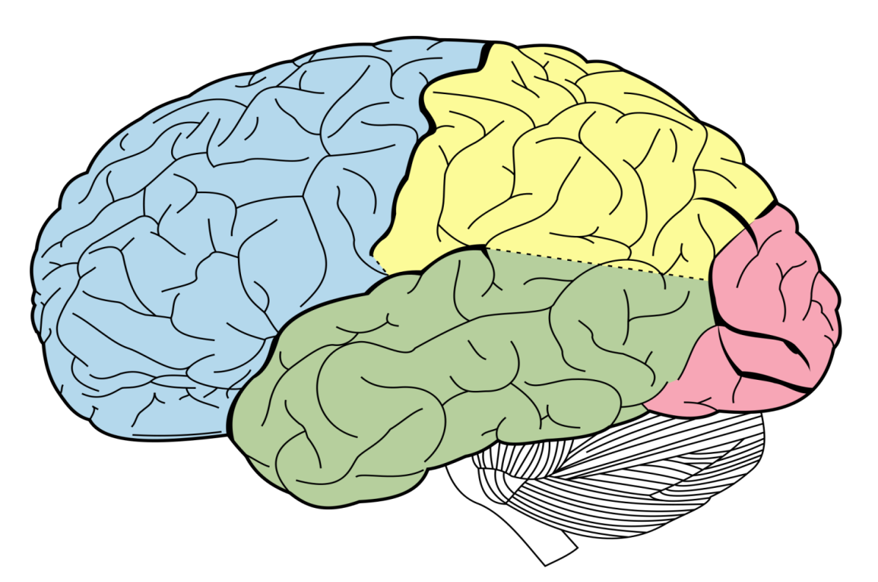
Areas of the brain and their function worksheet
Task
- Start by labelling the four lobes of the brain
- Next, identify and write in where the following structures are on the diagram: Motor area; Somatosensory area; Visual area; Auditory area; Broca’s area; Wernicke’s area
- Lastly, write a brief description of the function of each area, underneath its label

