**AS Psychology**

**Handbook**

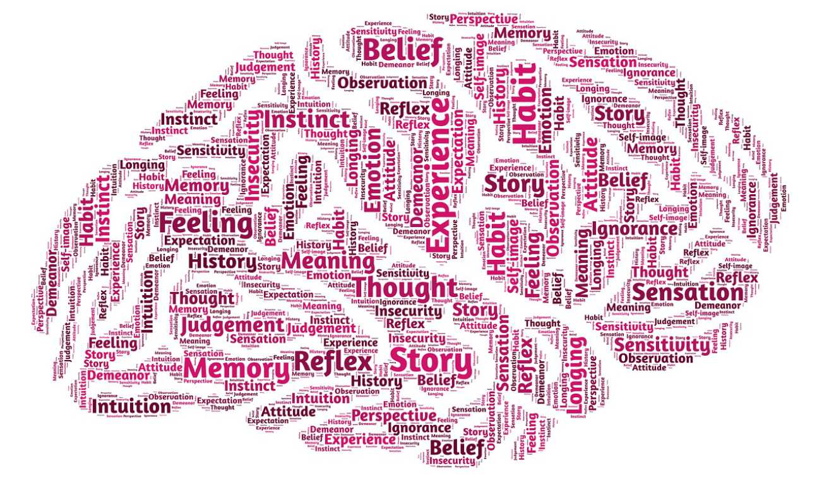

**Name ________________**

**Teacher: Sam Pedley**

**Bring this booklet with you to every lesson.**

**Welcome to the Psychology Department**

|  |  |  |  |
| --- | --- | --- | --- |
| **Teacher**  **Sammy Pedley** | Teacher of Psychology | Room 10 | s.pedley@bhasvic.ac.uk |

|  |  |  |  |
| --- | --- | --- | --- |
| Picture**Head of Department Nik Le Saux** | Head of Department | Room 10 | n.lesaux@bhasvic.ac.uk |

**Location of the team: Room 10 in the main building**

**Psychology Main teaching rooms- 37-40 on the first floor of the main building**

**Subject Extensions**

*Subject extensions are either an opportunity for a student to have one to one time with their class teacher, or small group sessions provided by other members of the department*

**When are subject extensions?**

The subject extension sessions will usually run at lunchtimes on _____________________________

If you wish to have a subject extension with your teacher, or your teacher requests a subject extension with you, this will be arranged between you at a mutually convenient time.

**Where do they take place?**

Subject extensions take place in Room 37A, which is the little room at the end of the Psychology corridor, next to Room 37. Sessions will usually be in a classroom on the Psychology corridor.

**How do I book an appointment with my teacher?**

You can book an appointment with your teacher at the end of your lesson, or through the email system

**What should I use subject extensions for?**

Subject extensions are student led, they are not taught lessons. Therefore, if you have been absent, you should follow the normal procedures for catching up, that have been outlined by your teacher, before attending a subject extension. Subject extensions should be used to:

• Go over a concept or part of a topic that you don’t understand

• Ask the teacher to explain where you went wrong in an assessment and how to improve

• Ask the teacher to read through extra exam questions that you have attempted



Paper 1 Introductory topics in Psychology

1 hour 30 13th May pm

3.1.1 Social influence

* Types of conformity: internalisation, identification and compliance. Explanations for conformity: informational social influence and normative social influence, and variables affecting conformity including group size, unanimity and task difficulty as investigated by Asch.
* Conformity to social roles as investigated by Zimbardo.
* Explanations for obedience: agentic state and legitimacy of authority, and situational variables affecting obedience including proximity, location and uniform, as investigated by Milgram. Dispositional explanation for obedience: the Authoritarian Personality.
* Explanations of resistance to social influence, including social support and locus of control.
* Minority influence including reference to consistency, commitment and flexibility.
* The role of social influence processes in social change.

3.1.2 Memory

* The multi-store model of memory: sensory register, short-term memory and long-term memory. Features of each store: coding, capacity and duration.
* Types of long-term memory: episodic, semantic, procedural.
* The working memory model: central executive, phonological loop, visuo-spatial sketchpad and episodic buffer. Features of the model: coding and capacity.
* Explanations for forgetting: proactive and retroactive interference and retrieval failure due to absence of cues.
* Factors affecting the accuracy of eyewitness testimony: misleading information, including leading questions and post-event discussion; anxiety.
* Improving the accuracy of eyewitness testimony, including the use of the cognitive interview.

3.1.3 Attachment

* Caregiver-infant interactions in humans: reciprocity and interactional synchrony. Stages of attachment identified by Schaffer. Multiple attachments and the role of the father.
* Animal studies of attachment: Lorenz and Harlow.
* Explanations of attachment: learning theory and Bowlby’s monotropic theory. The concepts of a critical period and an internal working model.
* Ainsworth’s ‘Strange Situation’. Types of attachment: secure, insecure-avoidant and insecure-resistant. Cultural variations in attachment, including van Ijzendoorn.
* Bowlby’s theory of maternal deprivation. Romanian orphan studies: effects of institutionalisation.
* The influence of early attachment on childhood and adult relationships, including the role of an internal working model.

Paper 2 Psychology in context

1 hour 30 16th May pm

3.2.1 Approaches in Psychology

Origins of Psychology: Wundt, introspection and the emergence of Psychology as a science.

The basic assumptions of the following approaches:

* Learning approaches: the behaviourist approach, including classical conditioning and Pavlov’s research, operant conditioning, types of reinforcement and Skinner’s research; social learning theory including imitation, identification, modelling, vicarious reinforcement, the role of mediational processes and Bandura’s research.
* The cognitive approach: the study of internal mental processes, the role of schema, the use of theoretical and computer models to explain and make inferences about mental processes. The emergence of cognitive neuroscience.
* The biological approach: the influence of genes, biological structures and neurochemistry on behaviour. Genotype and phenotype, genetic basis of behaviour, evolution and behaviour.

3.2.1.1 Biopsychology

* The divisions of the nervous system: central and peripheral (somatic and autonomic).
* The structure and function of sensory, relay and motor neurons. The process of synaptic transmission, including reference to neurotransmitters, excitation and inhibition.
* The function of the endocrine system: glands and hormones.
* The fight or flight response including the role of adrenaline.

3.2.2 Psychopathology

* Definitions of abnormality, including deviation from social norms, failure to function adequately, statistical infrequency and deviation from ideal mental health.
* The behavioural, emotional and cognitive characteristics of phobias, depression and obsessive-compulsive disorder (OCD).
* The behavioural approach to explaining and treating phobias: the two-process model, including classical and operant conditioning; systematic desensitisation, including relaxation and use of hierarchy; flooding.
* The cognitive approach to explaining and treating depression: Beck’s negative triad and Ellis’s ABC model; cognitive behaviour therapy (CBT), including challenging irrational thoughts.
* The biological approach to explaining and treating OCD: genetic and neural explanations; drug therapy.

3.2.3 Research methods

Students should demonstrate knowledge and understanding of the following research methods, scientific processes and techniques of data handling and analysis, be familiar with their use and be aware of their strengths and limitations:

* Experimental method. Types of experiment, laboratory and field experiments; natural and quasi-experiments.
* Observational techniques. Types of observation: naturalistic and controlled observation; covert and overt observation; participant and non-participant observation.
* Self-report techniques. Questionnaires; interviews, structured and unstructured.
* Correlations. Analysis of the relationship between co-variables. The difference between correlations and experiments.

3.2.3.1 Scientific processes

* Aims: stating aims, the difference between aims and hypotheses.
* Hypotheses: directional and non-directional.
* Sampling: the difference between population and sample; sampling techniques including: random, systematic, stratified, opportunity and volunteer; implications of sampling techniques, including bias and generalisation.
* Pilot studies and the aims of piloting.
* Experimental designs: repeated measures, independent groups, matched pairs.
* Observational design: behavioural categories; event sampling; time sampling.
* Questionnaire construction, including use of open and closed questions; design of interviews.
* Variables: manipulation and control of variables, including independent, dependent, extraneous, confounding; operationalisation of variables.
* Control: random allocation and counterbalancing, randomisation and standardisation.
* Demand characteristics and investigator effects.
* Ethics, including the role of the British Psychological Society’s code of ethics; ethical issues in the design and conduct of psychological studies; dealing with ethical issues in research.
* The role of peer review in the scientific process.
* The implications of psychological research for the economy.

3.2.3.2 Data handling and analysis

* Quantitative and qualitative data; the distinction between qualitative and quantitative data collection techniques.
* Primary and secondary data, including meta-analysis.
* Descriptive statistics: measures of central tendency – mean, median, mode; calculation of mean, median and mode; measures of dispersion; range and standard deviation; calculation of range; calculation of percentages; positive, negative and zero correlations.
* Presentation and display of quantitative data: graphs, tables, scattergrams, bar charts.
* Distributions: normal and skewed distributions; characteristics of normal and skewed distributions.
* Introduction to statistical testing; the sign test.

**Assessment**

**Command Words**

Before you start writing any extended answer you need to consider what exactly is being asked in the question. Each question will use a specific command word, which will require you to do something slightly different. Here are some of the **most common** command words and what they typically assess:

**Questions assessing A01 skills – (Knowledge and understanding)**

* **State, name, identify** in the briefest possible way give an answer – sometime 1 key term is enough. lengthy explanation is not required. (usually worth max of 2/3 marks)
* **Describe** Give an account of a theory, research, model… (usually a short mark Q e.g. total 4 marks)
* **Explain** Set out purposes or reasons…
  + **Explain how** Give a detailed account of a process or way of doing something.
  + **Explain why** Give a detailed account of reasons in relation to a particular situation.
* **Outline** Set out main characteristics.

**Questions assessing A02 skills – (Ability to apply knowledge to a scenario)**

* **Design** Set out how something will be done. Usually by proposing a way of research something.
* Outline the X explanation of X and **REFER** to ‘Billy’ in your answer.
* Using your knowledge of X, **explain how/why ‘Billy’** …

**Questions assessing A03 skills (ability to analyse, interpret and evaluate)**

* **Compare** Identify similarities and/or differences.
* **Discuss** Present key points about different ideas or strengths and weaknesses of an idea. Treat this **almost** like an Outline and Evaluate question.
* **Evaluate** Judge whether a theory or research is credible, useful, valid, reliable…. from available evidence.
* **Justify** Provide reasons, reasoned argument to support, possibly provide evidence.
* **Suggest** Present a possible case/solution.

Long response questions worth 8 or 12 marks begin with one or a combination of two command words. So examples of 8 and 16 mark questions will **typically** start in the following ways:

* Outline and evaluate at least one explanation of…..
* Discuss explanations of….
* Discuss research into….
* Discuss the contribution of x theory for our understanding of….
* Compare x explanation with x….explanation for…

**Marks available in relation to A01, A02 and A03**

Extended answers are marked on the quality of the whole answer; there are bands which an answer can be judged against however the division of the marks available for the skills you are being assessed are typically the same.

It is important to keep this in mind because if the answer you give to a 12 mark Questions is all description (A01) and no evaluation (A03) then you can only achieve half marks

 **What is meant by evaluation? (A03)**

Evaluation simply means “what is the value of this thing?” Take an Elephant, for example, how can we think about its value?

* One strength of an elephant is that it never forgets
* One limitation of an elephant is that it tends to make a lot of mess
* One application of an elephant is that we could use it to carry heavy loads.

You probably wouldn’t think of these if you were asked to evaluate an elephant. Asking for ‘evaluation’ is just a way of asking ‘what are the strengths or limitations of something.

Obviously you won’t be evaluating elephants in psychology. In psychology you will be evaluating the value of a theory, explanation or piece of research based on the evidence available. This means that you need to consider the strengths and limitations of the evidence.

**How to structure evaluation (A03)**

You should use the **PEEL** structure:

**Point -** State your claim using a lead-in phrase, such as:

|  |  |
| --- | --- |
| *One strength of this study is…* | *This explanation is supported by…* |
| *One limitation of this study is…* | *This explanation is challenged by…* |
| *A real world application is…* | *An alternative explanation could be…* |
| *Not everyone reacts the same way,* | *There may be cultural variations…* |

**Evidence/ Examples -** support your claimoutline evidence or an example, here are some examples:

**Explain/Elaborate –**This is where you show your understanding by explaining in more detail **how** and **why** your evidence supports your point. Your explanation should interpret the evidence for the reader. You can use a different suggestion from the grid above to extend your point.

|  |  |
| --- | --- |
| *This suggests that…* | *Therefore we can conclude that…* |
| *This shows that…* | *This demonstrates how…* |
| *Therefore we must be cautious when drawing conclusions about…* |  |

**Link -** The last sentence should reinforce your original point by linking it back to the theory, explanation or research you are discussing. This is where you explain what the critical point demonstrates. An easy way to check if you have linked back to the question and the topicSome of examples of how to link back:

**(P)**Zimbardo’s research does not fully support the situational hypothesis (**E)** This is because it **fails to explain** why not all of the guards behaved equally aggressively towards the prisoners. **(E)** Some were reluctant to exercise their authority, whereas one guard in particular was seen as the ringleader. This suggests that individual differences play a part in the way someone responds to role expectations. (**L)** Therefore Zimbardo’s assertion that situations cause people to behaviour in a particular way due to social roles cannot be regarded as a stand-alone explanation without taking into account additional contributory factors such as biological predisposition to aggression or past experience, which combined with the situation may trigger the aggressive behaviour

**Snap Planning**

The key to an effective essay is in part determined by the **coherence** of your argument.

“Na na na na na na Snap-plan”

This means it must be clear to the reader that you have understood and interpreted the demands of the question. This is achieved:

1. Carefully selecting the **relevant points** that can be linked together to form an argument.
2. **Structuring your points** in a way that makes sense.
3. Ensuring that each evaluation point follows on from the previous point – this is why **signposting your paragraphs** is so important.

It is therefore important that you can plan answers quickly and effectively. We refer to this as **snap planning.**

Snap plans should be brief; identify main concepts, key terminology, and examples of research. The purpose of the snap plan is to structure your answer to ensure there is a flow to your argument and that you don’t go off on a tangent.

For example – **Outline and evaluate research in to conformity to social roles (12 marks)**

**A03 (PEEL) (3 marks)**

**Individual differences:** Does not fully support theory – Not all guards reacted in same way. Some very abusive, some not at all.

**A01 (6 marks)**

* Zimbardo SPE

**Procedural details**

* Sample = Male volunteer students randomly allocated to role of guard or prisoner
* Participants given uniforms relevant to their role = deindividuation
* Guards instructed to use no physical force but to keep order. No other instructions

**Findings + Conclusions**

* Intended to last 2 weeks, lasted 6 days
* Guards became sadistic, tyrannical in abuse of power, unified.
* Prisoners became passive, depressed, submissive, divided.
* P’s conformed to the role they had been given, thus conforming behaviour = situational factors not dispositional.

**A03 (PEEL) (3 marks)**

**Ethical Issues:** approved by Stanford Ethics committee, BUT Zimbardo’s dual role (warden + researcher) led to loss of objectivity …e.g. Right to withdraw?? ‘I want parole’

**Evaluation**

**Approaches and Theory**

**Research**

* Where is the evidence?
* Is the Research valid and Reliable?
* Is there any challenging evidence?

**Application**

* What is the Usefulness of this theory?
* Does the theory have positive or negative implications?

**Debates**

* Which side of the Nature vs Nurture debate does it support and Is this a good or a bad thing?

**Individual Differences**

* Can the theory explain individual differences?
* Can the theory really explain the behaviour of everyone?

**Other**

* Is there an alternative or other explanation?
* Is this missing something that other explanations can better explain?

**Evaluation**

**Research Studies**

**V**ery **S**imple **R**esearch **E**valuation

**V**alidity

* Are the findings **true** to what they claim?
* Internal- Does the research measure what it claims to?
* External- Can the research/ findings be true outside of the study e.g Ecological- in real life circumstances? / Temporal- at another time? Population- to other groups?

**S**ample

* Bias- Is there a Gender or Culture Bias in the sample?
* Generalisability- Can the findings be generalised outside of the sample?
* Extrapolation- Can animal behaviour be extrapolated to explain this human behaviour?

**R**eliability

* Is the research **Consistent**? Can it be replicated and achieve the same results?
* Is there any challenging research?

**E**thics

* Has the research broken ethical Guidelines?
* Has this had negative implications on the participants/ their family/ other groups in society

**Additional Resources**

**The Library**

There are a whole range of Psychology textbooks available to borrow from the library. Ask the library staff to show you where the Psychology section is.

**The Website**

Specimen papers and mark schemes, along with practice questions and webinars can be found on **Psych205.com,**



**Tutor2u**

[**https://www.tutor2u.net/psychology/**](https://www.tutor2u.net/psychology/)

Some amazing resources including webinars- for topic areas and revision, Quizes, past sample answers and the list goes on….

**Social Media**

For up to date information on Psychology, access to relevant literature, news from our department and opportunities to network with Psychologists follow us on twitter and facebook.

***Facebook link:*** <https://www.facebook.com/BHASVICPSYCHOLOGY/>

***Twitter: @BHASVIC_Psych***