Attachment flip three

- Explanations of attachment – Learning theory and Bowlby’s theory

- Learning theory explanation of attachment

Classical conditioning:
Using your knowledge of classical conditioning (remember Pavlov and his dogs!) Label the diagram with the correct terms (e.g. conditioned stimulus, neutral stimulus etc) and add in precisely what it is for attachment (e.g. UCS, NS, mother, pleasure etc.)
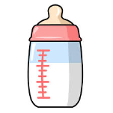

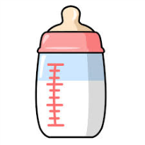

After enough pairings of the previous stage

Operant conditioning:
Read the information in the pack on operant conditioning (p11) then answer the following questions:
- Babies learn to attach through ………

- In attachment, what how are infants positively reinforced?

- In attachment, what is the primary reinforcer and the secondary reinforce?

- In attachment, how is the caregiver conditioned by the infant?

- Bowlby’s monotropic theory of attachment

Read about Bowlby’s monotropic theory on p12 in the pack, then test your knowledge by completing the CrIIMPS table below (one has been done for you as an example):

Key features of Bowlby’s theory  (What do these letters stand for?) | Description of key term in relation to Bowlby’s theory
Critical period | A child will find it difficult to form attachments in later life if they haven’t formed an attachment by the age of 2
I

I

M

P

S

