Approaches to Psychology: Biological Approach

At the end of this flip you must create a kahoot or quizlet quiz on the key terms for this approach. Your teacher will choose at random two students quizzes to do in class

Assumptions
- Behaviour can be largely explained in terms of Biology (e.g. g______/h________/ N____________).
- Behaviour and processes can be explained by the structure and function of the human nervous ________, particularly the brain.
- Human genes have evolved over millions of years to adapt behaviour to the ___________. Therefore, most behaviour will have an adaptive / evolutionary purpose.
- Psychology should be seen as a science, to be studied in a ____________ manner (usually in a ______________).
The Evolution of Behaviour
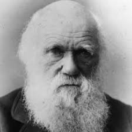
Using the pack and internet find out what the following terms mean/ answer the questions
1. Who was Charles Darwin?
2. What is the theory of evolution all about?

3.“Behaviour is adaptive”, What does this mean?

4. Darwin believed in the Survival of the fittest. Explain what he meant by this

5. What is Natural selection?

6. What is mate selection? Give an example

7. Briefly explain the evolutionary explanation of attachment (pack)
The Genetic Basis to Behaviour
Use the page on Genetics and behaviour in the pack.
What is meant by Heredity?

What is a genotype?

What is a phenotype?

Research into the Genetic Basis of behaviour

- What is a monozygotic twin?

- What is a dizygotic twin?

- What is a concordance rate?

- What would a perfect concordance rate be? (as a %)

- Identify the IV and DV for the meta-analysis in your pack

- Outline two findings from the research

- Explain how twin studies show that behaviour might be genetic (use examples from the meta-analysis)

- What side of the Nature Vs Nurture debate does this support and why?

- Is there a counter argument to this?

Biological Structures
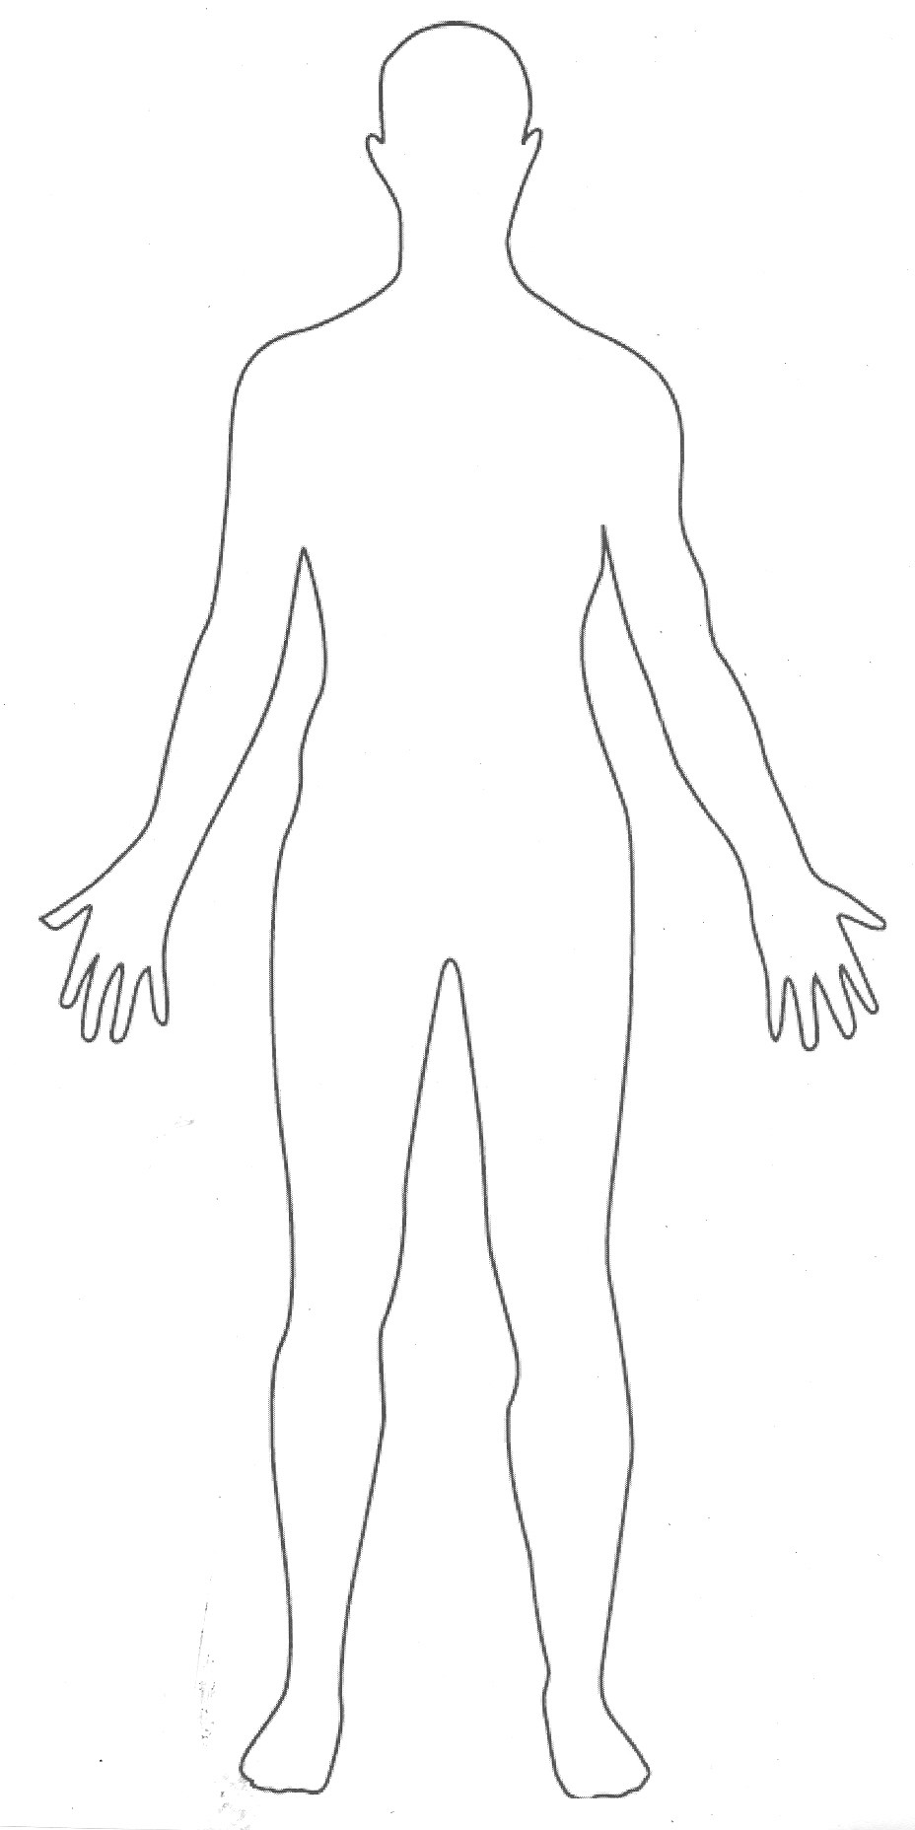
Draw and label the major parts of the nervous system on the below image of the human body.:

What are Neurotransmitters?

How do Neurotransmitters influence behaviour?

The Endocrine System

Now find out the location and function of the following glands/ hormones. Label them on the diagram above and explain them below

Oestrogen
Testes
Cortisol
Adrenal Glands
Pineal
Melatonin

The Brain
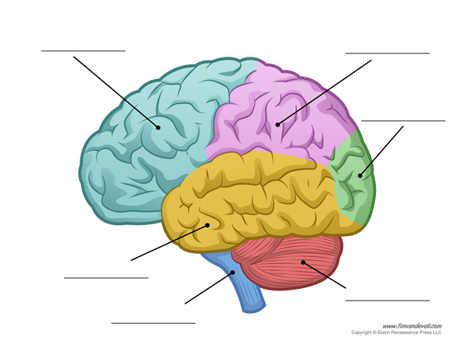
Label the brain diagram and research online what each lobe does.

Biological Reductionism
(Use the Evaluation of the Biological Approach page and answer the following)

What is Biological Reductionism?

What does Biology reduce behavior to? Give an example

Why is Reductionism useful?

What can be a limitation of Reductionism? E.g What does it ignore?

- You must now create a kahoot or quizlet quiz on the key terms for this approach.

- You can use the key terms grid in the approaches pack

- Your teacher will choose at random two students quizzes to do in class

