BioPsychology prep
This work must be completed by 26th February.
Any activities that require reading- Please note take on the content( You could make flaschards as you work through)
You do not have to print this document- You can copy out and draw the diagrams in your notes
Use the Bio Information pack, the clips and research online if you are stuck
Divisions of the Nervous System
The role of the nervous system
As well as understanding the structure of the Nervous System, you also need to be aware of the ‘role’ of each of the components (i.e. what they do). Click on the YouTube link below and listen carefully to a 6 minute webinar on the role of each component (from 1.20). Use the pack (pages 2,3 & 4) also and make notes below on the various areas of both the central and peripheral nervous system.
https://www.youtube.com/watch?v=w2qGl1pHO0I

The Central Nervous System: Brain and Spinal Cord
What is the function of the brain?

How many hemispheres does the brain have?

What are the four main regions?

What is the brain stem?

What is the spinal cord? Its Function? How long is it? (Use examples)
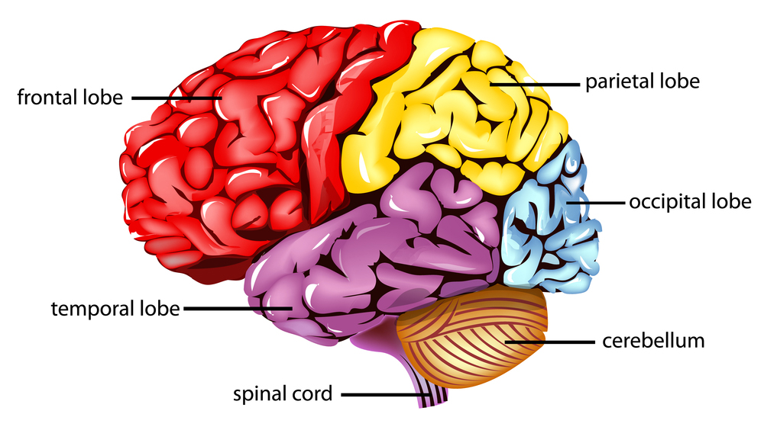

The Peripheral Nervous System:

What is the job of the Peripheral Nervous System (PNS)?

What does the somatic nervous system (SNS) do?

What does the somatic nervous system consist of?

What does the autonomic nervous system do?

What does it only consist of?

What is the role of the sympathetic nervous system?

What is the role of the parasympathetic nervous system?
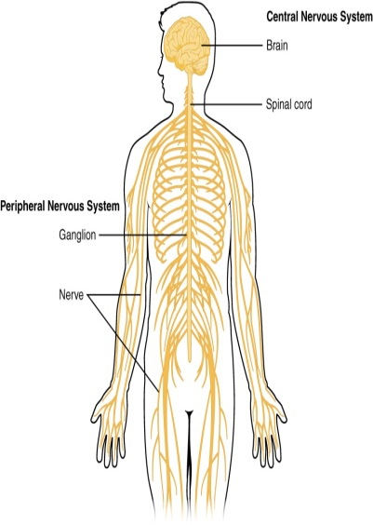

The structure and function of sensory, relay and motor neurons; the process of synaptic transmission, including reference to neurotransmitters, excitation and inhibition
Actively read the following
What are neurons?
Neurons are the main components of nervous tissue (the brain, spinal cord, PNS etc). They detect internal and external changes and form the communication link between the central nervous system, the brain and spinal cord and every part of the body.
Neurons are microscopic in size and can be one of three types: sensory, motor and relay. They typically consist of a cell body, dendrites and an axon but each type of neuron has a unique structure related to its function within the nervous system. The cell body consists of a number of short branching extensions called dendrites and one long extension called an axon. They vary in size from four micrometers (0.004 mm) to 100 micrometers (0.1 mm) in diameter. Their length varies from a few millimetres up to one metre.
How do they work?
Electrochemical messages or nerve impulses are conducted into the cell body by the Dendrites, whilst the axon conducts these impulses away from the cell body. Some neurons have myelinated axons. Myelin is a fatty insulative substance surrounding the axon cable. Its function is to help speed up the rate at which the nerve impulses are passed along the axon. When an impulse reaches the end of the axon it is passed onto another neuron, gland or organ via the axon terminals – short extensions found at the end of the axon. Neurotransmitters are the small chemicals that pass from one neuron to another to pass the signal being transmitted.
Task: Watch the YouTube clip and label the diagram below with these terms: (clip times: 0:00 – 1.10)
https://www.youtube.com/watch?v=FVo04B0_5R4
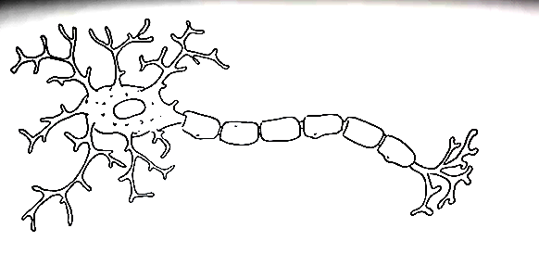
Dendrites Cell Body (Soma) Axon Myelin Sheath Synaptic Terminal

Task: continue watching the YouTube clip and label the diagram below with these terms: (Clip times 2.19 – 3.08)
Pre-synaptic membrane Post synaptic membrane Synaptic terminal Synaptic Cleft
Vesicles (containing neurotransmitters)

https://www.youtube.com/watch?v=FVo04B0_5R4
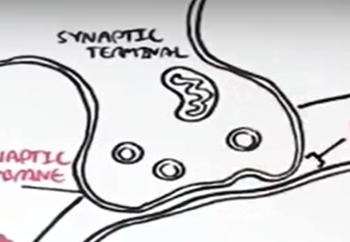

Core knowledge: synaptic transmission
Synaptic transmission is the process for transmitting messages from neuron to neuron. Since neurons form a network, they somehow have to be interconnected. When a nerve signal, or impulse reaches the ends of its axon, it has travelled as an action potential, or a pulse of electricity. However, there is no cellular continuity between one neuron and the next; there is a gap called synapse.
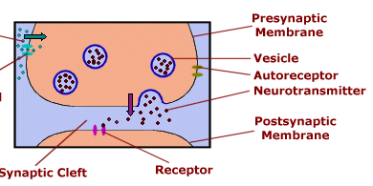
The membranes of the sending and receiving cells are separated from each other by the fluid-filled synaptic gap. The signal cannot leap across the gap electrically. So, special chemicals called neurotransmitters have this role. As an electrical impulse travels down the "tail" of the cell, called the axon and arrives at its terminal, it triggers vesicles containing a neurotransmitter to move toward the terminal membrane. The vesicles fuse with the terminal membrane to release their contents. Once inside the synaptic cleft (the space between the 2 neurons) the neurotransmitter can bind to receptors (specific proteins) on the membrane of the receiving neuron. This then converts to an electrical impulse that travels down the neuron to the next pre-synaptic terminal, so the impulse continues to be transmitted on. This happens at extreme pace, for example, when processing visual information, most of the information is processed in the first 50-100 milliseconds (milliseconds are 1000ths of a second). This is why if you are touched on the toe, and the shoulder at the same time, you would perceive that it was a slightly different times. Because of the distance the information has to travel down the sensory neurons to be registered by the CNS (Yamamoto and Kitazawa, 2001).
Excitation and Inhibition
Neurotransmitters have either an excitatory or inhibitory effect on the neighbouring neuron. For example, GABA causes an inhibition in the receiving neuron, resulting in the neuron becoming more negatively charged and less likely to fire. In contrast, adrenalin has an excitatory effect on the neighbouring neuron by increasing its positive charge, therefore making it more likely to fire. A good analogy is to think of excitation as an accelerator on a car, and inhibition as the brake.
Core Knowledge: Sensory, motor and relay neurons
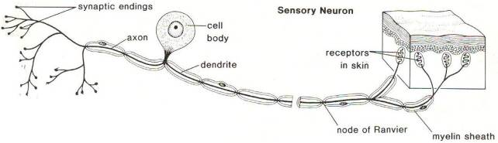

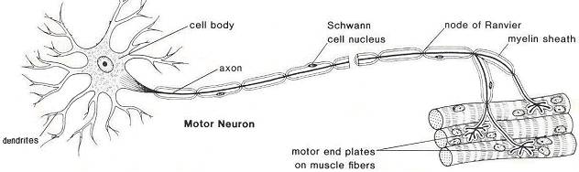
Sensory neurons, located in the peripheral nervous system (PNS) respond to stimulation in sensory receptors. They send signals to the spinal cord and brain about this sensory experience. There are sensory neurons for all senses (vision, hearing, smell, taste and touch). Most sensory neurons have long dendrites and short axons. Sensory neurons carry signals away from the organ to the brain and spinal cord.

Motor neurons are cells in the PNS that send messages from the brain and the spinal cord to the muscles and glands (effectors). These usually have long axons and short dendrites.
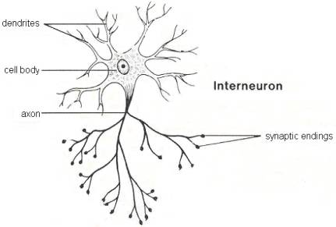
Relay Neurons (interneurons) form connections between other neurons. They can send signals to other relay neurons, or form links between sensory and motor neurons. All neurons in the CNS are relay neurons, and there are over 100 billion relay neurons

Core Knowledge:
Task 1: Label which neuron is represented in the diagram below (A, B, C)
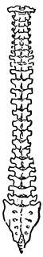
B
B

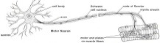
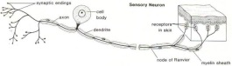
A C
Pain detected Arm moves from
source of pain

Back bone

TASK 2: true or false? If false, make the corrections.
- Motor neurons send signals from the CNS to the muscles and glands

- Muscles and glands are sometimes called effectors

- Sensory neurons often have short dendrites and short axons

- The CNS is consists entirely of motor neurons

- Relay neurons are also known as interneurons

- There are over 200 interneurons in the CNS

- Sensory neurons send signals to the brain and spinal cord from the sense organs

- Relay neurons only connect to sensory neurons

- Relay neurons can connect to other relay neurons

- There are gaps between the connections of neurons

Task 3: label the key structures to each neuron. Use the terms to fill in the boxes
Sensory Neurons
Synaptic endings Node of Ranvier Skin receptors Axon Dendrite Cell body Myelin sheath

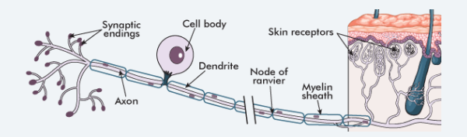
Motor Neurons
Motor end plates Axon Dendrites Schwann cell nucleus
Node of Ranvier Myelin Sheath Cell body
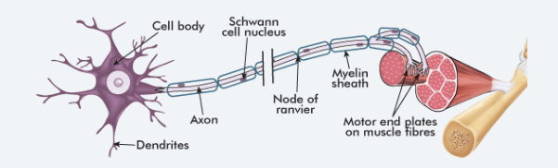
Task 3b
Draw an arrow to add the direction of impulse to each neuron (in other words, which way is the signal travelling in

Relay Neurons
Cell body Axon Synaptic endings dendrites
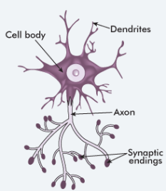

Details about each neuron
Read the further information about each neuron and answer the questions that follow
Sensory neurons are also known as afferent neurons, meaning moving towards a central organ or point, that is they move impulses towards the CNS . This type of neuron receives information or stimuli from sensory receptors found in various locations in the body, for example the eyes, ears, tongue, skin. This information enters sensory neurons through the dendrites and passes it to the cell body – the control centre of the cell. From here it is sent through the axon, until it reaches the end of the neuron (axon terminals ). Electrical impulses flow in one direction only through a neuron. So just like a series of electrical power lines that pass electricity through the suburbs of a city, so too do electrical impulses flow through the body along thousands of tiny neurons.
In sensory neurons, the cell body and dendrites are located outside the spinal cord in the torso, arms and legs. The dendrites (also known as dendrons) are usually long and the axons short.
Motor neurons are also known as efferent neurons meaning 'moving away from a central organ or point', that is they move impulses away from the CNS. This type of neuron takes information or responses from the brain to muscles or organs, which are referred to as effectors. The information enters a motor neuron through the dendrites, which then passes it into the cell body. From here it is sent down through the axon until it reaches the end of the neuron (axon terminals). If a motor neuron connects with a muscle, the axon terminals are called motor end plates . In a motor neuron, the dendrites are usually short and the axons are typically long. Information about a response required has been formulated in the brain and sent through motor neurons in the form of a series of electrical impulses, similar to the impulses sent along sensory fibres.
Interneurons are smaller neurons found only within the brain and spinal cord, and are responsible for linking sensory and motor neurons. They have short dendrites and axons.
Sensory Neurons (Afferent neurons)
Q1) Where do sensory neurons receive information from?
Q2) Why are sensory neurons called ‘afferent’ neurons? (Def: afferent means conducting or conducted inwards or towards something)
Q3) where do sensory neurons send information (using an electrical impulse) to?
Q4) which part of the neuron does information enter?
Q5) which part of the neuron is the control centre?
Q6) after information is sent to the control centre, where is it sent next?
Q7) where is the final destination for the information?
Q8) how many directions can electrical impulses flow through each neuron?
Motor neurons (efferent neurons)
Q9) Why are Motor neurons also called ‘efferent’ neurons? (Def: efferent means conducted or conducting outwards or away from something)

Q10) what are also known as effectors?

Q11) How does information enter the motor neurons?

Q12) where does information go after it has entered the neuron?

Q13) After the information is sent down the axon, where does it terminate?

Q14) if attached to a muscle, what are the axon terminals called?

Q15) what characterises the dendrites and the axons in motor neurons?

Q16) How is the information about the response required sent through motor neurons?

Relay Neurons
Q17) what characterises the sizer of relay neurons (interneurons)
Q18) where are relay neurons found?
Q19) what is the main responsibility of the relay neurons?
Q20) what is the length of their axons and dendrites?

Read and answer the questions below
Myelin sheath
Many neurons outside the CNS are myelinated . Myelin is rich in lipid (fat) and creates an electrically insulative layer around the axon that helps to increase the speed at which impulses travel. Specialised Schwann cells produce a tightly wrapped myelin sheath around the axon of a neuron. The outer-most membrane that covers the myelin is called the neurilemma. Myelin is rich in lipid (fat) and creates an electrically insulative layer around the axon that helps to increase the speed at which impulses travel. Small gaps between the myelin on the axon are called nodes of Ranvier . These help the electrical impulse 'jump' from section to section to increase the speed of the electrical impulse
Axon terminals and the synapse
Axon terminals are found at the end of an axon. This structure allows electrical impulses to be passed from one neuron to the next without the neurons physically touching. The gap between two neurons is called a synapse . The axon terminals are short extensions that terminate in tiny knobs that contain chemicals called neurotransmitters . When an electrical impulse arrives at the end of the axon, it causes neurotransmitter chemicals to be released from tiny storage vesicles . These move across the synaptic gap between the axon and the dendrite of the closest neuron
- What is the Myelin sheath?

- What is the function of the Myelin sheath?

- What are Schwann cells?

- What is the function of the Nodes of ranvier?

- What is the gap between the two neurons called?

- What are axon terminals?

- What are neurotransmitters?

- What do neurotransmitters do when the electrical impulse causes their release from the vesicles?

