Prep 3: Biological Approach

Task 1: Recapping Assumptions

You have already learnt the assumptions of the biological approach so test yourself with this fill in the gaps:

- Behaviour can be largely explained in terms of Biology (e.g. g______/h________/ N____________).
- Behaviour and processes can be explained by the structure and function of the human nervous ________, particularly the brain.
- Human genes have evolved over millions of years to adapt behaviour to the ___________. Therefore, most behaviour will have an adaptive / evolutionary purpose.
- Psychology should be seen as a science, to be studied in a ____________ manner (usually in a ______________).
For the following tasks, feel free to use the Biological Approach powerpoint on the prep page for extra support.

Task 2: The Evolution of Behaviour
Using the pack and the internet find out what the following terms mean/ answer the questions
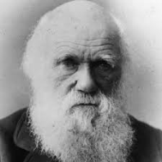
1. Who was Charles Darwin?
2. What is the theory of evolution about?

3.“Behaviour is adaptive”, What does this mean?

4. Darwin believed in the Survival of the fittest. Explain what he meant by this.

5. What is Natural selection?

6. What is mate selection? Give an example

7. In your own words, briefly explain the evolutionary explanation of attachment (pack)

Task 3: The Genetic Basis to Behaviour
Use the page on Genetics and behaviour in the pack.
- What is meant by Heredity?

- What is a genotype?

- What is a phenotype?

- Research into the Genetic Basis of behaviour

- What is a monozygotic twin?

- What is a dizygotic twin?

- What is a concordance rate?

- What would a perfect concordance rate be? (as a %)

- Identify the IV and DV for the meta-analysis in your pack

- Outline two findings from the research

- Explain how twin studies show that behaviour might be genetic (use examples from the meta-analysis)

- What side of the Nature Vs Nurture debate does this support and why?

- Is there a counter argument to this?

Task 4: Biological Structures

You have already learnt about biological structures in Biopsychology so use these tasks to test what you know and what you don’t know.

Complete the tasks without notes or the pack, then add in anything you couldn’t remember in a different colour.

The Nervous System:
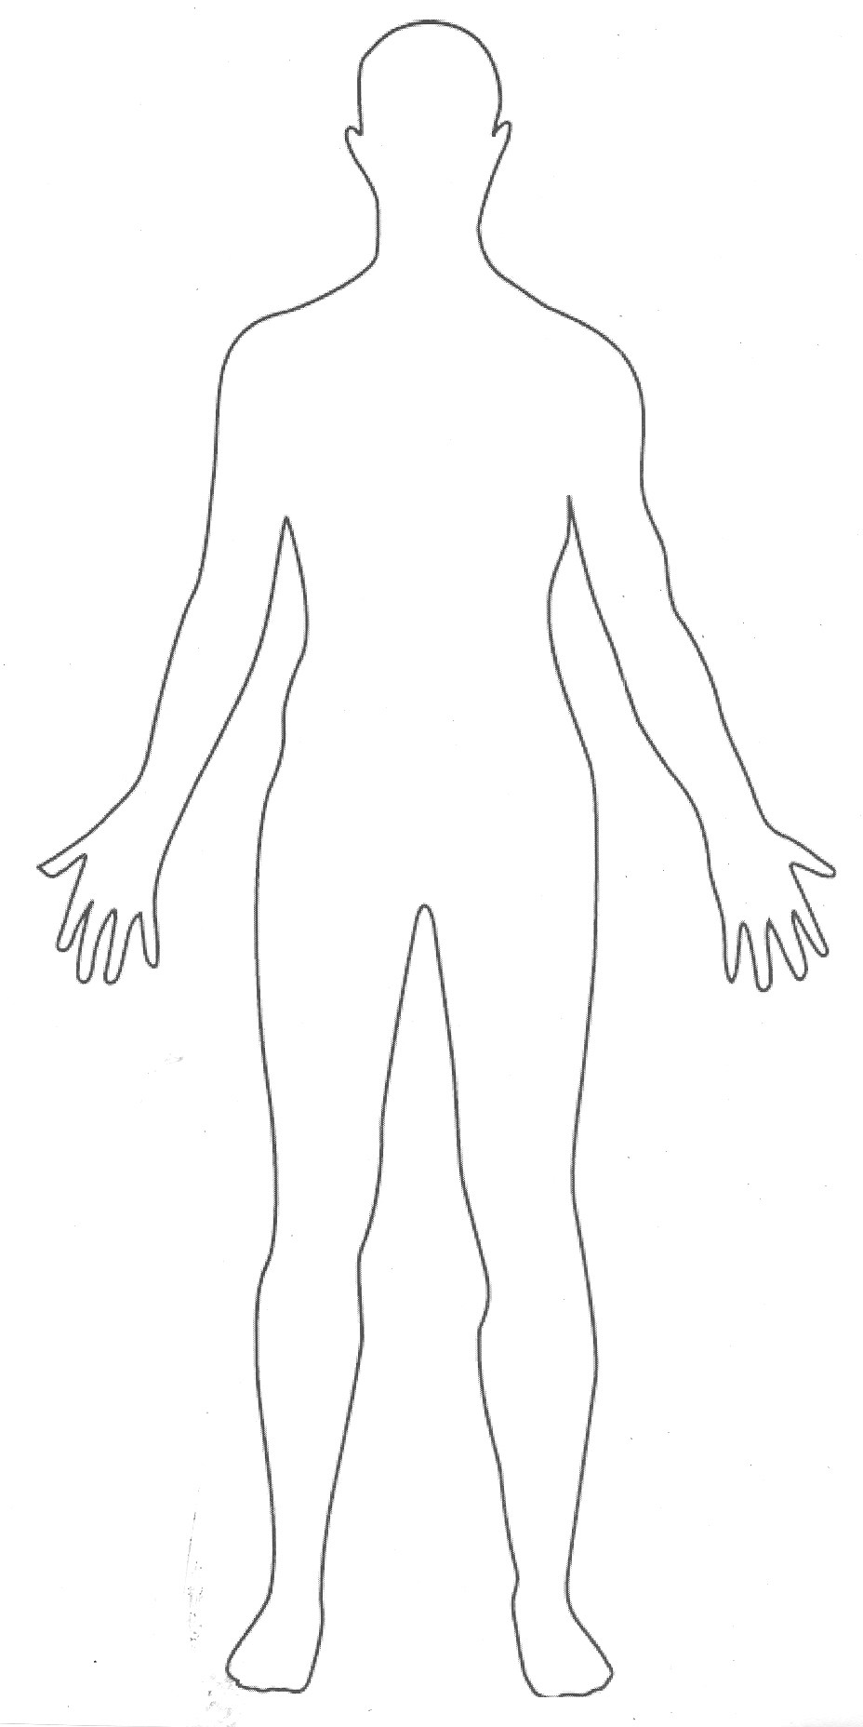
- Draw and label the major parts of the nervous system on the image of the human body.

- What are Neurotransmitters?

- How do Neurotransmitters influence behaviour?

The Endocrine System

- Label the following glands on the diagram.

Ovaries
Testes
Adrenal glands
Pineal gland
Pituitary gland

- Which hormones are produced from each of these glands?

The Brain
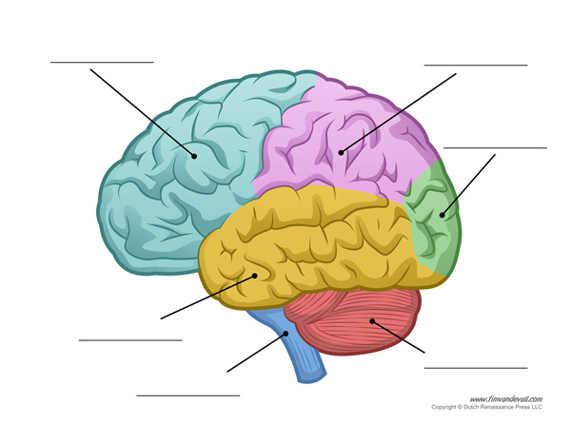

- Label the brain diagram based on what you learnt in Biopsychology.
Research online what each lobe does – add brief details to the diagram.

