Biopsychology – Unit 2

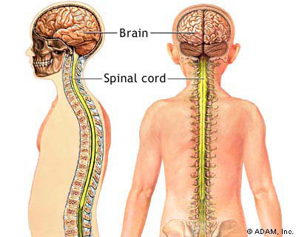
The Specification:

- The divisions of the nervous system: central and peripheral (somatic and autonomic).

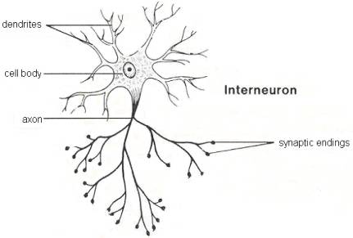
- The structure and function of sensory, relay and motor neurons. The process of synaptic transmission, including reference to neurotransmitters, excitation and inhibition.

- The function of the endocrine system: glands and hormones.

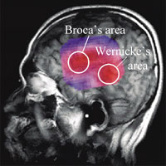
- The fight or flight response including the role of adrenaline.

- Localisation of function in the brain and hemispheric lateralisation: motor, somatosensory, visual, auditory and language centres; Broca’s and Wernicke’s areas, split brain research. Plasticity and functional recovery of the brain after trauma.
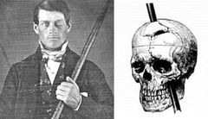
- Ways of studying the brain: scanning techniques, including functional magnetic resonance imaging (fMRI); electroencephalogram (EEGs) and event-related potentials (ERPs); post-mortem examinations.
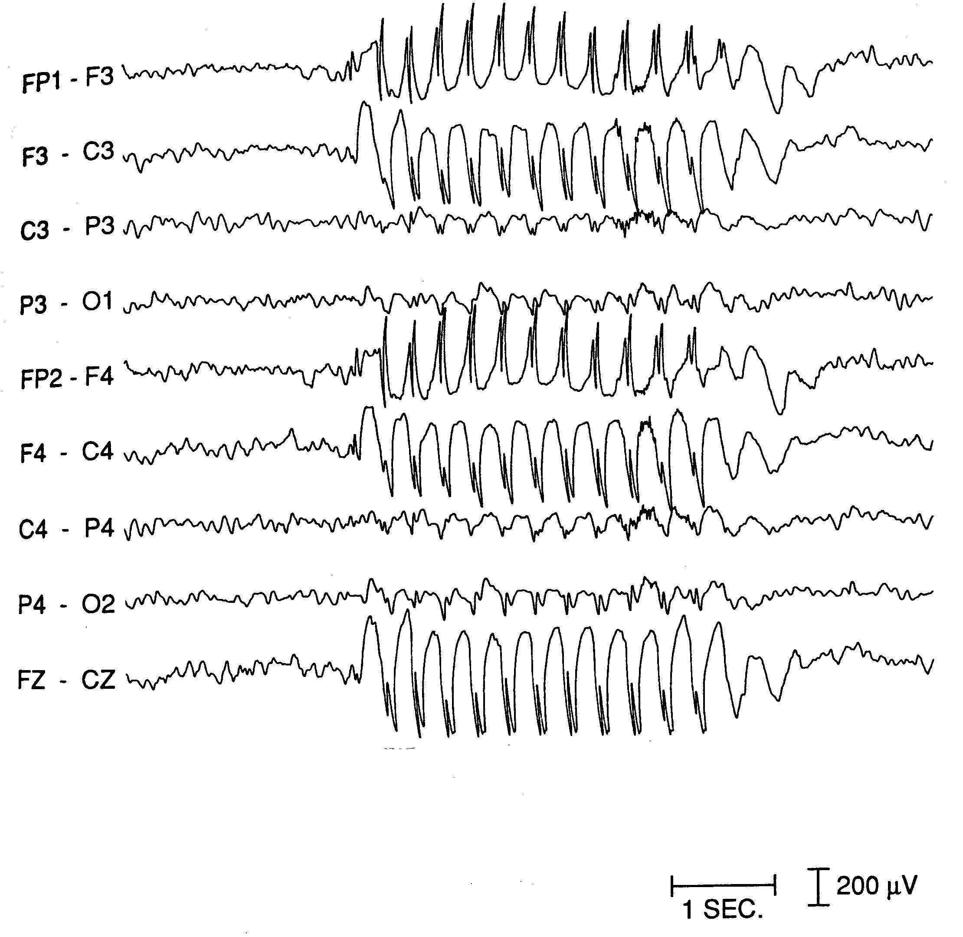
- Biological rhythms: circadian, infradian and ultradian and the difference between these rhythms. The effect of endogenous pacemakers and exogenous zeitgebers on the sleep/wake cycle.

The divisions of the nervous system: central and peripheral

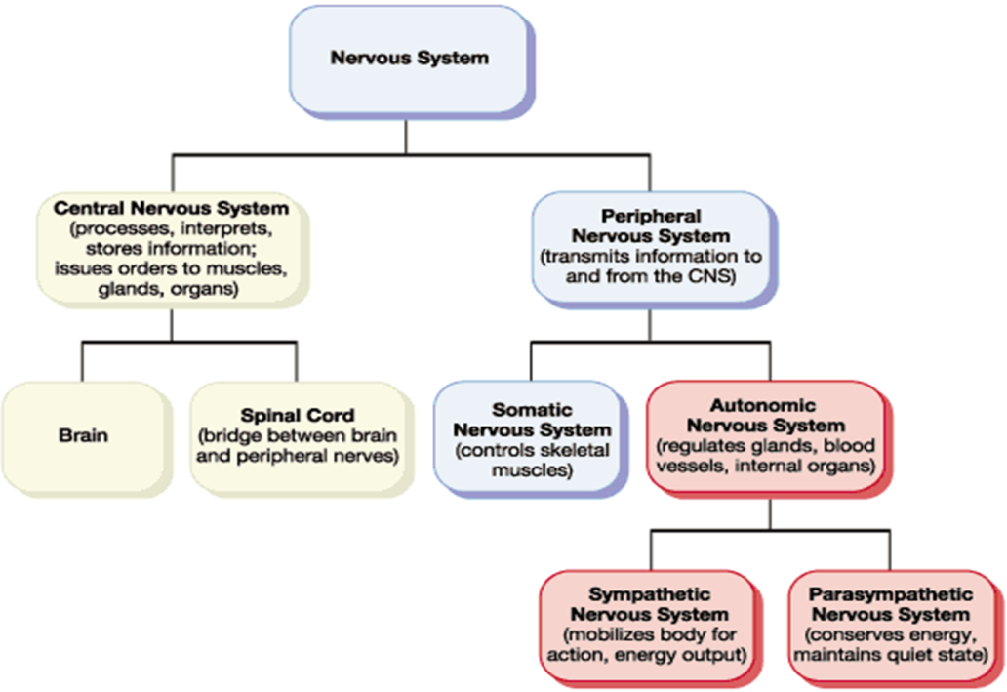

Part A The Central Nervous System (CNS)

Section 1: (The Brain)
The Central Nervous System consists of the brain and the spinal cord. The Cerebral Cortex, which is involved in a variety of higher cognitive (conscious thought), emotional, sensory, and motor (movement) functions is more developed in humans than any other animal. It is what we see when we picture a human brain, the gray matter with a multitude of folds making up the outer layer of the brain. The brain is divided into two symmetrical hemispheres: left (language, the ‘rational’ half of the brain, associated with analytical thinking and logical abilities) and right (more involved with musical and artistic abilities). These are further divided up into four distinct lobes, which you will learn more about later. Under the cerebral cortex is the area of the brain which is more primitive and are concerned with vital functioning and instinctive behaviour.

Section 2: (Spinal Cord)
The spinal cord is a white bundle of nerves, which runs from your brain down a canal in your backbone. It's roughly 40cm long and about as wide as your thumb for most of its length. Like the brain, your spinal cord is part of your central nervous system. Its main function is to relay information about what's happening inside and outside your body to and from your brain. It is also involved in reflex actions, such as the startle response.

Part B The Peripheral Nervous System (PNS)

The PNS is divided into two major systems, the Somatic Nervous System (SNS) and the Autonomic Nervous System (ANS)
Section 1: The Somatic Nervous System (SNS)
The Somatic Nervous System is part of the PNS that is concerned with the interaction of the outside world. It controls the voluntary movement of skeletal muscles. It also consists of the nerves that carry messages from the eyes, ears, skeletal muscles and the skin to give the CNS experience of its environment.

Section 2: The Autonomic Nervous System (ANS)
Is the part of the PNS that controls involuntary movement from non-skeletal muscles, for example, the ‘smooth muscles’ that control the intestines, bladder, pupil size etc. and the cardiac muscle (the heart). The ANS is spilt into two further systems: the sympathetic and parasympathetic systems.

Section 2a: The Sympathetic Nervous System
Is activated in situations requiring arousal and energy. When we feel threatened or under stress, the sympathetic branch of the ANS is activated which starts the instinctive reaction of ‘fight or flight’, aiding survival (you have more detail later). It produces increased heart and respiratory (breathing) rate, increasing blood flow to the muscles and pupil dilation (bigger pupils)

Section 2b: the Parasympathetic Nervous System
This is activated soon after the threat of danger has passed. This has the opposite effect of the Sympathetic Nervous System and allows for the body to return to homeostasis (balance). Here the person’s heart and respiratory rate decrease to normal levels and blood flow decreases. The pupils return to normal size. This system is vital for the individual to conserve energy and not to become exhausted.

The structure and function of sensory, relay and motor neurons

What are neurons?
Neurons are the main components of nervous tissue (the brain, spinal cord, PNS etc). They detect internal and external changes and form the communication link between the central nervous system, the brain and spinal cord and every part of the body.

Neurons are microscopic in size and can be one of three types: sensory, motor and relay. They typically consist of a cell body, dendrites and an axon but each type of neuron has a unique structure related to its function within the nervous system. The cell body consists of a number of short branching extensions called dendrites and one long extension called an axon. They vary in size from four micrometers (0.004 mm) to 100 micrometers (0.1 mm) in diameter. Their length varies from a few millimetres up to one metre.

How do they work?
Electrochemical messages or nerve impulses are conducted into the cell body by the Dendrites, whilst the axon conducts these impulses away from the cell body. Some neurons have myelinated axons. Myelin is a fatty insulative substance surrounding the axon cable. Its function is to help speed up the rate at which the nerve impulses are passed along the axon. When an impulse reaches the end of the axon it is passed onto another neuron, gland or organ via the axon terminals – short extensions found at the end of the axon. Neurotransmitters are the small chemicals that pass from one neuron to another to pass the signal being transmitted.

The process of Synaptic transmission

Synaptic transmission is the process for transmitting messages from neuron to neuron. Since neurons form a network, they somehow have to be interconnected. When a nerve signal, or impulse reaches the ends of its axon, it has travelled as an action potential, or a pulse of electricity. However, there is no cellular continuity between one neuron and the next; there is a gap called synapse.

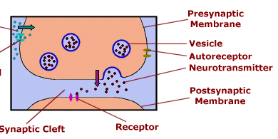
The membranes of the pre-synaptic and post-synaptic neurons are separated from each other by the fluid-filled synaptic gap. The signal cannot leap across the gap electrically. So, special chemicals called neurotransmitters have this role. As an electrical impulse travels down the "tail" of the cell, called the axon and arrives at its terminal, it triggers vesicles containing a neurotransmitter to move toward the terminal membrane. The vesicles fuse with the terminal membrane to release their contents.

Once inside the synaptic cleft (the space between the 2 neurons) the neurotransmitter can bind to receptors (specific proteins) on the membrane of the receiving neuron. This then converts to an electrical impulse that travels down the neuron to the next pre-synaptic terminal, so the impulse continues to be transmitted on. This happens at extreme pace, for example, when processing visual information, most of the information is processed in the first 50-100 milliseconds (milliseconds are 1000ths of a second). This is why if you are touched on the toe, and the shoulder at the same time, you would perceive that it was a slightly different times. Because of the distance the information has to travel down the sensory neurons to be registered by the CNS (Yamamoto and Kitazawa, 2001).

Excitation and Inhibition
Neurotransmitters have either an excitatory or inhibitory effect on the neighbouring neuron. For example, GABA causes an inhibition in the receiving neuron, resulting in the neuron becoming more negatively charged and less likely to fire. In contrast, acetylcholine has an excitatory effect on the neighbouring neuron by increasing its positive charge, therefore making it more likely to fire an impulse. A good analogy is to think of excitation as an accelerator on a car, and inhibition as the brake.

It is important to note that the excitatory and inhibitory influences are summed, if the net effect on the post synaptic neuron is inhibitory, the neuron will be less likely to ‘fire’ and if the net effect is excitatory, the neuron will be more likely to fire.

Sensory, motor and relay neurons

Sensory neurons, located in the peripheral nervous system (PNS) respond to stimulation in sensory receptors. They send signals to the spinal cord and brain about this sensory experience. There are sensory neurons for all senses (vision, hearing, smell, taste and touch). Most sensory neurons have long dendrites and short axons. Sensory neurons carry signals away from the organ to the brain and spinal cord.
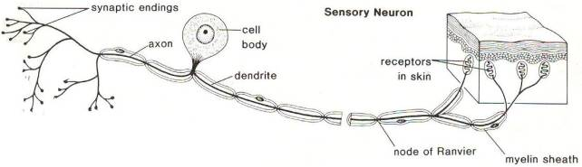

Motor neurons are cells in the PNS that send messages from the brain and the spinal cord to the muscles and glands (effectors). These usually have long axons and short dendrites.
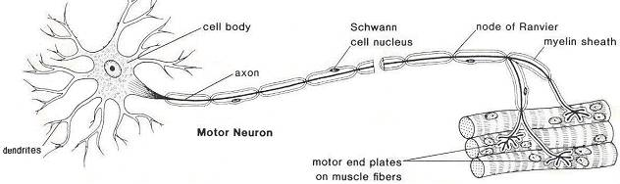

Relay Neurons (interneurons) form connections between other neurons. They can send signals to other relay neurons, or form links between sensory and motor neurons. All neurons in the CNS are relay neurons, and there are over 100 billion relay neurons

Sensory neurons are also known as afferent neurons, meaning moving towards a central organ or point, that is they move impulses towards the CNS . This type of neuron receives information or stimuli from sensory receptors found in various locations in the body, for example the eyes, ears, tongue, skin. This information enters sensory neurons through the dendrites and passes it to the cell body – the control centre of the cell. From here it is sent through the axon, until it reaches the end of the neuron (axon terminals ). Electrical impulses flow in one direction only through a neuron. So just like a series of electrical power lines that pass electricity through the suburbs of a city, so too do electrical impulses flow through the body along thousands of tiny neurons.
In sensory neurons, the cell body and dendrites are located outside the spinal cord in the torso, arms and legs. The dendrites (also known as dendrons) are usually long and the axons short.

Motor neurons are also known as efferent neurons meaning 'moving away from a central organ or point', that is they move impulses away from the CNS. This type of neuron takes information or responses from the brain to muscles or organs, which are referred to as effectors. The information enters a motor neuron through the dendrites, which then passes it into the cell body. From here it is sent down through the axon until it reaches the end of the neuron (axon terminals). If a motor neuron connects with a muscle, the axon terminals are called motor end plates . In a motor neuron, the dendrites are usually short and the axons are typically long. Information about a response required has been formulated in the brain and sent through motor neurons in the form of a series of electrical impulses, similar to the impulses sent along sensory fibres.

Relay (interneuron) are smaller neurons found only within the brain and spinal cord, and are responsible for linking sensory and motor neurons. They have short dendrites and axons.

Myelin sheath
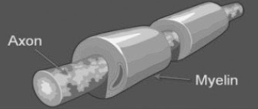
Many neurons outside the CNS are myelinated . Myelin is rich in lipid (fat) and creates an electrically insulative layer around the axon that helps to increase the speed at which impulses travel. Specialised Schwann cells produce a tightly wrapped myelin sheath around the axon of a neuron. The outer-most membrane that covers the myelin is called the neurilemma. Myelin is rich in lipid (fat) and creates an electrically insulative layer around the axon that helps to increase the speed at which impulses travel. Small gaps between the myelin on the axon are called nodes of Ranvier . These help the electrical impulse 'jump' from section to section to increase the speed of the electrical impulse
Axon terminals and the synapse
Axon terminals are found at the end of an axon. This structure allows electrical impulses to be passed from one neuron to the next without the neurons physically touching. The gap between two neurons is called a synapse . The axon terminals are short extensions that terminate in tiny knobs in the pre-synaptic neuron that contain chemicals called neurotransmitters . When an electrical impulse arrives at the end of the axon, it causes neurotransmitter chemicals to be released from tiny storage vesicles . These move across the synaptic gap between the axon and the dendrite of the closest post-synaptic neuron.

The Endocrine System
Gland | Hormones | Action
Pituitary gland | Oxytocin  Thyroid Stimulation Hormone (TSH) ACTH | The ‘Master gland’ as it controls all other glands, for example, TSH signals action in the thyroid, ACTH signals action in the adrenal glands
Thyroid gland | Thyroxine | Primarily involved with the regulation of metabolism, such as the conversion of food into energy for the muscles
Parathyroid gland | Parathormone | PTH essentially acts to increase the concentration of calcium in the blood from kidneys and bone
Pancreas | Insulin | Promotes the absorption of glucose from the blood into fat, liver and skeletal muscle cells
Adrenal glands | Adrenaline & Noradrenaline | Responsible for reacting to threat via the fight or flight response
Ovaries (female) | Oestrogen and progesterone | responsible for the development and regulation of the female reproductive system and secondary sex characteristics.
Testes (male) | Testosterone | a key role in the development of male reproductive system such as the testis and prostate, as well as promoting secondary sexual characteristics such as increased muscle and bone mass, and the growth of body hair.
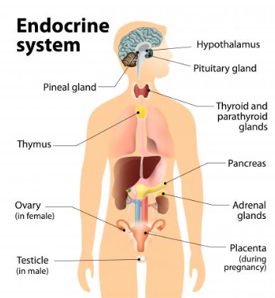

The endocrine system: Fight or flight
Outline the key processes involved with the fight or flight response, make reference to the role of adrenalin in your answer (6 marks)
Core knowledge 1: up for the fight (or flight)
A person will change from their normal resting state (the parasympathetic state) to the physiologically aroused sympathetic state when faced with a perceived threat. This causes the pituitary gland to release adrenocorticotrophic hormone (ACTH). This has the effect on the cells of the adrenal gland causing them to release adrenaline. This triggers physiological changes in the body which creates the physiological arousal necessary for the fight or flight response

Core knowledge 2: what biological changes occur due to increased adrenaline?
The physiological changes initiated by the secretion of adrenalin include increased heart rate, increased breathing rate, dilated pupils, inhibits digestion and inhibits saliva production
Q) feeling anxious? This often leads to the sensation of butterflies in the stomach, can you guess using a physiological reason why these may occur?
The physiological changes in the stomach cause this. Blood is diverted from the stomach to the vital organs, and the stomach muscles tighten. This adds to the feeling of ‘butterflies’ and people can feel quite ‘sick’ and occasionally experience nausea.

Core knowledge 3: - calming down again
Once the threat has passed, the parasympathetic nervous system is activated to calm the person down and return them to a resting state. Adrenaline is no longer secreted from the adrenal glands. Heart and breathing rates return to normal, and the person establishes homeostasis. The parasympathetic nervous system works in opposition to the sympathetic nervous system and act like a brake so we do not use up all our vital resources by staying in a constant state of heightened physiological arousal

So how does the ANS react to threat? – Fight or flight and the role of adrenaline
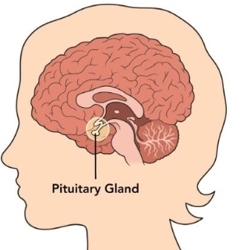

threat
detected by sensors (eye) and passed to….

Pituitary gland
heart rate increases to pump blood to vital organs
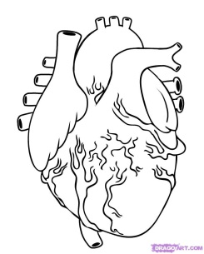
stomach to divert blood to the muscles to increase strength
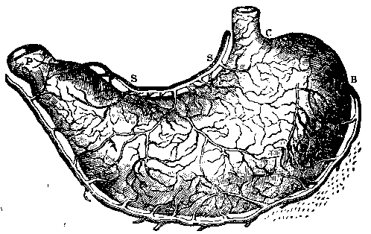
Releases adrenocorticotrophic hormone (ACTH)

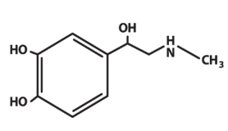

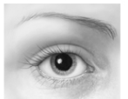
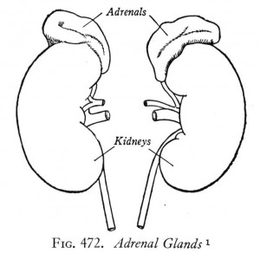
Adrenaline
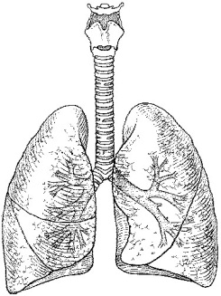
Detected by cells in the adrenal glands (adrenal medulla)
pupils dilate for increased vision

Lungs to increase breathing rate for more oxygen

Don’t forget the parasympathetic response: After a few minutes, the parasympathetic branch of the ANS is activated, and the body returns to normal by establishing homeostasis. Heart rate and respiratory rates decrease, adrenaline secretion slows down, the feeling of butterflies subside and sweating stops.

Localisation and Function of the Brain

The human brain is one of the most complex and fascinating biological systems.
Localisation of function theory
Localisation suggests that different functions of the brain are localised in specific areas and are responsible for different behaviours, processes or activities. You need to know the localisation of the following areas:
- Motor area - A region in the frontal lobe involved in regulating movement
- Somatosensory area - An area of the parietal lobe that processes sensory information (e.g touch)
- Visual area - A part of the occipital lobe that receives and processes visual information
- Auditory area – Located in the temporal lobe and concerned with analysis of speech.
- Language centres
- Broca’s area – An area of the frontal lobe in the left hemisphere (in most people) responsible for speech production
- Wernicke’s area- An area of the temporal lobe (encircling the auditory cortex) in the left hemisphere (in most people) responsible for language comprehension
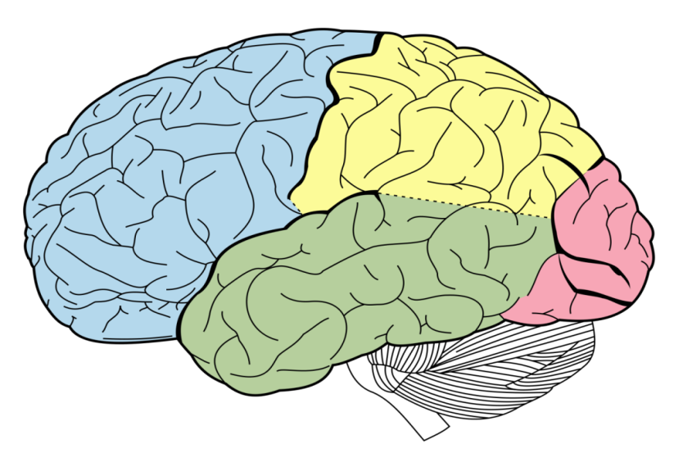
Wernicke’s area
Auditory area
Broca’s area
Occipital
lobe
Frontal Lobe
Parietal Lobe
Temporal Lobe
Visual area
Motor area
Somatosensory area

Visual area

Hemispheres of the Brain and the Cerebral Cortex
The Brain is divided into two symmetrical halves called left and right hemispheres. Some of our physical and psychological functions are controlled or dominated by a particular hemisphere. The outer layer of both hemispheres is called the Cerebral Cortex.
The Cerebral cortex sits like a tea cosy covering all the inner parts of the brain. It is 3mm thick and appears grey due to the location of cell bodies.

The Motor, Somatosensory, visual and Auditory centres
The Cortex is subdivided into four lobes. The lobes are named after the bones beneath which they lie; frontal lobe, parietal lobe, occipital lobe and temporal lobe.
Area | Functions
Motor area | Situated at the back of the frontal lobe in both hemispheres which controls voluntary movement in the opposite side of the body. Damage may result in a loss of control over find movements.
Somatosensory | Situated at the front of the parietal lobes. This is separated from the motor area by a valley called the central sulcus. This is where sensory information from the skin is presented (e.g heat) The amount of somatosensory area devoted to a particular body part denotes its sensitivity. For example receptors in our face and hands occupy over half of the somatosensory area.  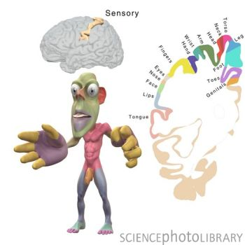
Visual | In the Occipital lobe at the back of the brain is the visual area (or cortex).  The eye sends information from the right visual field to the left visual cortex and from the left visual field to the right visual cortex.  This means that damage to the left hemisphere for example can produce blindness in the right eye.
Auditory | The Temporal lobes house the auditory area which analyses speech based information. Damage here may produce partial hearing loss.  Damage specifically to Wernicke’s area may affect an individual’s ability to comprehend language.

Language centres of the brain
In most individuals the Broca’s and Wernicke’s areas are in the left hempishere, and that is where most language processing is situated.
Broca’s area- The work of Broca identified the area responsible for speech production. Damage to this area can cause Broca’s Aphasia which is characterised by speech which is slow and lacking in fluency. Not all words are affected equally for example nouns and verbs seem relatively unaffected in patients with damage to Broca’s area but other classes of words such as conjunctions cannot be spoken.
Wernicke’s area- Karl Wernicke worked at a hospital in Germany and found patients who had damage in an area close to the auditory cortex in the left temporal lobe had specific language impairments including the inability to comprehend language and a struggle to locate the word they need.
Localisation of the brain
Evaluation
Supporting Evidence
The Case of Phineas Gage
Whilst working on the railroad in 1848 25 year old old Phineas Gage was preparing to blast a section of rock with explosives. During the process he dropped his tamping iron and caused the explosive to ifnight The explosion hurled the metre length pole through his left cheek passing through his left eye and exiting his skill taking a portion of his brain with it.
Incredibly Gage survived. Gage experienced initial problems with his speech and lost sight in his left eye however he recovered remarkably well with no marked effect on his functioning. However psychologically he was a changed man. Before the accident he was reported as calm and well-mannered however following the event he showed hostile, rude behaviour and used vulgar language
Arguments for localisation suggest the fact that Gage’s personality had significantly changed was a result of localisation in the brain and the area that was damaged was related to reasoning and control. Conversely arguments against localisation suggest Phineas’ recovery suggests a multifunctional brain supporting a holistic theory as the brain was able to compensate for damage.
Further case study evidence
The Case of Clive Wearing- An individual with brain damage as of a result of a viral infection had damage to his semantic long term memory however little damage to his procedural memory. This suggests localisation as if the function was spread throughout the entire brain there would not be specific deficits in this way.
Brain scan evidence of Localisation
Petersen et al (1988) used brain scans to demonstrate how Wenicke’s area was active during a listening task and Broca’s area was active during a reading task. These findings support a theory of localisation as the findings evidence specific areas of the brain having specific and different functions.
Neurosurgical evidence
Surgically removing or destroying areas of the brain to control behaviour was developed in the 1950s. Controversially neurosurgery is still used today to treat extreme cases of psychological disorders.
Dougherty et al (2002) reported on 44 OCD patients who had undergone a cingulotomy which is a procedure that lesions the cingulate gyrus. Findings showed a third of patients significantly improved and a further 14% showed partial improvement. The success of these procedures strongly supports that the symptoms and behaviours of mental disorders are localised.
Challenging theory and research
Lashley (1950) The work of Karl Lashley suggests higher cognitive process such as learning are not localised but distributed holistically
Lashley removed between 10-50% of areas of the cortex in rats. The ras were learning a maze. No area was proven to be more important in terms of the rats ability to complete the maze. This suggests the process of learning required every part of the cortex. This seems to suggest learning is too complex to be localised supporting a more holistic and multifunctional theory in regards to the function of the brain.
Criticisms of Lashley’s study however relate to the fact that the research was conducted on animals. This means we should be cautious in drawing conclusions related to human learning as we know the human brain is much more complex
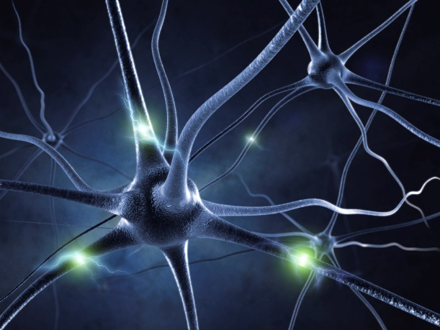
Plasticity
The notion of cognitive mapping or plasticity is a compelling argument against localisation.
Evidence shows that when the brain has become damaged through illness or accident and a particular function has been compromised or lost, the rest of the brain appears to be able to reorganise itself to recover the function. An example of this is in stroke victims many of whom seem to able to recover abilities that were seemingly lost as a result of illness (E.g speech)

Plasticity and Functional Recovery of the Brain After Trauma

What is Brain Plasticity?

This refers to the fact that the brain can change and develop as a result of our experience and learning, and also that it can recover after trauma.
The brain changes throughout the lifespan. During infancy, the brain experiences a rapid growth in the number of synaptic connections there are to other neurons, peaking at around 15,000 at age 2-3 years. This is around twice as many as there are in the adult brain. As we age, connections that we don’t use are deleted and connections that we use a lot are strengthened. This process is known as synaptic pruning.
Even though the majority of changes in neural connections happen during childhood, adult brains still change and develop, on a smaller scale, as a result of learning and experience.

Research into Brain Plasticity

Maguire et al (2000) studied the brains of London taxi drivers and found that there was a significantly greater volume of grey matter in the posterior hippocampus than in a matched control group. This part of the brain is associated with spatial and navigational skills in humans and other animals. Part of a London taxi driver’s training involves taking a test known as ‘the knowledge’, which assesses their ability to recall the names and locations of the streets in the city. The results of the study suggest that the learning the drivers undertake as part of their training alters the structure of their brains. It was also noted that there was a positive correlation between how great the volume of grey matter was and how long they had been in the job.
Draganski et al (2006) imaged the brains of medical students three months before and after their final exams. Learning induced changes were seen to have occurred in the posterior hippocampus and parietal cortex, presumably as a result of the exam.
Mechelli et al (2004) found a larger parietal cortex in the brains of bilingual people, compared to non-bilingual people.

Functional Recovery of the Brain after Trauma

The brain is often able to recover from trauma that is caused by physical injury or illness (e.g. stroke). This is another example of neural plasticity. Unaffected areas of the brain are often able to adapt and compensate for the areas that have been lost or damaged. Healthy brain areas may take over the functions of the areas that have been affected. Neuroscientists suggest that this process can occur quickly after the trauma, but then slow down after several weeks or months. The person may then require rehabilitative therapy to assist their recovery.

How Does Brain Recovery Work?

The brain is able to reorganise and rewire itself by forming new synaptic connections close to the area of damage. Secondary neural pathways that would not usually be used to carry out certain functions are activated to enable functioning to continue, often in the same way as before. Support for this comes from structural changes that are known to take place in the brain. Examples are:

- Axonal sprouting: The growth of new nerve endings which connect with other undamaged nerve cells to form new neuronal pathways
- Reformation of blood vessels
- Recruitment of homologous (similar) areas on the other side of the brain to take over specific tasks

Evaluation of Plasticity and Functional Recovery of the Brain following Trauma

Practical application | Our increased understanding in this area has contributed to the field of neurorehabilitation. In other words, it has helped in the treatment of those who have suffered brain trauma. The fact that we know that spontaneous brain recovery slows down after a few weeks, means that we are aware of when it may be necessary to start physical therapy to maintain improvements in functioning. Although the brain has the ability to fix itself to a certain extent, some intervention is likely to be necessary if full recovery is to be achieved.
Negative plasticity | The brain’s ability to rewire itself does not always have positive consequences. Some adaptations may be maladaptive (unhelpful). Prolonged drug use, for example, has been shown to result in poorer cognitive functioning as well as an increased risk of dementia in later life. Also, 60-80% of amputees are known to develop phantom limb syndrome. This is the continued experience of sensation in the missing limb. These sensations are usually unpleasant and painful and are thought to arise from cortical reorganisation in the somatosensory cortex that results from the limb loss.
Individual differences: Age & Gender | Functional plasticity tends to reduce with age, and this therefore affects the speed of recovery. Marquez de la Plata et al (2008) found that, following brain trauma, older patients (40+ years old) regained less function in treatment than younger patients and they were also more likely to decline in terms of function for the first five years following the trauma. However, Bezzola et al (2012) found that 40 hours of golf training produced changes in the neural representation of movement in participants aged between 40 and 60. Using fMRI they found that motor cortex activity was reduced for the novice golfers compared to a control group. Suggesting more efficient neural representation after training. This supports the view that neural plasticity does continue throughout the lifespan. There is also evidence to suggest that women recover better from brain injury because their function is not as lateralised (concentrated in one hemisphere)
Individual differences: Education | Evidence suggests that the person’s level of educational attainment will influence how well the brain recovers after trauma. Schneider (2014) found that the more time brain injured patients had spent in education, (known as their cognitive reserve) the greater their chances of a disability-free recovery.

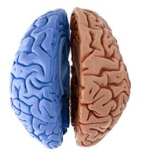
Biopsychology: Split-brain research

The ability to produce and understand language, for most people, is controlled by the left hemisphere. This suggests that for the majority of us, language is subject to hemispheric lateralisation. In other words, the specialised areas associated with language are found in one of the hemispheres rather than both.

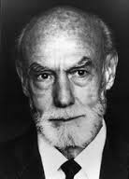
In the late 1960’s, Roger Sperry and his colleagues began to conduct a number of experiments investigating this, this collection of research became known as ‘split-brain research’.

Fun fact:
Sperry won the Nobel Prize in 1981 for his work.

Sperry’s studies involved a unique group of individuals, all of whom had undergone the same surgical procedure – an operation called a commissurotomy – in which the corpus callosum and other tissues which connect the two hemispheres were cut down the middle. This was done as a treatment for people who had frequent and severe epileptic seizures as separating the two hemispheres would help to control this.
This meant for the split brain patients the main communication line between the two hemispheres was removed. This allowed Sperry and his colleagues to see the extent to which the two hemispheres were specialised for certain functions and whether the hemispheres performed tasks independently of one another.

Sperry’s procedure

Sperry devised a way of being able to test hemispheric lateralisation using visual and tactile tasks. This involved using a piece of equipment called a ‘T-scope’ (see below) which allowed each hemisphere to be tested in isolation of the other.

The general procedure involved the participant being asked to focus on the ‘fixation point’ and then an image or word was projected very quickly (1/10th of a second) to one or both visual fields. For example, the word ‘key’ could be projected so that it only is processed by the participant’s right visual field (processed by the left hemisphere) and then the same, or different, image could be projected to the left visual field (processed by the right hemisphere).
To test for non-verbal processing, this equipment also enabled the participants to be able to pick up or match objects that were out of the participant’s sight.

In a ‘normal’ brain, the corpus callosum would immediately share information between both hemispheres giving a complete picture of the visual world. However, presenting the image to one hemisphere of a split-brain patient meant that information could not be conveyed from that hemisphere to the other.
Fixation point
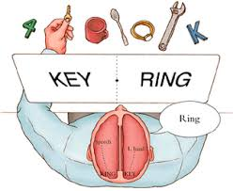
Sperry’s findings
Sperry and his colleagues have conducted a large number of studies on split brain patients. Here are some of the key findings from his original study.

1. When a picture/word was projected to the right visual field (information processed in left hemisphere), the patient could easily describe what had been shown. However when the picture/word was projected to the left visual field (information processed in right hemisphere), the patient could not describe what had been shown and typically reported that there was nothing there. This supports hemispheric lateralisation showing that language is processed in the left hemisphere as the patients could only describe what they had seen when it was projected to the right visual field

2. Although the patients could not describe what had been shown to their left visual field, they were able to use their left hand to point to a matching object or picture. This shows that the right hemisphere has processed the information but obviously cannot verbalise what was shown.
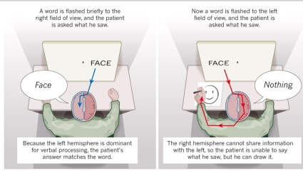
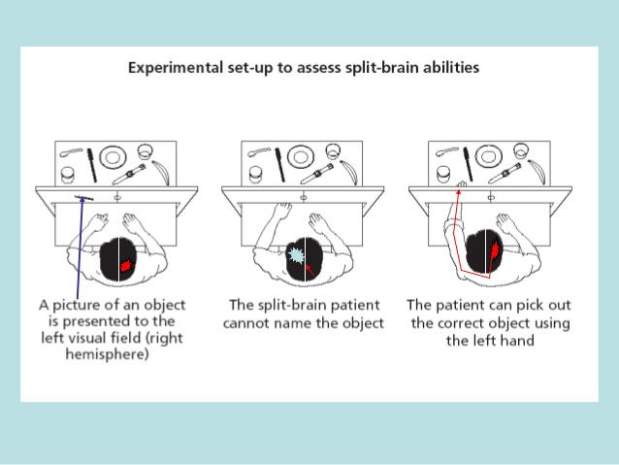
3. If two words/pictures were projected simultaneously, one on either side of the visual field (e.g. ‘a dollar sign’ on the left and ‘a question mark’ on the right), the patient would say that they saw a question mark but when asked to draw (with their left hand) what they saw, they would draw a dollar sign. The patients were not aware that they had drawn a different object or picture to the one they said they had seen. This suggests the two hemispheres were working separately from each other. It also suggests that drawing ability is dominant in the right hemisphere.

4. An object placed in the patients right hand (the patient could not see it just feel it) it could be easily described or named in speech or writing, whereas, if the same objects were placed in the left hand, the patient could only make wild guesses. However, when this object is taken from them and placed in a grab-bag along with other objects, the patient is able to search for and retrieve the object with their left hand. This also supports hemispheric lateralisation as it shows the left hemisphere is dominant for speech and writing. It also shows again that the right hemisphere is able to comprehend what the object is but just cannot identify it verbally.

Evaluation of Split Brain Research

Evaluation of Methodology:

Split brain research is experimental and involves the use of specialised equipment that can objectively measure the lateralisation of function in each hemisphere. The use of this equipment allows for the image or word to be projected extremely quickly (1/10th of a second) to one or both visual fields. This meant that the split-brain patients would not have time to move their eyes across the image and so the visual information would only be processed by one visual field (and one hemisphere) at a time, therefore increasing the internal validity of the research.

The standardised procedures used in the research, for example giving the same tasks to each participant and using standardised equipment (the T-scope) have helped to enable the research to be checked for reliability. The same procedure has been used on a number of split-brain patients and the results on the left hemisphere being dominate for language has been found to be consistent.

The control group used by Sperry were people with no history of epileptic seizures therefore they could be seen as an inappropriate group to use as a comparison. As the split brain patients suffered from epilepsy, it could be argued that it may have caused unique changes in the brain which could have influenced the results, so a more appropriate control group would have been people who had a history of epilepsy but had not had the split-brain procedure.

Small sample sizes are used in split brain research meaning it is difficult for the results on hemispheric lateralisation to be generalised to the wider population. However, as commissurotomy is a rare procedure, there is a limited amount of ‘split brain’ patients available for investigation therefore small sample sizes are unavoidable.

The data gathered from the split brain research came from the patients being testing under artificial conditions. In real life a severed corpus callosum can be compensated for by the unrestricted use of two eyes therefore the research findings cannot be generalised to how split brain patients function in everyday tasks.

Usefulness and Theoretical value:

- Split brain research has been very useful for investigating and demonstrating lateralisation of function. This has led to a significant improvement in our understanding of the role of each hemisphere and brain processes associated with each hemisphere.

- Sperry’s work prompted a theoretical and philosophical debate about the degree of communication between the two hemispheres in everyday functioning and the nature of consciousness.
Some theorists have suggested that the 2 hemispheres are so functionally different that they represent a form of ‘duality’ in the brain – that in effect we are all ‘two minds’ in contrast, other researchers have argued that, far from working in isolation, the two hemispheres form a highly integrated system and are both involved in most everyday tasks.

- Modern neuroscientists suggest that the differences in function may be overstated and that the actual distinction between the each hemisphere is less clear and more complex. In a ‘normal’ brain the two hemispheres are in constant communication when performing everyday tasks, and many of the behaviours typically associated with one hemisphere can be effectively performed by the other when the situation requires it.

Ways of investigating the brain
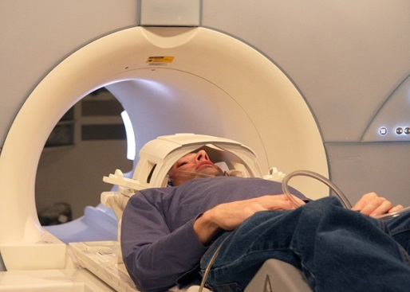
Advances in science and technology have brought with them even more sophisticated and precise methods of studying the brain. Ways of studying the brain include: functional magnetic resonance imaging (fMRI), electroencephalogram (EEG) and event related potentials (ERPs), and post-mortem examinations.

Functional magnetic resonance imaging (fMRI)
fMRI works by detecting the changes in blood oxygenation and flow that occur as a result of neural (brain) activity in specific parts of the brain.
When a brain area is more active is consumes more oxygen and to meet this increased demand blood flow is directed to the active area (known as the haemodynamic response).
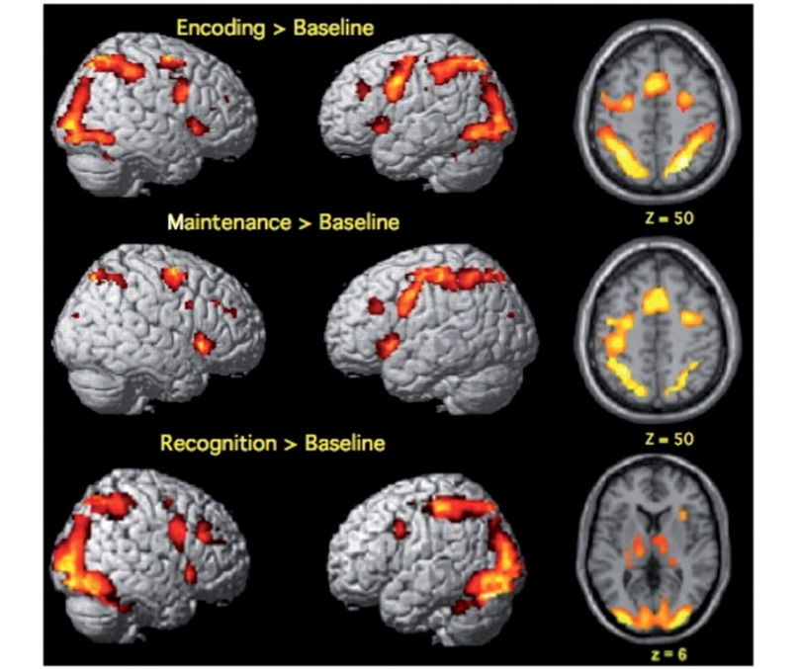
fMRI produces 3-dimensional images (activation maps) showing which parts of the brain are involved in particular mental processes and this has important implications for our understanding of localisation of function.
This brain scan shows which areas of the brain are more active (shown in red) during encoding, maintenance and recognition (memory processes). As you can see different areas of the brain are lit up for different tasks.

Strengths | Weaknesses
- Unlike other scanning techniques, fMRI does not rely on the use of radiation.  If administered correctly it is virtually risk-free, non-invasive and straightforward to use.  - It produces images that have very high spatial resolution, showing detail by the millimetre, and providing a clear picture of how brain activity is localised. | - fMRI is expensive compared to other neuroimaging techniques and can only capture an image if the person stays perfectly still.  - It has poor temporal resolution because there is around a 5 second time-lag behind the image on screen and the initial firing of neuronal activity.  - fMRI can only measure blood flow in the brain, it cannot tell us the exact activity of individual neurons and so it can be difficult to tell what kind of brain activity is being represented on the screen.

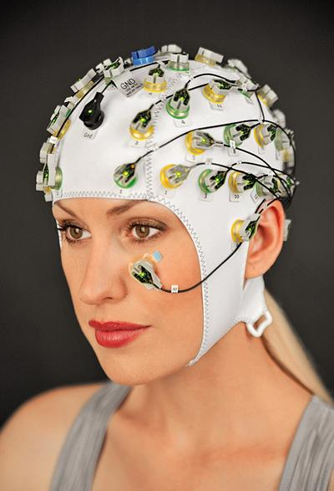
Electroencephalogram (EEG)
EEGs measure electrical activity within the brain via electrodes that are fixed to an individual’s scalp using a skull cap.
The scan recording represents the brainwave patterns that are generated from the action of millions of neurons, providing an overall account of brain activity.

EEG is often used by clinicians as a diagnostic tool as unusual arrhythmic patterns of activity (i.e. no particular rhythm) may indicate neurological abnormalities such as epilepsy, tumours or disorders of sleep.
The recording on the left, shows the brainwaves during an epileptic seizure. Notice they are quite erratic,

Strengths | Weaknesses
- EEG has been very valuable at helping diagnose conditions such as epilepsy because the difference in brain activity can be easily detected on the screen.  - It has contributed to our understanding of the stages of sleep.  - It has extremely high temporal resolution (unlike fMRI)-> it can accurately detect of a single millisecond. | - Only general information is received from an EEG (the activity of many thousands of neurons).  - EEG is not useful in pinpointing the exact source of neural activity and does not allow researchers to tell the difference between activity in locations that are very close to one another.

Event-related potentials (ERPs)
An ERP is the brain’s electrophysiological response to a specific sensory, cognitive, or motor event that can be isolated through statistical analysis of EEG data.
Whereas EEGs are a very general measure of brain activity, the EGG data contains all the neural responses associated with specific events and researchers have developed a way of teasing out and isolating these specific responses.
By using a statistical averaging technique, all extraneous brain activity from the original EEG recording is filtered out leaving only those responses that relate to, say the presentation of a specific stimulus or performance of a specific task.
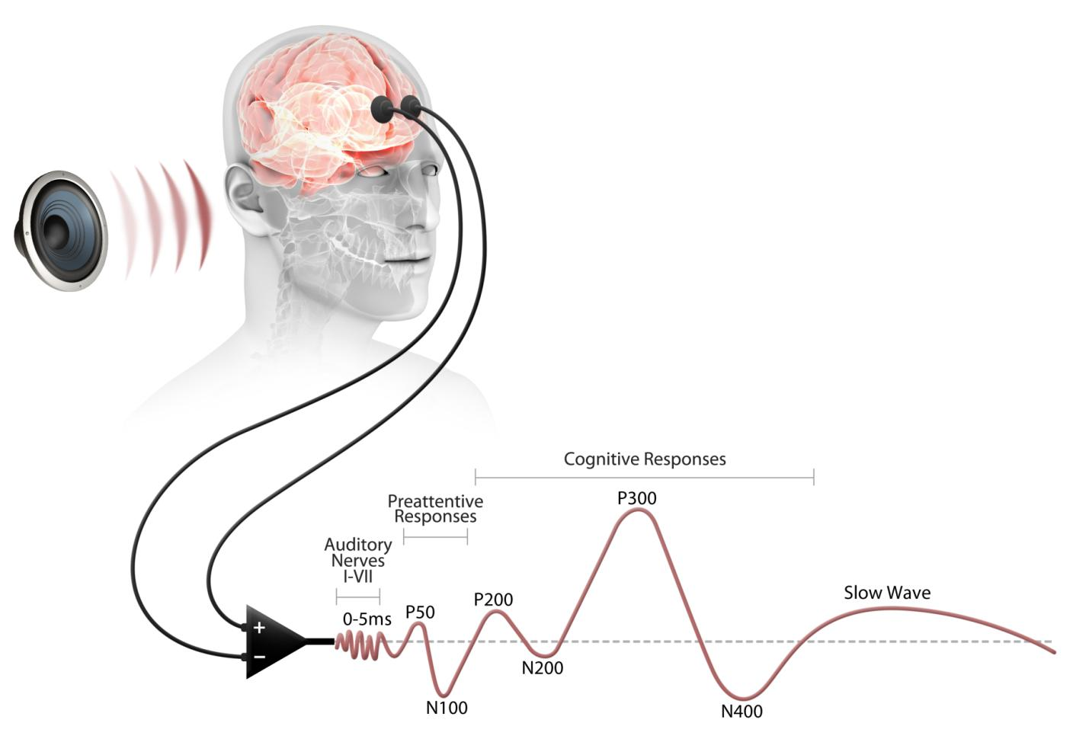
What remains are event-related potentials: types of brainwaves that are triggered by particular events. Research has revealed many different forms of ERP and how, for example, there are linked to cognitive processes such as attention and perception.

For example, in the graph on the left it shows the types of brain waves triggered by an auditory (sound) stimulus.

Strengths | Weaknesses
- The limitations of EEGs being too general are partly addressed by ERPs- they are much more specific to the measurement of neural processes.  - They also have excellent temporal resolution (because they are derived from EEGs). This has led to widespread use of ERPs to measure cognitive functions and deficits.  - Researchers have also been able to identify many different types of ERP and describe the precise role of these in cognitive functioning e.g. the P300 component is thought to be involved in the allocation of attentional resources in working memory. | - There is a lack of standardisation in ERP methodology between different research studies, which makes it difficult to confirm findings.  - It may not always be possible to completely eliminate background noise and extraneous material needed to establish pure data in ERP studies.

Post-mortem examinations
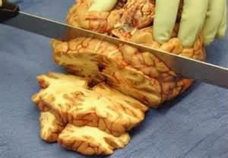
This is a technique involving the analysis of a person’s brain following their death.
In psychological research, individuals whose brains are subject to a post-mortem are likely to be those who have a rare disorder and have experienced unusual deficits in mental processes or behaviour during their lifetime.
Areas of damage within the brain are examined after death as a means of establishing the likely cause of the affliction the person suffered. This may also involve comparison with a typical brain in order to determine the extent of the difference between them.
Strengths | Weaknesses
- Post-mortem evidence was vital in providing a foundation for early understanding of key processes in the brain e.g. Broca’s and Wernicke’s areas were identified using post-mortem because neuroimaging did not exist at this time.  - Post-mortem studies improve medical knowledge and help generate hypotheses for further study. E.g. Zhou analysed the brains of female-male transsexuals and found an area of the brain associated with gender to be larger in these individuals- more similar to that of a male. | - Causation is an issue within these investigations. Observed damage in the brain may not be linked to the deficits under review but to some other unrelated trauma or decay.  - They raise ethical issues of consent from the patient before death. Patients may not be able to provide informed consent if they have brain damage, for example in the case of HM- he was unable to form new memories and therefore was not able to provide consent for post mortem in the event of his death.

- Biological rhythms: circadian, infradian and ultradian and the difference between these rhythms.
Biological rhythms are cyclical changes in the way biological systems (humans, animals, plants) behave. One of the most obvious is the sleep-wake cycle. In adult humans for example, we will typically spend approximately 16 hours of every 24 hour cycle in consciousness, and 8 hours of every 24 hour cycle in varying degrees of unconsciousness. In other words, we spend about one third of our day sleeping (although individual differences vary greatly) and two-thirds awake.
- Circadian Rhythms:

The most obvious circadian rhythm in humans is the sleep-wake cycle. This appears to be a 24 hour rhythmic cycle where there are differing levels of consciousness. People sleep for a certain time every 24 hours, and conduct other activities during wakefulness. These patterns are repeated regularly and are persistent even when the environment changes. For example, people will often feel ‘jet lag’ when they fly to a completely different time zone, and will want to sleep during the day yet be fully awake during the night.

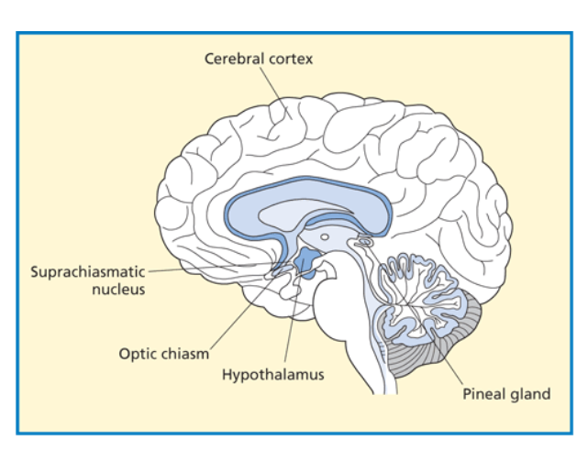
Research in this area has repeatedly found that circadian rhythms remain even when there are changes to the environment. If no clues are offered about daylight and night time, and other environmental factors are kept constant, the ‘biological clock’ will continue to regulate our bodies on approximately a 24 hour cycle. This suggests that the sleep-wake cycle is in-built and regulated by what scientists have called endogenous pacemakers. It is suspected that endogenous pacemakers are to be found in the brain, and structures such as the pineal gland and the Suprachiasmatic Nuclei (SCN) are thought to be influential in this regulation. The neurotransmitter serotonin and the hormone melatonin are considered important in the regulation of the sleep-wake cycle.

How the SCN works is not precisely understood, but according to Kalat (1998) the SCN generates its own internal rhythm as a result of protein production. It is likely that what happens is that the cells in the SCN produce a protein for a period of hours until the level inhibits further production, again for hours; next when the protein level drops below the threshold, the SCN starts producing the protein again.

This generates the biological rhythm which activates the pineal gland, since the SCN is connected to the pineal gland via a pathway; when the pineal gland is activated by the SCN it produces melatonin, which causes drowsiness. It continues to be emitted throughout the night providing it is dark; when it becomes light the SCN and its protein production is affected, so a pathway from the SCN to the pineal gland is activated and the secretion of melatonin falls.

What is also interesting is that the research has demonstrated that the endogenous pacemakers are not perfect, and when deprived of external influences, the circadian rhythm can become a little longer or shorter, so people require these exogenous zeitgebers if circadian rhythms are to be fully co-ordinated with the external world. The most influential exogenous zeitgeber is light, and its role in fine-tuning bodily rhythms has been reliably demonstrated in research.

Light influences our internal clock through specialized "light sensitive" cells in the retina of our eyes. These cells, which occupy the same space as the rods and cones that make vision possible, tell the brain whether it is daytime or night-time, and our sleep patterns are adjusted accordingly. So although the sleep wake cycle exists without light, light does influence the cycle. For example, if there is a shift in external cues, like travelling across time zones, the sleep wake cycle becomes aligned to new cues. This is called entrainment.
Evaluation: Research into circadian rhythms has found evidence for the role of the SCN.

Morgan (1995) removed and transplanted the SCNs from hamsters and shows support the importance of the SCN as an endogenous pacemaker. When the SCN was removed from hamsters their nocturnal circadian rhythms disappeared. Transplanting with SCN cells re-established the rhythms. Furthermore, when hamsters with nocturnal patterns of activity (usual) had their SCNs replaced with SCNs from mutated hamsters which slept through the night and were active during the day (unusual), the hamsters followed the new daytime activities of the donor’s patterns. Further evidence from lesioning (cutting) the SCN in rats showed a complete disruption to the animals sleep/wake cycle.

It is clear that exogenous zeitgebers also play a key role in the regulation of circadian rhythms. The case study of Michel Siffre shows that in the absence of external cues, such as light and contact with others, the biological clock can drift, as his did to a longer 25 hour clock, and similar findings have shown that some people, blind by birth, have difficulties adjusting to the 24 hour day because of the lack of light cues.
- Infradian Rhythm: the menstrual cycle
When a baby girl is born, she has all the eggs her body will ever use, and many more, perhaps as many as 450,000? They are stored in her ovaries, each inside its own sac called a follicle. As she matures into puberty, her body begins producing various hormones that cause the eggs to mature. This is the beginning of her first cycle; it's a cycle that will repeat throughout her life until the end of menopause.
Details of the complete cycle (between 24 and 35 days, although it’s often referred to as a 28 day cycle)
The hypothalamus releases the chemical messenger “Follicle Stimulating Hormone Releasing Factor” (FSH-RF) which trigger the pituitary gland to secrete “Follicle Stimulating Hormone” (FSH) and Leutenizing Hormone (LH) into the bloodstream which cause the follicles to begin to mature.
The maturing follicles then release another hormone, oestrogen. As the follicles ripen over a period of about seven days, they secrete more and more oestrogen into the bloodstream. When the oestrogen level reaches a certain point, the pituitary gland to releases a further amount of Leutenizing Hormone (LH). This surge of LH triggers the one most mature follicle to burst open and release an egg. This is called ovulation. [Many birth control pills work by blocking this LH surge, thus inhibiting the release of an egg.] After ovulation, the hormone progesterone causes the womb lining to thicken which readies the body for pregnancy. If the woman does not become pregnant, the unfertilised egg is absorbed back into the body and the womb lining comes away from the body; the menstrual flow (bleeding). Women can experience a variety of sensations during this infradian rhythm. Common effects include backache, pain in the inner thighs, bloating, nausea, diarrhoea, constipation, headaches, breast tenderness, irritability, and other mood changes. Women also experience positive sensations such as relief, release, euphoria, new beginning, invigoration, connection with nature, creative energy, exhilaration, increased sex drive.
Evaluation. It is unclear whether the menstrual cycle is effected by endogenous pacemakers (internal factors) or exogenous zeitgebers. Evidence supporting the role of zeitgebers is stated below.
Reinberg (1967) conducted a study where one female participant spent three months in a cave with only light from a small lamp. As a result her days lengthened to 24.9 hours and her menstrual cycle shortened to 25.7 days. This shows that the levels of light in the cave could have affected the woman's menstrual cycle suggesting infradian biological rhythms could be influenced by exogenous zeitgebers such as light

McClintock and Stern (1998)
Aim: to show that the menstrual cycle is influenced by pheromonal secretions from other women.
Sample: female university students, not taking birth control pills.
Design: A Longitudinal experiment with independent measures.
Method: A control group of women wore alcohol soaked pad in their armpits. The fumes from these were inhaled by another group of women (the experimental group) and their menstrual cycles monitored.
Result: when the experimental group inhaled secretions from women who were about to ovulate, their menstrual cycles became shorter. When they inhaled secretions from women who had just ovulated, their menstrual cycles became longer. The experimental groups’ menstrual cycles were affected by the secretions from the control group. On 68% of occasions the recipients of the sweat donation had responded to the pheromones.
Conclusion: This explains why when a group of women live in close proximity their menstrual cycles tend to synchronise and provides support for the role of exogenous zeitgebers (pheromones) in infradian rhythms

However, there are many confounding variables that could contribute to these findings. Females’ menstrual cycle can change for many reasons: change of diet; exercise; stress and by chance, and any of these could be justifiably used to explain the findings. Furthermore, recent research has not found a synchrony between women in close proximity, questioning the reliability of McClintock and Stern’s findings

- Ultradian Rhythms: ‘The cycles of sleep’
These occur more than once in a 24 hour cycle (shorter than 24 hours). Most are confined to either day or night, for example the stages of sleep. A typical night’s sleep takes you from stage 1 to 4 then back to 2 and finally into REM. This whole cycle then repeats itself three or four more times during the night, each cycle lasting about 90 minutes. Sleep is the perfect example of an ultradian rhythm, that is, one that repeats itself over a period of less than 24 hours. The cycle of sleep typically lasts about 90 minutes and during a typical night’s sleep we will repeat this cycle four or five times, although the cycles do differ through the night.
Below follows the details of a typical first cycle of sleep. The times vary between people and between cycles.
Awake
The brain is obviously active and shows what is called beta activity. When we relax, for example close our eyes or meditate the brain shows alpha activity. Alpha waves are slower waves with higher amplitude and indicate the beginning of sleep

Stage 1 sleep (15 minutes)
This occurs at the start of a night’s sleep. It lasts a matter of minutes and you will all be familiar with it since we often wake from this stage. For example sat watching a film late at night, we may nod off. We may wake from this stage and think that we’ve been dreaming. In fact these hallucinations are referred to as hypnogogic phenomena and usually comprise fleeting images rather than the bizarre stories more characteristic of dreaming. The eyes may roll slowly. Sometimes we may wake without realising that we’ve even ‘nodded-off’. Brain waves are slower and are called theta waves. Other times we may wake with a jerk or knee twitch.
Stage 2 sleep (20 minutes)
This is characterised by bursts of high frequency waves called ‘sleep spindles.’ We are still aware of sounds and activity around us and the brain responds to this with K-complexes. At this stage we are still very easily woken.
Stage 3 sleep (15 minutes)
The brain waves start to slow and become higher in amplitude and wavelength. These are called delta waves and are associated with deep sleep. We are now more difficult to wake. First time round in the night this stage is brief, only a few minutes, but we spend longer in it later in the night.
Stage 4 sleep (30 minutes)
In many respects this is a continuation of stage 3, however, delta waves now constitute most of the brain activity and we are now at our most relaxed. At this stage we are very difficult to wake up and even vigorous shaking may not be sufficient to wake some people. However, a quiet but meaningful sound such as a baby crying can be sufficient, again indicating that the brain still retains some degree of awareness to external stimuli. Heart rate and blood pressure fall, muscles are very relaxed and temperature is at its lowest.
We have now been asleep for about an hour in the first cycle . We start to ascend back through these stages in reverse order, i.e. back to level 3 and then to level 2. However, instead of going back to level 1, after just over an hour we enter a very bizarre state of consciousness.
REM sleep (10 minutes at start of night, up to an hour later in the night)
Sometimes referred to as stage 5, or more descriptively ‘paradoxical sleep.’ REM is strange. The brain now becomes very active, almost indistinguishable from a waking brain. The pons in the midbrain throws out bursts of electrical activity. Heart rate and blood pressure increase, as does body temperature, and the eyes twitch rapidly giving this stage its name. But, despite this frantic activity the body remains motionless, cut off from the brain by the pons. We are paralysed and unable to act out the brain’s bizarre thoughts.
Paralysis appears to be to prevent the body acting out our dreams and endangering our lives. Cats that have had lesions to the pons do in fact appear to act out their dreams. Remember, however, that we have no certain way of knowing whether lower species do dream; it is merely assumed that they do because all warm blooded creatures (birds and mammals), with the exception of the very early egg-laying mammals, have REM sleep.
Our first visit to REM typically lasts about for about 10 minutes and we start our journey back down to stage 2, stage 3 and stage 4 sleep. This cycle repeats throughout the night, however, as the diagram below illustrates, we spend most of the first half of the night in deep sleep (slow wave or NREM), and most of the second half in REM sleep.
The last cycle is referred to as the ‘emergent cycle’ since it is during this one that we wake up. This last cycle contains no stage 3 or stage 4 sleep so under normal conditions we will emerge from either REM or stage 2 and the waking process may be accompanied by further hypnogogic images as was mentioned in stage 1. (Strictly speaking on waking these are referred to as hypnopompic).
The outline above describes a typical or average night’s sleep. Obviously there are large individual differences between people. Some may sleep much shorter periods, others who have been sleep deprived will spend longer in stage 4 and REM, and the pattern changes with age.
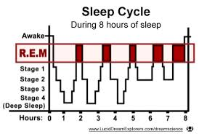
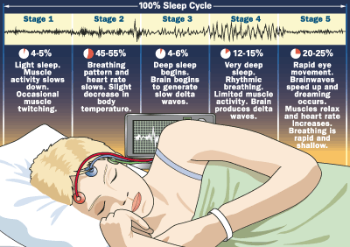

Supporting evidence for the distinct stages of sleep and the role of REM sleep

Dement and Kleitman (1957)
Aim The aim of this laboratory experiment was to investigate the relationship between eye movements and dreaming.
Method The nine participants were seven adult males and two adult females. The participants were studied under controlled laboratory conditions. Participants had to report to the laboratory at bedtime where they were connected to an EEG. The EEG took measurements throughout their time asleep all night. P's were asked not to drink caffeine.
Results The results show that REM sleep is predominantly, though not exclusively, associated with dreaming, and Non-REM sleep is associated with periods of non-dreaming sleep. P's were able to recall dreams when awakened during REM periods. If they were awakened in other stages they were less likely to report dreaming.
Conclusions: From these findings (which are reliable as there has been much replication) It can be said that the stages of sleep follow a typical pattern throughout the night and dreams mostly occur in REM

Dement (1960) compared participants who had been deprived of REM sleep with a control group who had been deprived of the same amount of NREM sleep. He found that the REM deprived group were more irritable, more aggressive and unable to concentrate on various tasks. Borbely (1986) found that REM deprived individuals made 31 attempts to re-enter REM on the first night of deprivation, 51 attempts on the second night and over 60 attempts on the third. This shows that REM is a distinct stage of sleep and important for our psychological well-being.

However, it may be argued that dreaming does occur in the other stages of sleep, it’s just that the participants are unable to report them in these studies. Additionally, there are large variations between individuals, for example, 20 year olds have long sessions of stage 4 sleep, where as people over the age of 80 have virtually none.

- The effect of endogenous pacemakers and exogenous zeitgebers on the sleep/wake cycle.
Endogenous pacemakers refer to our internal body clock which regulate our biological rhythms and exogenous zietgebers refer to aspects of the environment that have the effect of adjusting our biological clocks to fit in with what is happening in the environment.
For example, when we move time zones, for holiday or work, we find it hard to adjust to the new time because our biological clocks tell us we should be sleeping when we are awake, or vice-verser. So our bodies uses the exogenous zietgebers to quickly get our rhythms back in tune with our new environment.
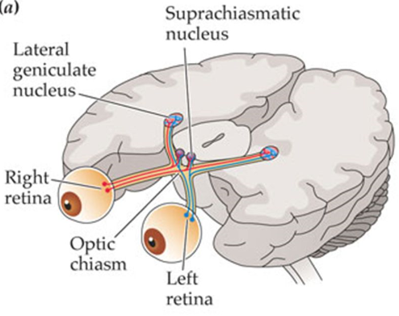
Endogenous pacemakers – The SCN and the pineal gland
The Suprachiasmatic nucleus (SCN) is a timy bundle of nerve cells located in the hypothalamus and is the primary endogenous pacemaker in humans and other mammals. One function is to regulate the sleep/wake cycle. Nerve fibres connected to the retina cross the optic chiasm and into the SCN and tells us when it is day (light) or night (dark). However, any established rhythm will continue in the absence of the exogenous zietgebers for a short time whilst the SCN adjusts to the new time. How the SCN works is not precisely understood, but according to Kalat (1998) the SCN generates its own internal rhythm as a result of protein production. It is likely that what happens is that the cells in the SCN produce a protein for a period of hours until the level inhibits further production, again for hours; next when the protein level drops below the threshold, the SCN starts producing the protein again. The SCN passes information about light and dark to just behind the hypothalamus to a structure called the pineal gland. This secretes melatonin when it gets dark which induces sleep. This does not occur during times of wakefulness.
Evidence: Morgan (1995) removed and transplanted the SCNs from hamsters and shows support the importance of the SCN as an endogenous pacemaker. When the SCN was removed from hamsters their nocturnal circadian rhythms disappeared. Transplanting with SCN cells re-established the rhythms. Furthermore, when hamsters with nocturnal patterns of activity (usual) had their SCNs replaced with SCNs from mutated hamsters which slept through the night and were active during the day (unusual), the hamsters followed the new daytime activities of the donor’s patterns. Further evidence from lesioning (cutting) the SCN in rats showed a complete disruption to the animals sleep/wake cycle.
Exogenous Zeitgebers – Light and Social Cues
Light is a key zeitgeber in humans. It a process known as entrainment, it can reset the main endogenous pacemaker, the SCN. Hormone secretion and blood flow are also influenced indirectly by light. Research has shown that light not necessarily be detected by the eyes to have an influence, as researchers were able to change some participants’ sleep/wake cycle by up to three hours by waking 15 participants and shining a light pad on the back of their knees (Campbell and Murphy, 1998). In studies where participants are placed in isolation, their sleep wake cycle can change a little. Michel Siffre is a classic example, and this case study has been replicated with similar results.
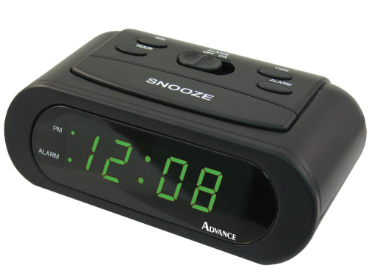
Social cues can also have an effect on the sleep/wake cycle. For example, mealtimes, work times, use of social media, and external noise levels may play an active role on changing people’s sleep/wake cycle. For example, Folkard et al (1985) investigated the effect of manipulating exogenous zeitgebers on the sleep-wake cycle. The researchers placed 12 participants in temporal isolation (isolated to only the time cues within their environment and not external time cues) for 3 weeks. The environment was a cave with no external light and a single large clock that the researchers were able to control. The participants agreed to go to bed when the clock showed 11:45PM and get up at 7:45AM. Initially the researchers set the clock to run at a normal 24 hour cycles, however they gradually increased its speed so that eventually a day passed of the participants synchronized their sleep-wake cycles to the pace of the clock. This shows that the sleep-wake cycle can be influenced by exogenous zeitgebers, at least gradually. Additionally, Luce and Segall (1966) showed how social cues as zeitgebers have an important role in circadian rhythms. In the Arctic Circle people still maintain a constant sleep pattern of 7 hours a night, despite having 6 months of darkness in the winter and light in the summer. In these conditions, knowing it is either day or night time (by looking at a clock), even in the absence of proper light conditions, is likely to help the rhythm to be maintained and fit in the outside world, supporting the view that social cues are important in sleep wake cycles also. In further evidence, Kelly et al (1999). studied submariners whose work schedule consisted of 6 hours on duty followed by 12 hours off duty, thus producing an 18-hour day. In spite of this schedule and their ability to control their own lighting conditions, the submariners had an average circadian rhythm for melatonin lasting just over 24 hours. It was concluded that this was because they had social contacts with people living on a 24-hour schedule, and unlike Siffre they were aware of clock time
Conclusion: It appears that both exogenous zeitgebers and endogenous pacemakers usually work together to regulate our 24 hour sleep wake cycle. We know that the SCN is a main endogenous pacemaker, and will keep a sleep wake cycle regulated in the absence of light, although it is unlikely to stick to a rigid 24 hours. There are ethical concerns about such research, as the invasive surgery on animals may be seen as unfair by critics of animal research, although such research maybe vital for helping people with sleep disorders.

