[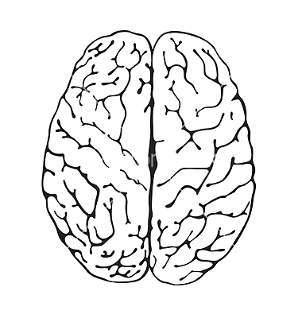](https://www.google.co.uk/url?sa=i&rct=j&q=&esrc=s&source=images&cd=&cad=rja&uact=8&ved=0ahUKEwjmi6SS67bNAhUcOsAKHS1nBiQQjRwIBw&url=https://www.vectorstock.com/royalty-free-vector/brain-a-top-view-vector-875168&bvm=bv.124817099,d.ZGg&psig=AFQjCNEgix3lnHBizyaYF5Y1v7QCbqxNYA&ust=1466520068388549)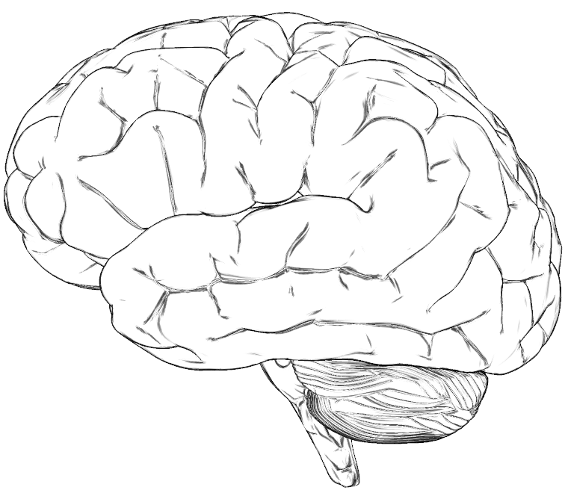

[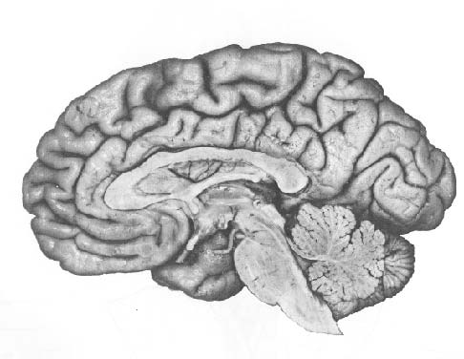](http://www.google.co.uk/url?sa=i&rct=j&q=&esrc=s&source=images&cd=&cad=rja&uact=8&ved=2ahUKEwihnoymn4zaAhWBvhQKHcNWD2sQjRx6BAgAEAU&url=http://www.ruf.rice.edu/~lngbrain/cglidden/brainpicts.html&psig=AOvVaw2Pv1Sj9ASg2ynXTjatz9kx&ust=1522231137354917)