Choosing statistical tests-revision
Question five
A psychologist is investigating the effect of depression on general health. He collects data on how many colds a sample of people diagnosed with depression caught in one winter, and the number of colds a group of people who did not show symptoms of depression caught in the same winter.

What statistical test should the researcher use? Justify your answer (4 marks)

Question six
A researcher wants to know if IQ is related to age in years.

What statistical test should the researcher use? Justify your answer (4 marks)

Question seven
A scientist wanted to know whether rats performed better in a memory test when they were tested in low light conditions than when they were tested in high light conditions. He tested 8 rats, each under both low and high light conditions.
What statistical test should the researcher use? Justify your answer (4 marks)

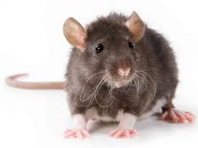

Question eight
A psychologist was investigating how the temperature of a room influences people’s reaction times. She collected the data shown in the table.
Participant | Temperature in room (Celsius) | Reaction time (seconds)  What statistical test should the researcher use? Justify your answer (4 marks)
1 | 32 | 5.26
2 | 38 | 3.47
3 | 20 | 8.53
4 | 18 | 9.45
5 | 25 | 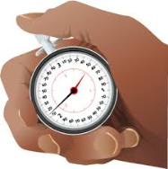  6.12

Answers

Question 5-unrelated t-test because unrelated data (colds in winter with depression compared to colds with no depression) but looking for a difference between these two groups and interval data (number of colds)
Question 6-Spearmans rho- test of correlation (link between IQ and age), IQ is at least ordinal.
Qu7-Wilcoxon
Difference, ordinal (memory test), repeated measures
Qu8-Pearson’s r
Correlation, interval, related data

