Cognitive flip

Activity one- Fill in the gaps
Assumptions
- Behaviour can be largely explained through ________ _________ processes i.e. the information processing approach
- The mind works in a way similar to a ________: inputting, storing and _________ data.
- Mediational processes occur between stimulus and response.
- Cognitive psychology is a pure________, based mainly on laboratory experiments.
Activity two- Inference
Write a definition of inference here

So if cognitive psychologists have completed experiments that show that people took longer to do a problem solving test when words were shown in bold than in itallics.
What can they infer from this?

Activity three- Schema
Read the following article below, watch the clip on the website and read your pack to answer the questions below.
Children rely on schemas to make sense of the world around them read the following information and watch
Does your child love to fill handbags, tins or pots with tiny things they have found? Are they obsessed with wheels, roundabouts or rolling things? Did you know these patterns of play are examples of schemas, behaviours that children go through when they are exploring the world and trying to find out how things work?
Each episode of of Twirlywoos is based around one of these 'schemas'.
From birth children have particular patterns of behaviour – like sucking and grasping schemas in babies – and as children grow these schemas increase in number and complexity.
Researchers believe there are a number of different schemas; vertical (going up and down), enclosure (putting things inside other things), circular (going round and round), going over and under, going through. Others have identified other patterns that have dominated children’s play such as ‘connecting’.
By going through these schemas, young children are equipping themselves with the knowledge and skills that lay the foundations for almost everything we do in later life, from writing to driving a car.
1. What is a schema?

2. Why are schema’s useful?

3. There are many different types of schema’s such as mentioned above in children but as we mature we develop different schema’s such as self schema’s and social schema’s. Find out what these are and how they help us make sense of the world
Self schema-

Social schema-
. Watch the clip on the website or follow this link and below explain how schemas can help to develop children’s skills in other areas. https://www.youtube.com/watch?v=xSW58hQDqw0

5. How can schema’s be problematic?
Example of a theory from Paper 3: Gender Schema theory
Read the Example of Gender Schema theory from your pack and explain this Cognitive explanation of Gender Identity below

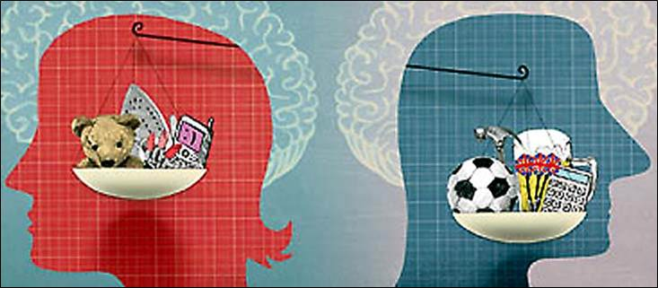

Activity four- Theoretical and Computer Models
Theoretical models are descriptive versions of how some aspect of human behaviour works, which may be represented visually. Think back to memory, can you draw below two theoretical models of how memory works (look in the pack if you need to, to give you a hint).

Computer Models
The cognitive approach says the mind is like a computer suggesting similarities to the way a computer processes in formation.
Computer models use the following concepts
1. _________________________
2._________________________
3. ___________________________
Such models have been useful in developing Artificial intelligence. What is this? Have a google and find out and write below.

Cognitive Neuroscience
Define Cognitive Neuroscience

Identify two scanning techniques that are used in methods of cognitive neuroscience

Examples of Cognitive Neuroscience (from pack)
Memory

Psychopathology

Evaluation- Use the pack page “Evaluating the Cognitive Approach”
Are human beings like computers?- What do you think?
Although there are similarities between the human mind and operations of a computer why do you think some psychologists criticise this way of studying behaviour?
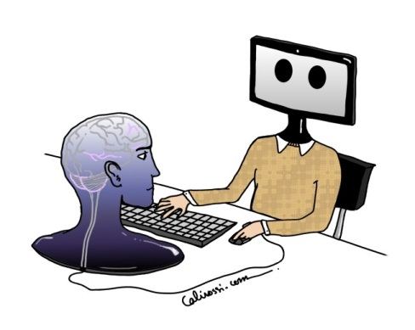
(Think back to what we know can affect our memory)

Inference
What could be the problem with inference? If Psychologists are making inferences about observations what could go wrong?

Cognitive Research Has High Internal but Lacks External Validity

What is Internal Validity?

Why does research from the Cognitive Approach have high internal validity? (Scientific)

So what?

What is External Validity?

Why does Cognitive research lack External Validity

So What?

