Prep 3: The Cognitive Approach

Task 1: Recapping Assumptions

You have already learnt the assumptions of the cognitive approach so test yourself with this fill in the gaps:

- Behaviour can be largely explained through ________ _________ processes i.e. the information processing approach
- The mind works in a way similar to a ________: inputting, storing and _________ data.
- Mediational processes occur between stimulus and response.
- Cognitive psychology is a pure________, based mainly on laboratory experiments.
Task 2: Key concepts from the cognitive approach
Read about these key concepts in the pack then complete the tasks/answer the questions below.
- Inference
Write a definition of inference in your own words.

So, if cognitive psychologists have completed experiments that show that people took longer to do a problem solving test when words were shown in bold compared to when they were shown in italics.
What can they infer from this?

- Schema
In addition to the pack, read the article below and watch the clip on the website to answer the questions below.
“Does your child love to fill handbags, tins or pots with tiny things they have found? Are they obsessed with wheels, roundabouts or rolling things? Did you know these patterns of play are examples of schemas, behaviours that children go through when they are exploring the world and trying to find out how things work?
Each episode of Twirlywoos is based around one of these 'schemas'.
From birth children have particular patterns of behaviour – like sucking and grasping schemas in babies – and as children grow these schemas increase in number and complexity.
Researchers believe there are a number of different schemas; vertical (going up and down), enclosure (putting things inside other things), circular (going round and round), going over and under, going through. Others have identified other patterns that have dominated children’s play such as ‘connecting’.
By going through these schemas, young children are equipping themselves with the knowledge and skills that lay the foundations for almost everything we do in later life, from writing to driving a car.”
- What is a schema?

- How are schemas useful?

- There are many different types of schemas such as the ones mentioned above but as we mature we develop different schemas such as self schemas and social schemas. Find out what these are and how they help us make sense of the world
Self schema-

Social schema-

- How can schemas be problematic?

- Read the example of Gender Schema theory in the pack (you will learn more about this in the Gender topic).
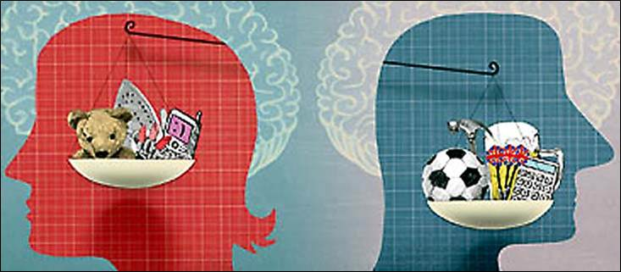

Task 3: Theoretical and Computer Models
Theoretical models are descriptive versions of how some aspect of human behaviour works, which may be represented visually.
Think back to memory, can you draw below two theoretical models of how memory works (look in the pack if you need to, to give you a hint).

Computer Models
Read the information in the pack on ‘computer models’ and ‘machine reductionism’ then answer the questions below.
  - What is a computer model?

  - Computer models have been useful artificial intelligence (AI) What is this? Do a quick google search on AI and write down what you find below.

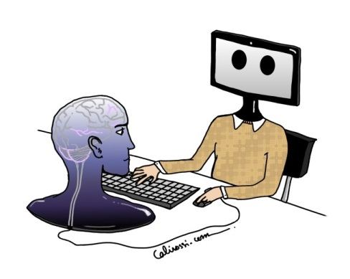
  - What do you think - is the human mind the same as a computer? Do you agree or disagree with the criticisms of computer models (machine reductionism)? Explain your thoughts on this.

Task 4: Cognitive Neuroscience
Read about the emergence of cognitive neuroscience in the pack and answer the questions below.
- What is Cognitive Neuroscience?

- Name two scanning techniques that are used in methods of cognitive neuroscience.

- Briefly describe one research example of cognitive neuroscience.

- Read the article (use the QR code or use link) and make brief notes on how cognitive neuroscience has been applied to the research depression.
This bit is tricky…Push yourself – how has cognitive neuroscience helped in our understanding of freewill? What do Libet studies suggest?
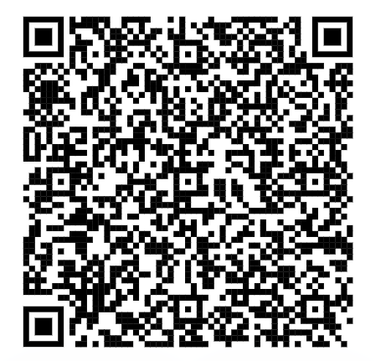
This is an article in psychology review. You do have access to the article but you will need to sign in using your bhasvic username and password.
https://www.hoddereducationmagazines.com/magazine/psychology-review/21/1/the-emergence-of-cognitive-neuroscience/

FYI: if you ever want to do further reading on a topic psychology review magazine is a fantastic resource. Access is via the library sharepoint page.

https://bhasvic.sharepoint.com/sites/bha-libraryhub/SitePages/Sub-Psychology-Subject-Resources.aspx

