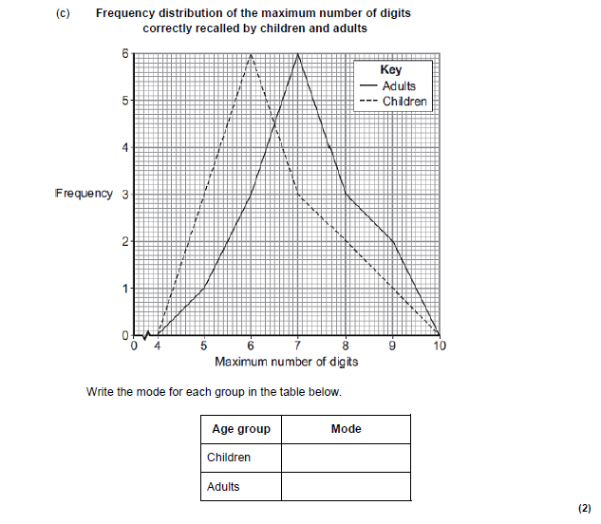
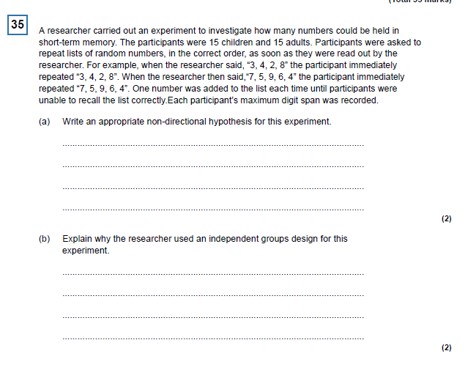
Data Handling Questions

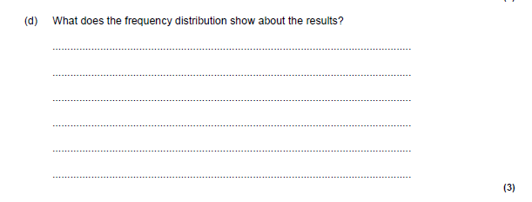
Q8

Read the text below and then answer the questions that follow.

Two researchers obtained a sample of ten people whose ages ranged from 20-years-old to
60-years-old. Each participant was asked to take part in a discussion of social care issues. This included
discussion about who should pay for social care for elderly people and how to deal with people struggling with mental health problems. A confederate of the researchers was given a script to follow in which a series of discussion points was written for the confederate to introduce. Each participant then came into a room individually and the discussion with the confederate took place. The maximum time allowed for a discussion was 30 minutes. The researchers observed the discussions between the confederate and participants and rated the active engagement of the participants in the discussion. The ratings were between 1, (not at all interested) and 20, (extremely interested.) The researchers believed that the rating provided a measurement of the participants’ attitudes towards social care issues. The following data were obtained in the study:

The relationship between age and attitude to social care.
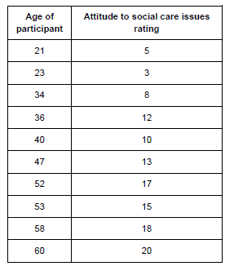

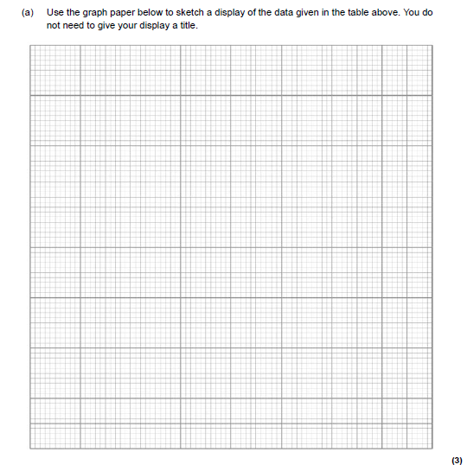
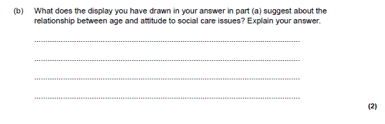

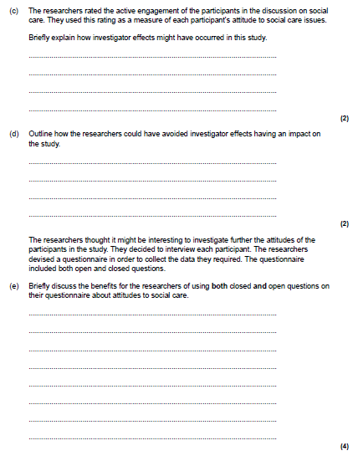

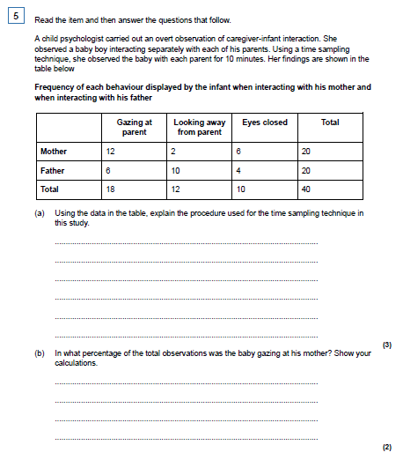
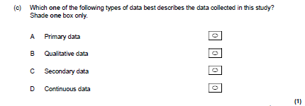

Q7
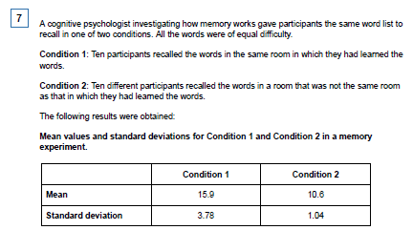
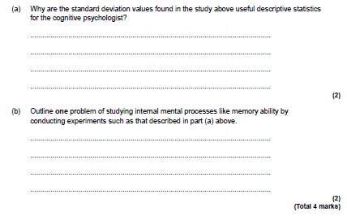

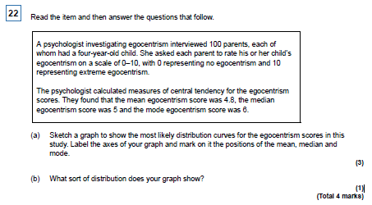
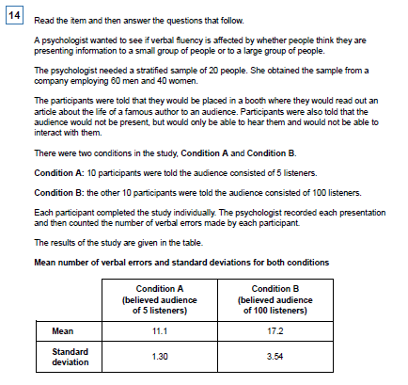
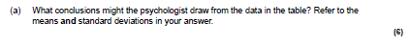

Sign test question
Q1.
A researcher wanted to see whether cognitive behaviour therapy was an effective treatment for depression. Twenty depressed patients who had all recently completed a course of cognitive behaviour therapy were involved in the investigation. From their employment records, the researcher kept a record of the number of absences from work each patient had in the year following their treatment. This was compared with the number of absences from work each patient had in the year prior to their treatment.
Those patients who had fewer absences from work in the year following their treatment than in the year prior to their treatment were classified as ‘improved’ (+). Those patients who had more absences were classified as ‘deteriorated’ (-). Those patients who had the same number of absences were classified as ‘neither’ (0).
The results of the investigation are included in Table below.

 | Patient | Improved | Deteriorated | Neither
 | 1 | +
 | 2 |  |  | 0
 | 3 |  | –
 | 4 | +
 | 5 | +
 | 6 | +
 | 7 |  | –
 | 8 |  | –
 | 9 |  |  | 0
 | 10 | +
 | 11 |  | –
 | 12 | +
 | 13 | +
 | 14 | +
 | 15 | +
 | 16 |  | –
 | 17 | +
 | 18 | +
 | 19 | +
 | 20 |  |  | 0

(4)

(b) Calculate the sign test value of s for the data in Table 1. Explain how you reached your answer.
______________________________________________________________
______________________________________________________________
______________________________________________________________
______________________________________________________________
______________________________________________________________
______________________________________________________________
(2)
Table 2: Critical values for the sign test

 | n | 0.005 (one  tailed)  0.01 (two  tailed) | 0.01 (one  tailed)  0.02 (two  tailed) | 0.025 (one  tailed)  0.05 (two  tailed) | 0.05 (one  tailed)  0.10 (two  tailed)
 | 16 | 2 | 2 | 3 | 4
 | 17 | 2 | 3 | 4 | 4
 | 18 | 3 | 3 | 4 | 5

For significance, the value of the less frequent sign is equal to, or less than, the value of the table.

(c) With reference to the critical values in Table 2, explain whether or not the value of s that you calculated in response to question (b) is significant at the 0.05 level for a two tailed test.
______________________________________________________________
______________________________________________________________
______________________________________________________________
______________________________________________________________
(2)

Mark Schemes
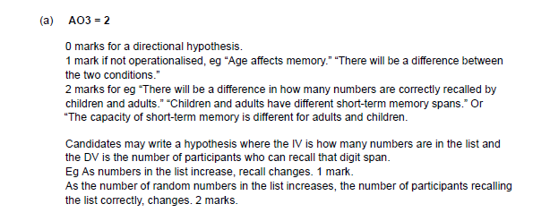
Q35

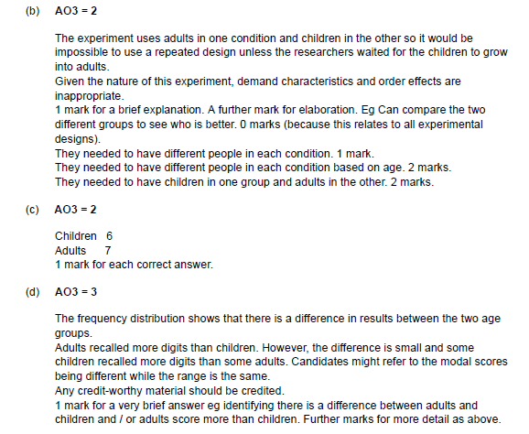

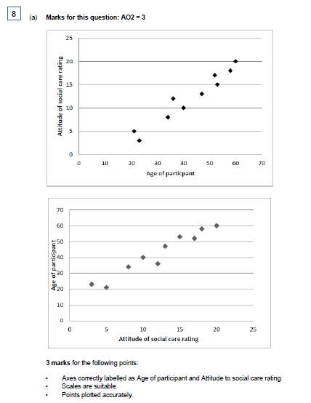

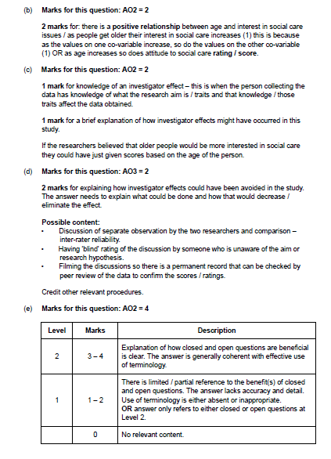

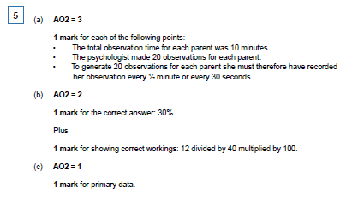
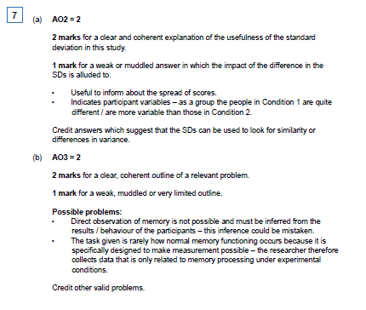

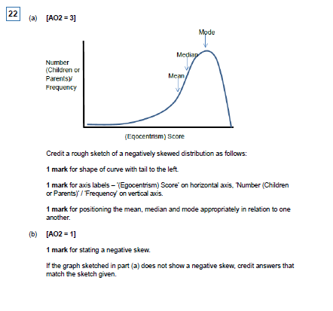
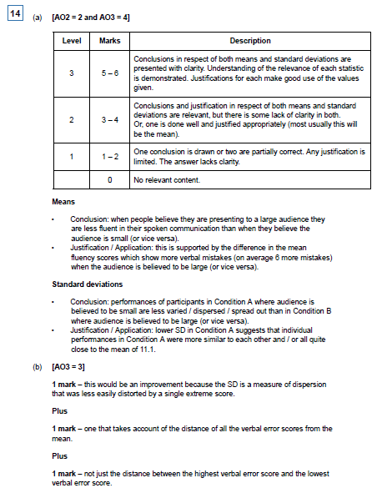

Q1
(b) AO2 = 2
1 mark for identifying the correct value of s as 5
Plus
1 mark for explanation/calculation of how this was arrived at:
• The most commonly occurring sign is + (12) and the least frequently occurring sign is – (5). The 0s are disregarded.
• The total for the least frequently occurring sign is the value of s = 5

(c) AO2 = 2
1 mark for stating that the value of s (5) is not significant at the 0.05 level.
Plus
1 mark for explanation:
• The critical value is 4. As the calculated value is higher than/exceeds the critical value, the result is significant not at the 0.05 level.
Accept alternative wording

