Design a study: Observation

Q16) Read the item and then answer the question that follows.

The psychologist focused on fluency in spoken communication in her study. Other research has investigated sex differences in non-verbal behaviours such as body language and gestures.

Design an observation study to investigate sex differences in non-verbal behaviour of males and females when they are giving a presentation to an audience.

In your answer you should provide details of:
• the task for the participants
• the behavioural categories to be used and how the data will be recorded
• how reliability of the data collection might be established
• ethical issues to be considered.
(12 marks)
Design a study: Experiment
Q48 f) A student teacher noticed that some students on her course commented that they were better able to recall information if they could read the information rather than listen to it in lectures.
.
Design an experiment to test the following hypothesis:

‘People who are given written information will recall more than people who hear information in spoken form.’

In your answer, you should refer to the following and justify your design decisions:

• the variables to be considered

• the experimental design to be used

• the sample

• relevant materials

• an outline of the proposed procedure
(8 marks)
Design a study: Content Analysis
Q41) In an observational study, 100 cars were fitted with video cameras to record the driver’s behaviour. Two psychologists used content analysis to analyse the data from the films. They found that 75% of accidents involved a lack of attention by the driver. The most common distractions were using a hands-free phone or talking to a passenger. Other distractions included looking at the scenery, smoking, eating, personal grooming and trying to reach something within the car.

(a) What is content analysis? (2)

(b) Explain how the psychologists might have carried out content analysis to analyse the film clips of driver behaviour. (4)

(c) Explain how the two psychologists might have assessed the reliability of their content analysis (3)

(Total 9 marks)

Design a Study: Quasi experiment

Q30) Imagine you have been asked to design a study to investigate possible gender differences in card sorting behaviours. You decide you will ask participants to sort a shuffled pack of playing cards into their suits of hearts, clubs, diamonds and spades. You decide you will time the participants as they do this using a stop watch.

Discuss the following aspects of this investigation:

• with reference to the card sorting task, explain how you would ensure that this is made the same task for all participants

• one methodological issue you should take into account when obtaining suitable participants for this study and explain how you would deal with this issue

• how you would ensure that the experience of your participants is ethical.
(Total 9 marks)

Design a study Self report (interview)

Q61) A psychologist wished to investigate which aspects of therapy were most useful. She decided to
interview a sample of the patients. The purpose of the interviews was to encourage patients to talk
freely and in detail about their experiences of therapy. Two of the questions used by the psychologist
were:

● ‘Please tell me about the most important aspects of the therapy which helped you to improve’

And

● ‘Please tell me about any aspects of the therapy which were less helpful to you in dealing with
your symptoms’.

- Would participant responses be in the form of quantitative or qualitative data? (1 mark)

- Explain how you would record the data from these interviews and your reason for choosing this method. (3 marks)

- Explain how you would analyse the qualitative data from the interviews. (5 marks)

(Total 9 marks)

Mark Schemes

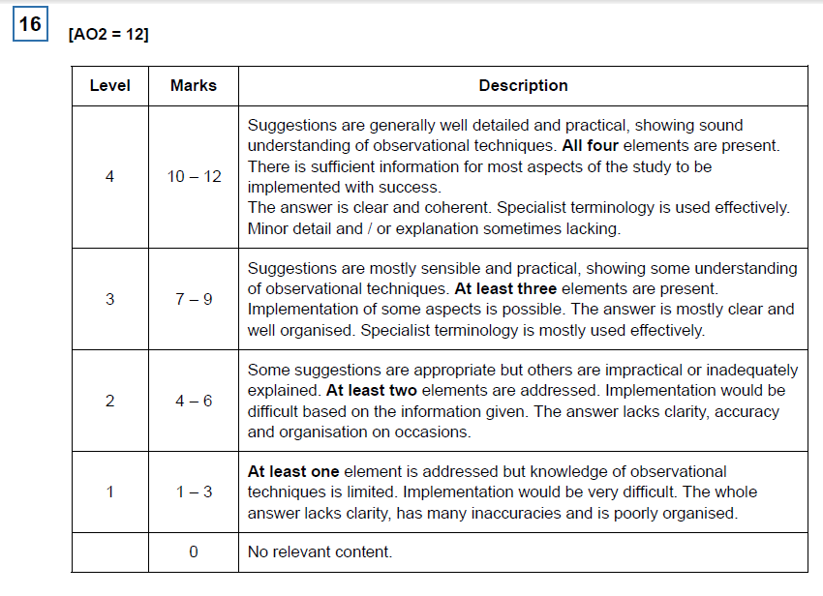

Four elements of design to be credited:

• The task for the participants – detail of what the men and women in the study will
have to do. This must go beyond ‘give a presentation to an audience’.

• The behavioural categories to be used and how the data will be recorded –
detail of specific and observable behaviours to be recorded. This must go beyond the
idea of global constructs such as ‘body language’ or ‘gesture’. Also detail of recording
method to be used, eg record sheet.

• How reliability of the data collection might be established, eg using two
observers / raters and comparing separate recordings; statistical comparison of data
from both observers / raters.

• Ethical issues to be considered, eg specific or more general ethical considerations
as applied to this study – protection of welfare, confidentiality and deception, respect
or integrity.

Examples of possible tasks:
• presentation of findings from a school project
• presentation on ‘My Hobby’
• presentation on ‘My Holiday’.

Examples of suitable non-verbal behaviours include:
• arm movements
• smiling
• speech hesitations
• pointing

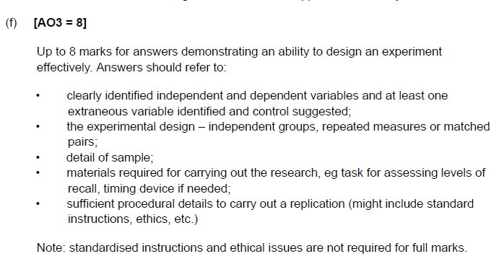
Question 48f

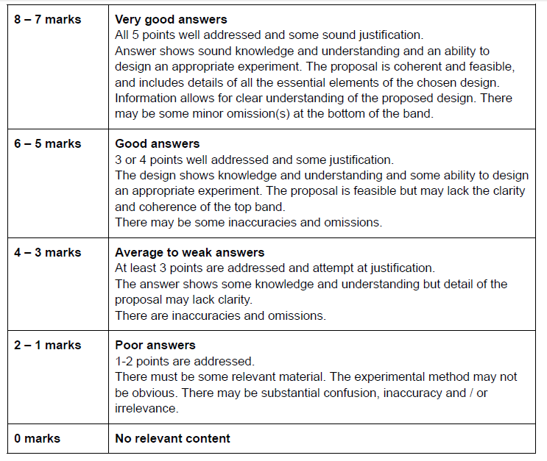

Question 41

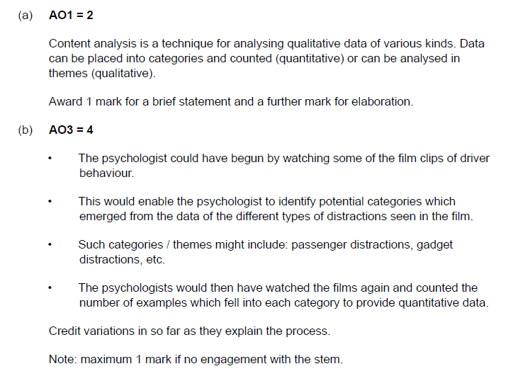
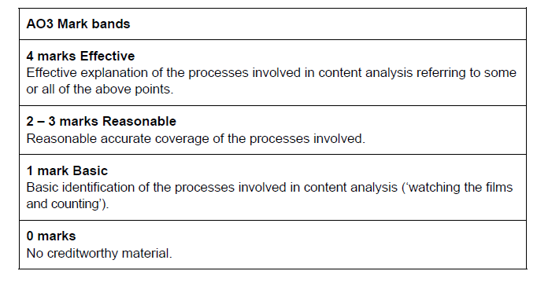
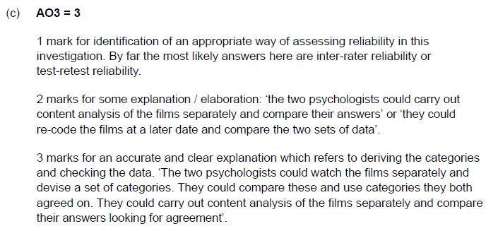

Question 30

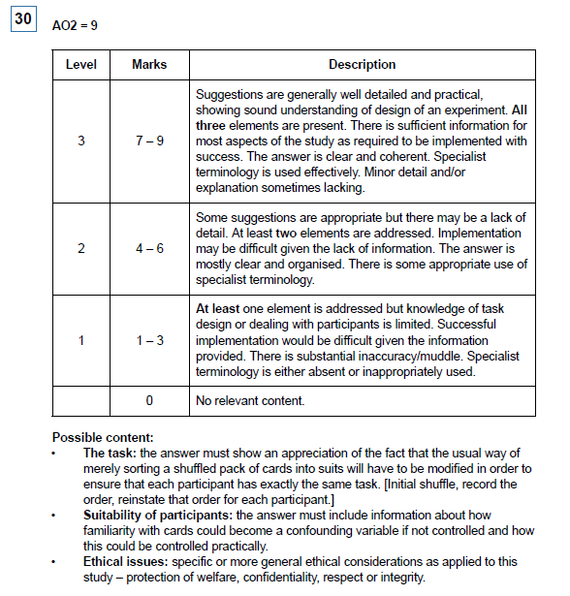

Question 61

- Qualitative data

- Three marks are available for a description of how to collect and record the data from the interviews. Possible methods include:

• Audio recording
• Video recording (filming)
• Making written notes during the interview.

Award one mark for identifying a method, one mark for explaining why the method would be used and a third mark for elaboration of either.
Eg: ‘I would choose to audio record the data using my phone (1 mark). This would be less intrusive than filming the patient (1 mark) so they would be more likely to agree to take part or be honest (1 mark).

- Five marks are awarded for the explanation of how the qualitative data would be analysed. A maximum of one mark should be awarded for identifying one or more appropriate methods and a further four marks for explanation of how the analysis would be carried out.

There are many different methods for analysing qualitative data and examiners should read the material presented carefully.

Two common methods include:

• Content analysis; this method would involve identifying important categories from a sub sample of interview responses (for example references to homework or warmth in the therapist). The researchers would then work through the written data, counting the number of occurrences of each of the categories to produce quantitative data

• Thematic analysis: This method would involve reading and rereading (familiarisation) the written transcripts carefully. Coding would involve looking for words which cropped up repeatedly in transcripts. These could then be combined to reduce the number of codes into three or four themes. The data would stay in qualitative format and would not be reduced to numbers.

