Paper two - Research methods
The extended answers in the research methods section are out of a maximum of 12 marks. They are not essay questions and should not be treated in the same way as the other topics.
You will be asked to design a study using a specific research method for example…experiment, observation, interview, case study, content analysis etc…
You will be given a brief summary of the concept being researched and will have to address a number of bullet points outlining what you would do, how you would do and why you do it in this way. The bullet points should serve as your checklist and form the structure of your answer. Do not include details of the procedure if they have not been requested. You will run out of time
Step 1 – Actively read the stem. Annotating important ‘clues’ that will help you.
Step 2 - Turn the bullet points into subheadings
Step 3 – Explain how and why you will doing what you are doing.
.
TOP TIP - USE THE BULLET POINTS AS SUBHEADINGS.

Here is an example of how to actively read the stem.
Lab experiment
Same p’s do both conditions
Lab experiment

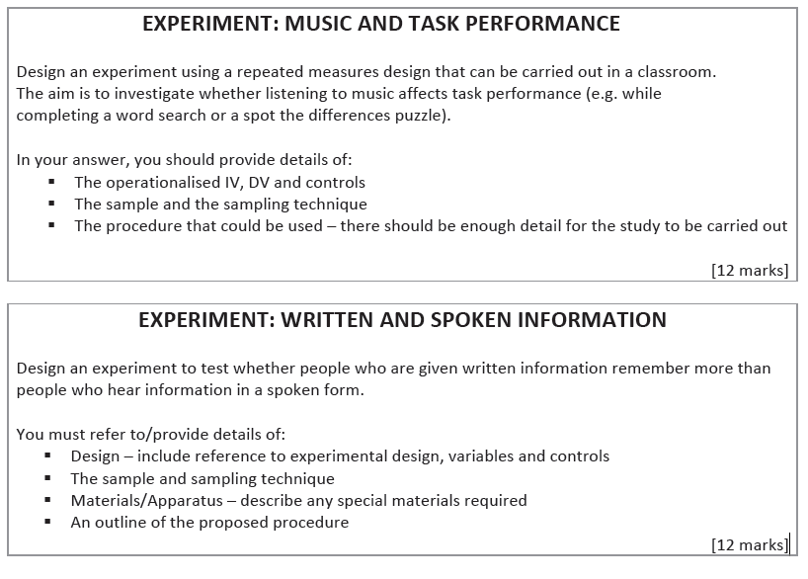
Behaviour? Emotion? cognition?
Performance = Behaviour. So task can be observed in errors made or time taken for P’s to complete a task.

Independent Variable –
Music vs no music.
Dependent variable.
Number of errors or time taken to complete task

After fully annotating the proposed research. Address each bullet point as shown below:

The operationalised IV, DV
The independent variable is whether the participant listened to music (classical music with no lyrics) or not (silent condition) while completing a word search. The dependent variable is the time taken (in seconds) to find five words in a word search puzzle.

Controls
In order to control order effects (e.g. practice effects, which might make the participants complete the second word search faster) counterbalancing will be used: half of the participants will complete the first puzzle listening to music and the second puzzle in silence, and the other half will complete the first puzzle in silence and the second puzzle listening to music. This will be done using random allocation, meaning that any order effects will be balanced across both conditions. Participants will complete both parts of the task wearing noise cancelling headphones to ensure that they are in complete silence for the silent condition, and to ensure that wearing headphones is not a confounding variable. The same piece of classical music will be used for all participants as different pieces of music may affect levels of concentration. Two different word search puzzles with equal difficultly will be used. In order to select the two word search puzzles a range of puzzles will be completed by another group of people. The average time taken to complete the puzzles will be calculated and the two puzzles with the most similar times will be selected.

The Sample and the Sampling technique

A sample of 20 sixth form students will be used for this experiment. They will be selected using a volunteer sampling method. A notice will be placed on the student notice board in a sixth form college asking for volunteers to take part in a psychology experiment to investigate factors that influence concentration. The first 20 participants to respond to the e‐mail address provided will become the sample.

The procedure.

Participants will be invited to a classroom at an allotted time between 9 am and 11 am. Materials used will be two word search puzzles, a pen, an iPod containing the classical music, and a set of headphones. They will be shown into the classroom, seated at a desk and given standardised instructions to read and a consent form to sign. The instructions will outline what will happen during the study: they will be completing two word search puzzles, either while listening music or in silence. When they have completed each puzzle, they should put down their pen to indicate that they have finished. They will then be asked to put on the headphones and adjust to a comfortable volume to suit their hearing. If they are completing the music condition first, then the first puzzle will be given to them and the experimenter will switch on the music and begin timing using a stopwatch. When they put down their pen on the table, the experimenter will stop timing and switch the music off. They will then be given the second puzzle (to be completed in silence) and the experimenter will begin timing them. When they put their pen on the desk the experimenter will stop timing and they will be thanked and debriefed. If they are completing the silent condition first then the tasks will be the other way around.

Snap Plan the following when instructed by your teacher.

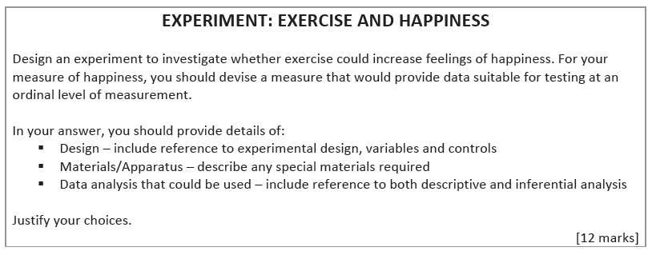

Design
Experimental design – independent groups, repeated measures or matched pairs? State which design you will use and how it will work in practice.

Variables – what is the IV and DV? Remember to fully operationalise both. (As happiness is an emotion what is the only way you can measure this?)

Controls. What extraneous variables could have an effect on happiness? How can you reduce this? How could you control for individual differences?

Materials/apparatus
What are you going to need to measure happiness. Give an example. How are you going to ensure ‘exercise’ is standardised – what apparatus might you need?

Data analysis
Descriptive Stats. What measure of Central tendency will you use and why? Mean, Media or Mode? What graph will you use to display data and why?
Inferential stats (year 2 only) Which test would be appropriate – (level of measurement, related/unrelated data/ and test of diff or relationship?)
Design
Experimental design – independent groups, repeated measures or matched pairs? State which design you will use and how it will work in practice. (think carefully about order effects – some design’s might not be suitable)

Variables – what is the IV and DV? Remember to fully operationalise both. (how will you score what they remember – what task could you set them?

Controls. How long will you give the groups to read/listen to the story? How will you ensure the story is experienced in the same way for both conditions (other than the IV). How can you overcome individual diffrerences?

Sample and sampling technique. How many Participants realistically will you get, who are they? How ill you sleect them? (bear in mind you are a sixth form student.

Materials/ apparatus What formats do you need the story in? How many words will it be? Apparatus for time and why needed? Materials for assessing recall?

Outline of the procedure Describe what will happen in a step by step outline. P’s will be given…. Then they will….
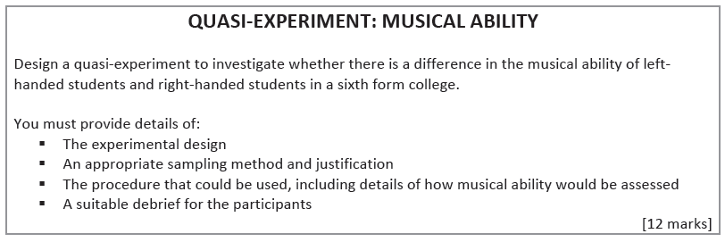
Experimental Design – Make your choice carefully. This is a QUASI experiment.

Sample and sampling technique (Describe how you would do it and fully justify why this technique – perhaps do this by saying why other techniques would not be suitable for gaining the right number of left and right handers)

Procedure. Including how musical ability would be assessed what task will you get P’s to do? And how will their performance be scored? Bear in mind that your P’s will have varying levels of experience.

A suitable debrief. You actually need to write what you would say/ give to the participants. You should - thank them, state the aim, remind them of their rights. Refer to DRIPP.
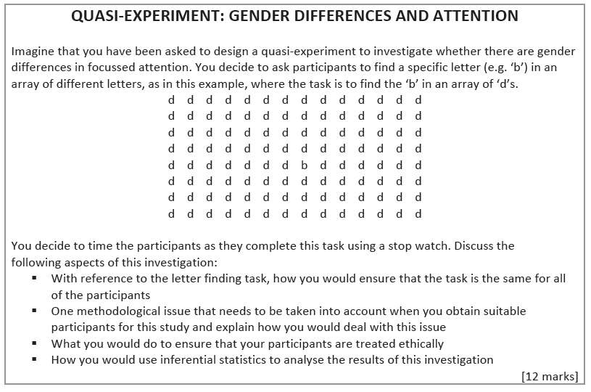
Standardising the task for all P’s – how can you ensure the instructions are always the same for each P? How would you check whether people understood the instructions? Are there other extraneous variables that might affect the difficulty of the task?

One methodological issue when sampling Participants – Why might some people be very good at this sort of task? How could you identify them? And what would you do about them?

Ethical considerations Which aspects of DRIPP will you consider and how you deal with these issues?

Descriptive stats (if year 1) / Inferential Statistics (if year 2)
Year 1 - Descriptive – Which measure of central tendency would you use and why?
Year 2 - Inferential test – Which test would be appropriate – (level of measurement, related/unrelated data/ and test of diff or relationship?)
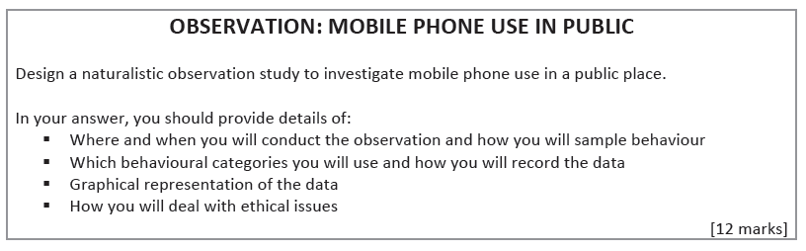

Where and when you will conduct the observation and how will you sample behaviour? - will you be overt/covert, participant/non-participant, at what times will you observe from and to? Which public place will you go to? Event or time sampling?

Behavioural categories and how will data be recorded - State 3 specific behaviours you will look for, what materials will you need to record the behaviours – Draw an example of the sheet you would use. How will it work in practice – ref event/time sampling.

Graphical representation What kind of data have you collected? Which graph is the only suitable type? Sketch it.

Ethical issues Which DRIPP issues should you consider and how will you deal with them? Bear in mind that it is a public space and therefore certain issues are not necessarily a problem.
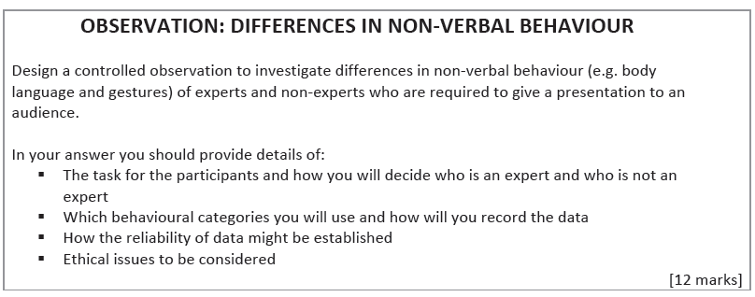
The task for the participants and how you will decide who is an expert and who is not an expert? What will the presentation be on? How long will it be? How will you ensure the presentation is the same for each participant? Who will the experts be and non-experts be? (Experts should be familiar with the content in the presentation – remember you are a sixth form student!)

Ethical issues Which DRIPP issues should you consider and how will you deal with them?

Behavioural categories and how will data be recorded - State 3 specific behaviours you will look for, what materials will you need to record the behaviours – Draw an example of the sheet you would use. How will it work in practice – ref event/time sampling.

How reliability will be established (year 2 Research methods) Outline how inter-observer reliability assessed. What would the 2 observers do? How would you find out how related the two observers scores are – what are you looking for?

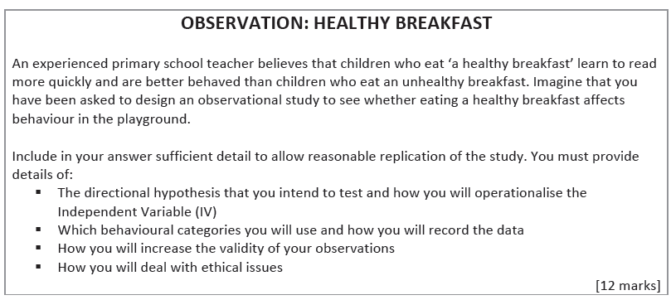
How will you increase validity of your observations? Year 2 only - As above – how will you ensure observers know which child at which type of breakfast?.... but this might lead to bias so how could you use a double-blind?
Behavioural categories and how will data be recorded - State 3 specific behaviours you will look for perhaps easier to focus on the bad behaviours e.g. hitting, what materials will you need to record the behaviours – Draw an example of the sheet you would use. How will it work in practice ref time/event sampling? How will observers know which children have had which breakfast ?

Directional Hypothesis (state both conditions of the IV and the impact this will have on the DV (think what better behaved actually looks like – what examples of ‘good’ behaviour might you see vs ‘bad’ behaviour.
Children who eat a healthy breakfast will…
Operationalising the IV What constitutes a healthy breakfast, give examples of healthy and non-healthy.

Ethical issues Which DRIPP issues should you consider and how will you deal with them?
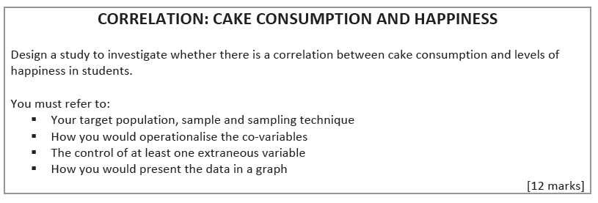
How would you present data in a graph - What is the only type of graph you can use when you have co-variables? Sketch what it would look like. What are you looking for if there is a relationship between cake and happiness?
Controlling extraneous variables What individual differences might be a factor e.g. gender, or subjects studied how will you deal with this? How could you reduce the chances of students guessing the aims of your research at the stage of collecting your data?
Operationalising the co-variables
How will you score levels of happiness? How will you measure cake consumption? How will you gather the information for these two co-variables.
Target population, Sample and sampling technique Who is your target population? How old age? How many people do you want? Do you want all girls/boys? Do you want students from the same subjects or a variety? You are a sixth form student bear all of the above in mind when choosing a suitable sampling method and describe how will it work in practice?

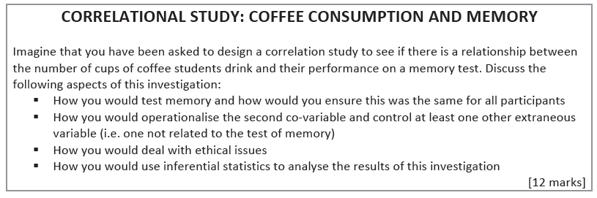

How would you use inferential statistics (second year) Which test would be appropriate – (level of measurement, related/unrelated data/ and test of diff or relationship?)
Ethical Issues Which issues of DRIPP will you need to consider and how will you deal with them? (don’t discuss all of them)
How would you operationalise the second co-variable state the second co-variable? What period of time will you ask about with regards to coffee drunk?

How would you control another extraneous variable – other than coffee - What other factors might affect concentration? How can you control for this?
How would you test memory ? What memory task could you set (think to memory topic – word lists), how long would they have to learn the words, what distractor task would you use, how would you assess performance?

How would you standardise it for all P’s? What needs to be kept the same for all P’s, how will you ensure the instructions are the same for all P’s?

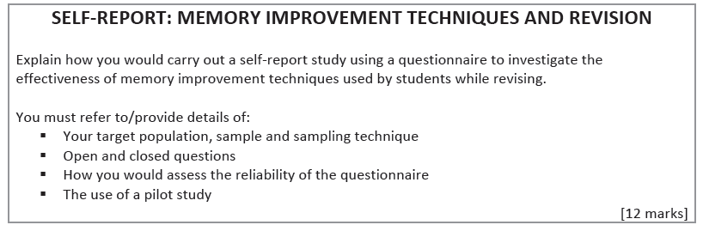
The use of a pilot study How many people would you test out your pilot questionnaire on? How could you find out if your p’s understood the questions? What could you do based on what your test p’s say? Perhaps give an example of potential problem that you could correct. e.g. confusing academic terminology.
How you would assess the reliability of the questionnaire – How would the test-re-test method work in practice and what would this allow you to see?
Open Questions and Closed Questions. Why might closed questions be more likely to be answered than open Q’s? What will this do to your response rate? Why might the data be more useful to you? Give at least 2 examples of closed Q’s – don’t just do yes/no.
Target population, Sample and Sampling technique Who specifically are you targeting (Age)? Realistic Size of sample bear in mind it is a questionnaire, You are a student your P’s are students which method is most appropriate and how will you actually do it?

