Design:

A repeated measures design should be used. Mood is so variable between people that such participant variable must be removed to infer cause and effect. The IV would be the office environment without plants and then without plants, whilst the DV would be operationalised as participants rating from 1-10 on the question “In general, how happy have you been at work this week?” 1 would indicate very unhappy whilst 10 would indicate very happy. This would create data at an ordinal level A number of environmental controls would include keeping the office temperature comfortable and constant over the duration of the study, and controlling any noise pollution that may occur. If these differ across the conditions, they may cause changes in mood, and cause and effect cannot be inferred.

Materials/Apparatus:

Participants would receive a consent form to sign, indicating their rights in the study. They would then be presented with a question sheet asking “In general, how happy have you been at work this week?” With a scale between 1 to 10. On the scale, there would be indications about what the marks mean, for example, 1 = very unhappy, 5 = neither happy nor unhappy, 10 = very happy. This simple measurement will produce ordinal data, and is straight forward for the participants to understand. The plants should be pleasant but understated, as to not be obvious to the study or over bearing in the working environment.

Data Analysis:

In relation to descriptive statistics, the median and range of participants’ mood rating is appropriate due to the data being ordinal. Each of the medians from the ‘before plants’ and ‘after plants’ conditions could be displayed in a bar chart, with the higher median score indicating in which condition participants felt happier. The range would indicate the extent of the variation in mood scores in each condition, useful to gauge whether some individuals were affected more than others by the plants. In relation to inferential statistics, the experimenter would choose a Wilcoxon test. This is because the data can be treated as ordinal, is a repeated measures design and is a test of difference. There is no indication of whether this is a replication, so the critical value would be chosen as 2-tailed with a p ≤ 0.05.

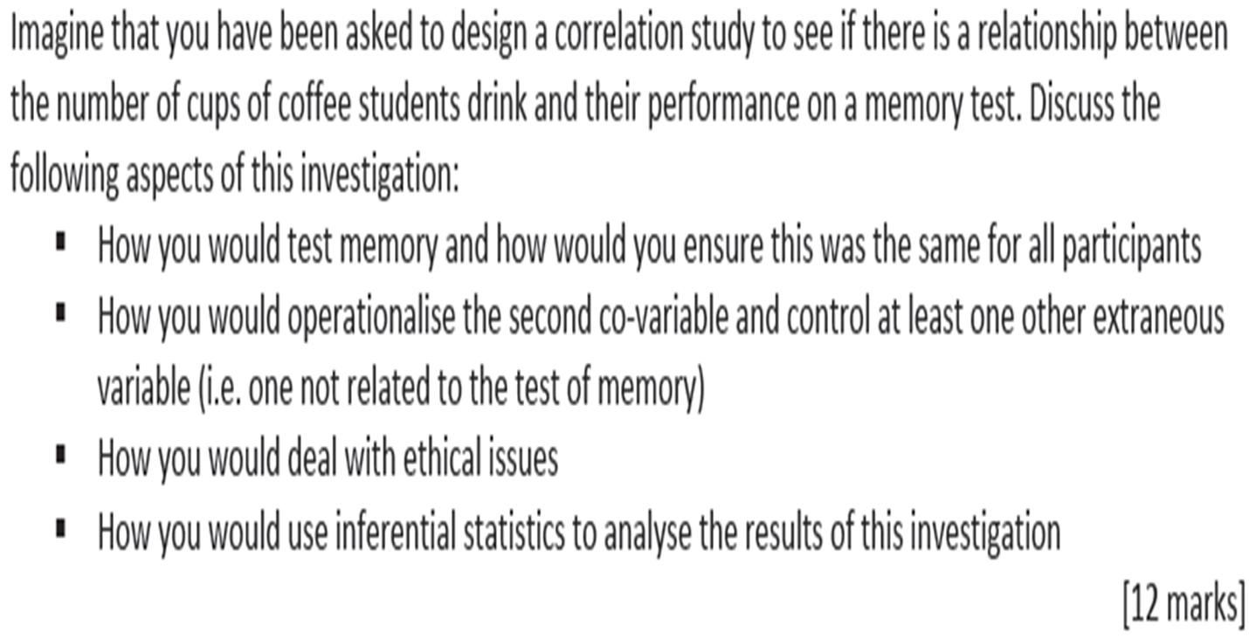

How you would test memory and ensure this was the same for all participants

How you would operationalise the second co-variable and control at least one other extraneous variable

How you would use inferential statistics to analyse the results of this investigation
How you would deal with ethical issues

