Recap prep: Ethical issues in Psychology
Use pages the Research methods pack plus the links.
Task one-Quick quiz (use pack and the QR code link which takes you to the full version of the ethical guidelines)

1. What does BPS stand for?

3. What is the BPS code of ethics and why is it used?

4. What is an ethical issue?

Fill in the table below
Ethical Issue | Describe | How do psychologist deal with this issue
Deception
Right to withdraw
Informed consent |  | (Must include all ways of getting consent)
Protection from harm
Privacy

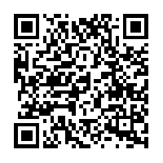
Task two-Why is it important to have ethical guidelines- a case from history.
Click on the link, read the article and summarise why we should be careful with our participants
Harvard's Experiment on the Unabomber, Class of '62

Task three-consent forms

In order to carry out a piece of Psychological research you need to produce and get all participants to sign an informed consent form. When you carry out your research you will need to do this. You need to search on line for examples of informed consent forms, choose one and either print off and bring to lesson or draw it out below.

