The endocrine system: Fight or flight
Instructions: Click on the link to watch a brief video about Flight or Flight https://www.youtube.com/watch?v=uxweRCXaLVAlight
Then attempt to fill out the gapped work sheet below using the appropriate word to answer this 6 mark exam question.
Outline the key processes involved with the fight or flight response, make reference to the role of adrenaline in your answer (6 marks)
Core knowledge 1: up for the fight (or flight)
A person will change from their normal resting state (the parasympathetic state) to the physiologically aroused ___________________ state when faced with a perceived ____________. This causes the __________________ ___________ to release ___________________________________________ ______________ (ACTH). This has the effect on the cells of the _____________________ _______________ causing them to release ___________________________. This triggers physiological changes in the body which creates the physiological arousal necessary for the _______________________ or _________________________ response
adrenaline threat sympathetic adrenocorticotrophic hormone
adrenal gland fight pituitary gland flight

Core knowledge 2: what biological changes occur due to increased adrenaline?
The physiological changes initiated by the secretion of adrenalin include increased heart rate, increased breathing rate, dilated pupils, inhibits digestion and inhibits saliva production
Q) feeling anxious? This often leads to the sensation of butterflies in the stomach, can you guess using a physiological reason why these may occur?

Core knowledge 3: - calming down again
Once the threat has passed, the parasympathetic nervous system is activated to ________ the person down and return them to a ______________ _________. __________________ is no longer secreted from the ________________ _________. Heart and breathing rates return to normal, and the person establishes _____________________. The parasympathetic nervous system works in ___________________ to the sympathetic nervous system and act like a _________ so we do not use up all our vital resources by staying in a constant state of heightened physiological arousal
adrenal gland calm homeostasis adrenaline
resting state brake opposition

TASK 2: Label the diagram using the words and phrases below
threat heart rate increases to pump blood to vital organs pituitary gland
Releases adrenocorticotrophic hormone (ACTH) Lungs to increase breathing rate for more oxygen
Detected by cells in the adrenal glands (adrenal medulla) adrenaline
pupils dilate for increased vision detected by sensors (eye) and passed to…
stomach to divert blood to the muscles to increase strength

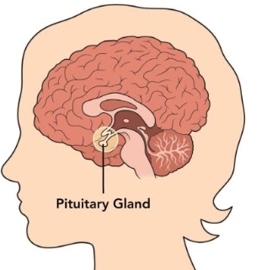
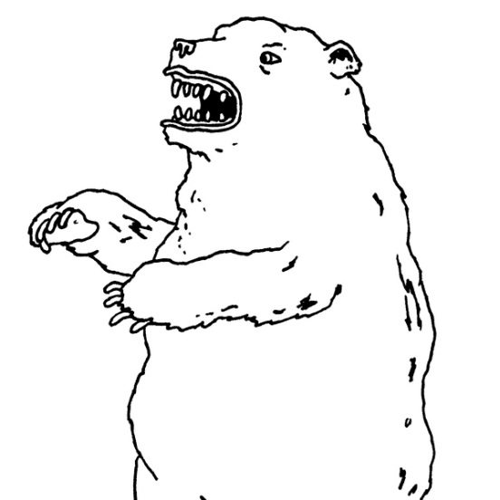

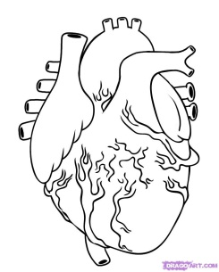

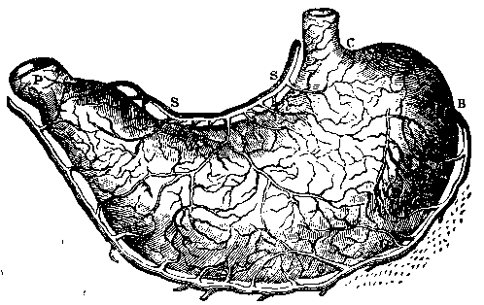

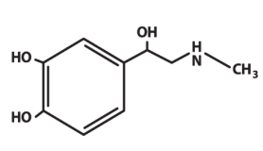

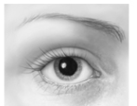
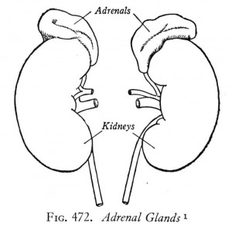
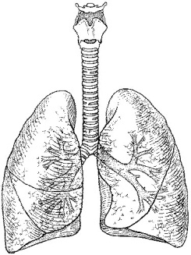

Don’t forget the parasympathetic response: After a few minutes, the parasympathetic branch of the ANS is activated, and the body returns to normal by establishing homeostasis. Heart rate and respiratory rates decrease, adrenaline secretion slows down, the feeling of butterflies subside and sweating stops.

