Unit 1: Memory

Homework for lesson 1: Use the memory information pack on psych205.
TASK 1: Glossary: Define these terms (use info above)
The Multi-store model of memory | The Multi-Store Model of memory
 | Sensory memory
 | Short-term memory
 | Long-term memory
 | Maintenance rehearsal
 | Unitary store
 | Linear model
The Working memory model | The working memory model
 | The central executive
 | Phonological store
 | Articulatory loop
 | Visual-Spatial Sketch pad
 | Episodic buffer
Types of LTM | Procedural memory
 | Episodic memory
 | Semantic Memory
TASK 2: Draw the multi-store model in the space below, and add detail to the model in the table below that. Then add further information as advised
Atkinson and Shiffrin (1968) The Multi-store model

The Nature of memory: fill in the table below
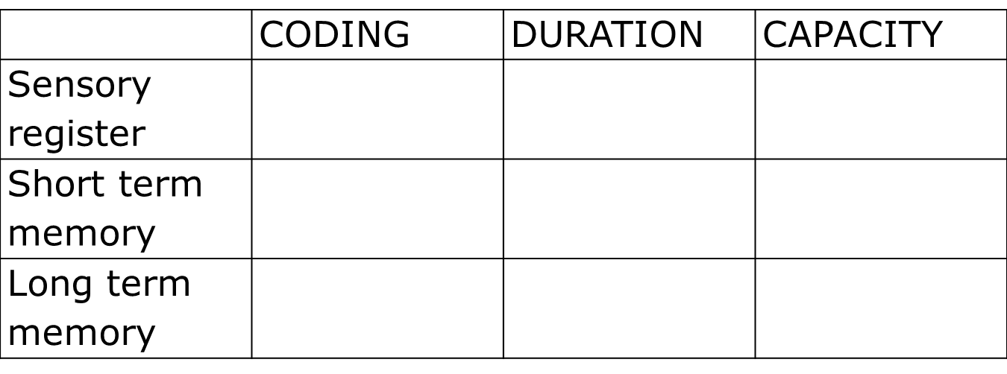
This is a linear model, this means that …
____________________________________________________________________________________________________________________________________________________________________________________________________________________________________________________
Each store is a unitary store, this means that…
____________________________________________________________________________________________________________________________________________________________________________________________________________________________________________________

Task 3: The working memory model
- Watch this video link and draw an annotated diagram of the Working Memory Model with information on each component of the model.
https://www.youtube.com/watch?v=IRBcKm0qJKE
NB-> Watch the whole video (so you are aware of the strengths and weaknesses of the WMM)- you do not have to make notes on the evaluation points.
- Using this website, make more detailed notes on the role and function of each store (central executive, visual spatial sketchpad, phonological loop and the episodic buffer):
- http://www.simplypsychology.org/working%20memory.html

Baddeley and Hitch (1974) the ‘working model of memory’

The Central Executive

The Phonological loop a) the phonological store

The phonological loop b) the articulatory process

The visual-spatial sketchpad

The episodic buffer

Which are the slave systems?
Do these slave systems have a limited capacity?

TASK 4: Types of long term memory: Using the information about the types of long term memory, answer the questions below.

Q1) What did Tulving (1972) suggest that episodic memory referred to?

Q2) Give three examples of your episodic memory

Q3) What are the three Ws which link to episodic memory?

Q4) Linked to our future, what does episodic memory allow us to do?

Q5) Episodic memories are not exact replications, what are they prone to? Give examples.

Q6) What is meant by semantic memory and give examples of your semantic memory

Q7) Does semantic memory have a lot of information? Can we add to it?

Q8) How does procedural memory differ from the other two types of LTM?

Q9) What is meant by procedural memory and give examples of your procedural memory

Q10) How does one acquire procedural memories?

Q11) give an example of a challenging task that becomes part of our procedural memory with practice.

Extension TASK 5: “Snap plan” this question.
What are the main differences between the notion of STM as described by the multi-store model of memory, and working memory, as proposed by Baddeley and Hitch (1974) ( 6 marks)
Advice: Try and give three differences, using linking words such as whereas, and however.

