Forensic flipped homework 2: Explanations of offending behaviour

Biological explanations | Psychological explanations
- An historical approach (atavistic form);  - Genetics and Neural explanations | - Eysenck’s theory of the criminal personality;  - Cognitive explanations (levels of moral reasoning & cognitive distortions);  - Differential association theory, Psychodynamic explanations

Task 1: Biological explanation 1 - The atavistic form

Read about the Atavistic form in the pack and complete the following activities:

a) Draw a picture of a ‘Lombroso’ criminal and label the key features he outlined as the ‘Atavistic form’

b) Give two advantages and two disadvantages of Lombroso’s research.

Task 2: Biological explanation 2 - Genetics and neural explanations

Read and make notes on the genetic and neural explanations from the pack and the links below. Amend the error on p14 in the pack - percentages for the Christiansen study. Optional: Notes on the evaluation sections.

http://www.tutor2u.net/psychology/reference/genetic-explanations-of-offending-behaviour
http://www.tutor2u.net/psychology/reference/neural-explanations-of-offending-behaviour

Task 3: Psychological explanations - Eysenck's theory

a) Read the information on Eysenck's personality theory in the pack and from the following link -
http://www.psychlotron.org.uk/newResources/criminological/A2_AQB_crim_EysenckTheory.pdf.

Once you have read over the information, answer the following questions:

- Name the three personality traits proposed by Eysenck.
- An individual who displays behaviours such as anxiety and nervousness would be characterised as which type of personality trait?
- What is the biological basis for extraversion and neuroticism?
- Explain how Eysenck's theory relates to the nature-nurture debate.
- Explain the different reasons why individuals with different personality traits may commit a crime.
- Describe one study that supports Eysenck's criminal personality theory and one study that challenges his theory.

b) Click on this link http://similarminds.com/eysenck.html and complete Eysenck's personality questionnaire.
Print off the results page to go with your notes.

Tasks continue on the next page.

- Read the extract below and answer the question:
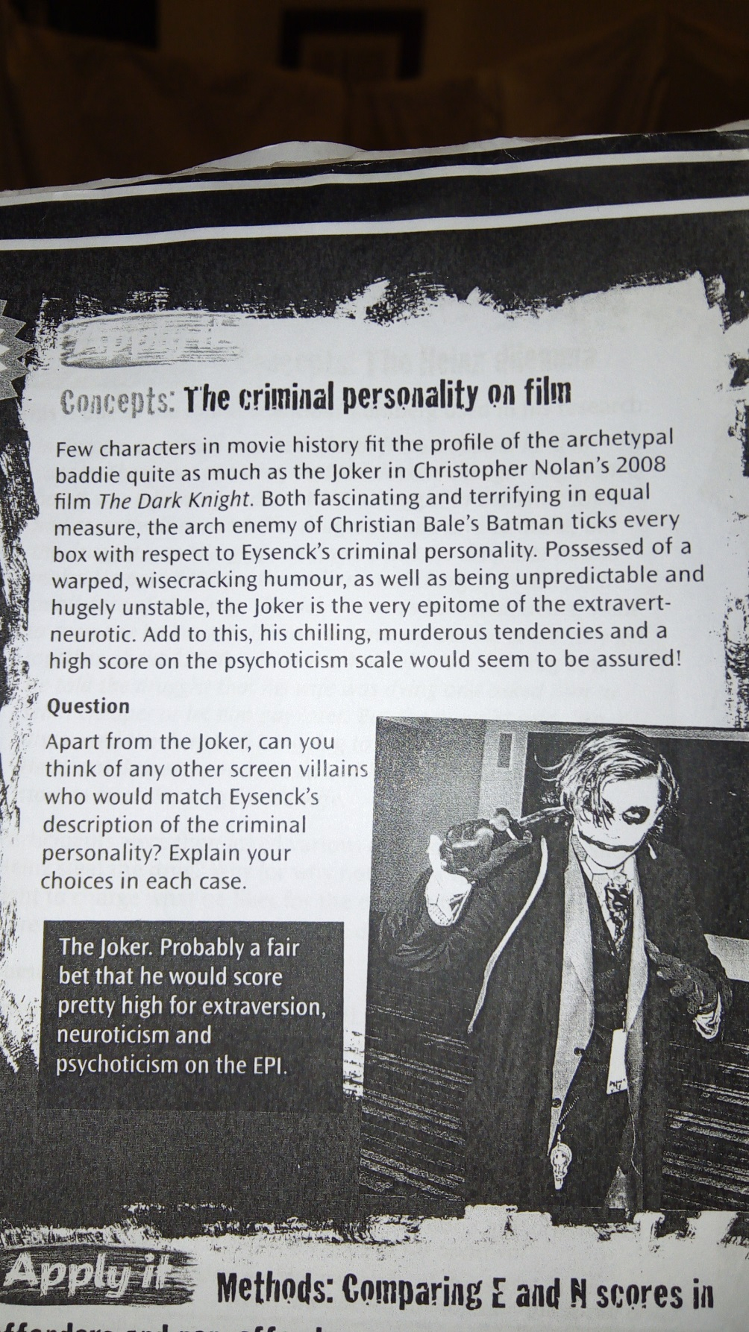

Task 4: Cognitive explanations

There are two cognitive explanations you need to know:

1. Levels of Moral reasoning 2: Cognitive distortions (including hostile attribution bias and minimalisation)

a) Explanation 1: Levels of Moral reasoning

Click on this link - http://www.simplypsychology.org/kohlberg.html – and follow the instructions below:

1. Watch the first video clip titled 'Heinz dilemma'- Which option did you choose and what was the stage of moral development?

2. Read through the section on Kohlberg's stages of moral development and watch the video showing examples of responses to the Heinz dilemma.

Note: The names of some of the stages in the clip are slightly different to the ones in the pack – do not worry about this, your understanding of the differences between the stages is more important.

3. Read the two pages outlining Kohlberg’s theory in the pack, then answer the question below:

According to Kohlberg, which level of moral reasoning is more likely to lead to offending behaviour? Explain the reason for your answer and refer to evidence. (4 marks)

Tasks continue on the next page.

b) Explanation 2: Cognitive distortions (Hostile attribution bias and Minimalisation)
Read the information on what these cognitive distortions are and the research studies investigating them.Once you have done this, answer the following questions to test your knowledge:
1. What is meant by hostile attribution bias in relation to explaining criminal behaviour? Refer to one piece of evidence (i.e. a study) in your answer.
2. Give an example of an offender displaying hostile attribution bias
3. What is meant by minimalisation in relation to explaining criminal behaviour? Refer to one piece of evidence (i.e. a study) in your answer.
4. Give an example of an offender displaying minimalisation – this must be different to the one in the pack.

Task 5: Differential Association Theory (DAT)
Read the information on this theory in the pack and go through the powerpoint (‘flipped work 4 differential association theory PowerPoint’) on psych205.com. Answer the questions on the last slide of the powerpoint below:
1.

2.

3.

4.

Tasks continue on the next page.

Task 6: Psychodynamic explanations
There are two psychodynamic explanations of offending behaviour:
1. The Inadequate Super-ego 2. Defence mechanisms

a) Explanation 1: The Inadequate Super-ego:
Read this theory in your pack and complete the following:
- What is the Superego

- Where does the Superego develop from?

- Which theorist constructed the theory of “The Inadequate Super-ego” to explain Criminal Behaviour?

- Complete the table:
Inadequacy | Cause | How it results in Criminal Behaviour
Weak Super-Ego
Deviant Super-Ego
Over-harsh Superego

b) Explanation 2: Defence mechanisms
Read about the defence mechanisms that are used to explain offending behaviour in the pack and, for each defence mechanism, come with your own example related to crime.
Displacement – example related to crime:
Sublimation: – example related to crime:
Rationalisation: – example related to crime:

