Forensic flipped homework 3: Biological explanation 2 – Genetics & Neural Psychological explanations (part 1) - Eysenck’s theory of the criminal personality; Cognitive explanations – Levels of moral reasoning

Task 1: Biological explanation 2: Genetics and neural explanations

http://www.tutor2u.net/psychology/reference/genetic-explanations-of-offending-behaviour
http://www.tutor2u.net/psychology/reference/neural-explanations-of-offending-behaviour

Read and make notes on the genetic and neural explanations in the links above. Optional: Notes on the evaluation sections.
Amend the error on p14 in the pack - percentages for the Christiansen study.

Task 2: Psychological explanations: Eysenck's theory of the criminal personality

a) Read the information on Eysenck's personality theory using pages 16 & 17 in the pack and the following link
http://www.psychlotron.org.uk/newResources/criminological/A2_AQB_crim_EysenckTheory.pdf.

Once you have read over the information, answer the following questions:

- Name the three personality traits proposed by Eysenck.
- An individual who displays behaviours such as anxiety and nervousness would be characterised as which type of personality trait?
- What is the biological basis for extraversion and neuroticism?
- Explain how Eysenck's theory relates to the nature-nurture debate.
- Explain the different reasons why individuals with different personality traits may commit a crime.
- Describe one study that supports Eysenck's criminal personality theory and one study that challenges his theory.

b) Click on this link http://similarminds.com/eysenck.html and complete Eysenck's personality questionnaire.
Print off the results page to go with your notes.

- Read the extract below and answer the question:
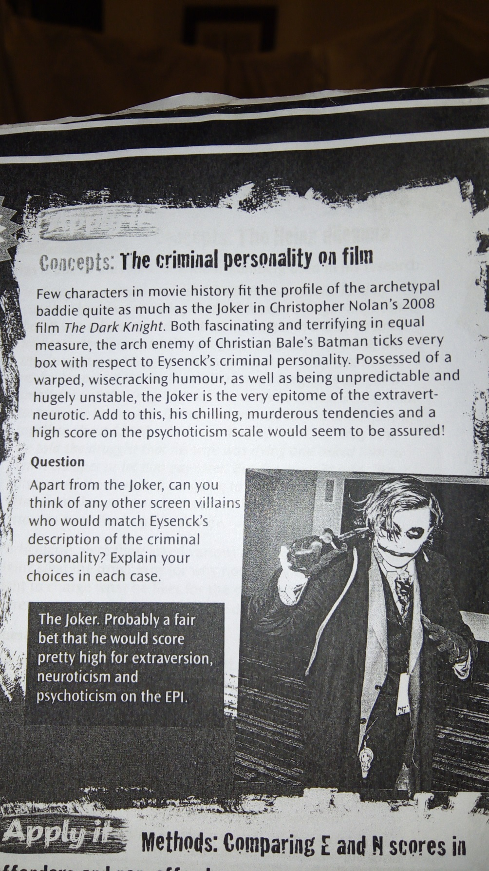

Tasks continue on the next page.
Task 3: Psychological explanations: Cognitive explanations - Levels of moral reasoning

Click on this link - http://www.simplypsychology.org/kohlberg.html – and follow the instructions below:

a) Watch the first video clip titled 'Heinz dilemma':
Which option did you choose and what was the stage of moral development?

b) Read through the section on Kohlberg's stages of moral development and watch the video showing examples of responses to the Heinz dilemma.

Note: The names of some of the stages in the clip are slightly different to the ones in the pack – do not worry about this, your understanding of the differences between the stages is more important.

- Read p20 in the pack, then answer the question below:

According to Kohlberg, which level of moral reasoning is more likely to lead to offending behaviour? Explain the reason for your answer and refer to evidence. (4 marks)

