Task: watch the youtube clip and label to diagram below with these terms: (clip times: 0:00 – 1.10)
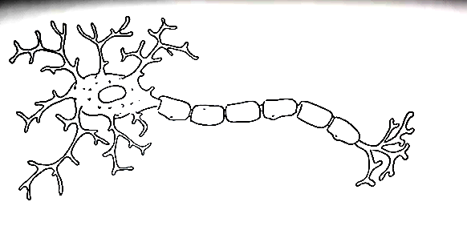
Dendrites Cell Body (Soma) Axon Myelin Sheath Synaptic Terminal

https://www.youtube.com/watch?v=FVo04B0_5R4
Task: continue watching the youtube clip and label to diagram below with these terms: (Clip times 2.19 – 3.08)
Pre-synaptic membrane Post synaptic membrane Synaptic terminal Synaptic Cleft
Vesicles containing neurotransmitters

https://www.youtube.com/watch?v=FVo04B0_5R4
