How to do the sign test.
Step 1 – collect data (example below)
participant | Score 1 | Score 2
P1 | 4 | 5
P2 | 8 | 10
P3 | 3 | 8
P4 | 6 | 2
P5 | 8 | 7
P6 | 9 | 4
P7 | 6 | 6
P8 | 3 | 8
P9 | 8 | 7
P10 | 9 | 9
P11 | 2 | 8
P12 | 4 | 6

Step 2 – Take away the second value from the first for each participant. This will leave you with a positive or negative value or 0. although shown here, you don’t need the actual value, just the sign
participant | Score 1 | Score 2 | Workings | difference | sign
P1 | 4 | 5 | 4 – 5 = | -1 | -
P2 | 8 | 10 | 8 – 10 = | -2 | -
P3 | 3 | 8 | 3 – 8 = | -5 | -
P4 | 6 | 2 | 6 – 2 = | +4 | +
P5 | 8 | 7 | 8 – 7 = | +1 | +
P6 | 9 | 4 | 9 – 4 = | +5 | +
P7 | 6 | 6 | 6 – 6 = | 0 | 0
P8 | 3 | 8 | 3 – 8 = | -5 | -
P9 | 8 | 7 | 8 – 7 = | +1 | +
P10 | 9 | 9 | 9 – 9 = | 0 | 0
P11 | 2 | 8 | 2 – 8 = | -6 | -
P12 | 4 | 6 | 4 – 6 = | -2 | -

Step 3 – you now need to find out how many + and –that you have
+ = 4 - = 6
Step 4 – the lowest value or either + or – is your calculated S score
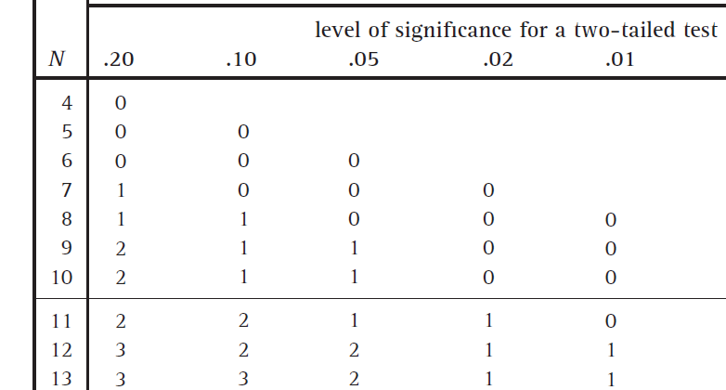
S = 4
Step 5 – you now have to find your critical value. First find the value of N
N is the number of participants where there is a difference. Discount all 0s
N = 12 – 2 = 10 (there are 12 participants in total but only 10 of them have a sign)
Chose the level of significance for a two-tailed test at .05 and N = 10 to get the critical value (why you do this will become clear in year 2)
Critical value = 1
Step 6 – for a sign test, the calculated value must be less than or equal to the critical value for the result to be significant. Is this the case?
No. The calculated value of 4 is greater than the critical value of 1, therefore we must reject the experimental hypothesis at p = 0.05 for a two-tailed test.
Your turn. You have a non-directional hypothesis meaning it is a two-tailed test of significance (Year 2 work) and you want to support your experimental hypothesis with a 0.05 level of significance or more. In other words, you will only accept your experimental hypothesis if you are at least 95% confident that the results are not due to chance.
Your experimental hypothesis is. There will be a difference in people’s recall of one-syllable words if they take the test in the same room as they learned the words, or if they take the test in a different room to where they learned the words.
participant | Score 1  (same room) | Score 2  (diff room) | difference | sign
P1 | 7 | 8
P2 | 5 | 9
P3 | 3 | 5
P4 | 9 | 9
P5 | 9 | 6
P6 | 3 | 7
P7 | 5 | 5
P8 | 7 | 8
P9 | 3 | 7
P10 | 5 | 8
P11 | 7 | 10
P12 | 3 | 9
P13 | 5 | 6
P14 | 2 | 3
P15 | 7 | 9

Step 1 – work out the difference
Step 2 – record the sign of each difference
Step 3 – take the smallest number of signs as your calculated S score
Step 4 – work out N (number of participants minus number of 0s)
Calculated S score = _______
N = 15 - _____ = _____
Step 5 – now work out your critical value for a two-tailed test at a significance level of 0.05 with N = _____ Critical Value = _________

Step 6 – your calculated value must be equal to or less than the critical value. Is this the case?
Calculated S = _____ critical value = _______
I can support/reject the experimental hypothesis

Step 7 - Delete the appropriate words to make your conclusion
Because the calculated value of S is less than/greater than the critical value at p = 0.05 and N = 15/13 for a two tailed test, we can be at least 95% confident that the results are not due to chance so will support/reject the experimental hypothesis: there is a/no difference in people’s recall of one-syllable words if they take the test in the same room as they learned the words, or if they take the test in a different room to where they learned the words.
Further work: Do it again on this data
X | 4 | 5 | 3 | 8 | 6 | 1 | 3 | 7 | 2 | 9 | 8 | 1
Y | 5 | 5 | 7 | 9 | 9 | 3 | 7 | 9 | 2 | 5 | 9 | 2

