Idiographic vs Nomothetic approaches in psychology
Task 1 – do this test. It’s confidential so do it honestly
http://similarminds.com/eysenck.html
After completion, read the analysis and scroll down to see where you are placed in the extroversion-neuroticism score. Plot it here
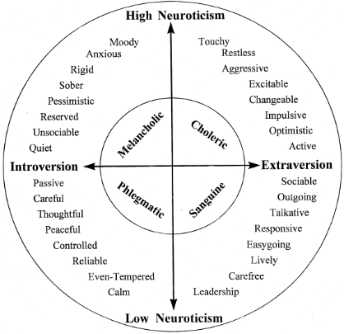

There are some questions you should consider for the idiographic vs nomothetic approaches class coming up.
1) Do you agree with this result (In other words, is this really you?)
2) Do you think that this questionnaires such as this measure the personality of all humans accurately?
3) there are 32 personality characteristics on the graph above. Are there any missing?
Task 2: regardless of the score and graph above, write a paragraph that best describes your personality. Please add as much detail as you can.

There are some questions you should consider for the idiographic vs nomothetic approaches class coming up
1) do you think anyone else in your class has written the exact same paragraph?
2) is every person unique? Why do you think this?
3) What is more useful when understanding humans, trying to generate general laws about what causes behaviour, or looking at each individual without pre-conception to discover the cause of their actions?
Task 3: in doing tasks 1 and 2, you have used both the nomothetic and idiographic approach to measure your own personality. Now read the article from ‘Simply Psychology’ and answer these questions below – use this link https://www.simplypsychology.org/nomothetic-idiographic.html
- What does the Greek term ‘nomos’ mean?

- What does the Greek term ‘idios’ mean?

- What do psychologists study and want to establish if they use a nomothetic approach?

- What do psychologists want to discover if they adopt an idiographic approach?

- When you did the personality questionnaire (based on Eysenck’s research) what approach was this?

- When you wrote down what you thought your personality was, what approach was this?

- Which approaches tend to adopt the nomothetic approach?

- Which methods of investigation do those who adopt the nomothetic approach tend to use?

- Which approach tends to adopt the idiographic approach?

- Which methods of investigation do those who adopt the idiographic approach tend to use?

- Which approach is difficult to pin down? Why?

Task 4: watch the webinar from tutor2U on this link and answer these questions
https://www.youtube.com/watch?v=FwaMpTv-Xgw
- How does the case study of KF (idiographic approach) change the MSM of memory (nomothetic explanation) ?

- Which approach is generally thought of to be more scientific. Nomothetic or idiographic?

- Why is the biological approach thought to be a nomothetic approach when explaining the causes of psychological disorders such as OCD and depression?

- Give one example of how the behaviourist approach is considered a nomothetic approach

- Why is Atkinson and Shiffrin’s model of memory (MSM) considered a nomothetic explanation?

- Why does the narrator consider this to be a debate? use the cognitive approach to explain.

Task 5: linked to forensic psychology.
Skim read your Social Influence psychology pack and try and find between 3-5 further examples of nomothetic and idiographic approaches. Make very brief notes with what you find. Look at these examples

