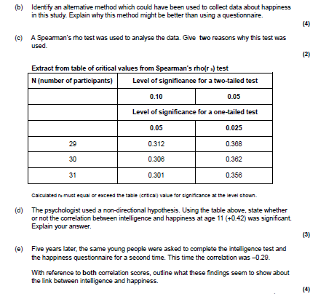
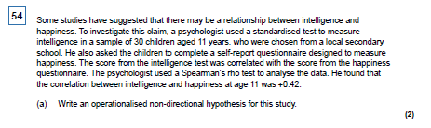
Inferential Statistics questions: Second year

Q41

Two psychologists designed an experiment to test the effects of using a hands-free
phone on drivers’ attention. They recruited a sample of 30 experienced police drivers and
asked them to take part in two computer-simulated driving tests. Both tests involved
watching a three-minute film of a road. Participants were instructed to click the mouse as
quickly as possible, when a potential hazard (such as a car pulling out ahead) was spotted.

Each participant completed two computer-simulated driving tests:
• Test A, whilst chatting with one of the psychologists on a hands-free phone
• Test B, in silence, with no distractions.
The order in which they completed the computer tests was counterbalanced.
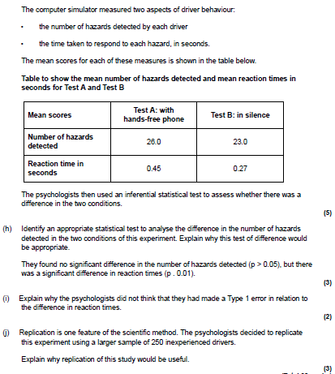

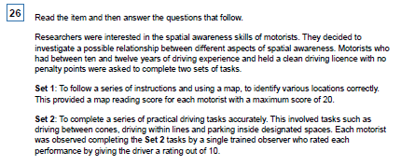

f) The researchers decided to analyse the data using a Spearman’s rho test. Explain why this is a suitable choice of test for this investigation. (3 marks)

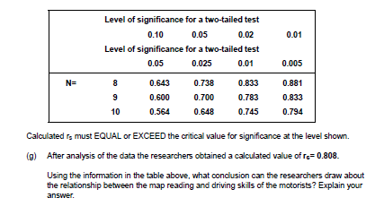

(4 marks)

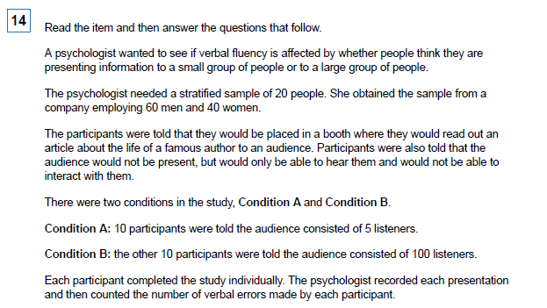
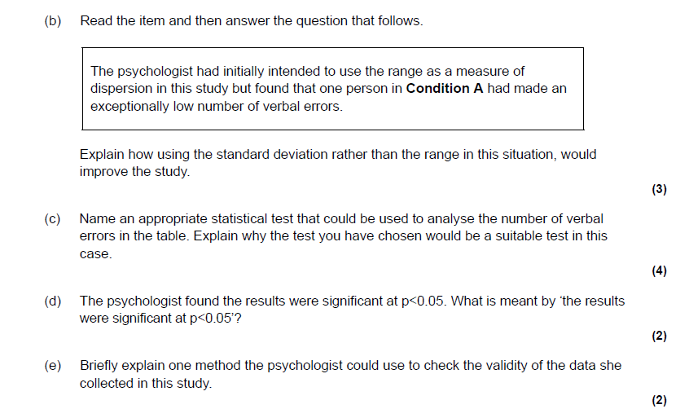

Mark Schemes
Q54
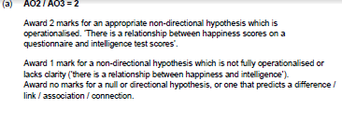

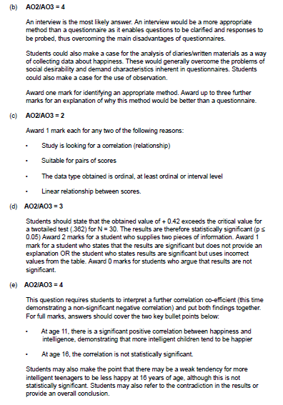

Q 41
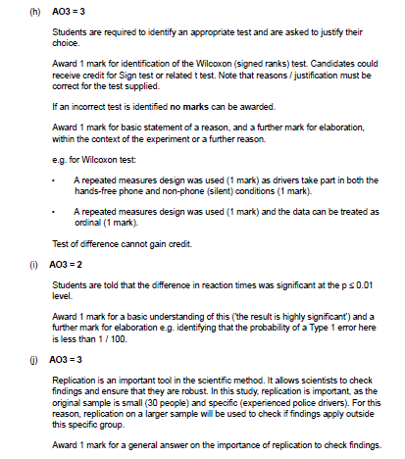

Q26 f and g
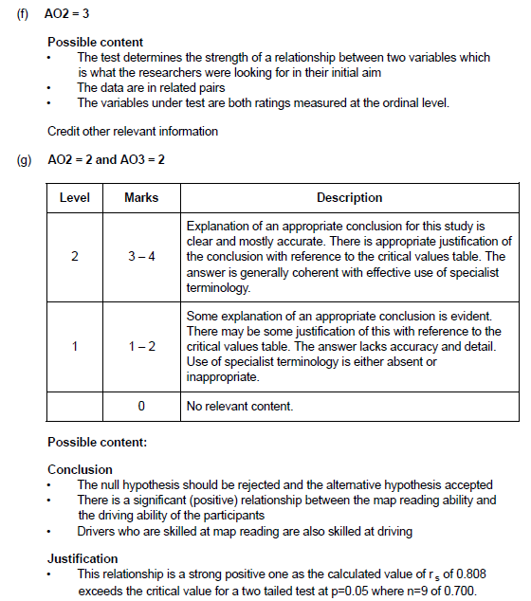

Q 14
