Below are three research methods exam questions. They are from the old specification but the questions will still be the same the only difference is NOW you have to work out the sign test and NOW the questions are worth 48 and not 35.
Once you have revised complete these (try to time yourself so give yourself about 45 minutes) and mark it afterwards.
The mark schemes are the full mark scheme for the whole paper that year so you have to go to the research methods section to get to the answers.

We expect these to be completed and marked in preparation for the mini-mock

June 2012
1 Explain what is meant by replicability. Why is replicability an important feature of science? (5 marks)

A maths teacher wondered whether there was a relationship between mathematical ability and musical ability. She decided to test this out on the GCSE students in the school. From 210 students, she randomly selected 10 and gave each of them two tests. She used part of a GCSE exam paper to test their mathematical ability. The higher the mark, the better the mathematical ability. She could not find a musical ability test so she devised her own. She asked each student to sing a song of their choice. She then rated their performance on a scale of 1-10, where 1 is completely tuneless and 10 is in perfect tune.

2 Suggest a suitable non-directional hypothesis for this study. (3 marks)

3 Why might the measure of musical ability used by the teacher lack validity? (3 marks)

4 Explain how the teacher could have checked the reliability of the mathematical ability test.
(3 marks)

5 Explain why the teacher chose to use a random sample in this study. (2 marks)

The results of the study are given in Table 1 below.

Table 1: Mathematical ability test scores and musical ability ratings for 10 students

Student | Mathematical ability test score | Musical ability rating
1 | 10 | 10
2 | 2 | 9
3 | 9 | 3
4 | 6 | 6
5 | 3 | 9
6 | 10 | 2
7 | 2 | 1
8 | 1 | 8
9 | 8 | 4
10 | 4 | 7

6 In your answer book, sketch a graph to show the data in Table 1. Give the graph an appropriate title and label the axes. (3 marks)

7 Discuss what the data in Table 1 and the graph that you have sketched seem to show about the relationship between mathematical ability and musical ability. (3 marks)

The teacher noticed that most of the students who were rated highly on musical ability were left-handed. The teacher is aware that her previous definition of musical ability lacked validity.

8 Design a study to test whether there is a difference in the musical ability of left-handed students and right-handed students. You have access to a sixth form of 200 students.
You should:

• identify the design that you would use
• explain an appropriate sampling method and justify your choice
• describe the procedure that you would use, including details of how you would assess musical ability
• write a suitable debrief for these participants. (10 marks)

9 In your answer book, draw a table to show how you would record your results. Identify an appropriate statistical test to analyse the data that you would collect. Justify your choice. (3 marks)

January 2013

Some studies have suggested that there may be a relationship between intelligence and happiness. To investigate this claim, a psychologist used a standardised test to measure intelligence in a sample of 30 children aged 11 years, who were chosen from a local secondary school. He also asked the children to complete a self-report questionnaire designed to measure happiness. The score from the intelligence test
was correlated with the score from the happiness questionnaire. The psychologist used a Spearman’s rho test to analyse the data. He found that the correlation between intelligence and happiness at age 11 was +0.42.

- Write an operationalised non-directional hypothesis for this study. (2 marks)

- Identify an alternative method which could have been used to collect data about
happiness in this study. Explain why this method might be better than using a
questionnaire. (4 marks)

- What is meant by internal validity? (1 mark)

- Describe how the internal validity of the happiness questionnaire could be assessed. (3 marks)

- A Spearman’s rho test was used to analyse the data. Give two reasons why this test
was used. (2 marks)

Table 1: Extract from table of critical values from Spearman’s rho(rs) test

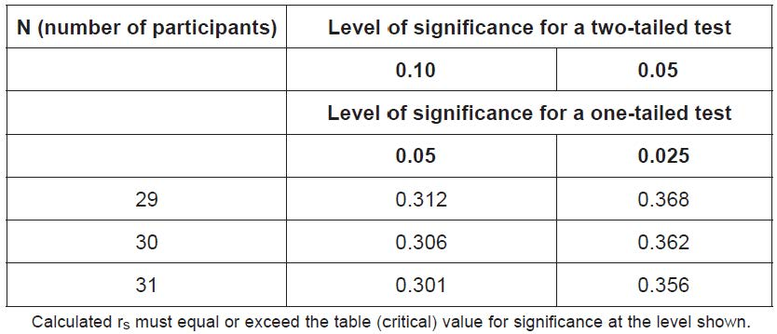

- The psychologist used a non-directional hypothesis. Using Table 1, state whether or
not the correlation between intelligence and happiness at age 11 (+0.42) was significant.
Explain your answer. (3 marks)

- Five years later, the same young people were asked to complete the intelligence test
and the happiness questionnaire for a second time. This time the correlation was −0.29.
With reference to both correlation scores, outline what these findings seem to show
about the link between intelligence and happiness. (4 marks)

The report was subjected to peer review before it was published in a journal.

- What is meant by peer review? (2 marks)

- Explain why peer review is an important aspect of the scientific process. (4 marks)

- A psychology student was asked to design an investigation to see whether taking
exercise could increase feelings of happiness. She proposed to do an experiment.
She decided to recruit a sample of volunteers who had just joined a gym, by putting up a
poster in the gym. She planned to carry out a short interview with each volunteer and to
give each one a happiness score. She intended to interview the volunteers again after
they had attended the gym for six weeks and to reassess their happiness score to see if
it had changed.

The psychology student’s teacher identified a number of limitations of the proposed
experiment.

Explain one or more limitations of the student’s proposal and suggest how the
investigation could be improved.
(10 marks)

June 2013

In an observational study, 100 cars were fitted with video cameras to record the driver’s
behaviour. Two psychologists used content analysis to analyse the data from the films.
They found that 75% of accidents involved a lack of attention by the driver. The most
common distractions were using a hands-free phone or talking to a passenger. Other
distractions included looking at the scenery, smoking, eating, personal grooming and
trying to reach something within the car.

- What is content analysis? (2 marks)

- Explain how the psychologists might have carried out content analysis to analyse the film
clips of driver behaviour. (4 marks)

- Explain how the two psychologists might have assessed the reliability of their content
analysis. (3 marks)

The psychologists then designed an experiment to test the effects of using a hands-free
phone on drivers’ attention. They recruited a sample of 30 experienced police drivers
and asked them to take part in two computer-simulated driving tests. Both tests involved
watching a three-minute film of a road. Participants were instructed to click the mouse
as quickly as possible, when a potential hazard (such as a car pulling out ahead) was
spotted.

Each participant completed two computer-simulated driving tests:
● Test A, whilst chatting with one of the psychologists on a hands-free phone
● Test B, in silence, with no distractions.
The order in which they completed the computer tests was counterbalanced.

- Explain why the psychologists chose to use a repeated measures design in this
experiment. (3 marks)

- Identify one possible extraneous variable in this experiment. Explain how this variable
may have influenced the results of this experiment. (3 marks)

- Explain how one factor in this experiment might affect its external validity. (3 marks)

- Explain one or more ethical issues that the psychologists should have considered in this
experiment. (4 marks)

- Write a set of standardised instructions that would be suitable to read out to participants,
before they carry out Test A, chatting on a hands-free phone. (5 marks)

The computer simulator measured two aspects of driver behaviour:
● the number of hazards detected by each driver
● the time taken to respond to each hazard, in seconds.

The mean scores for each of these measures is shown in Table 1.

Table 1 Table to show the mean number of hazards detected and mean reaction
times in seconds for Test A and Test B

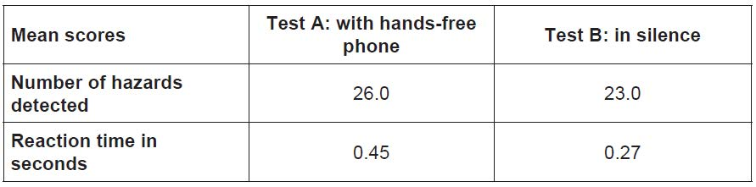

The psychologists then used an inferential statistical test to assess whether there was a
difference in the two conditions.

- Identify an appropriate statistical test to analyse the difference in the number of hazards
detected in the two conditions of this experiment. Explain why this test of difference
would be appropriate. (3 marks)

They found no significant difference in the number of hazards detected (p > 0.05), but
there was a significant difference in reaction times (p ≤ 0.01).

- Explain why the psychologists did not think that they had made a Type 1 error in relation
to the difference in reaction times. (2 marks)

- Replication is one feature of the scientific method. The psychologists decided to
replicate this experiment using a larger sample of 250 inexperienced drivers.
Explain why replication of this study would be useful.

