“Levels of revision”-making your revision more effective.

In case you're wondering why the amount of work you're doing isn't leading to the grades you just want or just how to revise more effectively, here are some tips below.

Basic level-organise yourself! You can't start revising unless you've got all of the packs and notes sorted and a plan of what and when you're going to revise so you can get it all done on time.

Maintenance rehearsal - before you start to "do something" with the material simply read through that section of the pack. Does it make sense to you? Don't start to make mind maps until you understand the material.

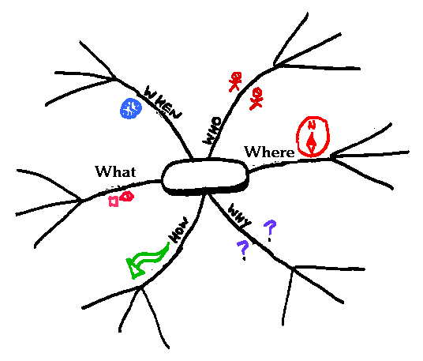

Elaborative rehearsal level one-condense and start to process the info by making a mind-map or cue cards or filling in the revision sheets.

Elaborative rehearsal level two-embed the knowledge. Test yourself, get others to test you using your cue cards/revision sheets, try practice exam questions on the topic area you've just revised. Try to explain or teach the info to others-if you can explain it without the notes it means you really understand it. This is where revising with others is helpful.

Linking knowledge with exam skills-once you think you're ready and have completed all the other levels for the topic or topics do timed exam papers without your notes. You should be able to do these without looking at your notes if you've revised effectively.

Triple checking-you should be able to fill in the revision sheets without notes and quickly if you're ready to roll and do the best that you can do in the exam. You can print as many off the website as you like and practice as much as you like!

Revision is not something you do just before an exam or test. You should be regularly (every week) revising/reviewing the topic areas covered in homework and in class.

Keeping your revision on track and checking you are fully prepared.
E.g. Psychopathology
 | Maintenance rehearsal | Elaborative rehearsal 1 | Elaborative rehearsal 2 | Exam practice | Triple checking
Definitions of abnormality: Social norms
Definitions of abnormality: Statistical infrequency
Definitions of abnormality: Ideal mental health
Definitions of abnormality: Failure to function adequately
Behavioural, emotional & cognitive characteristics of phobia, OCD & depression
Behaviourist explanations of phobias
Behaviourist treatments for phobias
Biological explanations of OCD
Biological treatments for OCD
Cognitive explanations of depression
Cognitive treatments for depression

