Localisation of Function in the brain
The human brain is simply one of the most complex biological systems. There are some theorists that argue different areas of the brain perform specific tasks. This is a localisation view. However, others suggest the brain is far more interdependent, in other words many areas of the brain are responsible for single tasks. This is a holistic or multi-functional view.
Task 1. Using your pack and the video on the website (Localisation clip), try and complete the following questions.
- How many hemispheres is the brain divided into?

- What are they called?

- Activity on the left side of the body is controlled by the ______ __________________ and

- Activity on the right side of the body is controlled by the _______ ______________________.

Task 2. Label the brain diagram from the YouTube clip on Psych205
(from 8.35 mins- just the cerebral cortex and the lobes)
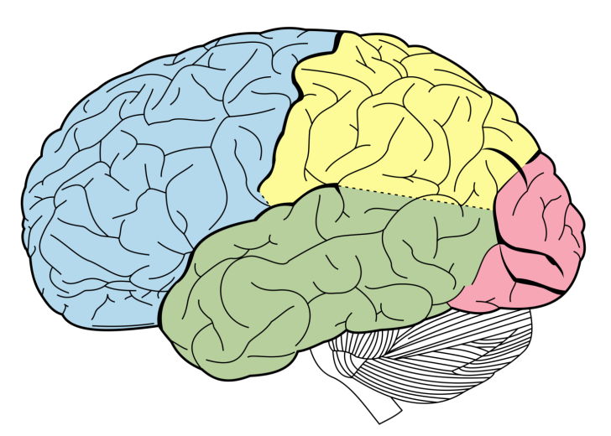
The Cerebral cortex is the outer layer of _____________________ and makes up _____ of the brain

- State the location in the brain for each of the following

- The Motor Area ____________________
- The Somatosensory Area____________________
- The Visual Area_____________________
- The Auditory Area___________________

- Take brief notes (or create a mind map) on each of the above areas in particular its function and fill out the grid below.

Motor Area | This area controls…
Somatosensory Area
(and give an example)
Visual
(can you briefly sketch how it works?)
Auditory Area

- What are the two language areas of the brain? Explain their function and add them to your brain diagram.

