Localisation of the brain
Motor area | Somatosensory | visual | Auditory
Language centres
Broca’s area |  | Wernicke’s area
Evaluation of localisation. Is the brain localised or holistic?
Supporting evidence

Supporting evidence

Challenging evidence

Challenging evidence

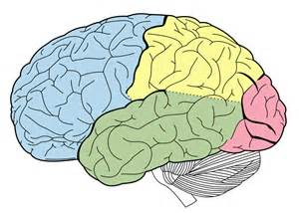

Fully label this brain
For each brain section below fully describe.

