Essential Maths Skills for Psychology

At least 10% of your marks in Psychology exams will require you to use your mathematical skills. You shouldn’t be afraid of this but see it as an opportunity to gain easy marks as a lot of the maths you will have already covered at GCSE and the rest we’ll cover with you.
We want you to come to your first lesson feeling confident about the maths and this pack will help you to do that.
We’ll be giving you a maths test in the first few lessons so we know where you’re at which will help us to help you in the coming year.

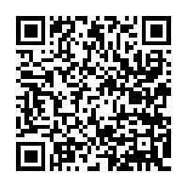
- Download a QR reader from an App store.
- Scan the QR code to go to the Psychology specification to see this in more detail. Don’t have a smart phone? Don’t worry all the information linked to QR codes in this pack are available on our website-www.psych205.com

Contents
What do I need to know?

Preparing for starting Alevel Psychology- What do I need to do?

Why maths? I thought I was studying Psychology
- Calculating percentages
- Percentages to decimals
- Fractions
- Using ratios
- Estimating results
- Probability
- Using Mathematical Symbols
- Algebraic equations
- Measures of central tendency-mean, median, mode
- Measures of dispersion-range, standard deviation
- Correlations
- Tables of data
- Normal and skewed distributions
- Graph skills

What do you need to do before your first Psychology lesson in September?
1. Fill in the first column of the table below to find out what you think you know and don’t know.
2. Now work through the pack playing particular attention to the example exam questions and Freud’s advice
3. Complete the three mini tests
4. Re-rate your confidence in the table
5. Complete the revision quizzes and the sign test activity
Be prepared for an assessment on this content at the start of your Psychology course

So what do you know already?
1-I’m totally clueless, no idea! 5-I’ve got this! Easy peasy

 | How confident are you with the following before completing the pack? | How confident are you after completing the pack? | Scores on mini test for each section
- Calculating percentages
- Percentages to decimals
- Fractions
- Using ratios
- Estimating results
- Probability |  |  | No test
- Using Mathematical Symbols
- Algebraic equations
- Measures of central tendency-mean, median, mode
- Measures of dispersion-range, standard deviation
- Tables of Data |  |  | No test
- Correlations |  |  | No test
- Distributions |  |  | No test
- Graph skills |  |  | No test
Hi! I am the famous Psychologist Sigmund Freud. Look out for me in this pack for exam tips and how to get marks for the maths questions in Psychology

Why maths? I thought I was studying Psychology!
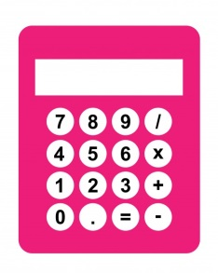
So why are we making you do maths? When an investigation is conducted data is collected and the process of turning that data into information is called data analysis. Maths is important if the data is quantitative (numerical data that can be counted) as it can be used to show us important things like what the average scores in an experiment are or how spread out the scores are, or if the experiment worked or not. Qualitative data (data expressed in words) can also be turned into quantitative data and so maths is needed here again.
You can use a calculator in the exam but you must show your workings or lose marks.
1. Calculating percentages
'Percent' means 'out of 100'. If 90 per cent of the population owns a mobile phone, we are simply saying that 90 out of every 100 people have one. The symbol '%' means per cent.

Finding percentages
A percentage is a fraction of 100.
30% (30 in each 100) as a fraction is ³⁰/₁₀₀
30% as a decimal is 0.3.
However it’s unlikely we’ll have a nice convenient 100 people in our sample (number of participants in our research) so we need a way to convert scores to percentages.

How to express a number as a percentage
For example in a class of 96, 60 passed a recent test. What percentage of students then passed the test i.e. express 60 as a percentage of 96?
Step one-divide the number of students who passed (or number you want expressed as a percentage) by the total number of students
60/96
Step two-multiple this by 100 to make it into a percentage.
60/96 x 100= 62.5%
How to find a percentage of a quantity.
For example a student got 40% on a test out of 50, what was her score?
Step one- First; write the percentage as a fraction or a decimal,
40/100
Step two- then multiply by the quantity.
40/100 x 50= 20 ans

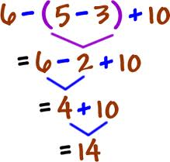
Show your workings out!!
In the exam you get marks for your working out so you must write down the answer step by step or lose marks.
You also must work out the answer using the above formula and not try to work out 1% then 10% etc. as it takes longer and you won’t get full marks.
There may be various different ways these questions can be asked and made more complicated so now try the questions below.
Scan here for test answers
Mini tests
Once you have completed each mini test scan the QR code above, mark you answers and put your score into the table. If some answers were incorrect look over the area again and redo the question until you get it right. Remember you get marks for your workings!
Mini test one
There were a total of 2625 students studying at BHASVIC this academic year, 350 were studying first year Psychology (AS) and 280 were studying second year (A2) Psychology.
- What percentage of students at BHASVIC studied Psychology this year? (3 marks)

- What percentage of students at BHASVIC, this year, were on the first year of the Psychology course? (2 marks)

- What percentage of students at BHASVIC were studying on the second year? (2 marks)

- What percentage of all students on Psychology courses at BHASVIC this year were on the second year course? (3 marks)

- 95% of all students studying Psychology this year said that they enjoyed the course so how many students said that they didn’t enjoy Psychology? (2 marks)

- 32% of the second year students who studied Psychology this year said that they will be studying Psychology at university next year. How many students is this? (2 marks)
Total- /14

2. Converting percentages to decimals
This is nice and easy!

To convert a percentage to a decimal. Remove the % sign and move the decimal point two places to the left (divide by 100)

For example: 37% is 37.0 then move the decimal point two places to the left which is 0.37 and 9% is 0.09.

3. Fractions

A fraction is part of a whole number such as ½ or ¾. You may want to present results from a study as a fraction.

For example, if there were 120 participants and 40 of them took part in condition A of an experiment then what fraction is this?

Step one-Divide 40 by 120= 40/120 (write it like this, don’t actually divide it)

Step two-Reduce the fraction by dividing both numbers by the lowest common denominator (i.e. the lowest number that divided them both equally). In this case it is 40. So the answer is 1/3

3a Converting a decimal to a fraction

Step one- First you need to work out the number of decimal places in your number i.e. how many digits after the decimal point. For example, 0.1 has one decimal place, 0.49 has two decimal places and 0.275 has three decimal places.

Step two-If there are two decimal places then you divide by 100, if there are three decimal places then you divide by 1,000 (the number of decimal places equals the number of zeros).

So to convert to fractions you get: 49 and 275
100 1000

Step three-You can simplify the fraction by finding the lowest common denominator (the biggest number that divides evenly into both parts of the fraction).

In the case of 275/1000 you can divide both by 25 and get 7/40. Even if the question doesn’t ask for it you must find the lowest common denominator for full marks.

3b Converting a fraction to a decimal and a percentage

So how would you change 19/36 into a percentage?

Step one-divide the numerator by the denominator (i.e. the top by the bottom)
19 divided by 36= 0.52777778

Step two- To make this a percentage you multiply by 100 by moving the decimal place two places to the right. So the answer is 52.8% (if to three significant figures).

Maths questions will be embedded into research scenarios. Take in a highlighter and highlight the key information in the research example first.
Exam Focus

The table below shows the results of a repeating measures design in which participants taking part drank an energy drink and water and the amount of words spoken in each condition was recorded i.e. Participant 1, said 110 words after drinking the energy drink and 112 words after drinking water.
Work out what percentage of participants spoke more in the energy condition than in the water condition

 | P1 | P2 | P3 | P4 | P5 | P6 | P7 | P8 | P9 | P10
Energy  condition | 110 | 59 | 206 | 89 | 76 | 141 | 152 | 98 | 198 | 57
Water condition | 122 | 45 | 135 | 90 | 42 | 87 | 131 | 113 | 129 | 62
We are all at risk of making human error- especially under exam conditions. Use your highlighter to extract the information you need.
There were 6 participants whose word score was higher in the energy drink condition than the water condition out of a total of 10 participants
To calculate the percentage we use the formula:

Number of participants who spoke more after the energy drink (6)
Divided by total number of ps in total (10) x 100 =
6/10 x 100 = 60%
Have a go at this example below using the highlighting technique.
Select your data first (the data above 12.23)

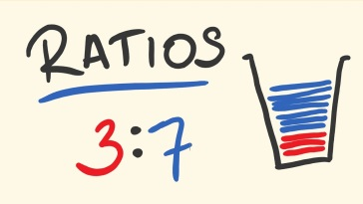
- Using ratios

A ratio is a way of comparing quantities; a way of demonstrating how much of one thing there is compared to another thing.
Betting odds are given in ratios. For example 4 to 1 (4:1) meaning that out of a total of five events you would be expected to lose four times and win once.
Ratios are always written X : Y with a semicolon separating one quantity of parts from the other
Ratios should always be written in their Simplest Form

Example
As part of a survey 100 men and 100 women were asked whether they regularly read celebrity magazines. 4 of the men responded yes compared to 36 of the women.
What is this ratio of men to women who said they regularly read celeb magazines (in its simplest form)?

- Put the numbers in the ratio as mentioned in the question 4:36
- Simplify the ratio- Find a common denominator (number that can divide into both sides of the ratio) In this example we can divide both 4 and 36 by 2 which gives us now 2:16
- Divide each side by the same number until you reach the smallest number possible on one side. We can divide by 2 again 1:8
Always make sure you write out the ratio in the same order that the numbers are mentioned in the question

- Estimating results
When doing any calculations it helps to estimate what the result is likely to be because then you can detect if you make a mistake. In the exam they could ask you to estimate results so it’s something you need to practice.
Consider the fraction 19/36. It is very close to 18/36 which is the same as a half (50%) therefore the answer should be slightly more than a half.
If asked to estimate the answer to 185,363x46,208 then you can round the numbers up to
200,000 and 50,000 and you can do 2x5 and add the nine zeros to get a rough answer of =10,000,000,000
So you know the answer is going to be less than this but not by too much. The actual answer is 8,565,235,504
Exam Focus
You could also be asked to estimate percentages. See exam question below:

A researcher is investigating gender differences in classification of attachment. They conducted a study using Ainsworth’s ‘Strange situation’. The results are shown below:
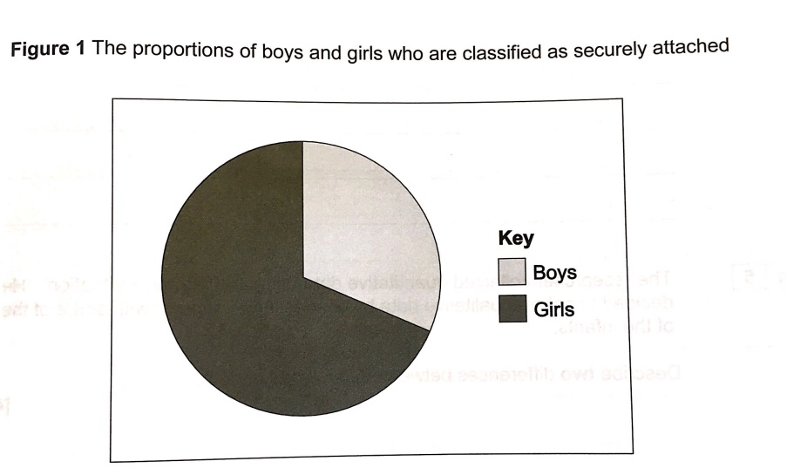
Question: Using the information, estimate the percentage of boys and girls that are securely attached. (2 marks)
Boys=
Girls=
Answer: Boys- 33%, Girls- 67%

NB Notice that a pie chart has been used in this question.

You are also required to be able to interpret and analyse the results of a pie chart.

Mini test two
Once you have completed each mini test scan the QR code next to mini test one, mark you answers and put your score into the table. If some answers were incorrect look over the area again and redo the question until you get it right. Remember you get marks for your workings! All answers should be to one decimal place.
- 95% of all students study Psychology this year said that they enjoyed the course, how would you write this a decimal? (1 mark)
1b How could this be expressed as a fraction? (2 marks)
- 32% of the second year students who studied Psychology this year said that they will be studying Psychology at university next year. How would you write this as a decimal? (1 mark)

2b How could this be expressed as a fraction? (2 mark)

3. 2% of Psychology students own a garden gnome, how is this written as a decimal? (1 mark)
3b How could this be expressed as a fraction? (2 marks)
4. Of the 280 students studying first year Psychology 80 had studied GCSE Psychology, express this as a fraction (2 marks)
5. Of the total number of students studying Psychology 189 of them were males. What is the ratio of males to female students studying Psychology at BHASVIC? (3 marks)

6. During an experiment conducted by Psychology students 80 participants were deceived, 32 of these participants later asked to withdraw their data as they felt unhappy. Express this as a fraction (1 mark)

6a. 3/8 of participants in the experiment said they had enjoyed taking part in the research, express this as a percentage (2 marks)

7. Estimate what the result would be if asked to multiply 3,21363 by 2,900. Do not use a calculator. (3 marks)
Total- /20

- Probability

Finding Probabilities

When you throw a die there are six possible outcomes. But when you throw a die looking for an even number now there are 3 possible outcomes. 3/6 = ½ =0.5 or 50% chance

The Probability of an outcome as a fraction is number of ways the outcome can happen over total number of possible outcomes 3/6

We can then cancel this down if possible ½

To convert a fraction to a decimal as discussued previously we simply divide the top number by the bottom number of ways the outcome can happen ÷ total number of possible outcomes 0.5

To convert this to a percentage we x by 100 50%

We use percentages in Psychology also to test for significant results. This will be covered in your statistics section of your research methods topics. Psychologists will only allow a certain probability percentage of risk that their results have occurred by chance (0.05 or p< 0.05) so that they can be 95% sure their results have occurred because of what they predicted.

- Interpreting mathematical symbols
You need to know the following symbols and be able to work with them in an exam question.

Symbol | Meaning
< | Less than
> | Greater than
≤ | Less than or equal to
<< | Much less than
>> | Much more than
≈ | Approximately equal
 | Proportional to

8. Using Equations

An Equation uses letters to show a general rule

For example an end of year Psychology mark might be worked out by adding up student’s scores on two tests M= a + b

Where M is the students end of year mark
A is the score in the first test
B is the score in their second test

How to use an equation
- Firstly make sure you know what each letter means before your start
- Write down what number each letter stands god
- Write out the equation with your numbers in the correct place

Example-
A psychologist combines participants scores in two tests using the formula S=2a + 3b where S is their final score a is their score in their first test and b their score in their second test.

What is the final score of a participant who scored 15 in the first test and 23 in the second?

- Write down the numbers and letters – a = 15 b =23
- Write the equation 2a+ 3b = (2 x 15) +(3 x 23)
- Use your calculator to find the answer = 99

Exam Question

A Personality assessment is made out of three test scores. The scores are combined using the equation P= 3r x (s-t). P is the combined Personality score, r is the score from the first test, s the second test and t is the score from the third.

A participant scores 2 on the first, 8 on the second and 3 on the third. What is their Personality score? (2 marks)

A Psychologist is developing a new way for measuring IQ using three different intelligence tests and a person’s age.

A Participant scores 98 in test 1, 89 in test 2 and 92 in tests 3. He is 18. What is his IQ? (2 marks)

9. Descriptive Statistics
Psychologists use descriptive statistics to describe their data. These include Measures of Central Tendency (averages; mean, mode, median) and Measures of Dispersion (range and standard deviation)
As Psychology students you are expected to be able to choose appropriate descriptive statistics for sets of data, justify this decision, calculate these values and evaluate their effectiveness
9a Measures of central tendency-mean, median, mode
Students often see the words measures of central tendency and claim “we’ve not done this!” You have though! This is just a posh phrase for finding average or the most typical values in a set of data. The three you need to know, work out and interpret are the mean, the median and the mode.
Mean: This is calculated by adding all the scores in a data set together and dividing by the number of scores.

So, in a data set with the following:-

5, 7, 7, 9, 10, 11, 12, 14, 15, 17

The total is 107 divided by the number of scores (10) which gives a mean value of 10.7

Median: This is calculated by putting all the scores in a data set in order, and identifying the score in the middle. In an even numbered data set, the two middle scores are added together and divided by 2 to find the median.

In the above data set: 5, 7, 7, 9, 10, 11, 12, 14, 15, 17
They are already arranged in order, they are an even set, the two middle scores are 10 and 11, so the median is 10.5 (21/2).

Mode: This is the most commonly occurring score. In some data sets, there may be more than one mode (bi-modal). In the above set of data the modal value is 7.
Evaluating measures of Central Tendency
You need to be able to consider the advantages and disadvantages of using the different measures of central tendency. These should be used to inform you of which to choose for a data set and to justify your choice in exam questions
Measure | Advantages | Disadvantages
Mean | The mean is the most sensitive measure of central tendency as it takes into account all of the values in the data set | As the mean is the most sensitive this means it is easily distorted by one or a few extreme values
Mode | The Mode is unaffected by extreme scores  The mode is the only measure of central tendency that can be used with data in categories (nominal data) | Sometimes a set of data may not produce a mode and therefore this measure cannot be used
Median | The median is unaffected by extreme scores | The Median is not as sensitive as the mean because the exact values of all in the data set are not considered.
9b Measures of Dispersion-range, standard deviation
Measures of central tendency tell us about the ‘averages’ of a set of data, but we also need to know how ‘spread out’ the data is. This just means how far scores vary and differ from one another and there are two measures you need to know called the range and standard deviation. There is just a tiny bit of maths here!

The range: This is an incredibly easy measure of dispersion to calculate. It involves subtracting the lowest score from the highest score, and (usually) adding 1.

For the following:- 5, 7, 7, 9, 10, 11, 12, 14, 15, 17

The range would be (17 – 5) + 1= 13
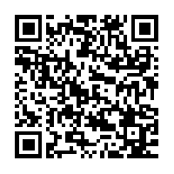
The standard deviation: This is a sophisticated measure of dispersion. It is a single value that tells us how far scores deviate (move away from) the mean (standard). You do NOT need to work this out just interpret it so you don’t need to worry about this yet but if you would like to get ahead for next year scan the QR code for more information.

Evaluating Measures of Dispersion

Measure | Advantages | Disadvantages
Range | The Range is very easy to calculate | Easily affected by extreme values  Does not take into account of the numbers as does not consider each individual data value
Standard Deviation | Most precise as takes into consideration all of the exact values in the data set | More difficult to calculate  May hide some of the characteristics of the data set e.g extreme values.
Exam Questions

What do the mean and standard deviation values suggest about the male and female performances in the investigation? (4 marks)
As Psychologists we must interpret the data with analysis. Yes the mean score for males is higher but look at the figures- it is 3 times higher this is a sig difference that you must refer to
 | Map reading scores
 | Males | Females
Mean | 15.4 | 5.25
SD | 2.7 | 2.22

You must interpret descriptive statistics in context. These figures represent scores on map reading so you must refer to this in your answer to get marks.

What about the SD? At first glance we would say it is bigger for females. But hold on it is only .5 larger. This is hardly any difference at all so we would refer to the results as being similarly dispersed disperdisperseddispersed

A psychologist wanted to see if verbal fluency is affected by whether people think they are presenting information to a small group of people or to a large group of people.
Condition A: 10 participants were told the audience consisted of 5 listeners.
Condition B: the other 10 participants were told the audience consisted of 100 listeners.
Each participant completed the study individually. The psychologist recorded each presentation and then counted the number of verbal errors made by each participant.
The results of the study are given in the table.
Mean number of verbal errors and standard deviations for both conditions
 |  | Condition A  (believed audience  of 5 listeners) | Condition B  (believed audience  of 100 listeners)
 | Mean | 11.1 | 17.2
 | Standard  deviation | 1.30 | 3.54
(a) What conclusions might the psychologist draw from the data in the table? Refer to the means and standard deviations in your answer.
(6)
(b) Read the item and then answer the question that follows.

The psychologist had initially intended to use the range as a measure of dispersion in this study but found that one person in Condition A had made an exceptionally low number of verbal errors.

Explain how using the standard deviation rather than the range in this situation, would improve the study.
(3)
Markscheme
- Means• Conclusion: when people believe they are presenting to a large audience they are less fluent in their spoken communication than when they believe the audience is small (or vice versa). Justification / Application: this is supported by the difference in the mean fluency scores which show more verbal mistakes (on average 6 more mistakes) when the audience is believed to be large (or vice versa).
Standard deviations• Conclusion: performances of participants in Condition A where audience is believed to be small are less varied / dispersed / spread out than in Condition B where audience is believed to be large (or vice versa)Justification / Application: lower SD in Condition A suggests that individual performances in Condition A were more similar to each other and / or all quite close to the mean of 11.1.
b) 1 mark – this would be an improvement because the SD is a measure of dispersion that was less easily distorted by a single extreme score.Plus 1 mark – one that takes account of the distance of all the verbal error scores from the mean.Plus1 mark – not just the distance between the highest verbal error score and the lowest verbal error score.
As you can see this requires you to use advantages of the SD referring to the context of the study (verbal errors)

Mini test three
Once you have completed each mini test scan the QR code next to mini test one, mark you answers and put your score into the table. If some answers were incorrect look over the area again and redo the question until you get it right. Remember you get marks for your workings!
The following data sets were gathered in a study looking at driver error and stress
A: 8, 6, 14, 9, 13, 8, 9, 8, 7, 7, 10
B: 22, 12, 14, 21, 20, 14, 14, 18, 16, 17, 17
1. What is the mean of data set A (2 marks)

2. What is the mean of data set B (2 marks)

3. What is the median of data set A. (2 marks)

4. What is the median of data set B. (2 marks)

5. What is the mode of data set A (1 mark)

6. What is the mode of data set B (1 mark)

7. What is the range for data set A (2 marks)

8. What is the range for data set B (2 marks)

Total- /14

11. Tables of Data

Tables are usually accompanied with a summary paragraph explaining the results…

The table below shows the mean number of words spoken in 5 minutes after participants take part in two conditions; drinking an energy drink and drinking water.

 | Energy drink condition | Water condition
Mean | 119 | 96
Standard deviation | 53.8 | 35.8

Answer
The mean values seem to suggest that there were more words spoken in the 5 minutes following consumption of the energy drink (119) , than from drinking water (96). This tells us that drinking an energy drink makes people more talkative than drinking water.

The standard deviation is significantly higher in the energy drink condition however (53.8) than the water condition (35.8) suggesting that there was a larger spread of scores. This suggests that not all participants were equally affected by the energy drink. In the water group, scores were close to the mean to a greater degree.

You must interpret the data in context- What does this tell us about energy drinks?

Remember the most important thing about interpreting tables is to think carefully as a psychologist and analyse the data. Are the scores different or similar? By how much? Would you say this is significant?

12. Correlations
A way Psychologists can measure the strength of a relationship between two or more co-variables (things that are measured).
For example, if the amount of aggressive games children play can have an effect on the amount of aggression they show in the playground. (The two co-variables here are aggressive games and aggression displayed).

Correlations are plotted on scattergrams (shown below). One co-variable is on the x-axis (horizontal) and the other on the y-axis (vertical). Each point or cross on the graph is the x and y position of each co-variable.
A positive correlation is where one co-variable increases and so does the other. For example the number of people in a room and noise are positively correlated. The more people in a room, the more noisy it becomes.
A negative correlation is where one co-variable increases and the other decreases. For example the temperature and number of gloves sold. The higher the temperature, the less number of gloves will be sold.

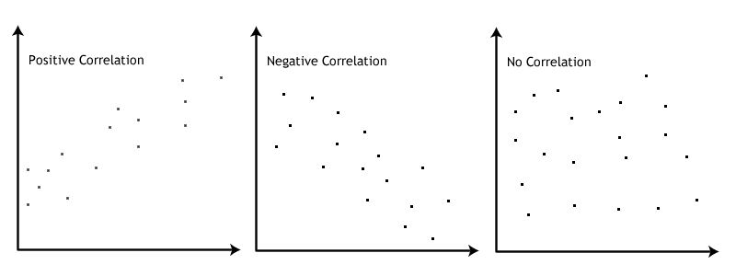
Correlation co-efficient

Correlations are designed to investigate the strength and direction of a relationship between two variables. The strength of the correlation is expressed by the correlation coefficient.
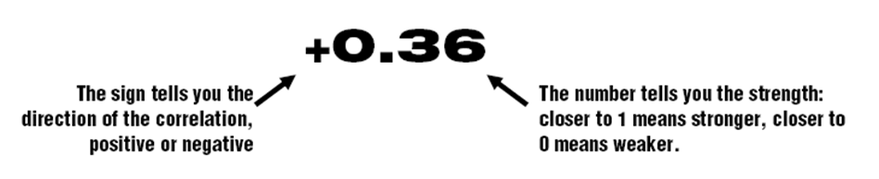
The correlation coefficient is always a figure between +1 and -1 where +1 represents a perfect positive correlation and -1 represents a perfect negative correlation and 0 means there is no correlation.
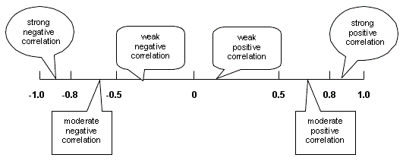

Perfect Positive
Perfect Negative

No correlation

Therefore -The closer the correlation coefficient is to 0, the weaker the correlation
The closer the correlation coefficient is to 1 or -1, the stronger the correlation
Examples…

Strong positive Moderate positive Weak negative Strong negative

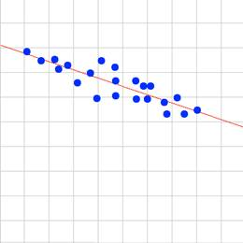
+0.8 +0.5 -0.40 -0.95
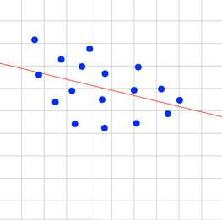

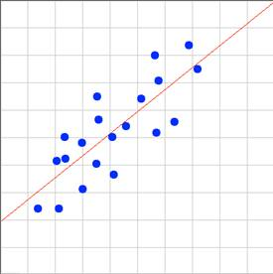
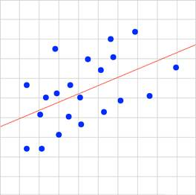
Practice – Estimate the following correlation coefficients

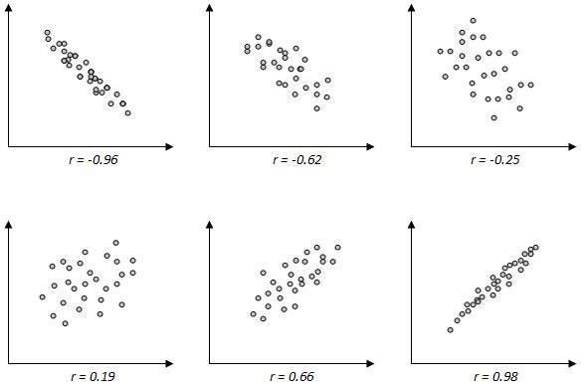

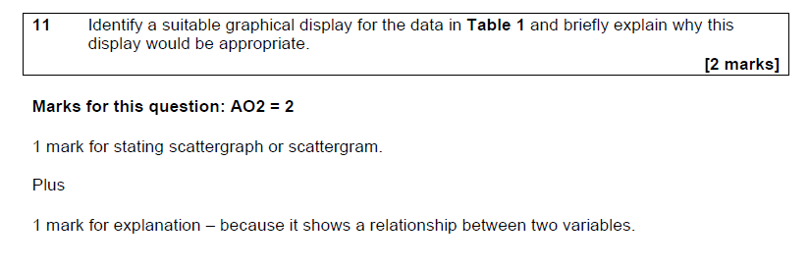
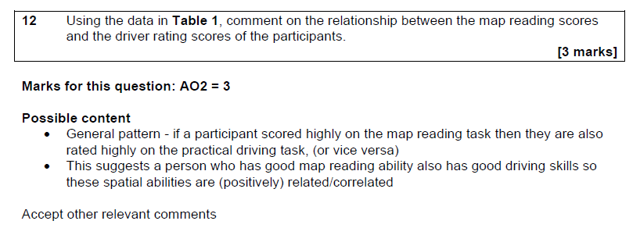
Exam Question

Table 1
Notice again how you must refer to the context of the research, the results in the table and the type of correlation for full marks

13. Normal and skewed distributions
One way data can be expressed is through distribution curves. The two main types you need to know are a normal distribution and skewed distribution.

Normal distribution

If you measured the height of all the students at BHASVIC, the frequency of these measurements would form a bell-shaped curve. This is called a normal distribution curve.
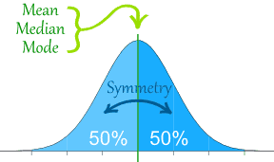
- Within a normal distribution curve, shown on the left, most of the students measured will be located in the middle area of the curve, with very few people at the extreme ends.

- The mean, median and mode all occupy the same mid-point of the curve.

- The ‘tails’ of the curve extend outwards and technically never touch the x axis (and therefore never reach zero)

Normal distribution curves have important statistical facts related to them. As seen in the curve below:-

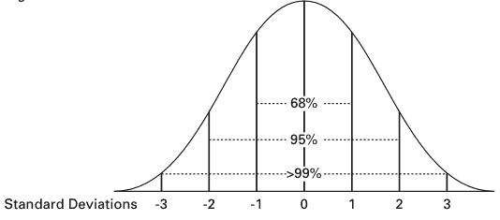
68% (68.26%) of the population fall between one standard deviation above and one standard deviation below the mean value (the middle section of the curve).

95% (95.44%) of the population fall between two standard deviations above and below the mean value

99% (99.73%) of the population fall between three standard deviations above and below the mean value

Skewed distributions (skewed means a lack of symmetry)
Not all distributions form such a symmetrical pattern. Some data from psychological scales for example, may produce a skewed distribution, in other words it appears to lean to the left or the right. Outliers (extreme ‘freak’ scores) can cause skewed distributions.
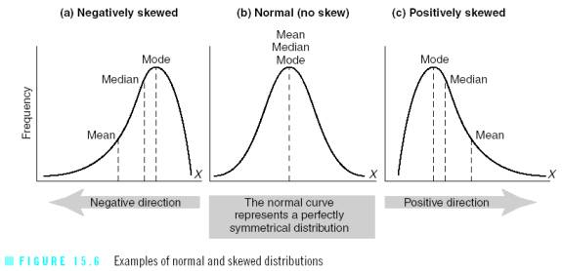

Positive skew
Shown above in (c) is a type of distribution in which the long tail is on the positive (right) side of the peak, and most of the distribution is concentrated on the left.
For example, if students were given a very difficult test in which most achieved very low marks. Only a handful got very high marks. This would produce a positive skew.
The measures of central tendency would be influenced in this situation.
- The mode, the most commonly occurring score remains at the highest point of the peak
- the median comes next
- the mean (remember how extreme scores can affect it) has been dragged across to the right. The few very high scores have had the effect of pulling the mean to the right.
- The median and mode (not affected by other scores) remain less influenced.
Negative skew
Shown above in (a) is where the opposite occurs. It’s a type of distribution in which the long tail is on the negative (left) side of the peak and most of the distribution is concentrated on the right.
For example, a very easy test would produce a distribution where the bulk of the scores are concentrated on the right- most people score very highly and only a few scored low marks.
- The mode (most commonly occurring score) remains at the highest point of the peak.
- The median will be in the middle
- The mean would be pulled to the left this time (due to lower scorers being in the minority),
You may need to sketch a distribution and describe a distribution. Always refer to the measures of central tendency and explain this in context
Exam Question

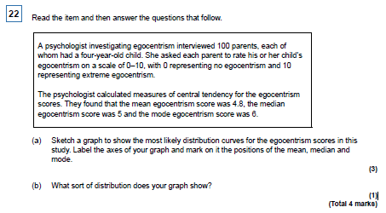

You may also need to explain and interpret distributions straight from a table of descriptive statistics- See below

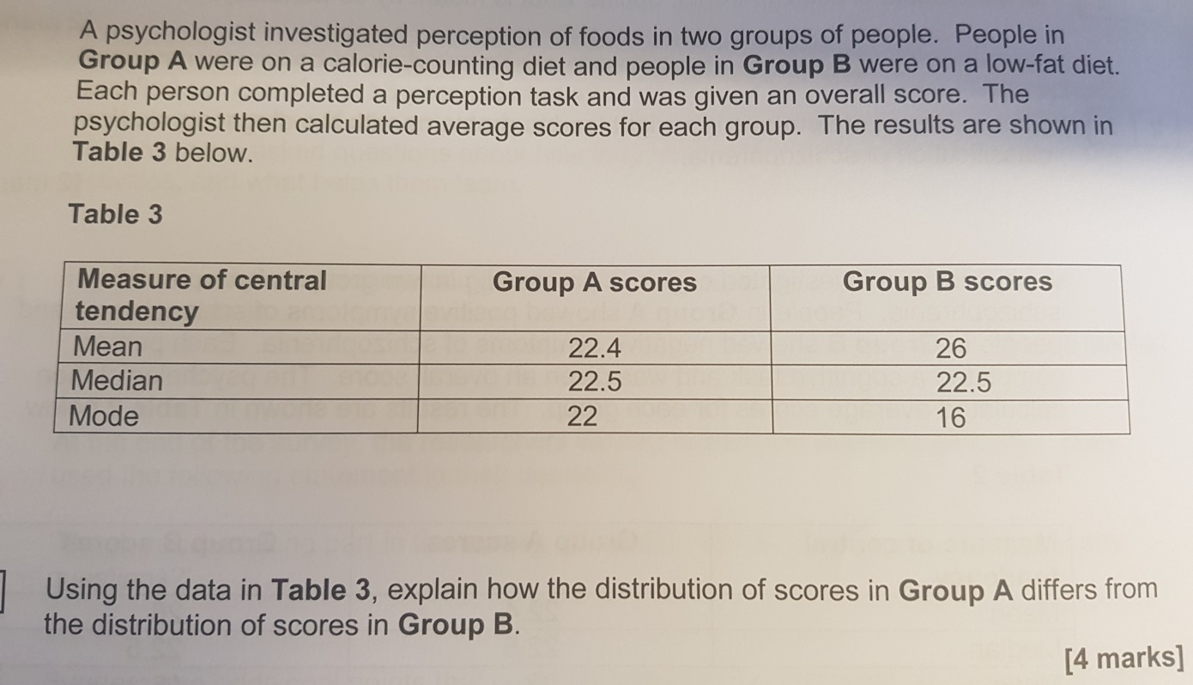

It makes sense to quickly physically sketch the two distribution graphs to assess the type of distribution or at least check your answer

Graph skills

Bar Charts

Data can be represented graphically so the difference in mean values can be easily seen. Bar charts are used when data is divided into categories, known as discrete data. Bar charts are not appropriate for continuous data

For example:

 | EastEnders | Casualty | Peak Practice | The Bill
Mean number of viewers (millions) | 15 | 10 | 5 | 7

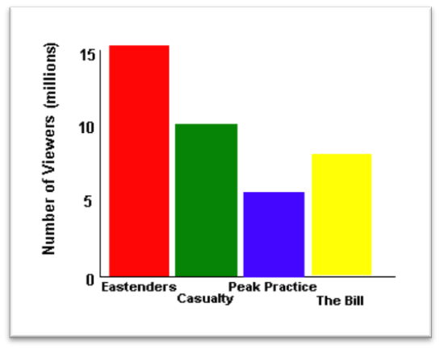
Bar chart showing number of people watching each television programme
Point to remember with a bar chart…
- Chart should be titled (difference in)
- Categories plotted on x axis (horizontal)
- Total number of each category plotted on y axis (vertical)
- Axes labelled
- Bars are separate, to show display of discrete categories

Scattergraphs (or Scattergrams)

These were mentioned earlier in this pack when we considered correlations. The scattergram below is displaying the relationship between the average number of hours children watch TV and the amount of aggressive behaviour they show.
They are only used to graphically display a relationship between 2 co-variables (a correlation- See the correlation topic previously discussed in this booklet)

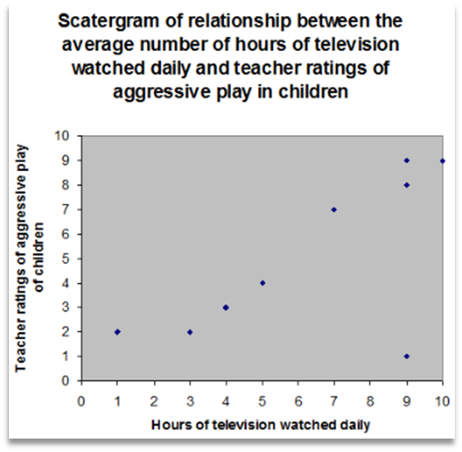
Points to remember about scattergrams…
- Should be titled (relationship between)
- One variable is plotted on the x axis, the other on the y axis (it doesn’t matter which goes where)
- Each axis should be labelled
- For each pair of scores a dot/cross is placed on the graph where the two scores meet

Histograms
In a histogram the bars touch which shows the data to be continuous, rather than discrete (bar chart).
Points to remember about histograms…
- The x axis is made up of equal sized intervals of a single category
- The y axis represents the frequency (number of people scoring a certain amount) within each interval.
- If there was a zero frequency for one of the intervals, there would be no bar
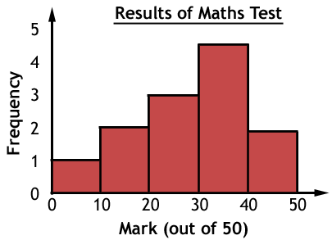

Exam Question
You may be asked to justify the choice of a graph
 | EastEnders | Casualty | Peak Practice | The Bill
Mean number of viewers (millions) | 15 | 10 | 5 | 7
For example why would the data on soap viewing be suitable for a bar chart

Answer- Because the data is categorical and in discrete categories (soaps) therefore not appropriate for a histogram which uses continuous data
You may be asked to interpret data from a graph
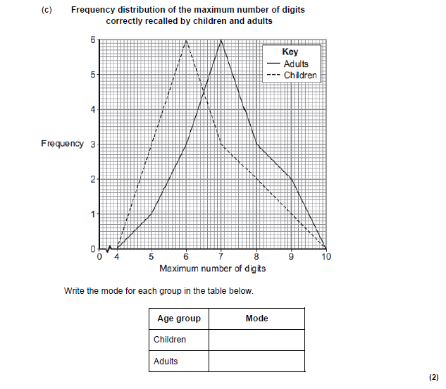

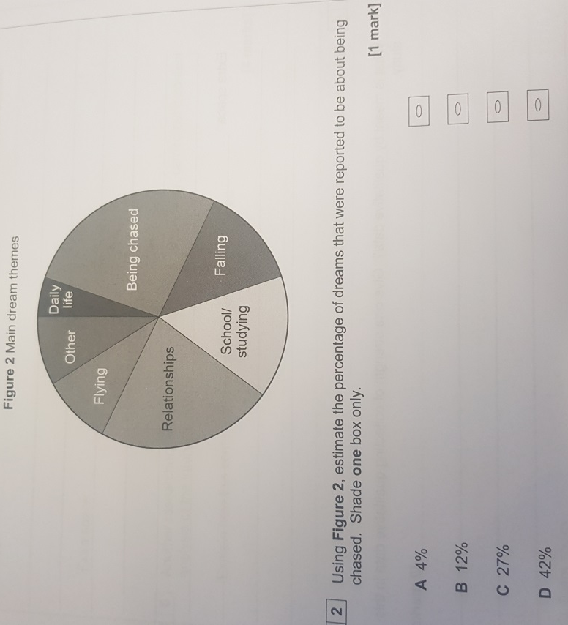

You will also need to be able to construct a graph using a data set (such as those below)

The following data were obtained in the study: The relationship between age and attitude to social care.
Sketch an appropriate graph ti display this data

Revision quiz
Now complete the following Revision Quiz to self-assess what you remember.
Every time you refresh the quiz it generates new questions

Challenge – The Sign Test
Have a go at challenging yourself and start looking at inferential statistics.
Scan the QR code to learn about the Sign Test.
This is the only Stats test you will need to calculate by hand for the Psychology Exam
Watch the first 3 mins for a bit of background on statistics. Do not worry too much about this now. This will be covered in future independent work and in your lessons.
From 3 mins in the clip start complete the following

Write the hypothesis for the study

Make notes on each step of the sign test

