Cognitive Psychology- Memory Flipped homework 1
These activities will prepare you for the next topic of study. I will expect you to know all the material that you cover in this homework. It is absolutely vital that you learn the information as you go. Don’t just complete it for the sake of doing the homework.
Doing this preparation allows you to come to class with a knowledge of all the concepts we will discuss. If you do not understand something then doing the homework in advance will give you time to look over the work a number of times before the lesson so you are completely prepared and can ask me specific questions about what you have not understood.

Task 1: Using the memory Information pack answer the questions below
Coding
- What does coding mean?
- How are things coded in the sensory register, short-term memory and the long-term memory?
- Give details of the research study (Baddeley, 1966) that was conducted to find out how information was coded in the STM and also the LTM.
Duration
- What does duration mean?
- What is the duration of the sensory register, the STM and the LTM?
- Give details of the research conducted by Peterson and Peterson (1959) to discover the duration of STM.
- Give details of the research conducted by Bahrick (1975) to discover the duration of LTM.
Capacity
- What does capacity mean?
- What is the capacity of the sensory register, the STM and the LTM?
- Give details of the research conducted by Jacobs (1887) that discovered the capacity of STM.
- What is chunking (Miller) and what does it have to do with the capacity of STM?
Using all the information from the questions you just answered draw and fill out this summary table in your notes. Example below:

 | Coding | Duration | Capacity
Sensory register |  |  | Very large capacity
Short term memory |  | 18 seconds  Peterson and Peterson (trigram study)
Long term memory

Task 2: The Multi-store model
- Watch this video link and draw an annotated diagram of the Multi-store model of memory
https://www.youtube.com/watch?v=fGY7-cxJby0
- Using the AO1 outline on this website as a guide, write a written outline of the key features and structure of the MSM and its stores:
http://aspsychologyblackpoolsixth.weebly.com/multi-store-model.html

Task 3: The working memory model
- Watch this video link and draw an annotated diagram of the Working Memory Model with information on each component of the model.
https://www.youtube.com/watch?v=IRBcKm0qJKE
NB-> Watch the whole video (so you are aware of the strengths and weaknesses of the WMM)- you do not have to make notes on the evaluation points.
- Using this website, make more detailed notes on the role and function of each store (central executive, visual spatial sketchpad, phonological loop and the episodic buffer):
- http://www.simplypsychology.org/working%20memory.html
Task 4
Copy this diagram of Types of long term memory into your notes:
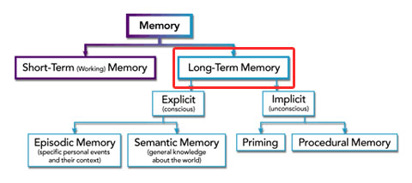

Use this website http://www.brainhq.com/brain-resources/memory/types-of-memory/long-term-memory and your cognitive information pack to makes detailed notes on:
- episodic memory
- semantic memory
- and procedural memory

