Cognitive Psychology- Memory Flipped homework 2
These activities will prepare you for the next topic of study. I will expect you to know all the material that you cover in this homework. It is absolutely vital that you learn the information as you go. Don’t just complete it for the sake of doing the homework.
Doing this preparation allows you to come to class with a knowledge of all the concepts we will discuss. If you do not understand something then doing the homework in advance will give you time to look over the work a number of times before the lesson so you are completely prepared and can ask me specific questions about what you have not understood.

Task 1
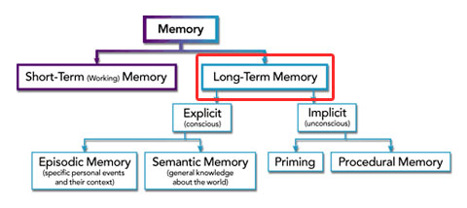
Copy this diagram of Types of long term memory into your notes:

Using your memory information pack make detailed notes on:
- episodic memory
- semantic memory
- and procedural memory

Task 2- explanations for forgetting- interference
Answer the questions below on this explanation for why we forget:
- what is the interference theory?
- What is proactive interference? Give an example.
- Give a personal example of when you have experienced proactive intereference
- What do Jacoby et al. think is the reason why this happens?
- What is retroactive interference? Give an example
- Give a personal example of when you have experienced retroactive inference

Task 3- explanations of forgetting- retrieval failure due to absence of cues
- What does this theory suggest is the reason why we forget?
- Tulving proposed the Encoding Specificity Principle (ESP), what is this?
- What is context dependent forgetting?
- Describe the details (procedure and results) of a research study that investigated context dependent forgetting (HINT: Godden and Baddeley)
- What is state dependent forgetting?
- Describe the details of a research study (procedure and results) that investigated state dependent forgetting (HINT: Carter and Cassaday)

