Unit 1
Memory
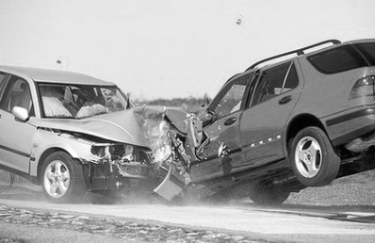
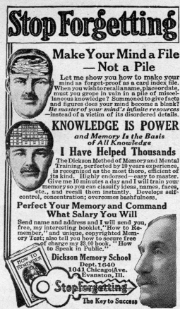

The Multi-Store Model of memory: Sensory register, short-term memory and long-term memory. Features of each store: coding, capacity and duration

Types of Long-Term memory: Episodic, semantic, procedural

The Working Memory Model: Central executive, phonological loop, visuo-spatial sketchpad and episodic buffer. Features of the model: coding and capacity

Explanations for Forgetting: Proactive and retroactive interference and retrieval failure due to absence of cues

Factors Affecting the Accuracy of Misleading information, including leading
Eyewitness Testimony (EWT): questions and post-event discussion; anxiety

Improving the Accuracy of EWT: The use of the cognitive interview

Multi-store model of memory (MSM)

Key Terms

Sensory register: The first store which holds the sensory information received through all the senses for a brief period of time. Examples include iconic (visual) and echoic (sound) memory.

Short-term memory: The memory for immediate events. These memories tend not to last for more than a minute or two, usually shorter, and disappear unless they are rehearsed. Capacity is limited to 7 plus or minus 2 individual items.

Long-term memory: The memory for past events that can last for the life-time of a person. Its capacity is most probably unlimited

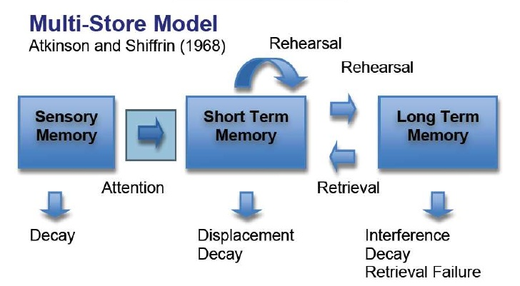
Prolonged
Maintenance
Key features of the MSM

- Information flows through a number of storage systems in a linear fashion (in a line)
- There are three main storage systems which are unitary (each a single unit)
- Each store differs in terms of:
- Coding – the form in which the information is stored
- Capacity – how much information can be stored
- Duration – how long information can be stored for
- Information can remain in short-term memory by maintenance rehearsal, and prolonged rehearsal (sometimes called elaborative rehearsal) will create a long term memory.
- The more information is rehearsed, the better it is remembered
- Information can be lost from each store, but in different ways

Describing the MSM

When describing or outlining the MSM, you need to include detail on the key features of the model (see above) as well as information on coding, capacity and duration of each store.

Here is an example of the kind of detail you would need for a 6 mark answer:

- The multi store model consists of three unitary stores; the sensory register, short term memory (STM), and long term memory (LTM). Information flows through these stores in a linear way.
- Information from the environment will pass into the sensory register along with other sights, sounds, smells etc. The two main stores in the sensory register are echoic, which is sound or auditory information and iconic which is visual information.
- Material in the sensory register only lasts very briefly, less than 3 seconds, but has a high capacity.
- Information from the sensory register only passes through into STM if we pay attention to it.
- STM has a limited capacity, 7 +/- 2 item, and information in STM has a duration of up to 30 seconds. If information is rehearsed it will be kept in STM, if not it will be lost. Information is usually encoded acoustically in STM.
- Repeating information over and over again is called maintenance rehearsal. If we rehearse the information for long enough it will pass to LTM and remain for a life time although loss is possible. Encoding here is semantic, and the capacity is unlimited with information lasting for a very long time.
- Although the information is stored in LTM when we want to recall it, it has to be transferred back to STM by a process called retrieval.

Evaluation of the Multi-Store Model of Memory

Supporting Evidence  (primacy-recency effect) | 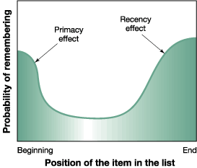  P – There is research that supports the separate stores identified in the Multi-store model.  E- Glanzer and Cunitz found that if participants were allowed to immediately recall a list of one syllable words they were asked to remember, they could remember the words at the beginning and the end of the lists, but not the words in the middle. This is known as the primacy-recency effect (first and last).  E- This supports the MSM in that the words at the beginning of the list are rehearsed and therefore placed in LTM, but the words in the middle of the lists are quickly displaced by rehearsing the first words. The words at the end of the list are remembered because they are still fresh in STM.  L- These findings support the distinction of STM and LTM and the role of rehearsal in passing information from STM to LTM.
Fails to explain why information can transfer to LTM without rehearsal | P- The MSM can be criticised for failing to explain why in our day to day lives a lot of information can transfer to LTM without prolonged rehearsal.  E- Craik and Lockhart suggested that enduring memories are created by the processing that you do, rather than through maintenance rehearsal, things that are processed more deeply are more memorable just because of the way they are processed ‘Deep’ means doing more complicated things with the item to be remembered rather than just repeating it.  E- Craik and Tulving (1975) gave participants a list of nouns (e.g. shark) and asked a question that involved shallow or deep processing – asked whether the word was printed in capital letters (shallow) or asked wither the word fitted in a sentence (deep). The participants remembered more words in the task involving deep processing rather than shallow processing.  L- This research contradicts the original claim that for memories to be transferred into LTM, maintenance rehearsal (verbal repeating) is required. Thus giving doubt to some of the assumptions of the multi-store model.
The STM and the LTM should not be considered a unitary store. | P- There is evidence to suggest that both the STM store and the LTM store should not be considered unitary stores.  E- In a case study, after a virus caused damage to the hippocampus, Clive Wearing had very little long term memory for events that had happened in his life but could still remember skills such as playing piano, reading music and writing in a diary.  E- This evidence challenges the idea that LTM is a unitary store.  L- It demonstrates that it may store and process episodic (memory for events) and procedural (skills) long term memories differently. As a result, the tripartite approach to describing LTM was introduced.

Features of each store: Capacity, Duration and encoding

Nature of The Sensory register
Encoding of SR
There is very little coding in the sensory register. Information enters the memory system through our senses, and it is thought that everything we see, hear, touch, smell and taste enters sensory memory (sensory register) and remains in its raw form. There are different registers of each sense, for example.
- Iconic register: memory for visual information
- Echoic register: memory for auditory information
- Haptic register: memory for touch

Duration of SR
Between the sensory register and short-term memory there is a filter called ‘attention’. It is believed that information that is not attended to is lost very quickly.

According to research, iconic memory (visual information) has a very short frequency, maybe up to ½ a second (500 milliseconds). It is a little longer in echoic memory (auditory information), with information remaining for about 3 seconds. Iconic memory is thought to cause the impression of an illuminated line when you wave a sparkler on bonfire night, you can even spell out someone’s name.

Capacity of SR

The capacity of the SR is very large, with the information contained being in an unprocessed, highly detailed and ever-changing format

Research Supporting the capacity and duration of the Sensory register
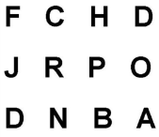
Sperling presented participants with a number of grids each containing three rows of four letters for 1/20th (50 milliseconds).

When asked to recall the whole grid Participants could only recall 4 or 5 letters HOWEVER many claimed to have seen more. Sperling assumed this happened because, while all letters had entered the SR they had faded before most of them could be reported. So Sperling tested this claim…

…This time he asked participants to recall only part of the information. He showed the 4x5 grid and then asked them to recall 1 of the rows either top, middle or bottom. This time recall was very good and suggested Iconic memory could hold 9 or 10 items.

Two main Conclusions…
Capacity - The fact that Participants did not know which line they would be asked to recall, yet had much better recall than the original experiment suggests that all of the letters in the grid had been available. Demonstrating the capacity of the sensory register is larger than 4/5 letters.

Duration – The time it takes to report the letters in 1 row is much quicker than reporting the whole grid, therefore the issue of letters fading is avoided, thus recall is very good compared to recalling the full grid. This suggests that while the capacity of the SR may be large the duration is very limited at approximately 0.5 seconds.

Nature of Short term memory
Supporting research for capacity of STM

Jacobs (1887) Participants were presented with a sequence of digits or letters and required to repeat them back in the same order (for example, 6,3,8,9,4,7,2 or G,S,T,J,W,V,K,L). The pace was controlled at half second intervals using a metronome. The procedure was repeated a number of times and the longest list of sequences that was correct 50% of the time was taken as the participant’s digit span.

Jacobs found that participants recalled more digits than letters. The average span for digits was 9.3, whereas it was 7.3 for letters. Jacobs also found that capacity increased steadily with age; in one sample of school girls he found that 8 year olds remembered an average of 6.6 digits whereas for 19 year olds it was 8.6 digits.

The capacity is usually phrased as 7 + or – 2, so the capacity of STM is known as 7+ or – 2 items.

Capacity of STM

How much information can be held in STM is limited.

It is universally agreed that people can hold about seven items in STM. (however this may vary depending on the type of information it is)

Supporting research of duration of STM

Peterson and Peterson (1959) investigated how long simple information stays in short term memory (STM) without repetition. On each trial the participants saw a trigram, which consisted of three consonants (e.g. BVM, CTG). A different trigram was used for each trial. They were asked to recall each trigram after a delay of seconds: 3,6,9,12,15 or 18.

Once they were shown the trigram they had to perform an interference task, which prevented repetition of the trigram in STM. They were shown a random three digit number (e.g.866, 532) and had to count backwards from it in threes. After the appropriate time delay the trigram had to be recalled.

The longer the time delay, the more the forgetting occurred in STM. After 3 seconds 90% of the trigrams were recalled, but after 18 seconds only 5% of the trigrams were recalled. Therefore it was concluded that information is lost rapidly from STM when there is no opportunity for repetition. Without repetition, STM lasts for little longer than 18 seconds. (most textbooks refer to 15-30 seconds duration)

Duration of STM

How long information can stay in short-term memory ranges from a few seconds up to a minute, but for most of us, it is somewhere in between 15 - 30 seconds. However this can be extended due to rehearsal.

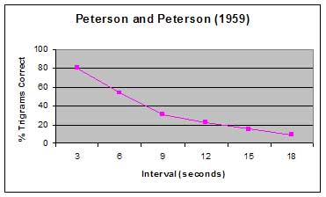

Coding in STM

In short term memory (STM) it is widely accepted that the coding is mainly acoustic. When a person is presented with a list of numbers and letters, they will try to hold them in STM by rehearsing them (verbally). Rehearsal is a verbal process regardless of whether the list of items is presented acoustically (someone reads them out), or visually (on a sheet of paper).

However, it is also recognised that visual coding does occur in STM, as does some semantic coding.

Supporting research for Coding in STM

Baddeley(1966) divided participants into groups (independent groups design) and gave them different lists of words to learn:

Acoustically similar | Acoustically dissimilar | Semantically similar | Semantically dissimilar
man, mad, map | pen, day few | great, big, large | hot, old, late

In the short term memory condition they had to recall the words in the correct order immediately after hearing them.

Results - In this condition - Recall of acoustically similar lists were remembered poorly, with a correct recall of about 10%. Whereas the acoustically dissimilar list was recalled the best at around 60-80%.

Conclusion – The fact the acoustically dissimilar words were recalled more accurately suggests that the STM is not getting muddled based on the sound of the words. However the acoustically similar words are recalled poorly and getting confused suggesting the STM relies on the acoustic coding.

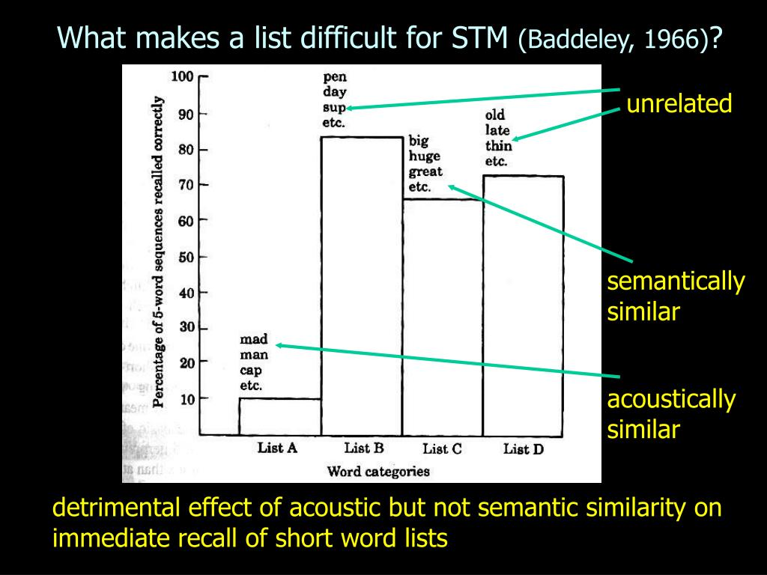

Nature of Long term memory
Supporting research of LTM
Konkle (2010) Presented participants with 2912 pictures of scenes at 3 seconds per scene followed by a test of recognition memory. The scenes belonged to a total of 128 different general categories. Long-term memory for these scenes was very good. When participants chose between a previously presented science and a new scene from a category not used during the initial presentation, they were correct 96% of the time.

Capacity of LTM

The capacity of LTM is generally accepted to be unlimited. Therefore, no matter how much information is stored long-term, the store never becomes full.

Supporting research of LTM
Bahrick et al. (1975)

A sample of 392 American ex-high school students aged from 17-74 were asked to remember the names of their classmates (free recall) and also shown faces and names of classmates and asked if they recognised them.

high-school year-books were used to check the names and pictures.

Results: There was 90% accuracy in face and name recognition, even with those participants who had left high-school 34 years previously.

After 48 years this was 80% for name recognition and 40% for face recognition. Free recall was less accurate: 60% after 15 years and 30% after 48 years.

Bahrick et al concluded that peoples’ long term memories can last for their whole life, even though they may weaken over time. Recognition is better than recall.

Duration of LTM

This is dependent of the person’s life span, as memories can last up to a life-time. Information that is processed at a deep level is likely to be remembered for longer, and memories based on skills rather than facts tend to be remembered better.

Supporting research for Coding in LTM

Baddeley(1966) divided participants into groups (independent groups design) and gave them different lists of words to learn:

Acoustically similar | Acoustically dissimilar | Semantically similar | Semantically dissimilar
man, mad, map | pen, day few | great, big, large | hot, old, late

In the long term memory condition they had to recall the words in the correct order 20 minutes after hearing them.

Results: In LTM, recall of semantically similar lists were recalled the worst, with a correct recall of 55%. With the other lists, accurate recalled was much better, between 70% – 85%, with acoustically dissimilar words recalled the best.

Conclusion: as semantically dissimilar words were recalled more accurately than semantically similar words, there must be some semantic confusion in LTM during recall, which suggests that coding is semantic.

As there was little difference in recall for the acoustically similar and dissimilar words, this would suggest that the sound of the words is not the coding used in LTM.
Coding in LTM

It is widely acknowledged that information is coded semantically in LTM, especially for verbal information. This means that information is stored in LTM when it has meaning or in other words, some relevance or importance to us.

However, there is some evidence for both visual and acoustic encoding in LTM.

Summary of the research into coding, capacity and duration

 | Sensory Register |  | Short-term memory |  | Long-term memory
Coding | Separate sensory stores for different sensory inputs | N/A | Mainly acoustic (by sound) but other codes used too | Baddeley (1966): immediate recall condition | Mainly Semantic (by meaning) other codes used too | Baddeley (1966): delayed recall condition
Capacity | Very large | Sperling (1960) | Small chunks of information (5 – 9 items or 7+/-) | Jacobs (1887) | Unlimited | Konkle (2010)  96% ACCURACY OF 2192 SCENES.
Duration | Brief (between ½ and 3 seconds) varies between sensory stores | Sperling (1960) | Short (maximum of 30 seconds) | Peterson and Peterson (1959) | Potentially for a life time | Bahrick et al (1975)

Look carefully. it might appear that you have loads of studies to learn for the nature of memory, But there are only 6 studies – some can be used more than once.
Evaluation of the research

 | Laboratory environment | Much of the research conducted uses the experimental method and therefore means that extraneous variables are controlled. For example in Peterson and Peterson’s study of duration of the STM, the distraction task meant that participants were prevented from using techniques such as rehearsing the trigram and therefore the variable of duration could be manipulated in order to establish cause and effect. However critics have argued that the distraction of counting backwards actually led to the trigrams being DISPLACED rather they ‘fading’. Therefore the scientific rigour of the laboratory method strengthens claims made by the likes of Peterson but there is some scope for argument.  This point can be applied to a range of concepts: Baddeley, Sperling, Jacobs ect.
 | Artificial nature of the research | The Highly artificial tasks that are used in memory experiments mean that we know very little about how memory operates in real life settings. For example trying to memorise strings of digits (Jacobs) or consonant syllables (Peterson and Peterson) does not reflect memory in everyday life. Although it must be noted that we do occasionally try to remember fairly meaningless things such as phone numbers or postcodes. This matters because the studies may lack ecological validity and therefore make it very difficult to generalise the conclusions to explain the complexity of memory in the real world, they simply tell us how people recall digits, trigrams or word lists under very strict laboratory conditions.  (For example March et al (1997) showed that if people were not expecting to have to recall information, STM had a maximum duration of four seconds).
 | Practical applications | A strength of research into the nature of memory is that it has positive real world benefits. Information about the capacity of STM is useful for teachers, students and anyone else who needs to know the cognitive limitations of people. For example teachers can plan lessons in ways that reduce the amount of new information that needs to be held in the STM and create tasks which enabled students to transfer information into the LTM where the capacity is much larger. Similarly simple initiatives such as the postcode system uses Miller’s research of Chunking, whereby the limited capacity of the STM can be increased if we group digits together. Therefore research is important as it has led to techniques to improve the limits of the memory.

The Working Memory Model (WMM) - Baddeley and Hitch (1974)

After the development of the multi-store model, research questioned the existence of a single STM store. Because we actively process information in STM, it is far too complex to suggest that STM is just a temporary store for transferring information into LTM. Baddeley and Hitch (1974) devised the ‘working memory model’ in an attempt to demonstrate what is happening to information when we are consciously thinking about it. Cohen described the WMM as the explanation of conscious thought happening ‘now’.
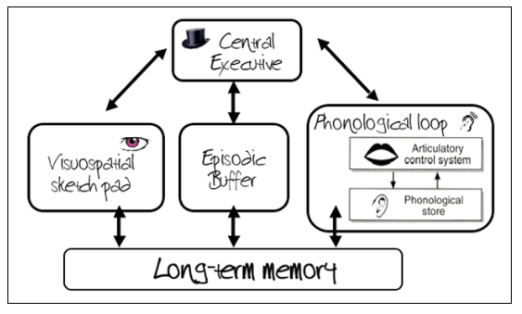
NB: Although LTM is shown here, it is not actually part of the working memory model.

The Central Executive

The function of the central executive is to direct attention to particular tasks, determining how the brain’s resources are allocated to tasks. The CE attends and monitors incoming information from the senses or LTM and this information is then sent to the other slave systems for processing and temporary storage. The CE has very little capacity so it cannot attend to too many things at once, and it has no capacity for storing data.

The Phonological Loop

The phonological loop has a limited capacity and its function is to store speech-based sounds for brief periods. It has two components:
- The phonological store
Allows acoustically coded items to be stored for brief periods (someone talking, a melody etc.) Hence its nickname - The Inner ear.
- The articulatory control process
Allows sub vocal repetitions of items in phonological store. This is similar to maintenance rehearsal. Hence it’s nickname - the inner voice.

The Visuo-Spatial Sketchpad

The VSS processes and stores mental images in terms of what they look like and their place in the visual field. It is independent from the phonological loop, and has a limited capacity.
It is used when people are planning a spatial task, like moving from one room to the next, reaching for their cup of coffee etc. Hence it’s nickname – the inner eye.

The Episodic Buffer

Added in 2000, the episodic buffer is a general store that allows both sound and visual information to be bound together.
It integrates information from the other systems and also offers a sense of time sequencing.
It records events (episodes) that are happening and sends information to LTM.
Like all the systems in working memory, it has a limited capacity.

Evaluation of the working memory model

Supporting evidence:  Separate existence of stores | P- There is evidence to support the limited capacity and separate nature of the slave systems, demonstrated by research into dual-task performance.  E- Gathercole and Baddeley (1993) found that participants had more difficulty doing two visual tasks (simultaneously tracking a moving point of light and describing the letter F) than doing both a visual and verbal task at the same time.  E-This increased difficulty is because both visual tasks compete for the same slave system, whereas when doing a verbal and visual task simultaneously, there is no competition.  L- The evidence indicates that the VSSP and the PL are separate slave systems but also demonstrates the limited capacity of the VSSP.
There is a lack of clarity over the central executive | P- The WMM can be criticised because there is a lack of clarity over the central executive and the exact role it plays in the model.  E- Baddeley acknowledges this flaw in the model when he stated in 2003 “The central executive is the most important but the least understood component of working memory.”  E- Evidence to support this argument was conducted by Eslinger and Demasio (1985. . They reported on the case study of EVR who had a cerebral tumour removed. He performed well on tests of reasoning, which suggests that his central executive was intact; however, he had poor decision-making skills, which suggests that his central executive was not wholly intact.  L- This suggests that the original concept of the central executive needs to be more clearly specified than just being simply ‘attention’ and that perhaps it may consist of separate components.
Comparison to MSM | P- The WMM compares favourably to the MSM. It attempts to explain how memory functions, as opposed to simply describing the structure of memory.  E- As a result of this, it has led to a greater understanding of cognitive dysfunction e.g. ADHD and dyslexia which are thought to be linked with impairments of working memory.  E- Research has led to a number of methods being developed to help children with ADHD focus on tasks e.g. use brief and simple instructions so they don’t forget what they are doing (limited capacity of phonological loop).  L- The development of the working memory model has many tangible benefits that clearly demonstrate the value of the model. In comparison, the practical applications of the MSM are limited.

Types of Long-Term memory - Episodic, semantic and procedural

One of the major limitations of the MSM is that its description of LTM as a single unitary store is now seen as outdated. Many research studies have shown that there are at least three different types of long-term store

Episodic Memory:
- First suggested by Tulving (1972), it is the type of long-term memory that gives individuals an autobiographical record of things that have happened to them (our memories of our experiences). In other words, it is the storage of episodes that happen throughout our lives. Examples of episodic memories are your 7th birthday party, your last holiday, what you did last night, your first kiss etc.
- Think of episodic memories in terms of 3Ws, containing information about what happened, where it happened, and when it happened. Individuals tend to see themselves as actors in these events, and the emotional charge and the entire context surrounding an event is usually part of the memory, not just the bare facts of the event itself. Furthermore, having episodic memory allows us to make predictions about what will happen to us in the future.
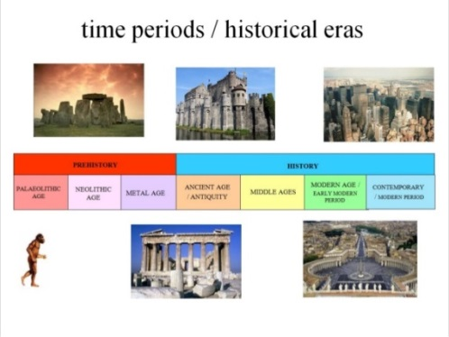
- That is not to suggest that episodic memories contain exact reproductions of what happened. It is suggested that episodic memories are constructed, rather than reproductive, and is prone to errors and illusions. The section on eye-witness testimony will explore this further, but our episodic memories are subject to stereotyping, subjective interpretation, missing out information or adding in missing parts.

Semantic Memory:
- This is a structured record of facts, meanings, concepts and knowledge about the external world that we have acquired. It refers to general factual knowledge, shared with others and independent of personal experience and of the time and place in which it was acquired.
- Semantic memories may once have had a personal context, but now stand alone as simple knowledge. It therefore includes such things as types of food, capital cities, social customs, historical dates, functions of objects, vocabulary, understanding of mathematics, etc.
- There is an enormous amount of information available in semantic memory, and is continually being added to.

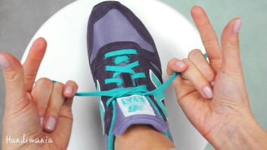
Procedural Memory:
- This differs from the other two types of long-term memory, as it tends to be unconscious, whereas the other two are conscious. Procedural memory (“knowing how”) is the unconscious memory of skills and how to do things, particularly the use of objects or movements of the body, such as tying a shoelace, playing a guitar or riding a bike.
- These memories are typically acquired through repetition and practice, and are composed of automatic sensorimotor behaviours that are so deeply embedded that we are no longer aware of them. Once learned, these "body memories" allow us to carry out ordinary motor actions more or less automatically. A good example of this is learning how to drive a car. Initially it is very difficult, but with repeated practice it becomes ‘second nature’.

Evaluation of the different types of Long-term memory

Supporting evidence  (biological evidence) | There is evidence to suggest that when a person uses episodic memory, they use a different region in the brain compared with when they use semantic memory. Tulving (1989) injected himself, his wife and 4 others with particles of radioactive gold that he could use to track brain blood flow in a scanner. He scanned each person’s brain whilst they thought about historical facts or childhood experiences. He found in 3/6 participants (including himself), that when they were thinking about historical facts blood flow increased at the back of his brain, whereas when he thought about childhood experiences blood flow increased at the front of his brain. The activation of the different areas of the brain when recalling facts or episodes suggests a biological basis to the different types of memory in LTM
Supporting evidence  (case studies) | In the case of Clive Wearing, as illness caused the near total destruction of his hippocampus. This left him with an inability to store new episodic or semantic information for any more than a few seconds. However, he was perfectly able to read, write, speak and play piano.  Other researchers investigated learning in people with Huntingdon’s Disease (a progressive, degenerative disease of the brain). They found that HD patients had no problems learning new facts and knowledge, but had severe problems learning new motor skills.  These findings give a strong indication that damage to specific areas of the brain leave the patients with deficits in one or more types of long term memory, whilst leaving other long-term memory stores intact, this offers support for the biological basis of separate long-term stores
Challenging research | Critics challenge the need of distinguishing between types of LTM. Cohen and Squire suggest that semantic and episodic memory should be understood as the same type of memory, called ‘declarative memory’, and research by Kan et al (2009) found that there was interdependence between episodic and semantic memory. Whether there are two or three types (or more) of LTM may be important when attempting to help people recover their cognitive functions after illnesses such as stokes.  (Counter point for extension: Being able to identify different aspects of LTM has led to psychologists targeting specific kinds of memory to make people’s lives better. Belleville et al (2006) demonstrated that episodic memories could be improved with training in older patients with mild cognitive impairment. This shows that the tripartite division of long-term memory has had tangible benefits for people with cognitive impairment, making it a useful theory).

Explanations for Forgetting: Interference and Retrieval failure

Proactive and retroactive interference

Interference theory suggests that forgetting is due to information in LTM becoming confused with or disrupted by other information during coding, leading to inaccurate recall. There are two types of interference: proactive and retroactive

Proactive Interference

This involves memory impairment for something we have learned by other learning that had occurred previously. In other words, old information interferes with the new information. Imagine that you had already learned Spanish, and later learned French, then some of the Spanish would interfere with you trying to speak French.

Jacoby et al (2001) argued that proactive interference occurs because of competition between the strength of the old learning and the weakness of the new learning. If you try to use a new password for an online transaction, the strength of an old password will interfere, and you lose the ability to recall the new one. Perhaps a more damaging example is calling your new partner by your old partner’s name!

Retroactive interference

This involves the disruption to recall of previously learned material by the interference of newly learned material (newer information interferes with older information). For example, the learning of a new car registration number plate disrupts the recall of the old one.

Evaluation of interference theories of forgetting

Supporting evidence | There is research to support the impact of old information interfering with new information. Underwood (1957) showed that participants, who were repeatedly asked to learn series of word lists made far more errors as the number of lists increased, compared with when they first began the study. As the participants made more errors in the word lists shown at the end of the study, this demonstrates how the old information (the first word lists) was interfering with the newly learned information (the most recent list), which is what proactive interference would predict.
Supporting evidence | Schmidt et al. (2000) collected a sample of 211 former students of a Dutch elementary school and sent them a map of the surrounding area of the school. The map had the street names removed and replaced with numbers from 1 – 48. Participants were asked to name as many as they could. The researchers found that there was a positive association with how many times the participants had moved outside the area, and the number of names forgotten. The researchers concluded that learning new street names (when they moved house) made recalling the old street names more difficult. This demonstrates that retroactive interference plays a role in forgetting because the new information interferes with the old information. It also shows that interference is key in forgetting and not just the amount of time that has passed. This is because increased forgetting was due to how many times they had moved not how long along they moved out of the area.
Fails to explain | The explanations are limited due to the focus on interference of very similar types of information. For example how one list of words interferes with another list however interference theories fail to explain how forgetting information, skills or other information happens in the majority of real life settings, where we are not juggling with similar material and yet still manage to forget a lot of what we experience. Therefore the explanations may be able to tell us how interference affects our memories in artificial situations, and of very similar types of information, but they do not explain most cases of forgetting in real-life.

Retrieval failure due to absence of cues

The reason that people forget information is because there are insufficient cues. When information is placed in memory, their associated cues are stored at the same time. If these cues are not available at the time of recall, then there is an appearance that the information has been forgotten. This theory suggests that the information is still available for recall, but it cannot be accessed until the correct cues are in place.

Tulving (1983) referred to what he called the Encoding Specificity Principle (ESP). This states that a cue is going to help us remember information; it has to be present during encoding (when we learn the information) and at retrieval (recall). If the cues at encoding and retrieval are different then some forgetting will occur. For example, if you revise at college, you are more likely to retrieve the information than you are if you revise at home, as the college will act as a cue for retrieval because the surroundings were there during encoding.
Context dependent forgetting:

This refers to external cues that are different when encoding information and when retrieving it. This is illustrated in to example above (college vs home revision)

State-dependent forgetting:
This refers to internal cues (states of awareness) that are different during encoding information and retrieving it. An example is encoding information while under the influence of alcohol, only to forget it the next day.

Evaluation of Retrieval failure due to absence of cues

Supporting evidence: context dependent forgetting | There is evidence supporting the role of context to explain why we forget. Godden and Baddeley (1975) studied deep water divers and the effects of context dependent memory. Participants had to learn lists of 36 words (two or three syllables) either on land or underwater and then recall them either on land or underwater. The percentage of accurate recall is shown for the 4 conditions below:  Learn on land – recall on land (same context) Recall accuracy = 37% Learn underwater – recall on land (different context) Recall accuracy = 23%  Learn on land – recall underwater (different context) Recall accuracy = 24% Learn underwater – recall underwater (same context) Recall accuracy = 32%  The higher percentage recall in the matched environments support the prediction that if the cues at encoding are the same as the cues at retrieval, recall is more likely, and if they are different, recall is less likely. This supports the concept of context dependent forgetting
Supporting evidence: state dependent forgetting | There is evidence which highlights the impact of your internal state on learning and recall. when Carter and Cassaday (1998) gave anti-histamine (anti-allergy) drugs or a placebo (vitamin pills) to participants (students from Nottingham University). Anti-histamines have a mild side-effect of causing drowsiness and therefore altering the state of awareness for the participants. Participants were asked to learn and recall information in four different conditions.  The results showed a marked decrease in accuracy of recall in a memory test when the participants’ internal state did not match at the time of encoding and retrieval, and an increased performance when the internal states did match.  This supports the concept of state dependent forgetting, as when the internal cues were different during encoding and retrieval, recall of a list of items was worse, as predicted by the theory.
Ability to generalise | Baddeley (1997) argued that these studies do not reflect real-life, and therefore the strength of the explanations should be questioned.  He claimed that the contexts or states have to be very different to have an effect and subtle changes of environment or internal states, that tend to be the norm, will not have a strong effect.  We must not make exaggerated claims about cue dependent forgetting based on evidence that alters both context and state in a dramatic way.
Applications | In places where getting instructions correct is absolutely vital, such as soldiers in novel environments, it is important to recognise that instructions maybe more likely to be forgotten if issued back in the safety of the camp.  This would be true for many different people, such as deep water divers repairing oilrigs, astronauts, medics etc. therefore care must be taken to recognise this, and much practice in different scenarios required  The value of these explanations maybe that they are used to save the lives of people in threatening and novel situations

Factors affecting the accuracy of Eyewitness Testimony (EWT)

Eye witness testimony is defined as an account or evidence provided by people who witnessed an event, such as a crime, reported from their memory.

In appeals against conviction in the United States, DNA evidence has overturned over 200 cases and in 75% of these, eye-witness testimony was the main evidence against them. In a famous case, Cornelius Dupree had spent 30 years in prison for rape because the victim incorrectly identified him as the perpetrator. DNA evidence proved that he was innocent, and the conviction was quashed.

Many variables can influence the accuracy of eye-witness testimony. These include being presented with misleading questions during police interviews, post-event discussion with other witnesses, and the anxiety that people feel if they witness or are a victim of the crime.

Misleading information

Most cognitive psychologists agree that our memories for events are not precise copies of what happened, as you might see if you were filming it. Instead, we only accurately retain fragments of the information, and fill in the gaps. This reconstruction of events leads to inaccuracies in recall, which can be compounded if we receive information after the event which distorts our original memory. For eye-witnesses to an incident, a subtle change in the wording of a question can have dramatic effects on what they recall, as is demonstrated by the findings of the study below

Key study: Loftus and Palmer 1974

Two experiments are reported in which subjects viewed films of automobile accidents and then answered questions about events occurring in the films. In experiment 1, 45 university students were divided into 5 conditions. The question “About how fast were the cars going when they smashed into each other?” elicited higher estimates of speed than questions which used the verbs collided, bumped, contacted, or hit in place of smashed. (see table 1 below).

Table 1: results for Loftus and Palmer (1974) leading question experiment:

Word | Average speed estimates
Smashed | 40.5 mph
Collided | 39.3 mph
Bumped | 38.1 mph
Hit | 34.0 mph
Contacted | 31.8 mph

In a second similar experiment, 150 different students were split into three conditions, one condition were asked the question with ‘smashed’, the other condition were asked the question with ‘hit’ and the other condition had no question (control). On a retest one week later, those subjects who received the verb smashed were more likely to say “yes” to the question, “Did you see any broken glass?”, even though broken glass was not present in the film (see table 2 below).

Table 2: results for Loftus and Palmer (1974) broken glass experiment

Response | Smashed | Hit | Control
Yes | 16 | 7 | 6
No | 34 | 43 | 44

In both of these experiments, it can be seen the memory of the incident was changed due to the leading question in the first experiment. These results get are consistent with the view that the questions asked subsequent to an event can cause a reconstruction in one’s memory of that event.

Evaluation of misleading information effect on EWT

Validity | P- There is an issue with the validity of Loftus and Palmer’s research.  E- A witness to a real-life car crash is likely to experience a greater emotional response compared with watching one on film, which research has shown may affect the memory of the witnesses in this study.  E- Other critics suggest that the participants may have worked out the aims of the study, and on hearing the word ‘smashed’, gave the higher answer that they thought the researcher was hoping to get (demand characteristics).  L- If either criticisms are correct, then the findings of these experiments tell us little about real-life eye witness testimony.
Reliability | P- The reliability of research in this area can be praised as many laboratory studies have found similar findings when participants are faced with leading questions.  E- However one experiment found that leading questions did not change the accuracy of the EWT when the misleading information was obviously incorrect.  E- Loftus (1979) showed participants slides that showed the theft of a large purse from a handbag. 98% of the participants remembered the correct colour of the purse. They were then asked to read an account of the incident that was allegedly written by a professor of psychology. In this account, the professor stated that the purse was brown, a false statement as the original colour was red. Only 2 participants changed their answer to brown on a subsequent test, with most keeping to their original identification of a red purse.  L- This means we cannot reliably conclude that all misleading information will have the same effect in all circumstances. The testimony is unlikely to change if the information they receive and the event they witnessed was obviously different.
Applications | P- Research into misleading information has led to some important practical applications.  E- For example, it has been used to train professionals e.g. the police not to use leading questions when questioning witnesses. In addition, psychologists (in conjunction with legal representatives) have also used research in this area to develop the cognitive interview, designed to increase the accuracy of eye-witness testimony.  E- As a result, this has led to positive economic implications. It has helped to conserve limited police resources and money by reducing the likelihood of police officers obtaining inaccurate information about criminal suspects.  L- This demonstrates the importance and value of the research conducted into misleading information and the positive impact it can have on obtaining accurate witness testimonies.

Post-event discussion

Co-witnesses are likely to discuss the event with eye-witnesses and this could be a source of further distortion. 58% of eye-witnesses had reported discussing the incident post-event with other witnesses (Skagerburg and Wright, 2008)

Errors in eyewitness accounts can occur when a witness comes into contact with post-event ‘misinformation’. A common way to encounter misinformation is through face-to-face interaction, in particular via conversation with other individuals who also witnessed the crime. The current research compares this kind of misinformation with the non-social post event narrative method typically employed in laboratory studies.

Key study: Gabbert et al, (2003)

Gabbert et al. (2003) investigated the effect of post-event discussion on the accuracy of eyewitness testimony. Her sample consisted of 60 students from the University of Aberdeen and 60 older adults recruited from a local community.

Procedure: Participants watched a video of a girl stealing money from a wallet. The participants were either tested individually (control group) or in pairs (co-witness group).

The participants in the co-witness group were told that they had watched the same video, however they had in fact seen different perspectives of the same crime and only one person had actually witnessed the girl stealing.

Participants in the co-witness group discussed the crime together. All of the participants then completed a questionnaire, testing their memory of the event.

Results: Gabbert et al. found that 71% of the witnesses in the co-witness group recalled information they had not actually seen and 60% said that the girl was guilty, despite the fact they had not seen her commit a crime.
These results highlight the issue of post-even discussion and the powerful effect this can have on the accuracy of eyewitness testimony.

Evaluation of post-event discussion

Validity | The mundane realism of these research findings are under scrutiny due to the controlled nature of the research. An eye-witness to a real crime who is then involved in post-event discussion may not act in the same way as the participants under laboratory conditions. For example, there might have been a conformity effect in this research because they knew it was a study. Thus, the outcome of the participant’s answers had no social impact and this meant no one would suffer as a result of their testimony (go to prison). This might make them more likely to conform and recall information they hadn’t seen, as there are no consequences for doing so. The lack of validity in laboratory research suggests we must be cautious when making firm conclusions about the role post-event discussion would play in real life testimonies.
Reliability | A strength of the research into post-event discussion is the consistency of the findings. There are many research studies that have found similar findings to Gabbert et al. (2003).  For example, Gabbert et al (2007) found that participants receiving misinformation after an event were less accurate at recalling the event than controls. Especially if this information came from a social source (another person) compared to a non-social source (written account). This means the research in this area has high reliability and allows us to suggest with confidence that EWT can be distorted by post-event discussion.
Applications | Research into post-event discussion has many practical applications. For example, police officers should advise witnesses not to discuss the case with any other co-witness and will strive to interview the witnesses as soon as possible, to prevent their testimony from being distorted by discussion with others. However, in the aftermath of an incident, it would be natural for co-witnesses to discuss what they have just seen. Thus, police officers are advised to take this into consideration when later questioning them on events. This demonstrates the value of these research findings and they can be used in many ways to improve the accuracy of testimonies.

Anxiety

Eye-witnesses are often very anxious and stressed when witnessing a crime, especially if they are victims themselves. This is because of the danger they perceive to be in, although there may be some important individual difference to how people react to this anxiety. It is thought that the anxiety can be a source of distortion for EWT.
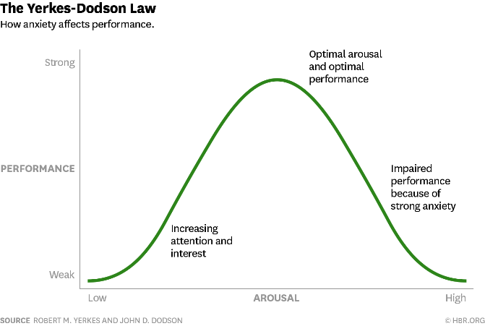
Anxiety tends to be accompanied by physiological arousal (e.g. pounding heart, rapid, shallow breathing) which has been found to have an effect on performance. The Yerkes-Dodson effect (as shown in the graph), is the observation that arousal has a negative effect on performance (such as memory recall) when it is very LOW or very HIGH, but moderate levels are actually beneficial. This is described as an inverted U-shape curve.

The Yerkes-Dodson effect can be used to explain errors made by eyewitnesses, particularly when recalling a violent crime. In such cases it is likely that the witness was in a high state of arousal during the crime and therefore their performance in recalling details is affected negatively.

Anxiety and The weapon focus effect

Loftus argues that anxiety is most problematic for later recall when a crime involves a weapon. Research suggests that the anxiety of seeing a weapon focuses all of your attention of the central details (the weapon itself) which means you are less able to recall the peripheral details such as what else was going on, what the perpetrator looked like. This effect is therefore known as the Weapon focus effect.

Evidence of the Weapon focus effect

Loftus (1979) reported the findings of Johnson and Scott’s 1976 study in which they created two conditions where the participants were asked to sit in a waiting room. A receptionist who was seated nearby excused herself to run an errand, leaving the participant alone. The experiment used an independent groups design, as participants were then exposed to one of two conditions:
- either heard a hostile and aggressive argument by two people in a different room, followed by one of them emerging holding a letter opener covered in blood,
- or they heard a harmless conversation between two people followed by one of them holding a pen with grease on his hands.

Participants were asked to identify the culprit from photographs, with only 33% correctly identifying the culprit in the letter opener condition, and 49% correctly identifying the culprit in the pen condition.

Loftus argued that the anxiety caused by seeing the letter opener caused the weapons focus which lead to them not paying attention to other information, hence poor recall of the culprit.

Loftus et al (1987) asked participants to watch one of two sequences: a person pointing a gun at a cashier and receiving some cash, and a person passing a cheque to the cashier and receiving some cash. Loftus found that participants correctly identified details about the incident in the ‘cheque’ condition more than they did the ‘gun’ condition, again demonstrating the weapons focus effect

Evaluation of the role of anxiety in EWT

Internal validity | One criticism of the weapon focus effect is that the effect may not be caused by anxiety. Critics have suggested that Loftus is testing surprise, and not anxiety. In another study, Pickel (1998) showed a video of an incident in a hair-dressing salon, in which the handheld item was either scissors, a wallet, a gun or a raw chicken. The scissors were the low anxiety item, low unusualness as it was a hair salon. Eyewitness accuracy was signficiantly poorer in the high unusualness conditions (chicken and handgun). This suggests hat the weapon focus effect is due to unusualness / surprise rather than anxiety/ threat and therefore tells us nothing specifically about the effects of anxiety on EWT.
Reliability and artificiality of research | There are differences in the results between research conducted on real-life eye-witnesses and research conducted in a lab environment, showing that there is a lack of consistency in the research.  Yuille and Cutshall (1986) conducted research into a real-life crime. 13 people, who had witnessed a shop keeper shooting a thief dead in Canada, were interviewed 5 months after the event. These interviews were compared with the original police interviews immediately after the event. Participants were asked to rate how much anxiety they felt during the incident. Those who had reported high anxiety levels reported the highest level of accuracy when recalling the incident five months later (88% accuracy), compared with those who had reported a relatively low level of anxiety (75% accuracy). This is in contrast to Loftus’s laboratory findings.  Extension of this point: Alternative explanations suggest that this can be explained by the physiological arousal triggering the fight and flight response which actually increases our alertness and improves our memory for the event because we become more aware of cues in the situation.
Applications | Research into the effect of anxiety has had important real world applications. Recognising the role of anxiety in EWT has meant the police proceed with extreme caution when pursuing lines of enquiry. Today criminal investigations rarely rely on Eye witness testimony’s alone and instead commonly look for alternative evidence, such as DNA sampling or CCTV footage that could be used to collaborate the witness’s testimony before charging someone or making a conviction. Therefore research into the effect of anxiety on EWT has had positive benefits for the criminal justice system by reducing the chances of erroneously convicting the wrong person.

Improving the Accuracy of EWT

The use of the cognitive interview- Geiselman et al.

Before the advent of the Cognitive interview, police interviews would often be conducted in such a way that it elicited false information, with witnesses unable to give accurate accounts of what happened. That changed when Geisleman et al. argued that police interviews must take into account the characteristics of human memory. These characteristics include:

- Memories are complex, and are made up from different types of memory
- Retrieval cues are important, and their absence can lead to inaccuracy
- Misleading information can distort recall

The four techniques used in cognitive interview are presented here.

Geisleman et al (1985) four instructions for CI |  | How does this differ from standard police interviews?
Recreate the context of the original incident | Ask the witness to try and picture the circumstances surrounding the crime. Next ask the witness to think about, or visualise the scene. Ask what the scene looked like, who was present or nearby, where the furniture was, what the weather was like, how the witness was feeling at the time or how they reacted to the event | Police do not ask witness to recreate the context, instead just to free recall the events and then answer questions
To report every detail | Tell the witness that some people withhold information because the feel it is irrelevant, but they should try and tell the whole story, leaving nothing out. Here the interviewer must be extremely patient and allow the recall as the witness sees it | The police interview uses the repetition technique, where they repeat the questions needed for the eyewitness testimony, often interrupting the witness
To recall the event in reverse order | Tell the witness that although it may not feel normal, to try and tell the story in the reverse order, starting at the end of the event or at a significant part of the event. This should help stop witnesses recreating the event in relation to expectations or stereotypes about what normally happens in crimes such as was witnessed | The police would ask for free recall, which would usually end up with a chronological account of events.
To change perspectives | Instruct the witness to recall the event from a different physical perspective, from a location other than where he or she was during the event. What might they have seen from across the street? What did any of the other witnesses see? What would they have heard? Again this is used to disrupt the personal expectations of what usually happens in a crime (as seen in films etc.) | The standard interview is more likely to focus only on the witness’s point of view, asking questions about what they saw directly.

Fisher et al (1987) added elements to CI. Called the enhanced cognitive interview (ECI) social dynamics were taken into account, such as when to (or not to) establish eye-contact, ways to reduce anxiety, minimising distractions, asking the witness to speak slowly and to ask open ended questions.

Evaluation of the use of Cognitive Interview

Supporting evidence | P- There is supporting evidence for the effectiveness of the cognitive interview.  E- For example, Kohnken et al (1999) carried out a meta-analysis of 53 studies investigating the Enhanced Cognitive Interview (ECI), and found, on average, a 34% increase in the amount of correct information generated compared with standard police interviews.  E- Although, caution is required in drawing conclusions about the effectiveness of the CI as most of these studies were carried out with volunteer participants in a laboratory and not in a ‘real life’ setting.  L- Despite the limitations of the research, there remains support for the use of CI over the current police interviewing standards.
Reliability of research | P- The research findings about the effectiveness of the CI are reliable.  E- Geisleman et al (1985) assessed whether the Cognitive Interview is more effective than standard police interviews when interviewing eye-witnesses. They showed police training videos to 89 students. About 48 hours later, the students were interviewed individually by American Law enforcement officers (detectives, CIA investigators and private investigators). The interviewers had either been trained in standard police interviewing techniques or in the new Cognitive Interview Schedule. Each interview was taped and analysed for accuracy of recall. The results of the study can be seen in the table below  Cognitive Interview Standard interview  Correct items reported 41.5 29.4  Incorrect items reported 7.3 6.1  Made up (confabulated) items 0.7 0.4  E- The findings from both Kohnken and Geiselman’s research studies demonstrate consistent results and clearly show that accuracy of EWT is improved by the use of cognitive interview.  L- As a result, it should be suggested that the CI procedures are used for all EWT in the future.
Economic Impact of the cognitive interview | P- The use of the cognitive interview has some limitations.  E- It tends to take longer and requires more training than the standard interview. Some critics also suggest that some of the procedures are more valuable than others.  E- For example, Milne and Bull (2002) found that a combination of report everything and context reinstatement produce the most effective reports, which confirmed some of the police officers’ views that some aspects are better than others.  L- Thus, the economic impact of using the CI must be considered. It may be more viable to only use aspects of the CI so that time and resources are not being used without good reason to do so.

Design a study exam question

Previous research has shown that various factors can affect the accuracy of eyewitness testimony. One of these factors is misleading information in the form of leading questions.
Design an experiment to find out if the use of leading questions can affect the accuracy of an eyewitness’s recall of an event.

In your answer you will be awarded credit for providing appropriate details of:
- An operationalised hypothesis
- Experimental design used with justification
- Materials used
- Ethical issues that have been considered

Practice short answer exam questions

1. Outline what psychological research has shown about short-term memory according to the multi-store model of memory. (4 marks)

2. Read the item and then answer the questions that follow.
A researcher investigating the multi-store model of memory tested short-term memory by reading out loud sequences of numbers that participants then had to repeat aloud immediately after presentation. The first sequence was made up of three numbers: for example, 8, 5, 2. Each participant was tested several times, and each time the length of the sequence was increased by adding another number.

Use your knowledge of the multi-store model of memory to explain the purpose of this research and the likely outcome. (4 marks)

3. Research has suggested that the encoding and capacity of short-term memory are different from the encoding and capacity of long-term memory. Explain what is meant by coding. (2 marks)

4. Briefly evaluate the multi-store model of memory (4 marks)

5.

Annie can still skateboard even though she hasn’t skated for many years. Germaine can still recall what happened on his first day at university even though it was ages ago. Billy remembers the names of the tools he needs to repair the broken tap.

Identify three types of long-term memory and explain how each type is shown in one of the examples above. (6 marks)

6. Give one example of a semantic memory and one example of an episodic memory. Briefly explain one difference between these types of long-term memory. (3 marks)

7. Briefly describe the working memory model (4 marks)

8.

Claire can search through family photos on her laptop and listen to music at the same time. However, she finds it difficult to read her e-mails when talking to a friend on the phone.

Use your knowledge of the working memory model to explain why Claire is able to perform the first two tasks at the same time, but finds it difficult to perform the second two tasks at the same time. (4 marks)

9.

A researcher carried out an experiment to investigate misleading information. Participants were shown a photograph in which a man and a woman were talking. The photograph was then taken away and the participants were asked questions about it. Participants were randomly allocated to condition one or condition two. Participants in condition one were asked: Question A “How old was the youth in the photograph?” Participants in condition two were asked: Question B “How old was the man in the photograph?”

(a) Why is Question A an example of misleading information? (2)

(b) Name an appropriate experimental design which could be used in this experiment. Explain why a repeated measures design would be unsuitable to use in this experiment. (4)

(c) Explain why it would be appropriate to use a pilot study as part of this experiment. (4)

(d) In this experiment, participants were asked to look at a photograph rather than watch a live conversation. Explain one strength and one limitation of carrying out the experiment in this way. (4)

10. (a) In the context of explanations of forgetting, what is meant by interference? (2)

(b) Choose one study in which the effects of interference were investigated. Briefly outline what the participants had to do in the study. (2)

(c) Briefly discuss one limitation of interference as an explanation of forgetting. (3) (Total 7 marks)

11. Outline one study that has investigated the effect of anxiety on eyewitness testimony. (4 marks)

Essay planning

“Outline and evaluate the Working Memory Model” (16 marks)

Outline (AO1)

Part a) Draw the model

Part b) describe the function of each component

Part c) Other information about capacity and relationships between each component

Evaluation (AO3)

Supporting evidence | Challenging evidence | Further evaluation
P: There are numerous studies which support the existence of each store in the WMM. | P: However, there is a lack of clarity over the central executive. | P: The WMM is considered a better explanation than the MSM.
E: Gathercole and Baddeley (1993) found…. | E = Explain/Evidence: | E = Explain: This is because…….
SW: This indicates that…… | SW: | SW: A greater understanding of cognitive dysfunction has led to many practical applications for children with dyslexia and ADHD. ………….
SSW: There is also other evidence that supports the existence of the stores is, Trojani and Grossi who found ……………

This shows us that……….

Outline and evaluate the role of proactive and retroactive interference in forgetting (16 marks)

Outline – Proactive interference Outline - Retroactive interference

Evaluation – supporting evidence Evaluation – supporting evidence
Underwood 1957 Schmidt et al (200)

Evaluation - Further supporting evidence for the role of interference over time – Baddeley and Hitch (1977)

Evaluation - The explanations fails to explain

Evaluation – Practical applications for students – including finding from McGeoch and McDonald (1931) on the role of similarity and interference

Other practice essay questions

1. Describe and evaluate the multi-store model of memory. Refer to evidence in your answer. (16 marks)

2.

A woman is being questioned by a police officer about a heated argument she witnessed on an evening out with friends. The argument took place in a bar and ended with a violent assault. A knife was discovered later by police in the car park of the bar.

‘Did you see the knife the attacker was holding?’, asked the police officer.

‘I’m not sure there was a knife – yes, there probably was,’ replied the woman. ‘I was so scared at the time that it’s hard to remember, and my friends and I have talked about what happened so many times since that I’m almost not sure what I did see.’

Discuss research into two or more factors that affect the accuracy of eyewitness testimony. Refer to the information above in your answer. (16 marks)

3. Outline and evaluate research into the effects of leading questions on the accuracy of eyewitness testimony. (8 marks)

4. Some psychologists argue that there is always more information about an event in a person’s memory than can be recalled at any one time. This means that eye-witness recall can be improved by using certain techniques and methods.

Describe and evaluate at least one way of improving eye-witness recall. Refer to evidence in your answer. (16 marks)

5. Discuss the types of long term memory (8 marks)

