Multi-store model of memory (MSM)

Key Terms

Sensory register: The first store which holds the sensory information received through all the senses for a brief period of time. Examples include iconic (visual) and echoic (sound) memory.

Short-term memory: The memory for immediate events. These memories tend not to last for more than a minute or two, usually shorter, and disappear unless they are rehearsed. Capacity is limited to 7 plus or minus 2 individual items.

Long-term memory: The memory for past events that can last for the life-time of a person. Its capacity is most probably unlimited

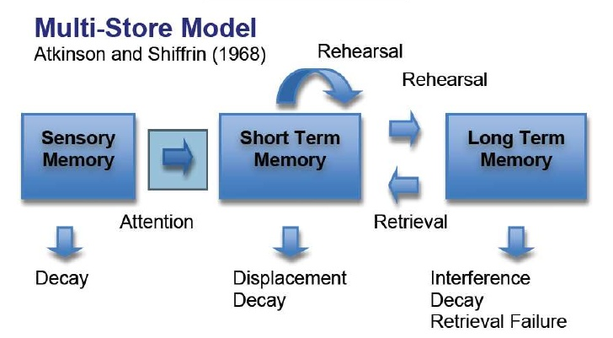
Prolonged
Maintenance

Key features of the MSM

- Information flows through a number of storage systems in a linear fashion (in a line)
- There are three main storage systems which are unitary (each a single unit)
- Each store differs in terms of:
- Coding – the form in which the information is stored
- Capacity – how much information can be stored
- Duration – how long information can be stored for
- Information can remain in short-term memory by maintenance rehearsal, and prolonged rehearsal (sometimes called elaborative rehearsal) will create a long term memory.
- The more information is rehearsed, the better it is remembered
- Information can be lost from each store, but in different ways

When describing or outlining the MSM, you need to include detail on the key features of the model (see above) as well as information on coding, capacity and duration of each store.
Here is an example of the kind of detail you would need for a 6 mark answer:
The multi store model consists of three unitary stores; the sensory register, short term memory (STM), and long term memory (LTM). Information flows through these stores in a linear way.
Information from the environment, for example the sound of someone’s name, will pass into the sensory register along with other sights, sounds, smells etc. The two main stores in the sensory register are echoic, which is sound or auditory information and is encoded acoustically, and iconic which is visual information and is encoded visually. Material in the sensory register only lasts very briefly, less than 3 seconds, but has a high capacity. Information from the sensory register only passes through into STM if we pay attention to it. STM has a limited capacity, 7 +/- 2 item, and information in STM has a duration of up to 30 seconds. If information is rehearsed it will be kept in STM, if not it will be lost. Information is usually encoded acoustically in STM. Repeating information over and over again is called maintenance rehearsal. If we rehearse the information for long enough it will pass to LTM and remain for a life time although loss is possible. Encoding here is semantic, and the capacity is unlimited with information lasting for a very long time. Although the information is stored in LTM when we want to recall it, it has to be transferred back to STM by a process called retrieval.

The Nature of Memory: Features of each store: coding, capacity and duration

Sensory register
Capacity

The capacity of the SR is very large, with the information contained being in an unprocessed, highly detailed and ever-changing format.

Duration

Between the sensory register and short-term memory there is a filter called ‘attention’. It is believed that information that is not attended to is lost very quickly

According to research, iconic memory has a very short frequency, maybe up to ½ a second (500 milliseconds). It is a little longer in echoic memory, with information remaining for about 3 seconds. Iconic memory is thought to cause the impression of an illuminated line when you wave a sparkler on bonfire night, you can even spell out someone’s name.

Coding

There is very little coding in the sensory register. Information enters the memory system through our senses, and it is thought that everything we see, hear, touch, smell and taste enters sensory memory (sensory register) and remains in its raw form. There are different registers of each sense, for example.
- Iconic register: memory for visual information
- Echoic register: memory for auditory information
- Haptic register: memory for touch

Short term memory
Capacity

How much information can be held in STM is limited.
Notwithstanding that there are differences in capacity depending on the type of information, it is universally agreed that people can hold about seven items in STM. We often say that the capacity of memory is 7 + or – 2 items

Duration

How long information can stay in short-term memory ranges from a few seconds up to a minute, but for most of us, it is somewhere in between: textbooks often refer to between 15 - 30 seconds, (but this can be extended due to rehearsal).

Coding

In short term memory (STM) it is widely accepted that the coding is mainly acoustic. When a person is presented with a list of numbers and letters, they will try to hold them in STM by rehearsing them (verbally). Rehearsal is a verbal process regardless of whether the list of items is presented acoustically (someone reads them out), or visually (on a sheet of paper). However, it is also recognised that visual coding does occur in STM, as does some semantic coding.

Long term memory

Capacity

The capacity in LTM is generally accepted to be unlimited. Therefore, no matter how much information is stored long-term, the store never becomes full.

Duration

This is dependent of the person’s life span, as memories can last up to a life-time. Information that is processed at a deep level is likely to be remembered for longer, and memories based on skills rather than facts tend to be remembered better.
Coding

It is widely acknowledged that information is coded semantically in LTM, especially for verbal information. This means that information is stored in LTM when it has meaning or in other words, some relevance or importance to us. However, there is some evidence for both visual and acoustic encoding in LTM.

Summary of the research into coding, capacity and duration

 | Sensory Register | Short-term memory | Long-term memory
Coding | Separate sensory stores for different sensory inputs | Mainly acoustic (by sound) but other codes used too | Mainly Semantic (by meaning) other codes used too
Capacity | Very large | Small chunks of information (5 – 9 items or 7+/-) | Unlimited
Duration | Brief (between ½ and 3 seconds) varies between sensory stores | Short (maximum of 30 seconds) | Potentially for a life time

The Working Memory Model (WMM) - Baddeley and Hitch (1974)

After the development of the multi-store model, research questioned the existence of a single STM store. Because we actively process information in STM, it is far too complex to suggest that STM is just a temporary store for transferring information into LTM. Baddeley and Hitch (1974) devised the ‘working memory model’ in an attempt to demonstrate what is happening to information when we are consciously thinking about it. Cohen described the WMM as the explanation of conscious thought happening ‘now’.
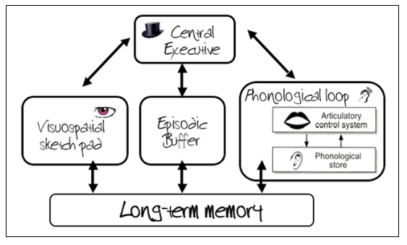
NB: Although LTM is shown here, it is not actually part of the working memory model.

The Central Executive

The function of the central executive is to direct attention to particular tasks, determining how the brain’s resources are allocated to tasks. The CE attends and monitors incoming information from the senses or LTM and this information is then sent to the other slave systems for processing and temporary storage. The CE has very little capacity so it cannot attend to too many things at once, and it has no capacity for storing data.

The Phonological Loop

The phonological loop has a limited capacity and its function is to store speech-based sounds for brief periods. It has two components:
- The phonological store
Allows acoustically coded items to be stored for brief periods (someone talking, a melody etc.)
- The articulatory control process
Allows sub vocal repetitions of items in phonological store. This is similar to maintenance rehearsal.

The Visuo-Spatial Sketchpad

The VSS processes and stores mental images in terms of what they look like and their place in the visual field. It is independent from the phonological loop, and has a limited capacity.
It is used when people are planning a spatial task, like moving from one room to the next, reaching for their cup of coffee etc.

The Episodic Buffer

Added in 2000, the episodic buffer is a general store that allows both sound and visual information to be bound together.
It integrates information from the other systems and also offers a sense of time sequencing.
It records events (episodes) that are happening and sends information to LTM.
Like all the systems in working memory, it has a limited capacity.

Types of Long-Term memory - Episodic, semantic and procedural

One of the major limitations of the MSM is that its description of LTM as a single unitary store is now seen as outdated. Many research studies have shown that there are at least three different types of long-term store

Episodic Memory:
- First suggested by Tulving (1972), it is the type of long-term memory that gives individuals an autobiographical record of things that have happened to them (our memories of our experiences). In other words, it is the storage of episodes that happen throughout our lives. Examples of episodic memories are your 7th birthday party, your last holiday, what you did last night, your first kiss etc.
- Think of episodic memories in terms of 3Ws, containing information about what happened, where it happened, and when it happened. Individuals tend to see themselves as actors in these events, and the emotional charge and the entire context surrounding an event is usually part of the memory, not just the bare facts of the event itself. Furthermore, having episodic memory allows us to make predictions about what will happen to us in the future.
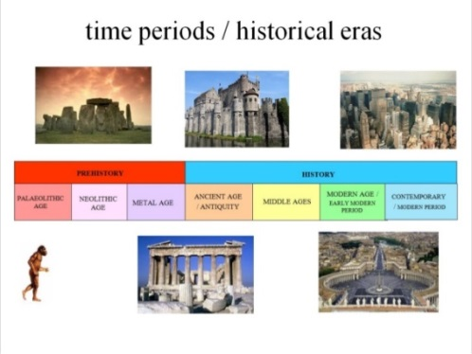
- That is not to suggest that episodic memories contain exact reproductions of what happened. It is suggested that episodic memories are constructed, rather than reproductive, and is prone to errors and illusions. The section on eye-witness testimony will explore this further, but our episodic memories are subject to stereotyping, subjective interpretation, missing out information or adding in missing parts.

Semantic Memory:
- This is a structured record of facts, meanings, concepts and knowledge about the external world that we have acquired. It refers to general factual knowledge, shared with others and independent of personal experience and of the time and place in which it was acquired.
- Semantic memories may once have had a personal context, but now stand alone as simple knowledge. It therefore includes such things as types of food, capital cities, social customs, historical dates, functions of objects, vocabulary, understanding of mathematics, etc.
- There is an enormous amount of information available in semantic memory, and is continually being added to.

Procedural Memory:
- This differs from the other two types of long-term memory, as it tends to be unconscious, whereas the other two are conscious. Procedural memory (“knowing how”) is the unconscious memory of skills and how to do things, particularly the use of objects or movements of the body, such as tying a shoelace, playing a guitar or riding a bike.
- These memories are typically acquired through repetition and practice, and are composed of automatic sensorimotor behaviours that are so deeply embedded that we are no longer aware of them. Once learned, these "body memories" allow us to carry out ordinary motor actions more or less automatically. A good example of this is learning how to drive a car. Initially it is very difficult, but with repeated practice it becomes ‘second nature’.

TASK 1: Glossary: Define these terms (use info above and/or google)
The Multi-store model of memory | The Multi-Store Model of memory
 | Sensory memory
 | Short-term memory
 | Long-term memory
 | Maintenance rehearsal
 | Unitary store
 | Linear model
The Working memory model | The working memory model
 | The central executive
 | Phonological store
 | Articulatory loop
 | Visual-Spatial Sketch pad
 | Episodic buffer
Types of LTM | Procedural memory
 | Episodic memory
 | Semantic Memory

TASK 2: Draw the model in the space below, and add detail to the model in the table below that. Then add further information as advised
Atkinson and Shiffrin (1968) The Multi-store model

The Nature of memory: fill in the table below
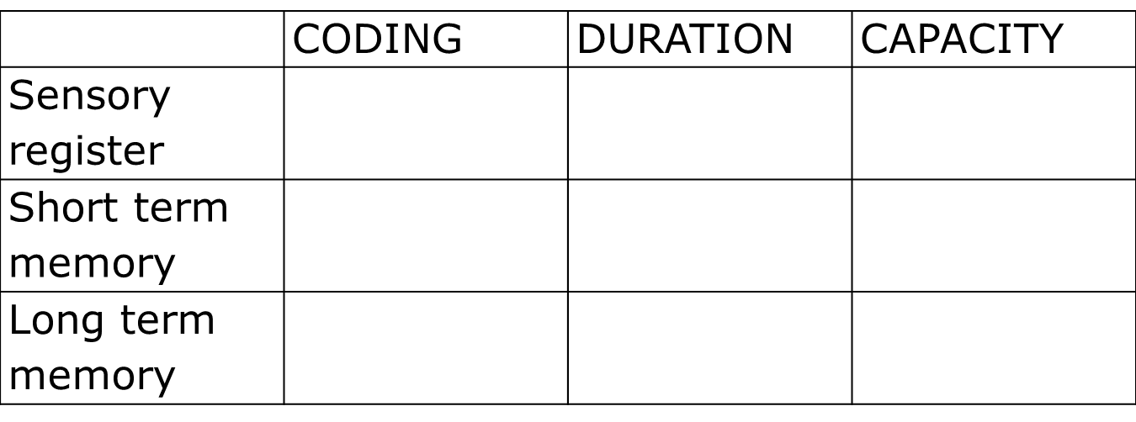
This is a linear model, this means that …
____________________________________________________________________________________________________________________________________________________________________________________________________________________________________________________
Each store is a unitary store, this means that…
____________________________________________________________________________________________________________________________________________________________________________________________________________________________________________________

Task 3: The working memory model
- Watch this video link and draw an annotated diagram of the Working Memory Model with information on each component of the model.
https://www.youtube.com/watch?v=IRBcKm0qJKE
NB-> Watch the whole video (so you are aware of the strengths and weaknesses of the WMM)- you do not have to make notes on the evaluation points.
- Using this website, make more detailed notes on the role and function of each store (central executive, visual spatial sketchpad, phonological loop and the episodic buffer):
- http://www.simplypsychology.org/working%20memory.html

Baddeley and Hitch (1974) the ‘working model of memory’

The Central Executive

The Phonological loop a) the phonological store

The phonological loop b) the articulatory process

The visual-spatial sketchpad

The episodic buffer

Which are the slave systems?
Do these slave systems have a limited capacity?

TASK 4: Types of long term memory: Using the information about the types of long term memory, answer the questions below.

Q1) What did Tulving (1972) suggest that episodic memory referred to?

Q2) Give three examples of your episodic memory

Q3) What are the three Ws which link to episodic memory?

Q4) Linked to our future, what does episodic memory allow us to do?

Q5) Episodic memories are not exact replications, what are they prone to? Give examples.

Q6) What is meant by semantic memory and give examples of your semantic memory

Q7) Does semantic memory have a lot of information? Can we add to it?

Q8) How does procedural memory differ from the other two types of LTM?

Q9) What is meant by procedural memory and give examples of your procedural memory

Q10) How does one acquire procedural memories?

Q11) give an example of a challenging task that becomes part of our procedural memory with practice.

Watch the clip on Psych205 on Sam’s memory page and make notes on Clive Wearing’s case study

Evidence of each store: coding, capacity and duration

Sensory register
Capacity

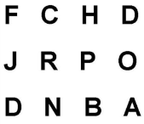
The capacity of the SR is very large, with the information contained being in an unprocessed, highly detailed and ever-changing format.

Supporting evidence: Procedure and findings
In the original experiment, Sperling (1960) flashed grids of letters in 3 x 4 format on screens for 1/20th of a second and participants on average recalled 4/5 letters correctly. For example, F, C, H, D, J

However, Sperling changed the method slightly to a partial report procedure. In this task participants had to recall the letters from a specified row as indicated by a high pitch (top row) medium pitch (middle row) or low pitched (bottom row) tone. On average participants remembered at least 3 letters e.g. J, R, P.

Participants did not know which they line they would be asked to recall, yet the participants were able to recall any information from the grid. This suggests that all the 12 letters in the grid had been available in the participants’ sensory register for recall, thus demonstrating the capacity of the sensory register is larger than 4/5 letters (as proposed in the original experiment).

Duration

Between the sensory register and short-term memory there is a filter called ‘attention’. It is believed that information that is not attended to is lost very quickly

According to research, iconic memory has a very short frequency, maybe up to ½ a second (500 milliseconds). It is a little longer in echoic memory, with information remaining for about 3 seconds. Iconic memory is thought to cause the impression of an illuminated line when you wave a sparkler on bonfire night, you can even spell out someone’s name.

Supporting evidence: Procedure and findings
Treisman (1964) presented identical information to both ears through headphones but with a slight delay. At 2 seconds or less, participants could state that the messages were identical. After 2 seconds, this task became more difficult and errors were made. This is because the echoic trace from the first sound had decayed by the time the second sound was played and therefore they could not compare if the sounds were identical. This suggests an echoic memory in SR of around 2 seconds.

Coding

There is very little coding in the sensory register. Information enters the memory system through our senses, and it is thought that everything we see, hear, touch, smell and taste enters sensory memory (sensory register) and remains in its raw form. There are different registers of each sense, for example.
Iconic register: memory for visual information
Echoic register: memory for auditory information
Haptic register: memory for touch

Supporting evidence
Crowder (1993) suggests that the different duration in SR between echoic and iconic registers suggests that information is coded according to the sense modality which registers it. It is suggested that it is pre-perceptual, that is that very little processing, if any, is conducted on the information

Short term memory
Capacity

How much information can be held in STM is limited.
Notwithstanding that there are differences in capacity depending on the type of information, it is universally agreed that people can hold about seven items in STM.

Supporting evidence: procedure and findings
Jacobs (1887) conducted the first systematic study on the capacity of memory. Participants were presented with a sequence of digits or letters and required to repeat them back in the same order (for example, 6,3,8,9,4,7,2 or G,S,T,J,W,V,K,L). The pace was controlled at half second intervals using a metronome. The procedure was repeated a number of times and the longest list of sequences that was correct 50% of the time was taken as the participant’s digit span.

Jacobs found that participants recalled more digits than letters. The average span for digits was 9.3, whereas it was 7.3 for letters. Jacobs also found that capacity increased steadily with age; in one sample of school girls he found that 8 year olds remembered an average of 6.6 digits whereas for 19 year olds it was 8.6 digits.

The capacity is usually phrased as 7 + or – 2, so the capacity of STM is known as 7+ or – 2 items.

In further research, Miller found that not only could people recall about 7 individual items, but could also recall 7 chunks of information. Miller suggested that the capacity for STM is 7 ± 2 chunks (in other words, nearly all people can recall between 5 and 9 small chunks of information).

Duration

How long information can stay in short-term memory ranges from a few seconds up to a minute, but for most of us, it is somewhere in between: textbooks often refer to between 15 - 30 seconds, (but this can be extended due to rehearsal).

Supporting evidence: procedure and findings
Peterson and Peterson (1959) investigated how long simple information stays in short term memory (STM) without repetition. On each trial the participants saw a trigram, which consisted of three consonants (e.g. BVM, CTG). A different trigram was used for each trial. They were asked to recall each trigram after a delay of seconds: 3,6,9,12,15 or 18. Once they were shown the trigram they had to perform an interference task, which prevented repetition of the trigram in STM. They were shown a random three digit number (e.g.866, 532) and had to count backwards from it in threes. After the appropriate time delay the trigram had to be recalled.

The longer the time delay, the more the forgetting occurred in STM. After 3 seconds 90% of the trigrams were recalled, but after 18 seconds only 5% of the trigrams were recalled. Therefore it was concluded that information is lost rapidly from STM when there is no opportunity for repetition. Without repetition, STM lasts for little longer than 18 seconds. (most textbooks refer to 15-30 seconds duration)

Coding

In short term memory (STM) it is widely accepted that the coding is mainly acoustic. When a person is presented with a list of numbers and letters, they will try to hold them in STM by rehearsing them (verbally). Rehearsal is a verbal process regardless of whether the list of items is presented acoustically (someone reads them out), or visually (on a sheet of paper). However, it is also recognised that visual coding does occur in STM, as does some semantic coding.

Supporting evidence: procedure and findings
Baddeley(1966) divided participants into groups (independent groups design) and gave them different lists of words to learn:
- Acoustically similar words (they sound the similar) e.g. man, mad, map
- Acoustically dissimilar words e.g. pen, day few
- Semantically similar words (they mean similar things) e.g. great, big, large
- Semantically dissimilar words e.g. hot, old, late

In the short term memory condition they had to recall the words in the correct order immediately after hearing them.

Results: In STM, recall of acoustically similar lists were remembered poorly, with a correct recall of about 10%. With the other lists, accurate recall was much better, between 60% – 80%, with acoustically dissimilar words recalled the best.
Conclusion: as acoustically dissimilar words were recalled more accurately than acoustically similar words, there must be some acoustic confusion during recall, which suggests that coding is acoustic. As there was little difference in recall for the semantically similar and dissimilar words, this would suggest that meaning is not the coding used in STM.

Long term memory

Capacity

The capacity in LTM is generally accepted to be unlimited. Therefore, no matter how much information is stored long-term, the store never becomes full.

Supporting evidence: Procedure and findings
Standing et al. (1970) gave participants a single presentation of a sequence of 2560 photographs for 5 or 10 seconds per picture. Even after 36 hours, participants could identify the correct photo when paired with a new scene approximately 90% of the time. This shows that a vast amount of material can be stored in LTM, at least in picture form, and gives support for the argument that LTM is probably an unlimited store.

Duration

This is dependent of the person’s life span, as memories can last up to a life-time. Information that is processed at a deep level is likely to be remembered for longer, and memories based on skills rather than facts tend to be remembered better.

Supporting evidence: Procedure and findings
Bahrick et al. (1975) aimed was investigate the duration of long term memory to see if memories can last over decades, and thus support the idea that the duration of memory can be a lifetime.

A sample of 392 American ex-high school students aged from 17-74 was studied. They were asked to remember the names of their classmates (free recall) and they were then shown faces and names of classmates and asked if they recognised them.
The accuracy of participants recall could be assessed by using their high-school year-books, which contained both pictures and names.

Results: There was 90% accuracy in face and name recognition, even with those participants who had left high-school 34 years previously. After 48 years this was 80% for name recognition and 40% for face recognition. Free recall was less accurate: 60% after 15 years and 30% after 48 years.

Bahrick et al concluded that peoples’ long tem memories can last for their whole life, even though they may weaken over time. Recognition is better than recall.

Coding

It is widely acknowledged that information is coded semantically in LTM, especially for verbal information. This means that information is stored in LTM when it has meaning or in other words, some relevance or importance to us. However, there is some evidence for both visual and acoustic encoding in LTM.

Supporting evidence: Procedure and findings
Baddeley (1966) divided participants into groups (independent groups design) and gave them different lists of words to learn:
- Acoustically similar words (they sound the similar) e.g. man, mad, map
- Acoustically dissimilar words e.g. pen, day few
- Semantically similar words (they mean similar things) e.g. great, big, large
- Semantically dissimilar words e.g. hot, old, late

In the long term memory condition they had to recall the words in the correct order 20 minutes after hearing them.
Results: In LTM, recall of semantically similar lists were recalled the worst, with a correct recall of 55%. With the other lists, accurate recalled was much better, between 70% – 85%, with acoustically dissimilar words recalled the best.
Conclusion: as semantically dissimilar words were recalled more accurately than semantically similar words, there must be some semantic confusion in LTM during recall, which suggests that coding is semantic. As there was little difference in recall for the acoustically similar and dissimilar words, this would suggest that the sound of the words is not the coding used in LTM

TASK 1. Add brief notes to the grid below about each study which supports the nature of memory. Yes, you really do need to be able to recall these nine studies!
Capacity | Duration | Coding
Sensory register | Sensory register | Sensory Register
STM | STM | STM
LTM | LTM | LTM

