Outline and Evaluate the Multi-Store Model of Memory (16 marks)
Exam advice AO1: (Description) When there is a visual representation of a model or theory, such as the MSM, you can draw it as part of your answer. However, if you do not explain in in full detail, you will not receive the full marks for the question.
Task: Fully label the diagram below then fill in the gaps. This would probably get you the full 6 AO1 marks on offer.
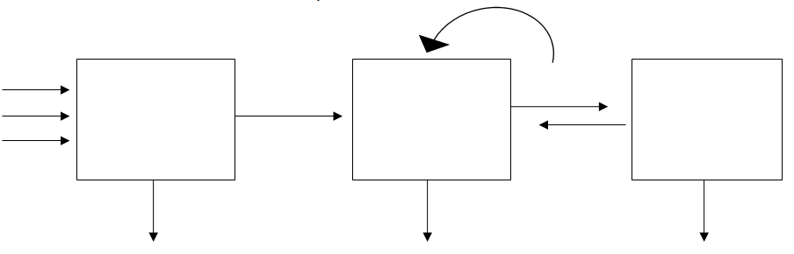

The multi store model consists of _____unitary, separate stores; ________register, _______term, and long term. Information flows through these stores in a one way, ______flow. Information from the environment, for example the sound of someone’s name, will pass into the sensory register along with lots of other sights, sounds, smells and so on. The store has ______stores (one for each of our senses) and the two main stores are ________(sound or auditory information so encoded_________) and iconic (visual information so encoded_________). Material in the sensory store only lasts very briefly (less than half a_________) but has a high capacity. Very little information from the sensory store passes into STM, it only passes through if we pay _________to it. So the key process here is________. The capacity of STM is limited (________) so once in STM if information is rehearsed it will be kept in STM, if not it will be lost from STM (within about 15-30 seconds according to______________). Information is usually encoded ______________at this stage. Simply repeating information over and over again in our heads is called ____________rehearsal. If we rehearse the information for long enough it will pass to LTM and remain for a life time although loss is possible. Capacity is ____________and information can last for a very long time. Although the information is stored in LTM when we want to recall it it has to be transferred back to STM by a process called__________.

Exam advice AO3: (Evaluation) For 10 marks in this question, you should aim for at least three detailed evaluative paragraphs setting out the arguments for and against the model. When writing each paragraph do these things.
- Use the PES model of evaluation. (see ‘burger’ analogy)
- Make the narrative flow. Use linking words to join the paragraphs. Don’t let an evaluative point just float unanchored in an essay.
- In a 16 mark essay, give a balanced evaluation if appropriate.
- Choose the best evaluative points for the essay, to do that, you must plan the essay first. In the exam, give yourself between one - two minutes planning time. Always plan!
TASK: complete the evaluation burgers that follow. Point 3 is complete, do the ‘so what’ for point 1, the ‘explain’ for point 2 and all of point 4. Use your initial plan from your homework to help you.
Please note the transitional words in bold that allow the essay to flow.

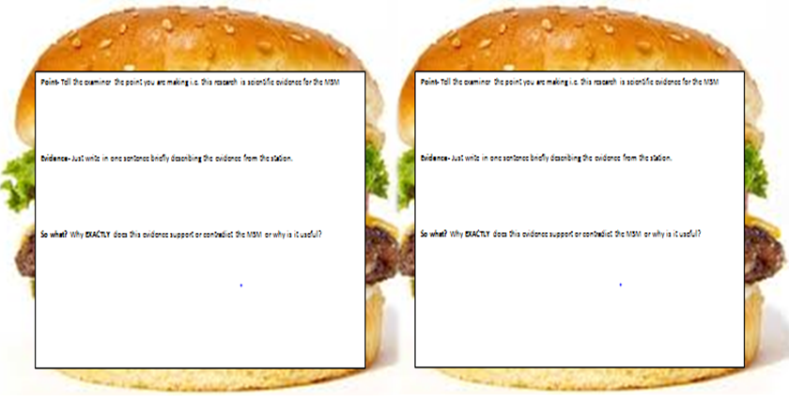
Evaluation point 1 Evaluation point 2
(P) In support of the MSM, There has been evidence to demonstrate the distinction between STM and LTM
(E) Glanzer and Cunitz found that when asked to recall a list of words in order, participants remembered those at the beginning and end of the series, but not those from the middle. The words recalled at the beginning had entered LTM due to rehearsal (primacy effect) but those at the end were still in STM and accessible (recency effect). Additionally, the primacy effect occurred due to maintenance rehearsal of those words, which meant the middle words were displaced.
(S)

(P) However, the case study of Clive Wearing contradicts the unitary store assumption made by Atkinson and Shiffrin
(E)

(S) Wearing’s ability to perform skills but not recall episodes shows that LTM is not the single unitary store that Atkinson and Shiffrin assumed, so critics argue that LTM should be reconceptualised to account for findings like this and similar. It should be noted that Wearing’s case does support the STM-LTM distinction

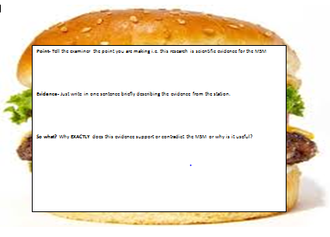
Evaluation point 3 Evaluation point 4

(P) Nevertheless,

(E)

(S)
(P) An additional criticism contrasts the importance placed on maintenance rehearsal for information transfer with the levels of processing theory

(E)Craik and Lockhart used evidence to show that memory storage lasts longer depending on the level the information is processed. For example, when participants were asked questions about whether words were written in capital letters (shallow processing), fewer words were recalled than when they were asked a question about the meaning of the word (deep processing). For example, “Is this a fruit?”

(S) This demonstrates that how we think about information is vital to memory storage, not just how many times we rehearse it, contradicting Atkinson and Shiffrin’s assumption about the necessity of maintenance rehearsal for transfer from STM to LTM
(super so what) We know this to be true, as when we revise for a test, deep processing using mnemonics are more successful than rote learning

