Models of Memory
Multi-store Model of Memory: Atkinson & Shiffrin (1968)
This model builds on the idea of three memory stores and tries to explain how they work together. The model sees memory as a flow of information through a system. The model takes an information processing approach and as such it is usually represented in the form of a flow diagram. Exam tip: in your exam it is advisable to describe the model in words.
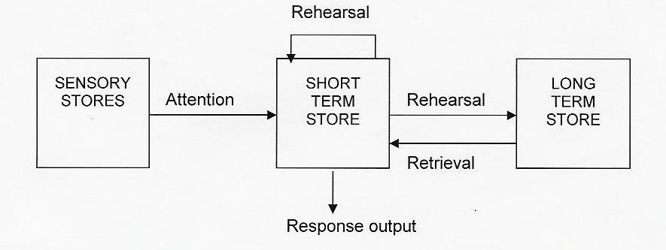
Sensory Memory stores the incoming information from the senses. The model assumes that these are modality specific, that is there is a separate store for each of the five senses. The store is very brief and the vast majority of information is lost here. Only information that is relevant or important is attended to and passed on to STM. Forgetting from the sensory store is by decay.
STM Atkinson & Shiffrin believed the store to be fragile and retains information for about 30 seconds. Compare this to the 18 seconds of the Brown–Peterson technique. Material that is rehearsed is passed on to LTM. Forgetting from STM is by displacement or decay. LTM can store this information for a lifetime. Forgetting from LTM is by decay or interference. (note: displacement is not an issue since capacity is limitless).
Processes
Attention: needed to transfer information from the senses to STM. Most stimuli that reach the senses are ignored because they aren’t seen as important. Only relevant or interesting information, or material that we choose to concentrate on is passed to the STM. 99% is lost at this stage.
Rehearsal: needed to transfer information from STM to LTM. We can rehearse information out loud as a child would do learning times tables by rote, or we can rehearse sub-vocally, in our heads. Either way it is seen as crucial and is one of the main criticisms of the theory, as we shall see. Later models distinguished between maintenance rehearsal in which material is repeated in ‘rote’ fashion to maintain it in STM and help with transfer to LTM. Elaborative rehearsal links the information with existing material or elaborates it in some other way, again as an aid to longer term storage.

Evaluation
The model has simplistic appeal and has been influential in stimulating research. Other models such as the ‘working memory model’ take the multistore model as starting point and then add to it. Various studies that suggest the existence of two separate stores support the theory. For example Murdoch (1962) found evidence for a primacy and recency effect. As already mentioned primacy effect due to information heard first being rehearsed and passed to LTM and recency effect because recently heard or seen information is still present in the STM. On the face of it, amnesiac case studies such as Clive Wearing, H.M. and K.F. also provide evidence for a distinction between two different stores, since usually amnesiacs have one aspect of memory such as STM intact whilst other aspects show impairment. There appears to be a distinction between stores in terms of capacity, duration and encoding.
However
The model is too simplistic. Given the multitude of different memories we store it is unlikely that LTM is a unitary store. Others have distinguished between semantic memory (for skills) and episodic memory (for facts and events) as already mentioned.
When considered more closely case studies of amnesiacs suggest that both STM and LTM are far more complex than the multi-store model suggests, e.g. Clive Wearing has an intact memory for skills but a severely impaired memory of facts. KF has a severely impaired STM but his LTM is intact. According to the multi-store model this could not happen since the memories in LTM must pass through STM first. Flow of information is assumed to be one way, but it seems likely that our LTM is able to assist our STM suggesting a ‘reverse flow.’ Consider the chunking exercise we did: 106619381945. In order to chunk this successfully you would need to use your vast knowledge of historic dates stored in your LTM, clear evidence of LTM aiding STM.
Ruchkin et al (2003) took this idea a stage further. They gave participants lists of a mixture of real words and made-up words to recall from STM. The brain activity for real words was very different suggesting other brain areas (presumably areas of STM) were being involved in the memory process (this area would be able to distinguish real from made-up).
The researchers concluded that in fact STM was probably just the bit of LTM being used at any one time!
The role of rehearsal is probably over stated. We often remember facts without conscious rehearsal. Tulving (1967) got participants were asked to read a list of words over and over again. Later participants were asked to remember another list of words containing a mixture of ‘old’ (ones read earlier that day), and ‘new’ words. Tulving found that participants were just as likely to recall the new words as the old ones suggesting that rehearsal has little effect in transferring memories to LTM.
Finally the multi-store model provides a passive explanation of memory. Research suggests that memory is an active process, for example STM being involved in our ability to focus attention and guide our thinking and LTM being used to help STM in this process.

