Divisions of the Nervous System prep
Fill in the boxes and give relevant information about the main function. Use notes, books and go online to help you.

The division of the Nervous System:
The Nervous System

The _________________ _______________ System (PNS)
Main Function:
The ________________ _________________ System (CNS)
Main Function:

________________________
Main Function:

________________________
Main Function:

________________________
Main Function:

______________________
Main Function:

Main Function:

Main Function:

The role of the nervous system
As well as understanding the structure of the Nervous System, you also need to be aware of the ‘role’ of each of the components (i.e. what they do). Click on the YouTube link below and listen carefully to a 6 minute webinar on the role of each component (from 1.20). Use the pack (pages 2,3 & 4) also and make notes below on the various areas of both the central and peripheral nervous system.
https://www.youtube.com/watch?v=w2qGl1pHO0I

The Central Nervous System: Brain and Spinal Cord

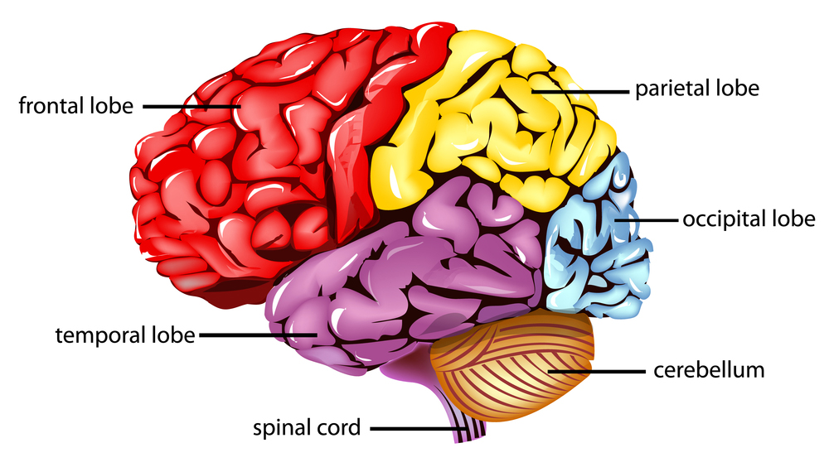
What is the function of the brain?

How many hemispheres does the brain have?

What are the four main regions?

What is the brain stem?

What is the spinal cord? How long is it? (Use examples)

The Peripheral Nervous System:

What is the job of the Peripheral Nervous System (PNS)?

What does the somatic nervous system (SNS) do?

What does the somatic nervous system consist of?

What does the autonomic nervous system do?

What does it only consist of?

What is the role of the sympathetic nervous system?

What is the role of the parasympathetic nervous system?
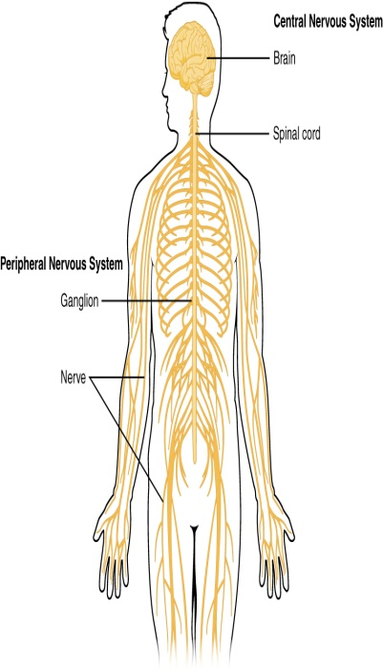

Part A - The Central Nervous System
Q1) The Central Nervous System consists of …
- The brain and the spinal cord
- Four distinct lobes
- The sympathetic and parasympathetic nervous systems
- The somatic and autonomic nervous systems
- All of the above
- None of the above
Q2) The ___________?___________ which is involved in a variety of higher cognitive (conscious thought), emotional, sensory, and motor (movement) functions, is more developed in humans than any other animal.
- Cerebellum
- Spinal Cord
- Cerebral Cortex
- White matter
- All of the above
- None of the above
Q3) The brain is divided into ? symmetrical hemispheres
- Three
- Four
- Five
- Six
- All of the above
- None of the above
Q4) the cerebral cortex is made up from…
- White matter
- Gray matter
- Dark matter
- No matter
- All of the above
- None of the above

Q5) The left hemisphere is associated with…
- Language
- Rationality
- Analytical thinking
- Logical abilities
- All of the above
- None of the above
Q6) the right hemisphere is associated with…
- Language
- Musical and artistic ability
- Logical thought
- Analytical thinking
- All of the above
- None of the above
Q7) The spinal cord is a white bundle of ? , which runs from your brain down a canal in your ? .

- Fibres & hippocampus
- Chemicals & ribs
- Nerves & backbone
- Tendons & skin
- All of the above
- None of the above

Q8) How long is the spinal cord?

- 28 cm
- 35 cm
- 43 cm
- 47 cm
- 50 cm
- None of the above

Q9) Its main function is to __________?___________about what's happening inside and outside your body to and from your brain

- Relay information
- Think rationally
- Process information
- All of the above
- None of the above

Q10) It is also involved in…

- Artistic abilities
- Musical abilities
- Forming procedural memories
- Reflex actions
- All of the above
- None of the above

Part B – The peripheral Nervous System (PNS)

Q1) The PNS consists of…

- The somatic nervous system
- The autonomic nervous system
- The systematic nervous system
- The parasympathetic nervous system
- All of the above
- None of the above

Q2) The somatic nervous system is part of the PNS that is concerned with…

- Relaying information between brain and the spinal cord
- Fight or flight
- Rational thought
- Interaction with the outside world
- All of the above
- None of the above

Q3) The SNS controls

- Involuntary movement of the ‘smooth muscle’ attached to organs
- Voluntary movement of the skeletal muscles
- Digestion
- Heart rate
- All of the above
- None of the above

Q4) It also consists of nerves which carry messages from the..

- Eyes
- Ears
- Skin
- Skeletal muscles
- All of the above
- None of the above

Q4) The Autonomic Nervous System controls

- Involuntary movement of the ‘smooth muscle’ attached to intestines, bladder, pupil size etc.
- Voluntary movement of the skeletal muscles
- Information to and from the ears
- Information to and from the eyes
- All of the above
- None of the above

Q5) The ANS is split into ? Systems

- Three
- Four
- Five
- 20
- All of the above
- None of the above

Q6) The sympathetic nervous system is active in situations requiring…

- Calmness and serenity
- Rational and logical thought
- Arousal and energy
- All of the above
- None of the above

Q7) The sympathetic nervous system is responsible for ? or ? .

- Sleep or wakefulness
- Thought or action
- Fight or flight
- Anxiety or calmness
- All of the the above
- None of the above

Q8) The sympathetic branch…

- Increases heart rate
- Increases breathing rate
- Dilates pupils
- Increases blood flow to muscles
- All of the above
- None of the above

Q9) The parasympathetic nervous system is responsible for…

- Increasing the biological response to threat
- Decreasing the biological response when the threat has passed
- Voluntary movement of the limbs
- Relaying information between the CNS and the PNS
- All of the above
- None of the above

Q10) The parasympathetic nervous system…

- Increasing the biological response to threat
- Decreasing the biological response when the threat has passed
- Voluntary movement of the limbs
- Relaying information between the CNS and the PNS
- All of the above
- None of the above

