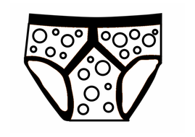[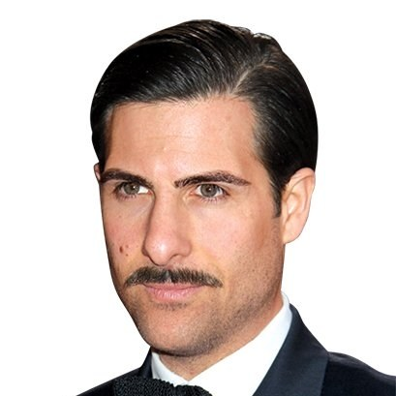](https://www.google.co.uk/url?sa=i&rct=j&q=&esrc=s&source=images&cd=&ved=2ahUKEwjkw-rd24njAhXC5eAKHS7zBQAQjRx6BAgBEAU&url=https://www.gq.com/gallery/mustache-experiment-inspiration-grooming&psig=AOvVaw1Mwd6tDtaflymUr3JJJeIB&ust=1561726685661437)[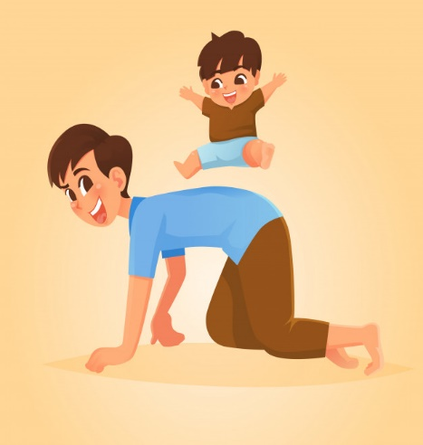](https://www.google.co.uk/url?sa=i&rct=j&q=&esrc=s&source=images&cd=&ved=2ahUKEwj_k42j3InjAhUV5uAKHWeAD8QQjRx6BAgBEAU&url=https://www.freepik.com/premium-vector/father-son-play-horse-ridding_2299934.htm&psig=AOvVaw2xQ5yqfjE0lwnfDAImJPOv&ust=1561726910030602)[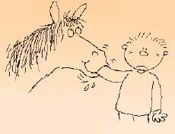](http://www.google.co.uk/url?sa=i&rct=j&q=&esrc=s&source=images&cd=&ved=2ahUKEwjk_KzH2onjAhXi8eAKHRa0C_AQjRx6BAgBEAU&url=http://logicishard.blogspot.com/2006/07/stories-from-my-past-shelter-from.html&psig=AOvVaw1hzwGOW1jYPcYxLTL8b2R3&ust=1561726444747224)[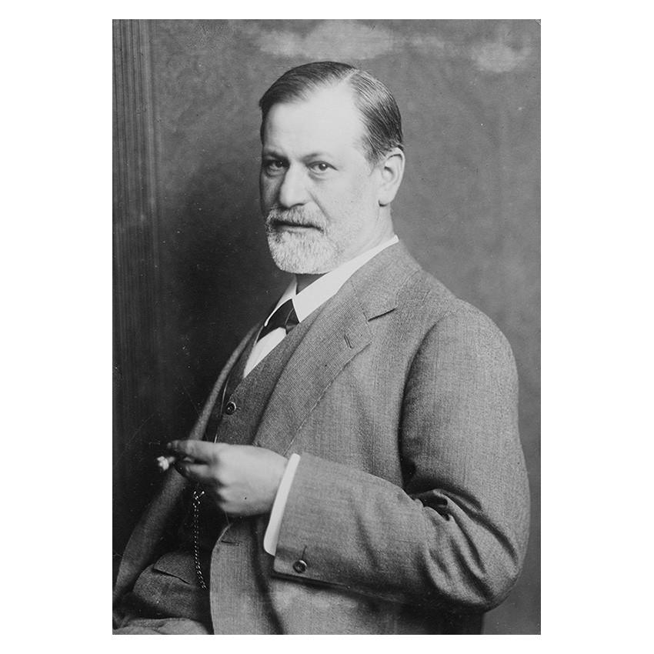](https://www.google.co.uk/url?sa=i&rct=j&q=&esrc=s&source=images&cd=&ved=2ahUKEwjyktnY3InjAhWpyIUKHRJ0BiwQjRx6BAgBEAU&url=https://shop.freud.org.uk/products/sigmund-freud-cat-no-13-jpg&psig=AOvVaw1Xg13EiE_j7Xtlobiw-Cu9&ust=1561726998471192)[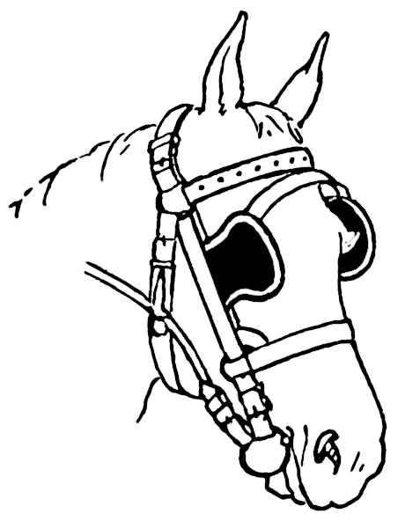](http://www.google.co.uk/url?sa=i&rct=j&q=&esrc=s&source=images&cd=&ved=2ahUKEwjXrqD52YnjAhUXD2MBHbBqCkkQjRx6BAgBEAU&url=http://www.clipartpal.com/clipart_pd/animal/horse/horse_10045.html&psig=AOvVaw080_mj0YxFyukgY9Iq2W0V&ust=1561726284241596)[](https://www.google.co.uk/url?sa=i&rct=j&q=&esrc=s&source=images&cd=&ved=2ahUKEwinlY7L3YnjAhVE4YUKHUjwAuQQjRx6BAgBEAU&url=https://www.pinclipart.com/pindetail/hJToxo_clip-stock-plumber-clipart-plumbing-cartoon-plumber-png/&psig=AOvVaw0WfxFJi77Jtw2gyID8eGDp&ust=1561727137196866)[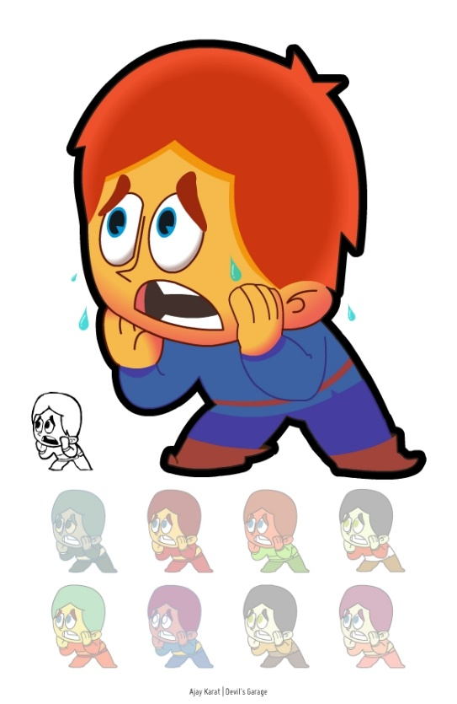](http://www.google.co.uk/url?sa=i&rct=j&q=&esrc=s&source=images&cd=&cad=rja&uact=8&ved=2ahUKEwi3o8WJ2YnjAhUm3OAKHfGcB_oQjRx6BAgBEAU&url=http://www.google.co.uk/url?sa%3Di%26rct%3Dj%26q%3D%26esrc%3Ds%26source%3Dimages%26cd%3D%26ved%3D2ahUKEwjo48f_2InjAhXJDmMBHbzbBMUQjRx6BAgBEAU%26url%3Dhttp://clipart-library.com/scared-picture.html%26psig%3DAOvVaw1x4FWTN4Af-tb7RczIveWl%26ust%3D1561725929409104&psig=AOvVaw1x4FWTN4Af-tb7RczIveWl&ust=1561725929409104)