Prep 10-The influence of early attachment on childhood and adult relationships
Remind yourself of what they internal model is (use page 15 and then pages 28-29 of the attachment information pack on the prep work page)
What is the internal working model?

How is it formed?

Is the internal working model consistent, fill in the table below?
 | How does it view the internal working model? | Which one does Bowlby support? | Which one to you agree with and why?
Prototype perspective

Revisionist perspective

So which perspective does the psychological evidence support?
Firstly complete the love quiz on line (the link is on the prep page just click the love quiz button) and add where you are on the diagram and summaries your results in the box.
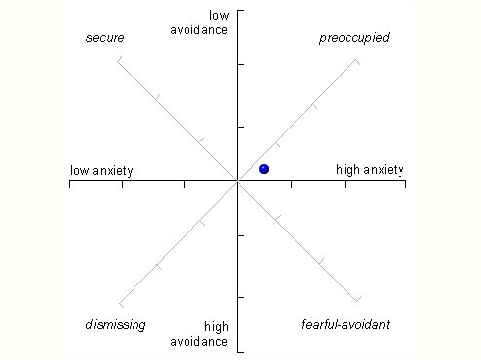
Summary of your results
Turn to page 29 and answer the following questions about the love quiz
Procedure
They gave the respondents that same love quiz that you have just carried out but…
Where did they get the sample from?

Who were the sample (and the breakdown)-

The questionnaire asked questions about what 3 things?

Findings (write the different findings for the different attachment styles below)

Avoidant
SECURE
Resistant

Which perspective then does the love quiz support?

How does further research disagree with this though?

Now what do you think? Look at your love quiz results-do you agree with them, which perspective do you take?

