Prep 1: Correlations
Read about correlations in the pack and work through the tasks below

- Fill in the gaps:
This is a measure of _____________________ between ______ _______________. It measures how strongly the variables are related with each other, and in which ______________________. If a strong correlation is found, a value from one variable can be used to ___________________ the corresponding value of the other.

- Draw a positive and negative correlation on the axes below

Positive Negative

3a) what are these graphs called? _________________________
3b) Give one example of a positive correlation and one example of a negative correlation

+
-
4) Correlations also have hypothesis and as are predicting a relationship and not a difference are worded differently. A directional hypothesis states if it will be positive or negative and a non-directional simply states there will be a correlation.
Identify below whether these are directional or non-directional
There will be a significant correlation between deaths by drowning and ice creams eaten between the months of June and august
There will be a significant negative correlation between amount of Christmas presents bought and cash in the bank.
There will be a significant positive correlation between mince pies eaten and size of waste line.

5) Fill in the gaps:

We use a formula to find out what a correlation coefficient is. This indiciates the strength and direction of the correlation. The correlation coefficient cannot be any value other than those between -1 and 1. A score of ______ indicates a perfect negative correlation, and a score of _____ indicates a perfect positive correlation. A score of _____ indicates no correlation

6) What correlation coefficient would indicate a…

Weak positive correlation? Strong negative correlation?

Negative moderate correlation? weak negative correlation?

7) Estimate the correlation coefficients for the scattergraphs below. Write next to graph.
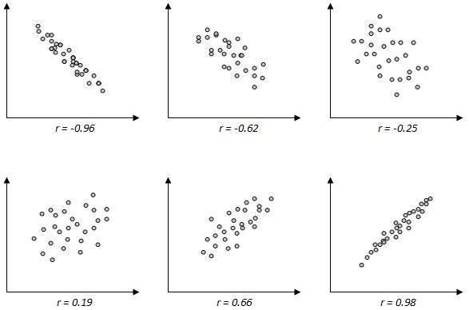
8) Which of these are positive and which are negative criticisms of correlations and add some detail in to create full evaluation
Can be used when research would be impossible or unethical to manipulate an IV for example …………………………..
Cannot and must not infer cause and effect relationships because …………………
Can only detect linear (straight line) relationships.

Correlations are useful tools………….

