Prep 3

Task 1: Resistance to social influence
Read page 16 of the information pack and answer the following questions
Situational explanation of resistance : Social Support
- What does the term ‘social support’ refer to?

- Why does social support have an effect on conformity/obedience rates?

- What did Milgram find when two disobedient confederates were present during his procedure?

- In the variation of Asch’s study, did it matter if the dissenting confederate gave the right or wrong answer? What does your answer suggest about the importance of social support?

Dispositional Explanation of Resistance: Personality: Locus of Control
Task 2: Complete the locus of control questionnaire and the conformity questions which follows it which can be found on psych205.com under linear A level/social influence/resistance to social influence. After you have completed it, use the scoring system to find out whether you have a high or low locus of control and find out your conformity score

Now use the information in the pack to answer the following questions

- What does it mean if someone has a high internal locus of control?

- Give an example of a statement that someone might make if they had a high internal locus of control:

- What does it mean if someone has a high external locus of control?

- Give an example of a statement that someone might make if they had a high external locus of control:

- Why would someone who has a high internal locus of control be less likely to conform or obey?

Task 2 Minority Influence

Task : Use the information on p.18 of the information pack to answer the following questions

- How does minority influence differ from majority influence (conformity)?

- Look at the 6 factors (bullet pointed) that make a minority more likely to be successful and then, for each one, come up with an example, either from the present or the past, either a person or a small group, that has demonstrated that quality, and give details of exactly what they have done. Your example person or small group might be a historical figure, a celebrity, a musician, a sports person, a pressure group etc, but they must have been influential with a minority.

Is consistent:

Not dogmatic:

Acts from principle, not self interest:

Makes sacrifices

Is similar to the majority:

Views are consistent with social trends:

Task 3: Research methods

Correlations

Read through Research methods year 1 pack from page 26 off the website and work through the tasks below
- Fill in the gaps:
This is a measure of _____________________ between ______ _______________. It measures how strongly the variables are related with each other, and in which ______________________. If a strong correlation is found, a value from one variable can be used to ___________________ the corresponding value of the other.
- Draw a positive and negative correlation on the axes below

Positive Negative

3a) what are these types of graphs called? _________________________
3b) Give one example of a positive correlation and one example of a negative correlation
+
-
4) Correlations also have hypothesis and as are predicting a relationship and not a difference are worded differently. A directional hypothesis states if it will be positive or negative and a non-directional simply states there will be a correlation.
Identify below whether these are directional or non-directional
There will be a significant correlation between deaths by drowning and ice creams eaten between the months of June and august
There will be a significant negative correlation between amount of Christmas presents bought and cash in the bank.
There will be a significant positive correlation between mince pies eaten and size of waste line.

5) Fill in the gaps:

We use a formula to find out what a correlation coefficient is. This indiciates the strength and direction of the correlation. The correlation coefficient cannot be any value other than those between -1 and 1. A score of ______ indicates a perfect negative correlation, and a score of _____ indicates a perfect positive correlation. A score of _____ indicates no correlation

6) What correlation coefficient would indicate a…

Weak positive correlation? Strong negative correlation?

Negative moderate correlation? weak negative correlation?

7) Estimate the correlation coefficients for the scattergraphs below. Write next to graph.
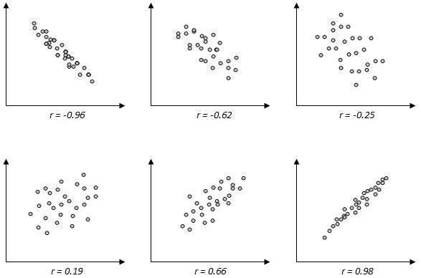
8) Which of these are positive and which are negative criticisms of correlations and add some detail in to create full evaluation
Correlations can be used when research would be impossible or unethical to manipulate an IV for example …………………………..
However we cannot and must not infer cause and effect relationships because …………………
Can only detect linear relationships and at times do not know the direction of the relationship as it may be bi-directional or there may be other factors affecting both the variables. For example we do not know for sure whether Personality causes conformity as there may be other factors that contribute to both of these for example upbringing.

Correlations are useful tools………….

Task 4- Continue revision of the following topics

You will have a tracking test on Thursday 3rd October where your revision will be checked

- Types of Conformity- Compliance, Identification and Internalisation
- Explanations of Conformity- NSI and ISI
- Sherif’s research – ISI
- Evaluation of Sherif’s research
- Asch’s research – NSI
- Evaluation of Asch’s research
- Zimbardo’s research
- Evaluation of Zimbardo’s research
- RM- experiments key terms Directional hypothesis, Non-directional hypothesis, Independent variable
Dependent variable Operationalisation, Extraneous variables, Controlled variables, Confounding variables
- Research methods- Types of Experiments strengths and limitations
- RM: Controls: Demand characteristics: Investigator effects: Randomisation: Standardisation:
- RM- types of Reliability and Validity
- Ethics

