Prep 3- the role of the father
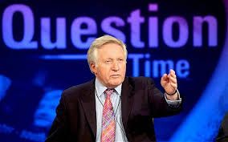
So what exactly is the role of the father? This is a tricky question to get asked in the exam because nobody can really agree on the answer. There are various reasons for this that you will find out in your lesson. The following activities are designed to get your thinking about your own opinion on what the role of the father is and if it is backed up by any research evidence.
The question time will be based on these questions so make sure you have an opinion-“I don’t know” isn’t acceptable!
Activity one-what do you think?
1. In the UK today what do you think the role of the father is? Does it differ across the country, cultural groups or even amongst your friends?

2. In an ideal world what do you think the role of the father should be?

3. Amongst people your age is there any stigma surrounding men staying at home with the kids?

3. Regardless of sex would you be happy to go to work and let your other half look after the children all day without you? Would you be happy to give up work and spend all day with your kids?

4. Are men as good at looking after children as women? Why?

5. Men who do look after the kids often report that they face sexism from other mothers? Have a read of the following article (use qr code or link) and write below some examples of sexism that Dad’s face.
https://www.bbc.co.uk/news/stories-44718727

