Prep 5: Quantitative data: descriptive statistics and data representation
Task 1: Complete the following table based on the powerpoint on Psych205 - http://www.psych205.com/research-methods-year-1.html
Definition | Strengths | Limitations
Descriptive statistics
Mean
Median
Mode
Measures of Dispersion
Range
Standard deviation

Task 2 – Refer to the relevant pages in your RM pack
Calculate the mean, median and mode for the following:

1a) Data from a psychology quiz:

1, 2, 3, 7, 10, 20, 30, 43, 47, 48, 50

Mean = Median= Mode=

1b) The number of faces recalled out of 12 in a free recall task:

1, 1, 5, 2, 3, 7, 6, 5, 2, 1, 8, 7, 9, 5, 4, 3, 2, 5

Mean = Median= Mode=

Task 3 : What is the range for the following data sets?

a) 5, 4 ,1, 2, 1, 2, 3, 4, 5, 6, 8, 7, 2. Range _______________________
b) 9, 11, 16, 4, 6, 17, 22, 35, 2, 12, 13. Range _______________________
c) 3, 4, 5, 8, 11, 14, 12, 16, 1, 9, 15, 17. Range _______________________

If the standard deviation is low, this tells us that the mean is _______________________
.
If the standard deviation is high, it this tells us that the mean is _____________________
Task 4 : Read the research scenarios below and then answer the questions for each one:
- Ps were tested on their ability to avoid obstacles in a computer driving simulation. The simulator recorded how many times the Ps hit an obstacle during the simulation (max. 30). Half of the Ps were engaged in conversation during the simulation by the experimenter, so they had to respond verbally to a series of questions. The other half completed the same task but in silence.
Directional Hypothesis: Participants will be more likely to hit obstacles when they are engaged in conversation than when they are not

 | Conversation condition | Silence condition
Mean | 7.3 | 5.4
Standard Deviation | 4.7 | 1.2

- What do the means in each condition suggest about the effect of the distraction task on their performance? ______________________________________________________________________________________________________________________________________

- Comment on what the standard deviations in each condition tell us about the data: _________________________________________________________________________________________________________________________________________________________________________________________________________

Researchers asked A Level student PPs, to complete a questionnaire about how long they spent studying each week. They were divided into two groups: those who spent more than ten hours a week studying and those who spent ten hours or less. After the exams, the researchers compared the exam marks (max. 100) of the two groups.
 | Less than 10 hrs | 10 hrs or more
Mean | 65.9 | 68.3
Standard Deviation | 15.4 | 8.9
Directional Hypothesis: Students who study for more than ten hours per week will achieve higher exam scores than those who study for less than ten hours per week.

- What do the means in each condition suggest about the effect studying on their performance? ______________________________________________________________________________________________________________________________________

````
- Comment on what the standard deviations in each condition tell us about the data: _________________________________________________________________________________________________________________________________________________________________________________________________________

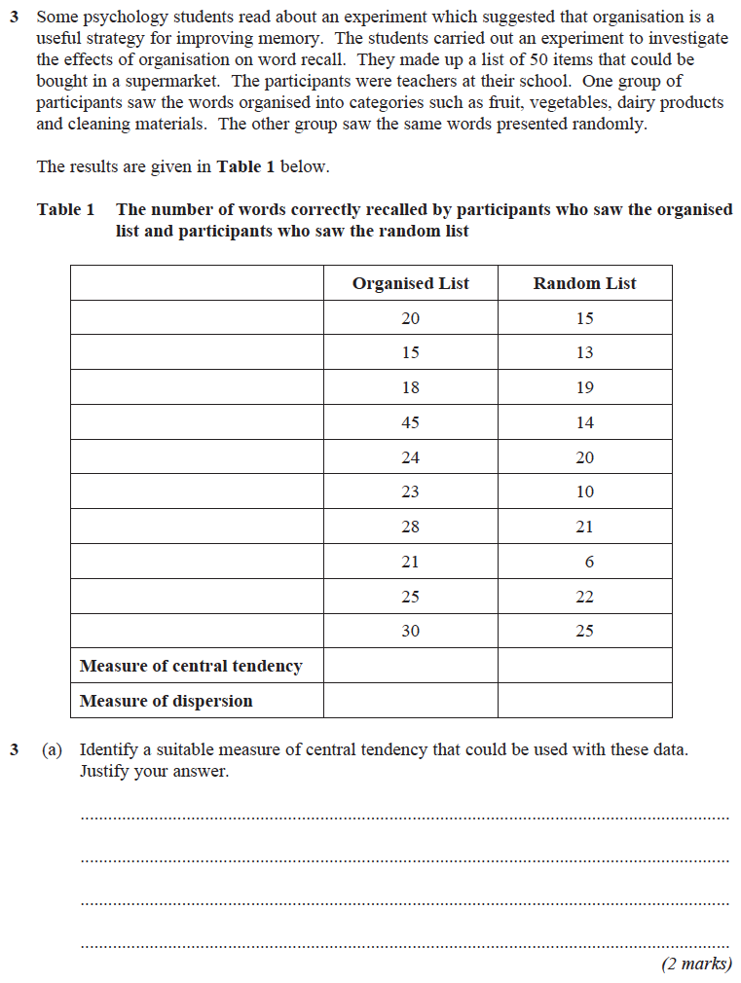

The Display of Quantitative Data
Task 1: read about this in the information pack.
- What types of data are represented in the following charts or graphs?
Tables

Bar Charts

Histogram

Scattergram

Task 2: Watch the videos and note take on bar charts and a histogram
https://www.youtube.com/watch?v=JsEwJD1mYpU
https://www.youtube.com/watch?v=iYIuqvuGvAw
Bar Charts Histogram

Draw a graph for the following sets of data
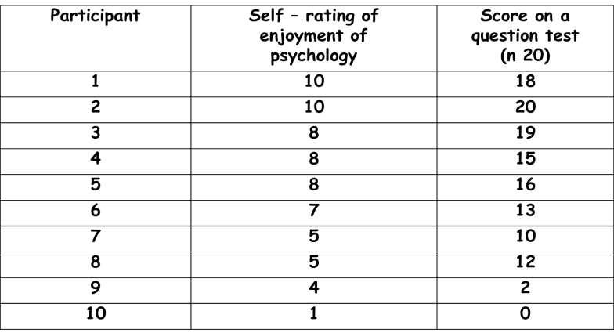
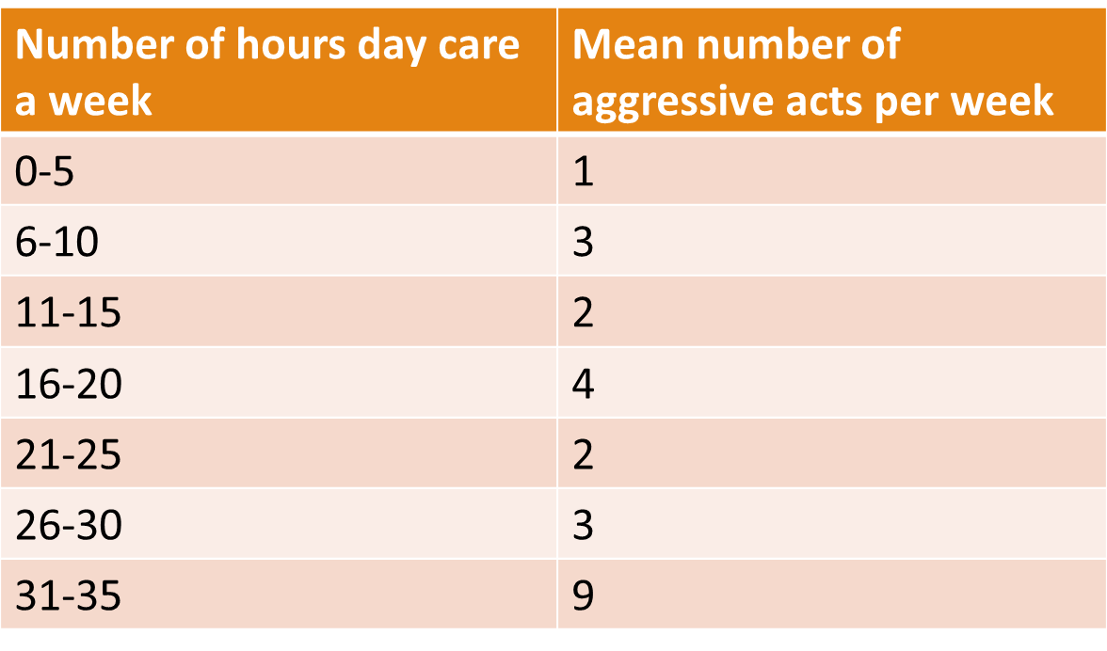
Data set 1 Data Set

