Approaches to Psychology: Biological Approach

***you will need to use the Approaches information pack on psych205. Go to the biological page (17 -20 ish) and/ or use the internet to do your own research***

Assumptions
- Behaviour can be largely explained in terms of Biology (e.g. g______/h________/ N____________).
- Behaviour and processes can be explained by the structure and function of the human nervous ________, particularly the brain.
- Human genes have evolved over millions of years to adapt behaviour to the ___________. Therefore, most behaviour will have an adaptive / evolutionary purpose.
- Psychology should be seen as a science, to be studied in a ____________ manner (usually in a ______________).

The Genetic Basis to Behaviour

- What is meant by Heredity?

- What is a genotype?

- What is a phenotype?

- What is a monozygotic twin?

- What is a dizygotic twin?

- What is a concordance rate?

- What would a perfect concordance rate be? (as a %)

- Explain how twin studies show that behaviour might be genetic

- Do you own research to find any example of a famous twin study – in which Mz and Dz twins have been compared. Outline some of the key procedures, findings (can you find any concordance rates) and conclusions.

- Why do you think twin studies can be used to help us understand the impact of nature or nurture?

***Highly recommended if you want to see a really dodgy study about twins. Watch the three identical strangers documentary on channel 4 4OD.
Neurotransmitters and synaptic transmission

You will now need to open the biopsychology information pack or use the internet to do your own research.

You will find that there are loads of youtube clips on synaptic transmission. Some of these break it down into easy to understand processes. Watch a few and then answer the questions.

e.g. https://www.youtube.com/watch?v=WhowH0kb7n0

https://www.youtube.com/watch?v=kFVP9wpqj-8

- What is a neurotransmitter?

- Give two examples of a neurotransmitter

- Label and fully annotate this diagram of a synapse

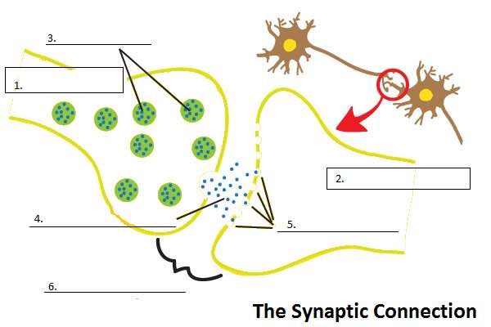

- Describe what is happening in each of these diagrams….

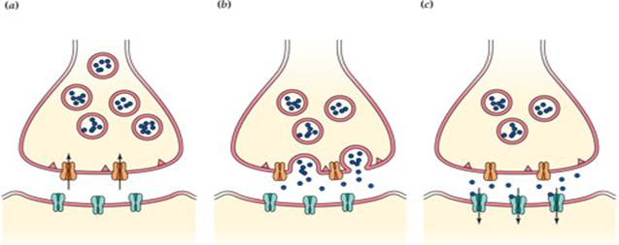

What is happening (Include re-uptake):
What is happening:
What is happening:

