A level Year 2 Summer
Summer Homework - Approaches
Complete the following using
- The Approaches pack
- www.simplypsychology.org/psychodynamic.html
- Research skills – searching online
The Psychodynamic Approach
Our behavior and feelings are powerfully affected by __________________. Our behavior and feelings as adults are rooted in our _____________________.
All behavior has a cause (usually unconscious), even slips of the tongue. Therefore all behavior is ___________________.Personality is made up of three parts (i.e. ______________): the ___, ________ and ________________.
*Behavior is motivated by two _______________ drives: Eros (the sex drive & life instinct) and Thanatos (the aggressive drive & death instinct). Both these drives come from the “id”. Parts of the __________________ (the id and superego) are in constant conflict with the conscious part of the mind (the ego). This conflict creates______________, which could be dealt with by the ego’s use of ___________________.
___________________is shaped as the drives are modified by different conflicts at different times in childhood (during _______________________________).

Label the following diagrams with the following words
SuperEgo Ego ID
Conscious Preconscious Subconscious

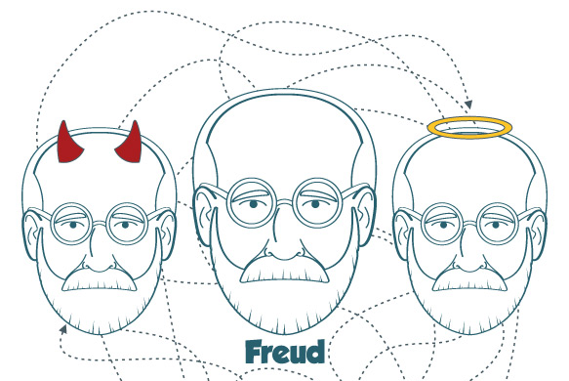

What would the ID, EGO and SUPEREGO suggest you do in the following situations
- You have missed lunch and are walking past a cake shop

- You are just leaving work and your boss asks you to stay an extra hour to help

- You are sat on a bus and notice someone has left a wallet full of £50 notes

- You are driving home and another car pulls out in front of you nearly causing a collision

Research online and summarise the case study of little Hans and the Oedipus complex

Define the Following and provide an example
Defence Mechanisms

Repression

Denial

Displacement

Read http://www.simplypsychology.org/psychosexual.html
Complete the following
Stage/ age | Description/Fixation | Consequence of conflict at this stage
Psychosexual stages of Development

The Above is said to be Subjective- What does this mean?

The Psychosexual stages are also said to be unfalsifiable- What does this mean?

Evaluation
Research the following terms, define and explain them as strengths/weakness of the approach
- Useful Application- Psychoanalysis

- Psychic Determinism
Firstly- What is meant by “Determinism?”

What is meant by the “Psych”?

So what is Psychic Determinism?

Is this a strength or a weakness of the approach?

- Can explain the unexplainable

- Untestable concepts and falsification

