Prep 5 - The Psychodynamic Approach
Complete the following using
- The Approaches pack
- www.simplypsychology.org/psychodynamic.html
- Research skills – searching online

Task 1 – General Assumptions
Our behaviour and feelings are powerfully affected by __________________. Our behaviour and feelings as adults are rooted in our _____________________.
All behaviour has a cause (usually unconscious) and is therefore ___________________.Personality is made up of three parts (i.e. ______________): the ___, ________ and ________________.
*Behaviour is motivated by two _______________ drives: Eros (the sex drive & life instinct) and Thanatos (the aggressive drive & death instinct). Both these drives come from the “id”. Parts of the __________________ (the id and superego) are in constant conflict with the conscious part of the mind (the ego). This conflict creates______________, which could be dealt with by the ego’s use of ___________________.
___________________is shaped as the drives are modified by different conflicts at different times in childhood (during _______________________________).

Task 2: The Personality and the Unconscious mind

Label the following diagrams with the following words
SuperEgo Ego ID
Conscious Preconscious Unconscious

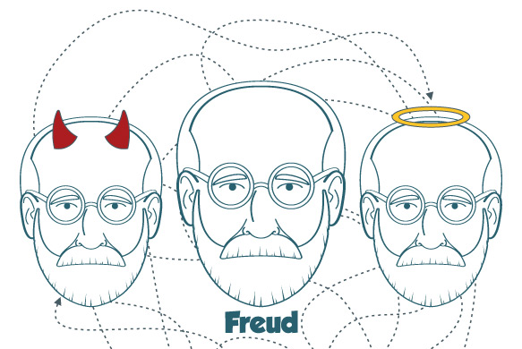

Task 3: The Psychosexual stages
- Click on the link: http://www.simplypsychology.org/psychosexual.html
Read and complete the following table:
Stage/ age | Description/Fixation | Consequence of conflict at this stage

- The Oedipus and Electra complex:
Use the pack to take notes and create a diagram demonstrating the process of both the Oedipus and Electra complex

- Consolidating your understanding of the Oedipus and Electra complex:
Watch the clip from the Prep page or access here https://www.youtube.com/watch?v=G7zZPrY8tGs
Make notes under the below key features of the theory based on what the clip suggests about the complex that children go through. They are in order of how they appear in the clip.
- Possess

- Both little girls and little boys

- Satisfaction and pleasure

- Competition and rivalry

- Strong love for…… jealousy of…..

- The Father represents….

- Resolution through identification

- Gender Identity

- Research support for the Oedipus complex
Research online and summarise the case study of little Hans and the Oedipus complex
https://www.tutor2u.net/psychology/reference/freud-1909
https://www.simplypsychology.org/little-hans.html
Aim
Method

Results/Conclusions

The above research has been criticised due to researcher bias and subjective interpretation
- What does this mean and why?
Task 4: Defence mechanisms:

Define the following defence mechanisms and provide an example relating to how an individual might deal with the conflicted feelings of not doing well in an exam when they hadn’t revised properly

Defence mechanism: | Definition | Example:
Repression

Denial

Displacement

